**OPENING OF ACCOUNTS**

Revisions Page

| **Revision Date** | **Chapter** | **Change** | **Description** |
| --- | --- | --- | --- |
| 02/2019 | 2.6 | Review | Amendment of customer engagement forms to comply with KYC and AML requirements and introduction of Critical data element requirement Table |
| 02/2019 | 2.2 |  | 16) Additional KYC requirements for Mpesa Agents |
| 03/2019 | 10.2 | Update | **Amend Contact details**  Confirmation of existence of E-Loan on Mco-opcash system before change of telephone number. |
| 03/2019 | 2.2 | Update | **Account Opening Requirements** - Additional Account Opening Requirements for Petroleum Dealers. |
| 03/2019 | 2.7 | New | Requirements for Opening a Medical Fund Account |
| 03/2019 | 2.9 | New | Requirements for Change of Signatories and signing mandate for joint account and partnerships account. |
| 05/2019 | 5 | New | Escrow Accounts |
| 07/2019 | 2.2 | Review | Account Opening Requirements - Account Opening Requirements for Government Accounts |
| 07/2019 | 8.3 | Review | Amendment done at BOS |
| 07/2019 | 8.10 | Review | **AML Risk Level Customer Categorization process,** Risk coding done at BOS |
| 09/2019 |  | Review | Data capture at Branch and BOS |
| 11/2019 | 2.5 | Review | Account Opening Requirements for Scrap Metal Dealers |
| 01/2020 | 8.10 | Review | AML Risk Level Customer Categorization process |
| 02/2020 | 2.10 | Review | Customer Engagement Forms - Critical Data Elements – removal of requirement for Next of Kin details. |
| 02/2020 | 2.2 | Review | Account Opening Requirements - Self Help Groups / Associations / Committees / Club / Societies – KRA PIN Requirement |
| 04/2020 | 2.2 | Update | **Account Opening Requirements – Limited Company** Enhanced and Incorporated Electronically/online registered companies (Opened under Companies ACT 2015) -'PVT companies. |
| 04/2020 | 2.7 | Review | Requirements for Change of Signatories for Club, Society, Association, Mission, NGO, Trade Union, and Self-Help Groups  added - Source of instructions/Reason to freeze an account |
| 06/2020 | 8.9.5 | Update | Jumbo Junior - Data Capture. |
| 06/2020 | 2.2 | Update | **Additional requirement for AML/CFT High risk customers**  No. 1- Forex Bureaus  New- No. 3 – Betting & Gambling Companies |
| 06/2020 | 8.3 | Added | Alterations on Account Opening Mandates |
| 12/2020 | 2 | Added | Completion of the Digital Account Opening Form on BPMS |
| 12/2020 | 8.2 | Added | Personal and Jumbo Junior Account Opening Process Flow On BPMS |
| 3/2021 | 8.9.4 | Added | Capture of Student details |
| 8.11 | Added | Industrial Sector Classification - BPMS |
| 8.32 | Added | Industrial Sector Classification -FINACLE |
| 11.4 | Added | Industrial Sector Code |
| 06/2021 | 2.2 | New | Account Opening Requirements for Recruitment Agencies |
| 8.5  8.14 | New | Creation of Party ID for marketed Accounts  Opening of multiple accounts |
| 2.2 | New | Account Opening Requirements for Private Security Firms |
| 2.1 | Amended | Search will not be required for a Church Branch- where the Main Church Banks with us |
| 2.7 | New | Account Opening Requirements for Religious Institutions |
| 5.3 | Amended | Escrow Account - 01240- to be opened by Branch SDO |
| 10/2021 | 2.9 | Review | Requirements for opening of additional account |
| 12/2021  12/2021 | 2.2 | Updated | **Personal Saving/Transactional and Current Accounts, Jumbo Junior Access and YEA** – KRA PIN Number Mandatory |
| 2.5 | Updated | Account Opening Requirements for Scrap Metal Dealers- Personal Accounts- KRA PIN Number Mandatory |
| 8.7.3 | Review | Capture of KRA PIN number |
| 04/2022 | 8.18 | Review | Upload of documents |
| 05/2022 | 8.21 | Review | Deferred cases |
| 06/2022 | 8.31 | New | Jumbo Junior for expectant mothers |
| 07/2022 | 2.2 | Updated | Account opening requirements for **Digital Credit Providers** |
| 08/2022 | 2.2 | Updated | Account Opening Requirements: CBK authorization Certificate allowing Payment Facilitators/Remittance Companies to conduct/carry out the business of a Payment Service Provider in Kenya. |
| 12/2022 | 2.2 | Deleted | Account opening requirements for Private Security Firms.   * Certificate of registration from The Private Security Regulatory Authority * Certificate of Security Training issued by The Private Security Regulatory Authority |
| 12/2022 | 13 | Update | Appendix I – Detection and Prevention of Account Opening Fraudulent Schemes |
| 03/2023 | 2.2 | Review | Account Opening Requirements: **Jumbo Junior** account opening requirements   * Use of Birth notification up to 3 years from date of birth. |
| 03/2023 | 2.2 | Review | **Account Opening Requirements** - requirementsforLicense from the Energy Regulatory Commission allowing the customer to trade in Petroleum business has been made optional.  If Customer does not the license, the branch shall undertake a Site visit and prepare a call report as per the attached call report template. |
| 03/2023 | 2.8 | Added | Account opening requirements for Private Institutions |
| 06/2023 |  |  | Alignment to Finacle processes. |

OPENING OF ACCOUNTS

TABLE OF CONTENTS

1 INTRODUCTION 11

1.1 General 11

2 ACCOUNT OPENING REQUIREMENTS 11

2.1 Know Your Customer (KYC) 11

2.2 Account Opening Requirements on Referee 11

2.3 Documentation Required for Account Opening 12

2.4 Account Opening Requirements for Foreign Nationals 34

2.4.1 Resident Foreign Nationals 34

2.4.2 Account Opening Requirements for Non-Resident Foreign Nationals (As Per CBK Prudential Guidelines). 35

2.4.3 Minimum requirements for Resident Foreigners 35

2.4.4 Account Opening Requirements for Companies with Foreign Nationals as Directors 35

2.4.5 Account Opening Requirements for Temporary Residents (Students, Spouses, Attaché’s to Foreign Missions in Kenya, Next Of Kin etc.) 36

2.4.6 Non-resident Foreigners 36

2.5 Account Opening Requirements for Scrap Metal Dealers 36

2.5.1 Additional Account opening requirements for Scrap Metal Dealers 36

2.6 Requirements for Opening a Medical Fund Account 37

2.7 Account Opening Requirements for Religious Organizations 39

2.7.1 Main Church 39

2.7.2 Church Branch Account 39

2.8 Account opening requirements for Private Institutions 40

2.9 Requirements for Change of Signatories for Club, Society, Association, Mission, NGO, Trade Union and Self-Help Groups 41

2.9.1 Disputed Changes 41

2.9.2 Source of instructions/Reason to freeze an account 41

2.10 Requirements for Opening of Additional Accounts 42

2.11 Type of Forms 42

2.11.1 Conditions for Use of Form A1 (g) 43

2.12 Requirements for Change of Signatories and signing mandate for joint account and partnerships account. 45

2.13 Customer Centric Products Engagement Forms 48

2.14 Customer Engagement Forms - Critical Data Elements 50

3 LIABILITY PRODUCTS 54

4 General Information 55

4.1 Deposits to Accounts 55

4.2 Withdrawals from Accounts 56

4.3 Interest on Accounts 56

4.4 Cheque Books 56

4.5 National Government Constituency Development Fund Accounts 56

4.5.1 Dormant Accounts 56

4.5.2 Transfer of Accounts 57

5 ESCROW ACCOUNTS 57

5.1 Customer Initiated Escrow Accounts: 57

5.2 Bank Initiated Escrow Accounts: 58

5.3 Escrow Account Management 58

5.4 Escrow Account Properties 59

6 STAFF ACCOUNTS 59

6.1 Ex-staff Current Accounts 59

6.1.1 Transferring of staff accounts to Ex staff accounts in Finacle at the branch. 60

6.2 Ex-staff Loan accounts 60

6.3 Staff Credit Cards 62

6.3.1 Credit Card Operation While still in Service 62

6.3.2 Staff Members on suspension 62

6.3.3 Staff Leaving the Bank 62

6.3.4 Implications 63

7 STANDARDS OF SERVICE 63

7.1 Interviews 63

7.1.1 Prohibited Accounts 63

7.2 Controls 64

7.3 Time 64

7.4 Authorizing Officer 65

8 ACCOUNT OPENING PROCESS FLOW (BPMS) 65

8.1 Responsibility 65

8.2 Personal and Jumbo Junior Account Opening Process Flow on BPMS 65

8.3 Logging in BPMS (Process Maker) 66

8.4 Starting a case 67

8.5 Customer Type Selection 68

8.6 Creation of Party ID for Marketed Accounts 69

8.7 Applicant Identification Document Verification 69

8.8 Verification Results 70

8.8.1 Finacle Blacklist Results 70

8.8.2 IPRS Information 70

8.8.3 KRA PIN information 72

8.8.4 Finacle Existing Accounts 73

8.8.5 Party Relationships 73

8.9 Capture of Customers Details 74

8.9.1 Customer Details 74

8.9.2 Party Address Details 75

8.9.3 Physical Address 75

8.9.4 Residential Status 75

8.9.5 Contacts Details 76

8.9.6 Contact Person Details 76

8.9.7 Contact Preference 77

8.9.8 Other Co-op Accounts 77

8.9.9 Employment Details 77

8.9.10 KYC Details 79

8.9.11 Product Selection and AML Details 79

8.9.12 AML Risk Calculation 81

8.9.13 Account Relationship Details 82

8.9.14 Fatca Details 82

8.10 Cross Selling 82

8.10.1 My payments 82

8.10.2 Mco-op Cash and Online Banking 83

8.10.3 Alerts Subscription 83

8.10.4 Standing Order 84

8.11 Capture of Customers Photo, ID Document Front and Back 84

8.11.1 Walk In Customers 84

8.11.2 Marketed Accounts 85

8.12 Select the Signature Type 85

8.12.1 Capture of Customers Signature 86

8.13 View Account Details 87

8.14 Opening of Multiple Accounts 87

8.15 Generating Documents (e-form) 89

8.16 Signing of Terms and Conditions 89

8.16.1 Upload of Documents 90

8.16.2 Saving of Documents 90

8.16.3 Uploading of Documents 90

8.16.4 RTS Cases for Wrong Attachment 91

8.16.5 Amendment Process 91

8.17 Forwarding to BOS for Verification and Quality Assurance 92

8.18 Deferred Case 92

8.19 Joint, Sole Proprietorship and Company Accounts Opening Process 93

8.19.1 Process Flow 93

8.20 Alterations on the Account Opening Mandate 94

8.20.1 Confirmation of the Alteration 95

8.21 Blacklist Enquiry 95

9 ACCOUNT OPENING PROCESS FLOW (FINACLE) 96

9.1 Responsibility 96

9.2 Retail CIF Process Flow 97

9.3 Creating a Retail Customer Information File (CIF) 98

9.4 Selecting Customer Type 99

9.5 Performing Dedup, Negative List, blacklist & IPRS Checks 100

9.6 Capturing Basic Details 103

9.7 Capturing Identification Document for a Retail CIF 103

9.7.1 Identification Document Summary 103

9.7.2 Adding a Saved Document using the Add Mode 106

9.7.3 Adding a Saved Document Using Link Mode 106

9.7.4 Adding Document using Capture Mode 108

9.7.5 Adding of Customers Address 109

9.8 Adding Residence/Permanent Address (Physical Address) 110

9.9 Capturing of Diaspora Accounts Address 111

9.10 Capturing Contact Details 112

9.11 Capturing Other Details 114

9.12 Capturing the Residential Details 114

9.13 Capturing Miscellaneous Details 115

9.14 Capturing Currency Details 115

9.15 Generating KRA Details: 116

10 CIF ENRICHMENT (FINACLE) 117

10.1 Additional Details 118

10.2 Previous Name Details 118

10.3 Qualification Details 119

10.4 Employment details 120

10.5 Reporting and References Details 121

11 bank defined details 121

11.1 Foreign Account Tax Details/FATCA 122

11.2 Details of Business Entities 123

11.3 Relationship Details with other banks 124

11.4 Group and Household Details 125

11.5 Customer Mapping Details 125

11.6 Next of kin Details 126

11.7 Bank Defined Details 127

11.7.1 Pricing Details 127

11.7.2 Business Analytics 127

11.7.3 Risk Rating and Score Details 128

11.7.4 Relationship Manager Details 129

11.7.5 Access Control Details 129

11.8 Details for Official Use 130

11.9 Details for Core Banking 131

11.10 Disaster Relief Details 131

12 Preference Details 132

12.1 Personal Preferences 132

12.2 Preferences in Bank Services 132

12.3 Product Preferences 133

12.4 Contact Preferences 133

13 Financial Details 135

13.1 Asset and Charge Details 136

13.2 Income and Expenditure Details 136

14 RELATIONSHIP Details 137

14.1 Social and Banking relationship List 137

14.2 Corporate Relationship List 138

15 Verifying Retail Customer INFORMATION File (CIF) 139

15.1 Approve 143

15.2 Rework 144

15.3 Close 144

16 Account Opening Individual Retail customer 145

16.1 Introduction 146

16.2 Account Opening Menus 146

16.3 Opening a Retail Account 146

16.4 Additional Details 148

16.5 Tax Details 151

16.6 Scheme Details Field 152

16.7 Nomination Details Field 153

16.8 Related Party Details 154

16.9 Account Limit Details 155

16.10 General Details 155

16.11 Signature Mandates 156

16.12 Funding Instructions 156

16.13 Exception Limit Details 157

16.14 Bank Employee Details 158

16.15 Documents Details 158

16.16 Flexi Fixed Deposit Details 159

16.17 Payment System Details 160

16.18 MIS Details 161

16.19 Other Details 162

17 Capture Of Customers Photo, Signature for Individual Retail Account 163

17.1 Generate Form 163

17.2 CACOF Verification for Individual Retail Account 164

17.3 Modifying Account Before Verification 165

17.4 Account Opening Verification 166

18 Joint Account Opening 168

18.1 Introduction 168

18.2 Joint Account Opening 168

18.3 Additional Details 170

18.4 Tax Details 173

18.5 Scheme Details Field 174

18.6 Nomination Details Field 175

18.7 Related Party Details 176

18.8 Account Limit Details 177

18.9 General Details 177

18.10 Signature Mandates 178

18.11 Funding Instructions 178

18.12 Exception Limit Details 179

18.13 Bank Employee Details 180

18.14 Documents Details 180

18.15 Flexi Fixed Deposit Details 181

18.16 Payment System Details 182

18.17 MIS Details 183

18.18 Other Details 184

18.19 Joint Account Opening Photos & Signature Joint Account 185

18.20 Verification of Joint Account Opening 186

19 Corporate Account Opening Process 187

19.1 Creating a Corporate Customer Information File 187

19.2 Basic Details 190

19.3 Capturing of Identification Document for a Corporate CIF 191

19.4 Adding Address for Corporate CIF 192

19.5 Capture Other Details 196

19.6 Additional Details 198

19.7 Background Check Details 200

19.8 Customer Mapping 203

19.9 Risk rating and Score Details 204

19.10 Access Control Details 204

19.11 Details for Official Use 205

19.12 Details for Core Banking 205

19.13 Review Details 206

19.14 Other Details 206

19.15 Preference Details 207

19.16 Product and Preferences 207

19.17 Financial Details 209

19.17.1 Transaction Details 209

19.17.2 Corporate Financial Details 209

19.17.3 Other Details 210

19.17.4 Relationship Details 211

19.17.5 Corporate Branch Relationship 212

19.18 Corporate CIF Verification 214

19.19 Corporate Account Opening Process 219

19.19.1 Additional Details 220

19.19.2 Photo & Signature capture for Corporate Account Opened 235

19.19.3 CACOF Verification for Corporate Account Opening 236

19.19.4 Corporate Account Opening Verification 237

19.20 Corporate Account /Joint accounts Rules (Maintaining and mapping of the rules) 237

19.20.1 Add a Rule 237

19.20.2 Verify Rule 242

19.20.3 Inquire Rule 243

19.20.4 Common Rules 245

19.20.5 Mapping Account Rules 245

19.20.6 Verify Account Signature Map 247

20 MINOR ACCOUNT OPENING 249

20.1 Introduction 249

20.2 Minor CIF Creation 249

20.3 Capturing Basic Details. 250

20.4 Adding Customer Address 253

20.5 Capturing Contact Details. 253

20.6 Capturing Other Details. 253

20.7 Additional Details. 253

20.8 Bank Defined Details. 253

20.9 Preferences Details. 253

20.10 Financial Details. 253

20.11 Relationship Details. 253

20.12 Verification of Retail CIF 254

20.13 Minor Account Opening 254

20.13.1 Basic Account Details 254

20.13.2 Capture Additional Details 255

20.14 Photo & Signature Capture for Minor Account 257

20.15 CACOF Verification for Minor Account 258

20.16 Minor Account Opening Verification 258

20.17 Unborn CIF Creation 258

20.18 Basic Details Page 260

20.19 Adding Customer Address Summary 262

20.20 Capturing Contact Details 262

20.21 Capturing Other Details 262

20.22 Unborn Child Account Opening 263

21 Marketed Account 263

22 ModifyING Account Before Verification 264

23 CancelING Savings/Current Account Opening Before Verification 266

24 Transfer of account between schemes 268

24.1 Cancelling of account transfer between schemes 269

24.2 Verification of transfer of accounts between schemes 269

OPENING OF ACCOUNTS

# INTRODUCTION

## General

This section deals with the procedure of opening both transactional and Savings Bank accounts.

The initial deposits into a new account can be in the following forms:

* Cash
* Bankers’ cheque
* Cheque drawn on Co-operative Bank of Kenya
* Cheque drawn on other banks (Allowed for Corporate Customers only)

Where cheques are used in opening accounts care shall be taken to ensure that no drawing is allowed until the proceeds of the cheque have been received.

# ACCOUNT OPENING REQUIREMENTS

## Know Your Customer (KYC)

KYC at the point of account opening is crucial and staff shall perform a thorough KYC for the persons opening the account and understand the nature of their business.

Staff shall ensure that all accounts opened meet the legal requirements of KYC. This includes ensuring that all the identification documents are obtained at inception.

Staff shall ensure that all documents obtained from customers are properly filed and readily available for audit purpose.

Hand-over process and procedures on stamps shall be adhered to.

**Note:**

* + When a business relationship is being established, the staff Onboarding the customer shall establish the nature of the business that the customer expects to conduct with the Bank to show what might be expected as normal activity. The legitimacy of the customer’s business shall be clearly understood.
  + The staff shall identify the customer and verify the customer’s identity using reliable, independent source documents, data or information.
  + The customer information shall be properly captured and archived for future reference and audit purposes

## Account Opening Requirements on Referee

In instances where the Branch requires additional information to confirm the identity of a customer, a referee is required.

Acceptable referees are as follows: -

* + - Bank Relationship Officer, to be countersigned by the Branch Manager.
    - Letter of introduction from employer/Sacco;
    - Certified bank statements
    - Bank reference

A business search shall be required except for the following entities:

* Natural persons
* National Government Departments
* County Governments
* Government owned institutions e.g., Parastatals, Authorities etc.
* National/County Government owned educational institutions i.e. Primary Schools, Secondary Schools, Colleges, Tertiary Institutions and Universities.
* Companies listed in the Nairobi Securities Exchange
* Banks & DTMs regulated by CBK
* Church Branch, where the Main Church Banks with us
* For SHGs, Call back shall be done to the DSDO to confirm the officials appointed as signatories.

On receipt of the search results from Legal Department, the Account Opening Officer shall verify the following details against details provided by the customer on the account opening form and details provided on the account opening documents.

* + Company Name
  + Registration Number
  + Company Postal Addresses (must tally in all account opening documents and company search results)
  + Company Physical Address
  + Names of directors
  + Postal addresses of the directors,
  + Nationality (shall guide on the expected identification document)

**All details must tally in all aspects**

Any discrepancies must be referred to the Branch Manager for advice on the way forward.

## Documentation Required for Account Opening

**Note:**

1. All copies of the required documents must be certified against the original documents.
2. Refer to additional information section for Foreign Nationals as detailed under “Account Opening Requirements for Foreign Nationals”

|  | **Personal Saving/Transactional Accounts (Savings Bank Accounts -SBA)** | **Joint Saving/Transactional Accounts** | | **Personal Current Accounts**  **(Current Bank Accounts- CAA)** | **Joint Current Accounts** | | **Jumbo Junior Access (MINOR)** | **YEA (YETRA)** | **Foreign Persons** |
| --- | --- | --- | --- | --- | --- | --- | --- | --- | --- |
|  | Valid Identification Card /valid Passport | Valid Identification Card /valid Passport | | Valid Identification Card / valid Passport | Valid Identification Card / valid Passport | | Valid Identification Card / Birth certificate/Birth Notification | Identification Card | Valid Passport |
|  | Passport size coloured photograph / Digital passport Photo | Passport size coloured photograph / Digital passport Photo | | Passport size coloured photograph/ Digital passport photo | Passport size coloured photograph/ Digital passport photo | | Parent/Guardian Passport size coloured photograph / Digital passport photo | Passport size coloured photograph/ Digital passport Photo | Passport size coloured photograph/ Digital passport photo |
|  | Minimum Opening Balance | Minimum Opening Balance | | Minimum Opening Balance | Minimum Opening Balance | | Minimum Opening Balance | Minimum Opening Balance | Minimum Opening Balance |
|  | No Referee | No Referee | | A reference document in form of either of the following in instances where the branch requires additional information to confirm the identity of a customer:   * Letter of introduction from a Bank relationship officer, to be countersigned by the Branch Manager. * Letter of Introduction from Employer/Sacco; * Certified Other bank statements; * Bank Reference. * KRA PIN Number Mandatory | A reference document in form of either of the following in instances where the branch requires additional information to confirm the identity of a customer:   * Letter of introduction from a Bank relationship officer, to be countersigned by the Branch Manager. * Letter of Introduction from Employer/Sacco; * Certified Other bank statements; * Bank Reference. * KRA PIN certificate Mandatory | | No Referee | No Referee | * Valid Work Permit * Referee/Letter from the Embassy in instances where the branch requires additional information to confirm the identity of a customer |
|  | Completion of the Digital Account Opening Form on BPMS/ Completion of the Account Opening Form | Completion of the Digital Account Opening Form on BPMS/ Completion of the Account Opening Form | | Completion of the Digital Account Opening Form on BPMS/Completion of the Account Opening Form | Completion of the Digital Account Opening Form on BPMS/Completion of the Account Opening Form | | Completion of the Digital Account Opening Form on BPMS/Completion of the Account Opening Form | Completion of the Account Opening Form | Completion of the Account Opening Form |
|  | KRA PIN Number Mandatory | KRA PIN Certificate Mandatory | | Complete Cheque book requisition form  **KRA PIN certificate** Mandatory | Complete Cheque book requisition form  KRA PIN certificate Mandatory | | Child’s Birth certificate/Birth notification certificate  **Note**: Birth notification certificate shall be applicable for use up to three years from the date of birth  KRA PIN Number for the parent(s)/Guardian is mandatory. | KRA PIN Number Mandatory | FATCA document for US citizens  TAX identification Number |
|  | Additional Requirements for Politically Exposed Persons (PEPs)-refer to KYC manual on definition of a PEP | Additional Requirements for Politically Exposed Persons (PEPs)-refer to KYC manual on definition of a PEP | |  | | Approval to open an account including loan accounts by a customer or beneficial owner who is a PEP is vested in the Branch Manager who will undertake enhanced due diligence. Approval is by signing and stamping the account opening form after verifying KYC documents. | | | |
|  | Additional Requirements for United States Persons | Additional Requirements for United States Persons | |  | | Completion of W-8BEN and W-9 forms in addition to the account opening form after proper KYC has been done as per the Financial Account Tax Compliance Act. Refer to the FATCA identification requirements and process in Appendix VI | | | |
|  | | |  | **Business Accounts** | | | | | |
| 1. **Requirements** | |  | |  | | Account signatories  Kenyans - Identification Cards  Foreign Directors - Valid Passport and Work permit | | | |
|  | |  | | Signatory’s Passport size coloured photograph/ Digital passport photo | | | |
|  | |  | | Minimum opening balance | | | |
|  | |  | | Completion of the Account Opening Form | | | |
|  | |  | | Completion of Cheque Book Requisition Form/ticking on the checked box for cheque book requisition on the Enterprise/business engagement form for (Current account) | | | |
|  | |  | | KRA PIN Number Certificate -Mandatory | | | |
|  | |  | | Where applicable, reference document in form of either of the following shall be obtained:   * Bank Relationship Officer, to be countersigned by Branch Manager. * Letter of introduction from employer/Sacco * Certified other bank statements; * Bank reference   **Note**   * For non-solicited limited liability companies’ i.e. **“Walk in customers”** a reference document for all the directors of the company shall be given in instances where the branch requires additional information to confirm the identity of a customer: | | | |
| 1. **Additional to 1 above if a limited Company** | | * Memorandum and Article of Association * Certificate of incorporation copy * For foreign limited liabilities   + Certificate of Incorporation of subsidiary in Kenya or certificates of approved enterprise.   + Certificate of compliance for foreign limited liabilities if the company is opening a branch in Kenya. * A Board Resolution to open the account, specifying the manner in which the account shall be operated and naming the signatories to the account Change of Business Name (where applicable) * Certified copy of Certificate of Compliance * Search results   Electronically/online registered companies (Opened under Companies ACT 2015) are commonly referred to as 'PVT companies'.  Account opening requirements for PVT companies:   1. Form CR1 - Company Registration Form 2. Form CR2 - Memorandum of Association (forms CR3 and CR4 for companies limited by guarantee and unlimited liability companies respectively) 3. Form CR8 - Notice of Residential Address (Change of Address) of Director of Company; 4. CR12 - this is a certificate/search result issued by the Registrar of Companies confirming the names of the shareholders and directors of a company as well as the shares held by the shareholders 5. Board resolution to open an account/s with the bank.    * Where the company has only one director - required to confirm that the director is acting as such and not in his or her own individual capacity.    * Written resolutions (resolution by circulation and not through a board meeting) are now acceptable where the Articles of the Company provide for written resolution. 6. A system generated certificate of incorporation. 7. KYC documents for the company and shareholder(s) /director(s) i.e. ID/Passport copies, PIN certificates for the company and its shareholder(s) /director(s). 8. For complex structured companies (i.e. companies whose shareholders are other companies), the ultimate beneficial owners shall be identified up to the natural persons owning and controlling the entity wishing to open an account with the Bank and KYC documents provided as per procedure. This applies to both PVT and older companies. 9. Company Searches shall be conducted through legal before opening the account as per procedure.   **N/B**  A Board Resolution to open an account is also required for single director companies   * In a complex company structure where shareholding of 10% or more is by another company, establish the natural person (an individual) who has the ultimate control over the share holding company and conduct KYC on the directors and the share holding company**.**   According to the Proceeds of Crime and Anti-Money Laundering Regulations Sections 19 page 231, all reporting institutions are required to establish ultimate beneficial ownership.  Businesses with such ownership and complex structures need to go through an enhanced due diligence (EDD) process that includes but is **not** limited to the below as highlighted in the Proceeds of Crime and Anti-Money Laundering Regulations sections 12 -19:   |  |  | | --- | --- | | **KYC Document Required** | **Rationale and Uses of the document** | | **Certified Incorporation documents** issued by relevant Government Agency, Company **Memorandum and Articles of Association /Relevant Entity Constitution document, CR12, KRA PIN** of the Kenyan registered entity seeking to open an account with the bank | This is a mandatory requirement as stipulated in the in fulfilment of the Proceeds of Crime and Anti-Money Laundering Regulations Section 14 (1) (b) | | Full year **Audited Financial Statements** (where entity is >18 months old); OR **Un-Audited Financial Statements** (where entity is >12 months old but **cash flow forecasts** for new entities (exceptional waivers may apply where suitable alternatives are provided e.g., **certified 12 months statement of account from other bank)** for the entity seeking to open an account | This is a mandatory requirement as stipulated in the in fulfilment of the Proceeds of Crime and Anti-Money Laundering Regulations Section 14 (1) (e) | | The full names, identity or passport number and address of the natural persons managing, controlling, or owning the entity | This is a mandatory requirement as stipulated in fulfilment of the Proceeds of Crime and Anti-Money Laundering Regulations Section 14 (1) (d)  This information is similarly important for screening against sanctions lists to ensure that the bank is not engaging with, either directly or indirectly, sanctioned individuals/ entities. According to US Sanctions programs, if an entity is owned or controlled (at least with 50% shareholding) by a sanctioned individual, the entity and the entire relationship is sanctioned. | | A Certified Copy of the **Board resolution** stating authority to open an account or transact business with the bank and designating persons having signatory authority thereof. The resolution shall be signed in accordance with the entity’s memorandum and articles of association. | This is a mandatory requirement in accordance with Section 14 c) of the regulations and serves the purpose of notifying the bank, whom it shall deal with during the tenure of the banking relationship. | | Certified True Copies **Identification Card / National Passport** of Stakeholders and Authorized Signatories; **Signatories’ PIN Certificates / PIN Numbers** (PIN Check to be undertaken in all cases) (For Non- Residents may not be available & can be waived through appropriate process); One **Passport Size Colour Photograph** of each Authorized Signatory; **Valid Work permit document/ Foreigner Certificates** of all foreign signatories | This is a mandatory requirement | | **Notarized Incorporation documents** of the foreign shareholding entities | This enables the bank to confirm that it is dealing with entities that have a physical presence i.e., are not shell entities as breach of this would result in contravention of the International AML and KYC regulations and contravene the Section 25 (1) prohibiting reporting institutions from dealing with shell banks and by extension shell entities. | | **Certificate of Compliance** for Foreign entities | This is NOT a mandatory requirement unless the Foreign entity is willing to register its business in Kenya | | **Organizational structure** showing the percentage ownership of all the shareholding entities up to the natural person’s owning and controlling the entity seeking to open an account with the bank | This is a mandatory requirement according to Section 19 of the POCAML regulations.  This requirement may be waived for listed entities with many shareholders however, this shall be replaced by providing the ultimate beneficial owners of the entities with more than 10% shareholding or less depending on the level of risk presented by the entity being onboarded and the shareholding companies | | **Official Search** at relevant government Agencies carried out by the Bank | Mandatory requirement | | **Power of Attorney** - Legal & advocate witnessed plus registered PoA certified true copy by Bank Official, verified via registry search conducted through the Legal team  **Foreign drafted Power of Attorney** need to be registered at the Kenyan local courts before being admissible for use in Kenya and presented to the bank for a registry search to be conducted by the legal team | Where applicable. This helps to indemnify the bank from any litigation proceedings regarding persons authorized to deal with the bank | | **FATCA** Execution of additional documents in relation to FATCA i.e. Form W9, W-8BEN-E and W-8ECI | Optional depending on whether the answer is ‘YES’ to any of the 3 questions below:   1. Are any of the stakeholders US persons (based on questions under stakeholder details)? If so, is the total shareholding of the US persons >10%? 2. Has the customer indicated whether the entity expects to receive US source investment income? 3. Has the customer indicated whether the entity expects to receive US source trade and business income? | | Establishing the person’s or entity’s source of funds; expected volumes and values of transaction | This is a mandatory requirement according to regulations and assists in the transaction monitoring review to be done by the account relationship manager with exceptions/ suspicious activities raised with the Compliance department for further investigation | | Completed and executed **Customer Engagement Form** per entity constitution documents | Mandatory Requirements with all fields complete and an appropriate risk rating assigned.  All such entities shall be marked as high risk | | Obtaining the business Director/ Senior Management approval for the new business relationship or transaction | This is mandatory as stipulated in section 18 c) of the regulations. |   All documents shall be independently verified by a bank official as per policy and procedure  In order to avoid constant back and forth and compromise on the bank’s service standards to our customers, ensure that all KYC/ Due diligence requirements and documents for such accounts are reviewed and understood by the account relationship manager and provided in **totality** to the Compliance team for review **before** the account is opened.  **N/B:** For any existing relationships where the Ultimate Beneficial Ownership is not determined, ensure that a review of the account is conducted soonest possible in line with POCAML Regulations to avoid inconveniences to the clients especially when opening additional accounts or when such accounts are under review or audit. | | | | | | | |
| 1. **Additional to 1 above if a Club, Society, Association, Mission, Trade Union.** | | * Certificate of Registration / letter from relevant authority e.g. Ministry of Education, Social Services, Church HQ, Central Organisation of Trade Unions, and NGO Coordination Board. * Certified Copy of Constitution, Rules / By –Laws | | | | | | | |
| 1. **Additional to 1 above if an NGO.** | | * Certificate of Registration * Certified Copy of Constitution, Rules / By –Laws * Copy of latest annual returns to NGO Co-ordination Board (New NGOs are exempted – New means that an NGO has been in existence for less than one year). * Company Business Search * Approval letter to open account from NGO Coordination Board showing the Officials, and Signatories. The signing mandates shall be as per the NGO Minutes. Any change of Officials/Signatories must be approved by the NGO Co-ordination Board before being effected by the Bank. * The Branch Manager shall review the documents and sign on the account opening form to approve the opening of the account. | | | | | | | |
| 1. **Additional to 1 above if a Non-Trading Partnership- Professionals not engaged in buying and selling of goods e.g. Lawyers, Doctors, Accountants** | | * Certificate of Registration * Appointment of Bankers | | | | | | | |
| 1. **Additional to 1 above if a Sole Proprietor / Partnership** | | * Certified copy of Certificate of registration * Certified copy of Certificate of change of Particulars | | | | | | | |
| 1. **Additional to 1 above for Group – Self Help Groups / Associations / Committees / Club / Societies** | | * Certificate of registration or Partnership Deed * Minutes of the last meeting authorising the official(s) to open an account with the Bank. The minutes of the meeting must give clear details of how the account shall be operated by stating the signatories to the account. * Certified copy of the resolution (appointing the Bank as the group’s Banker) and the By-Laws/Constitution to be obtained. * Letter of introduction from the Ministry of Culture and Social Services (for Self Help Groups) or from the Office of the Attorney General (for Welfare Associations).   **KRA PIN Requirement**   * For groups registered under Social Services e.g. Self-help Groups, Community Based Organizations (CBOs) & Welfares, the KRA PIN Number Certificate is only required for the Account Signatories. * For groups registered as Limited companies - Group KRA PIN Number Certificate plus the KRA Pin certificates for the account signatories must be provided. * Informal Groups/Unregistered groups shall open a Joint Mshiriki Account under the names of the signatories. KRA PIN Number Certificate for the account signatories must be provided. The joint Mshiriki account shall have at least four signatories. | | | | | | | |
| 1. **Additional to 1 above for Provident Funds/Trust Accounts** | | A trust is “an equitable obligation imposing upon a person (called a trustee) the duty of dealing with property over which he/she has control (called trust property) for the benefit of persons (called beneficiaries) of whom he/she may himself/herself be one, anyone of whom may enforce the obligation”.  The requirements are: -   * Trust Deed must be scrutinised to ensure that no undue onus is placed on the Bank when opening accounts of this nature. * Where there is a trust, a certified copy of the Trust Deed must be obtained and filed with other mandates. * lf not known, the Trustee(s) shall be satisfactorily introduced, and where more than one is appointed, then a mandate is required the mandate shall show the full names and addresses of the trustee, and the Specimen Signatures. * All trustees are required to sign cheques and other authorities, so the choice of who is to sign does not apply unless such delegation is authorised in the Trust Deed. * To comply with Proceeds of Crimes and Anti-Money Laundering Act and Regulations, the following particulars must be obtained before onboarding trusts:   • Its registered name, if any.  • Its registration number, if any.  • Evidence of registration or incorporation such as a certificate of incorporation or registration.  • Trust deed.  • Formative document such as partnership agreement, memorandum and articles of association.  • Official returns showing registered office and if different the principal place of business.  • Full names and details of the management company of the trust or legal arrangement, if any.  • Names of the relevant persons having senior management position in the legal person or trustees of the legal arrangement.  • Full names of the trustee, beneficiaries or any other natural person exercising ultimate effective control over the trust.  • Full names of the founder of the trust  • Any other documentation from a reliable independent source proving the name, form and current existence of the customer | | | | | | | |
| 1. **Additional to 1 above for Trusts not created by Deed** | | There are occasions when trusts are not created by a deed. The commonest form of a trust here is a trust created by a will, where on death; the deceased has left instructions in his will for money to be held in trust for his/her beneficiaries.  If there are such accounts, the bank must treat them as trust accounts and not allow the trustee to withdraw the money for his own purposes.  In handling such accounts, the Branch Manager shall seek guidelines from the Company Secretary for confirmation of the same in writing before releasing any funds to the beneficiaries. | | | | | | | |
| 1. **Additional to 1 above for Accounts of Executors and Administrators** | | * Reference shall be taken up if the persons are unknown * The account shall be styled, by way of: John Mwangi and Irene Kungu Executors ofJames Mwangi deceased, for example. (it is not mandatory for both administrators to sign. One can delegate to the other through the usual letter of authority to the Bank). * Where two or more executors are to act, a mandate similar to that for a joint account shall be signed, with clause incorporating joint and several liabilities for any borrowing. * Any transaction or instructions must be signed by all the executors. * Letters of Administration in case of Administrators or Probate Letters for executors duly admitted shall be obtained. | | | | | | | |
| 1. **Additional to 1 and 2 Above, for Recruitment Agencies** | | * Must be registered as a limited liability company under the Companies Act 2015. * The shareholders must include a Kenyan citizen. * Copy of current operating licence from the Director of Employment - Labour Institutions * Tax Compliance Certificate. * Copy of a certificate of incorporation. * Copies of identity cards or passports for all directors. | | | | | | | |
| i) National Government Constituency Development Fund (NG CDF) ACCOUNT  ii) CDF Funded Project Management Committee (PMC) Accounts  iii) Funded Schemes Accounts – (County Governments Car, Mortgage, Bursary, Farm Inputs, Alcoholic Drinks, youth Empowerment Fund etc.).  iv) Funded Schemes accounts for the National Government Entities  v) National Government Affirmative Action Fund Accounts:  vi) Constituency Office account/ Senator’s office account/ Woman Representative Office account  vii) County Governments and County Entities  viii) National Government Ministries (Government Projects/ Programmes/Sub County Accounts)  ix) National Government Agencies (e.g. Parastatals & Public Universities  (The accounts must be current accounts and must be authorised) | | 1. **National Government Constituency Development Fund (NG CDF) ACCOUNT**   Account opening requirements   * Formal approval Letter from the National Treasury indicating the Bank and Branch * Minutes of the National Government Constituency Development Committee (NGCDFC) duly signed by the committee Chairman, Secretary and Fund Account Manager on each page - carrying specific resolution to open the NGCDFC a/c with Co-operative Bank * Normal account opening requirement by the Bank   The signatories of the NGCDFC accounts:   * Fund account Manager-Mandatory – (Act) * Sub-county (District) Accountant-Mandatory (Board Guidelines) * At least two members of NGCDF committee (including the Chairman) (Act & Board guidelines)  1. **CDF Funded Project Management Committee (PMC) Accounts**   **Account opening requirements**   * Formal letter of introduction by the Fund Account Manager for the respective constituency * Approved and signed minutes by any member of the constituency development committee * Normal account opening requirements by the Bank   **The signatories to PMCs**   * Chairperson, Secretary and Treasurer elected as per the provisions of the NGCDF ACT regulations of 2016, Section 16 (5)  1. **Funded Schemes Accounts** – (County Governments Car, Mortgage, Bursary, Farm Inputs, Alcoholic Drinks, and Youth Empowerment Fund).   Account opening requirements   * A gazetted Act of the County Assembly establishing the fund * Approval to open the account by the CECM in charge of Finance indicating the signatories * Normal account opening requirements by the Bank.  1. **Funded Schemes accounts for the National Government Entities**  * National Treasury Approval * Act of Parliament establishing the Agency * Board resolution to open the fund account with Co-op Bank and indicating the signatories (for Parastatals) * Introduction letter from the Parent Ministry * Normal account opening requirements by the Bank.  1. **National Government Affirmative Action Fund Accounts:**  * Kenya Gazette notice by the Cabinet secretary responsible for matters relating to gender affairs appointing the committee members as per regulation 16(7) of National Government Affirmative action regulations 2016 * Approval from the National Treasury to open the account in Co-op Bank * Formal introduction letter by the Chief executive officer of the Board * Normal account opening requirements by the Bank.   Signatories:   * National sub–County Accountant – Mandatory * County Fund Manager * Any other person designated by the Chief Executive officer of the Board in writing. * Signing instructions – At least two signatories with the Sub County accountant being Mandatory,  1. Constituency Office account/ Senator’s office account/ Woman Representative Office account  * Approval letter from the Parliamentary Service commission approving opening of the account * Introduction letter by the sitting area MP/ Senator/Woman Representative as applicable * Normal account opening requirements by the Bank.   Signatories:   * The constituency office manager -Mandatory * Two signatories appointed by the sitting Member of Parliament / Senator/ Woman Rep as applicable  1. County Governments and County Entities  * Approval by the County executive committee member in charge of Finance indicating the signatories * Board resolutions in the case of County Entities (e.g. County Investment Company, County Water Company) * Normal account opening requirements by the Bank.  1. National Government Ministries (Government Projects/ Programmes/Sub County Accounts)  * National Treasury approval * Formal introduction letter by the accounting officer of the State Department/ Ministry indicating the signatories * Normal account opening requirements by the Bank.  1. National Government Agencies (e.g. Parastatals & Public Universities)  * Act of Parliament or special Kenya Gazette Notice establishing the Agency * National Treasury approval. * Formal introduction by the Parent Ministry/ State Department indicating the Signatories * Normal account opening requirements by the Bank. | | | | | | | |
| 1. **In addition to 1 and 2 above, if a Digital Credit Provider** | | * + Must be licensed by the Central Bank of Kenya under the Digital Credit Providers Regulations, 2022.   + Must be a company incorporated under the Companies Act.   **NB:** A digital credit provider shall not invite or collect deposits in any form while carrying out digital credit business. | | | | | | | |
|  | | |  | **Additional requirement for AML/CFT High risk customers below:** | | | | | |
| 1. **Additional to 1 and 2 above for**:   Forex Bureaus | | * KYC due diligence questionnaire must be completed (Appendix III) * Valid License issued by CBK shall obtained. * **Before** opening the account in the system, the branch must seek for approval from Head – Compliance Department. * CBK Guidelines stipulates that Forex Bureaus shall not maintain “**Foreign Currency accounts in more than two banks”** SDO shall confirm compliance to the requirement before opening the account. * The request to open account by the Forex Bureau shall be for both Kenya Shilling and Foreign Currency Accounts. | | | | | | | |
| 1. Correspondent Banks | | The following documents shall be obtained on the Financial Institution (FI) for review **before** approval by Head Compliance;  KYC on the Financial Institution  • Certificate of Incorporation  • Valid Banking License  • Registered Physical Address of the Financial Institution’s Head Office  • Details of the Applicant Bank’s Group Structure (where applicable)  KYC on Ownership and the Financial Institution’s Executive Management  • Names, a brief background and KYC details (profiles and a copy of certified valid Passport &/or ID) of the key personnel e.g Board of Directors and the CEO/MD  • Ownership structure of the Financial Institution  • Information on Corporate Governance (includes Mem Arts or Company By-laws)  • The Financial Institution’s latest Annual Report  AML Controls  • A signed copy of the Wolfsburg AML/KYC Questionnaire  • A copy of the AML Policies and Procedures or an AML statement or a Risk Appetite statement  • A Copy of the USA Patriot Act Certification, where applicable | | | | | | | |
| 1. **Betting/ Gambling Companies** | | * KYC due diligence questionnaire must be completed * Betting and gaming licence- from the Betting & gaming board * **Before** opening the account in the system, the branch must seek for approval from Head – Compliance Department.   **AML Controls**   * Cross Border transactions are not permitted for Betting/Gambling Companies * For any account opened, the branch shall raise an ITSM Request to ICT - BAS to block the account for inward/outward SWIFT transactions. | | | | | | | |
| 1. **Additional to 1 and 2 above for** Deposit Taking Microfinance (DTMFIs | | * KYC due diligence questionnaire must be completed * Valid License issued by CBK shall be obtained. * **Before** opening the account in the system, the branch must seek for approval from Head – Compliance Department. | | | | | | | |
| 1. **Additional to 1 and 2 above for** Securities Brokers | | * Co-op Bank AML questionnaire * **Before** opening the account in the system, the branch must seek for approval from Head – Compliance Department. * Valid Licence issued by CMA | | | | | | | |
| 1. Money transfer/remittance | | * Certified copy of id/passport of the directors * copy of pin certificate/tax number of the business and the directors * proof of address of the business * proof of address of the directors * passport size photos of directors * memorandum and articles of association * board resolution to form partnership/open account * customer journey * compliance policy * profile of the company * CBK business license/CBK authorization Certificate allowing Payment Facilitators/Remittance Companies to conduct/carry out the business of a Payment Service Provider in Kenya. * certificate of incorporation * Anti- money laundering policy * Contract/agreement * Wolfsburg AML questionnaire * CO-OP AML questionnaire * **Before** opening the account in the system, the branch must seek for approval from Head – Compliance Department. | | | | | | | |
| 1. **Additional to 1 and 2 above for** Insurance Companies/ | | * Wolfsburg AML questionnaire must be completed * Valid license issued by Insurance Regulatory Agency shall be obtained * Before opening the account in the system, the branch must seek for approval from Head – Compliance Department. | | | | | | | |
| 1. **Additional to 1 above for** FOSA | | * An introduction letter from the Ministry of industrialization and enterprise development introducing the Sacco and its officials and authorizing opening of accounts * A certified copy of board minutes/extract authorizing the Sacco to open accounts at Co-opbank and indicating the signatories and their signing mandates * KYC documents for the officials/signatories * Certified copy of by-laws * Certificate of registration * Valid SASRA Licence * **Before** opening the account in the system, the branch must seek for approval from Head – Compliance Department | | | | | | | |
| 1. **Additional to 1 above for SACCO Accounts** | | * An introduction letter from the Ministry of industrialization and enterprise development introducing the Sacco and its officials and authorizing opening of accounts * A certified copy of board minutes/extract authorizing the Sacco to open accounts at Co-opbank and indicating the signatories and their signing mandates * KYC documents for the officials/signatories * Certified copy of by-laws * Certificate of registration | | | | | | | |
| 1. **Additional KYC requirements for M-PESA Agents** | | In addition to the existing account opening requirements, Mpesa Agents shall avail the following documents:   * Original and copy of valid signed Contract with SAFARICOM. Original to be returned to customer after Copy has been certified as true copy of original. * List and details of all the sub-agents (outlets), name, agent number, owner details & location * Details of the expected income level and source of funds to be clearly captured. * One year bank statement * Brief profile of the customer | | | | | | | |
| 1. ***Additional Account Opening* Requirements *for Petroleum Dealers.*** | | A Petroleum dealer is one who conduct a business of importation, refining, exportation, wholesale, retail, storage or transportation of petroleum.  A person shall not conduct a business of importation, refining, exportation, wholesale, retail, storage or transportation of petroleum, except under and in accordance with the terms and conditions of a valid license.  A licensee shall not sell petroleum to a person for the purpose of exportation or for resale in Kenya unless that person has a valid exporters or retail license.  ***Requirements.***   * The normal account opening requirements for a registered business. * License from the Energy Regulatory Commission allowing the customer to trade on Petroleum business. * If Customer does not the license, the branch shall undertake a Site visit and prepare a call report as per the attached call report template. | | | | | | | |
| 1. **Additional Requirements for United States Entities** | | Completion of Form W-8BEN-E after proper KYC has been done as per the Financial Account Tax Compliance Act. Refer to the FATCA identification requirements and process | | | | | | | |

## Account Opening Requirements for Foreign Nationals

### Resident Foreign Nationals

A **Foreign National** is any person who is not a citizen of Kenya.

A **Resident Foreign Nationa**l is a non-citizen living/residing in Kenya.

**Dual Citizenship** – a citizen of Kenya by birth who acquires citizenship of another country is entitled to retain the citizenship of Kenya and are allowed to use any of the passport or travel documents.

**Temporary Residents** (students, spouses, attaché’s to foreign missions in Kenya, next of kin etc).

The law requires that the presence in Kenya of any person who is not a citizen of Kenya shall unless authorized under the law be in a possession of a valid work permit, valid residence permit or valid pass.

Valid permits and passes however do not apply to the persons described

Below, nonetheless official documents to confirm the same must be provided and must be verified; A valid passport is a requirement too for this category.

* + 1. Accredited representatives to Kenya of any commonwealth country including their spouses, children, and staff.
    2. Accredited envoy to Kenya of a foreign sovereign state including their spouse and children, staff.
    3. accredited diplomatic/consular staff
    4. Persons with lawful immunities and privileges
    5. Persons exempted by the cabinet secretary

Residence permits/work permits/passes are issued under the classes indicated below; the permit must specify the profession or area of specialty.

**Class A** – Prospecting and Mining

**Class B** – Agriculture and animal husbandry

**Class C** – Prescribed profession

**Class D** – Employment

**Class F** – Specific manufacturing

**Class G** – Specific trade, business, or consultancy

**Class I** – Approved religious or charitable activities

**Class K** – Ordinary residents

**Class M** – Refugees

**Permanent Residence** Certificate

**Special Pass** – for temporary business, trade or profession. Can be used to open a bank account.

**Other passes**

1. Dependant’s Pass
2. Visitors
3. Research
4. Interns
5. Transit
6. Prohibited immigrant
7. Inadmissible person’s Passes

All these passes are not permissible for opening bank accounts.

### Account Opening Requirements for Non-Resident Foreign Nationals (As Per CBK Prudential Guidelines).

For prospective non-Kenyan resident customers who wish to open accounts without face-to-face contact, it will not be practical to seek sight of an original passport or national identity card. There are a few alternative measures that can be taken:

1. Branches, subsidiaries, head offices, representative offices or correspondent banks in the prospective customer’s home country may be used to confirm identity or as an agent to check personal verification and address details;
2. Where the institution has no group presence or correspondent relationship in the country of residence, a copy of the passport authenticated by an attorney, notary or consulate could be obtained; or
3. Call back through the embassy

### Minimum requirements for Resident Foreigners

1. Photocopy of the customer’s Valid Passport whose expiry is not less than 12 months
2. A valid Visa or Entry Permit
3. Work Permit specifying the profession or area of specialty.
4. Alien Certificate of Registration ID or document confirming Immigrant status in Kenya.
5. Foreign national registration certificate (Alien Certificate)

### Account Opening Requirements for Companies with Foreign Nationals as Directors

Foreign Nationals who are Directors of companies/entities incorporated in Kenya must provide an appropriate residence or work permit in addition to the other account opening requirements.

### Account Opening Requirements for Temporary Residents (Students, Spouses, Attaché’s to Foreign Missions in Kenya, Next Of Kin etc.)

1. Valid Passport
2. Valid Visa
3. Valid Proof of Residence (utility bills)
4. An employment contract or short duration assignment letter from the employer
5. Student ID Card and student admission letter
6. Referee for other category such as spouse, next of kin etc apart from students and those employed

### Non-resident Foreigners

1. A valid Passport whose expiry date is not less than 12 months
2. Entry Visa/permit
3. Prove of ties with Kenya. E.g. Marriage certificate for spouses, employment contract for non-resident directors/employees, etc

## Account Opening Requirements for Scrap Metal Dealers

Scrap metal dealers are customers dealing in the business of acquiring/buying/selling/disposal of reclaimed metals.

The Scrap Metal Act No. 1 of 2015 was assented on 7th January and commenced on 23rd January 2015.

Under the act Part 1-Preliminary definitions, the following are the players in the Industry:

* Agents
* Collectors
* The scrap metal council (Yet to be Formed)
* Licensee
* The Cabinet Secretary and the
* Permanent Secretary who all have functions and roles to play.

### Additional Account opening requirements for Scrap Metal Dealers

| **Account Type** | **Requirements** |
| --- | --- |
| Personal account | * Identification Card / Identification Report/Passport * Passport size coloured photograph / Digital passport Photo * KRA PIN Number * Business Permit * Completion of the Account Opening Form |
| Business Accounts | |  | | --- | | Account signatories  Kenyans - Identification Cards  Foreign Directors - Passport and Work permit | | Signatory’s Passport size coloured photograph | | Minimum opening balance | | Completion of the Account Opening Form | | Completion of Cheque Book Requisition Form (Current account) | | KRA PIN Number Certificate | | Business Permit | | Reference document in form of either of the following:   * Bank Relationship Officer, to be countersigned by Branch Manager. * Certified other bank statements. * Bank reference * KRA PIN Number Certificate   **Note:** For non-solicited limited liability companies’ i.e. **“Walk in customers”** a reference document for all the directors of the company must be given. | |

## Requirements for Opening a Medical Fund Account

| **Category** | **Requirements** |
| --- | --- |
| Applying on behalf of the beneficiary | * Duly filled and signed account opening form stating purpose and duration (including ID copy of the patient/beneficiary) * Certified ID and PIN certificate of the applicants * Certified supporting documents from the Hospital and Doctor treating the patient which shall * Confirm the need for the collection e.g. reference to an operation/required treatment. This shall be done on the institution’s letterhead, stamped and signed by authorized personnel. * Letter from the beneficiary appointing the signatories to operate the account. * Signing instructions must be any two and above * Call back shall be conducted to confirm validity of the provided documents (to the hospital or the treating Doctor * Branch shall monitor and close the account after its mission has been accomplished (after the expiry of the period except for those which the treatment period may be for a longer duration and contributions may continue being made e.g. for illnesses requiring long term treatment) * This will ensure that the account will not be used to solicit for funds illegitimately thereafter |
| Applying on behalf of the beneficiary (If the person is incapacitated) | * Certified supporting documents from the Hospital and Doctor treating the patient which shall * Confirm the need for the collection e.g. reference to an operation/required treatment. This shall be done on the institution’s letter head, stamped, and signed by authorized personnel * Certified copies of IDs & PIN Certificates for both parties will be required. (The patient and the appointed signatories) * Letter from the administration - shall include list of appointed persons to operate the account and their proposed mandates. * Minutes/resolution by the signatories to open the account. * This shall be signed by all the proposed signatories * Call back shall be conducted to confirm validity of the provided documents (to the hospital or the treating Doctor) * Signing instructions must be any two and above * Branch shall monitor and close the account after its mission has been accomplished (after the expiry of the period except for those which the treatment period may be for a longer duration and contributions may continue being made e.g. for illnesses requiring long term treatment) * This will ensure that the account will not be used to solicit for funds illegitimately thereafter |
| Applying on behalf of a minor | * The parents/guardian of the child shall apply, and the child’s birth certificate shall be attached to the rest of the documents as listed above * The accounts will be opened in the name of the Patient in need of medical funds-Kamau Murage Medical funds. * The signatories to provide the normal account opening requirements e.g. ID copies, KRA PIN Number certificate, addresses both physical and postal, e-mail addresses * Signing instructions must be any two and above   Branch shall monitor and close the account after its mission has been accomplished (after the expiry of the period except for those which the treatment period may be for a longer duration and contributions may continue being made e.g. for illnesses requiring long term treatment)   * This will ensure that the account will not be used to solicit for funds illegitimately thereafter |

## Account Opening Requirements for Religious Organizations

### Main Church

1. Registration Certificate from the registrar of societies
2. Board resolution to open the account, signed off by the trustees/Directors.
3. Church’s KRA PIN certificate
4. Church’s constitution
5. IDs of Signatories- Originals and copies for certification
6. Signatories KRA PIN certificate
7. One coloured passport size photograph for every signatory
8. Search- A fee of Kes. 1,500.00 shall be deposited to the account.
9. Duly filled Account opening Mandate

### Church Branch Account

1. Registration Certificate from the registrar of societies for the main church. Certification of the document by SDO’s shall not be required if original document has not been sighted. The signatories shall be required to sign on the presented copy of registration certificate, and the SDO to verify the signatures against those appended on the account opening mandate.
2. Board resolution to open additional/branch account
3. Letter from parent church signed off by the directors/trustees.
4. Call back to be done, and details indicated on the Letter as per stipulated call back procedure.
5. Church’s KRA PIN certificate
6. IDs of Signatories- Originals and copies for certification
7. Signatories PIN certificate
8. One coloured passport size photograph for every signatory
9. For churches that do not bank with us- Search for the main church MUST be provided – A search fee of Kes. 1,500.00 will be deposited into the account.
10. Duly filled Account opening mandate

**Note: Affiliate Churches Account Opening requirements are the same as those of a Church Branch Account.**

## Account opening requirements for Private Institutions

| **Entity** | **Requirements** |
| --- | --- |
| Learning institution registered as a Limited Company | * Standard account opening requirements for a limited company * Provisional Certificate (For new schools) valid for 1 year ONLY. |
| Learning institution registered as a Sole Proprietorship and/or Partnership | * Standard account opening requirements for Sole Proprietorship and/or Partnership * Provisional Certificate (For new schools) valid for 1 year ONLY. |
| Learning institution registered as a Private entity (Primary, Secondary) | * School registration certificate * Provisional Certificate (For new schools) valid for 1 year ONLY. |
| Learning institution operating under a religious Organization set up. | * Account opening requirements as updated in the Opening of Accounts Manual * If church - based school, letter from the appointing authority. |
| Learning institution registered as a Private University | * License to operate from the commission for University Education **OR** Letter of Interim Authority (shall be gazetted) **OR** Charter. |
| Learning institution operating within an NGO setup. | * Account opening requirements as updated on the Opening of Accounts Manual. |
| **Mandatory requirements**   * KRA pin certificate for the Institution * ID and KRA pin certificates for the signatories/proprietor. * Minutes detailing the resolution to open an account, signed off by the University Council- Private University OR Proprietor – Private school. The resolution shall state: * Account signatories * Account signing mandate * The intention to open account with the Bank. * Introduction letter from County/Sub-County Education Office. Call back to be done and details indicated on the letter as per the stipulated call back procedure. * Practicing license/certificate from Ministry of education/licensing body. For TVETS, Technical and Vocational Education and Training Authority license.   **For Change of signatories.**   * Introduction letter from County / Sub-County Education Office. Call back to be done and details indicated on the letter as per the stipulated call back procedure. * If church-based school, letter from the appointing authority. | |

## Requirements for Change of Signatories for Club, Society, Association, Mission, NGO, Trade Union and Self-Help Groups

The following procedure shall be applied in the event that there is need to change signatories to an account by the above category of clients:

* + Current officials shall report the need for change the domicile Branch.
  + Change of Signatories form shall be given to the Customer
  + The incoming officials shall execute the form and attach a copy of the resolution endorsed by the relevant authority as per the registration of the organization.

**Note:** Relevant Authority being representatives of the concerned ministries or parent body

|  |  |
| --- | --- |
| Club | Ministry Social service |
| Society | Ministry of Industrialization and enterprise management |
| Association | Ministry Social service |
| Missions | Ministry Social service/Parent Body |
| NGOs | Ministry of Devolution and Planning. |
| Trade Union | Ministry of Labour |
| Groups | Ministry Social service |
| National Government-Constituency Development Fund | As stated under requirement sections specific for NGCDF |
|  |  |
|  |  |
|  |  |
|  |  |

### Disputed Changes

* In case of disputes, the account shall be frozen until the disputing parties resolve the dispute through court of law or the relevant authority for arbitration. The account shall only be allowed to operate after confirmation from the Court or Arbitrator writes to the Bank on the resolution taken.
* The officials recognised by the High court/Societies Registrar shall be the ones recognised by the Bank.

### Source of instructions/Reason to freeze an account

* Where the bank has received a freeze order from a court of law
* Minutes of a meeting held by the members endorsed by the relevant authority being representatives of the concerned ministries or parent body.
* Where the bank has reasonably established that the customer is involved fraudulent activities
* Where the customer is deceased
* Dispute between parties issued though a court order or board resolution to freeze the account pending solution of a dispute
* Money laundering/terrorism financing

Action to freeze the account shall be communicated to the customer.

## Requirements for Opening of Additional Accounts

An additional account is an account opened for a customer who already has another account with the bank. This account is created from the CIF nine digits of the existing account i.e.

New Customer account number format

* 01101234567001
  + - CCY – 2 Digit
    - 101234567- CIF – 9 Digits
    - RSN – 3 Digits
* 01101234567 001

If account 01101234567001 is the first account opened by the customer, the additional accounts can be opened as below:

* + - 01101234567002
    - 01101234567003
    - 01101234567004

The difference will only be seen on the Running sequence number RSN in the account id.

**KYC** process must be done by the SDO for all category of customers.

## Type of Forms

|  |  |
| --- | --- |
| **Form** | **Account Applicant** |
| **BPMS Mandate -** SDO carries out the digital account opening process on BPMS | Personal Accounts |
| **Form A1(f)** - Additional Products Engagement Form completed by the Customer. | * Joint accounts * Partnership/Sole Proprietorship accounts |
| **Form A1(g) –** Additional Account Opening Form – Enterprise/Business Accounts completed by the SDO. | Enterprise/Business Accounts |

### Conditions for Use of Form A1 (g)

* All customer data must be confirmed to exist in the Core Banking System.
* Where data is missing in the Core Banking System, the same shall be updated before using Form A1(g).
* Confirmation of validity of KYC documents i.e., passports, work permits/special passes/licences
* The forms must be approved by the Branch Manager or the Service Manager before they are submitted to BOS.

**Requirements**

| **Account Type** | **Requirements** |
| --- | --- |
| Personal accounts | * Individuals present themselves to the branch * SDO carries out the digital account opening process on BPMS |
| Joint accounts – Same Signatories | * Duly completed additional account opening Form no. A1 (f). |
| Joint account with different signing mandates from existing Account | * Duly completed additional account opening Form no. A1 (f) * Resolution by the signatories on the Change |
| Partnership/Sole Proprietorship - Same Signatories | Duly completed additional account opening Form no. A1 (f) |
| Partnership/Sole Proprietorship with different signing mandates from existing account | * Duly completed personal/joint engagement form. Form no. A1 (a) * Resolution to change the signing instructions. |
| Limited liability - Same Signatories | * Form A1(g), Additional Account Opening Form, Enterprise/ Business Accounts completed by the SDO. * Board resolution authorizing opening of additional account. * Where existing account is more than 12 Months   + Obtain Current CR 12   + Do a fresh legal search |
| Limited liability accounts where there is change of directors | * Duly completed Account Opening Form (Form A1(b). * Board resolution authorizing for the opening of additional account.   + Obtain Current CR 12   + Do a fresh legal search. |
| Limited liability accounts where there is/are different signatories, | * Duly completed Account Opening Form (Form A1(b). * Obtain Current CR 12 * Where existing account is more than 12 Months do a fresh legal search. |
| Group accounts – Same signatories | * Form A1(g), Additional Account Opening Form, Enterprise /Business Accounts completed by the SDO. * Introduction letter by the ministry of Social Services * Group’s minutes approving/authorizing opening of additional account showing the current signatories. |
| Group accounts where signing instructions differ from existing Account or where additional signatory is introduced | * Duly completed Account Opening Form (Form A1(b). * introduction letter by the ministry * Group’s minutes approving/authorizing opening of additional account. * Resolution to change the signing mandates |
| National/County Government – Same signatories | * Form A1(g), Additional Account Opening Form, Enterprise /Business Accounts completed by the SDO. * Approval letter to open the account in Co-operative Bank from:   + National Treasury for National Government Agency/ Entity   + Head of County Treasury for County Government Agency/ Entity |
| National/County Government where signing instructions differ from existing Account or where additional signatory is introduced | * Duly completed Account Opening Form (Form A1(b). * Approval letter to open the account in Co-operative Bank from:   + National Treasury for National Government Agency/ Entity   + Head of County Treasury for County Government Agency/ Entity * Resolution to change the signing mandates |
| NGO accounts – Same Signatories | * Form A1(g), Additional Account Opening Form, Enterprise and Business Accounts completed by the SDO. * Fresh introduction/approval letter from NGO Coordination board * Minutes/Resolution by the NGO |
| NGO accounts where signing instructions differ from existing account or where additional signatory is introduced | * Duly completed Account Opening Form (Form A1(b). * Fresh introduction/approval letter from NGO Coordination board, minutes/Resolution by the NGO and Internal bank form completed by the bank officials |
| Learning institutions (Private institutions) – Same Signatories | * Form A1(g), Additional Account Opening Form, Enterprise and Business Accounts completed by the SDO. * Letter from Ministry * Minutes/resolution by the institution |
| Learning institutions (Private Institutions) where signing instructions differ from existing account or where additional signatory is introduced | * Duly completed Account Opening Form (Form A1(b) * Letter from ministry and minutes/resolution by the institution and Internal bank form completed by the bank officials * Resolution to change the signing mandates * New signatory to fill account-opening mandate |
| Churches – same Signatories | * Form A1(g), Additional Account Opening Form, Enterprise and Business Accounts completed by the SDO. * church board minutes/resolution and * introduction letter from the parent church |
| Churches where signing instructions differ from existing account or where additional signatory is introduced | * Duly completed Account Opening Form (Form A1(b) * Church Board minutes/resolution and introduction letter from the parent church * Resolution to change the signing mandates |
| Saccos – Same Signatories | * Form A1(g), Additional Account Opening Form, Enterprise and Business Accounts completed by the SDO. * Minutes/ Resolution to open account * Approval from County Co-operative office (CCO)/Sub County Co-operative Officer. |
| Saccos - where signing instructions differ from existing account or where additional signatory is introduced | * Duly completed Account Opening Form (Form A1(b) * Minutes/ Resolution to open account * Approval from County Co-operative office (CCO)/Sub County Co-operative Officer. |

## Requirements for Change of Signatories and signing mandate for joint account and partnerships account.

An account mandate is a document that sets out:

* who owns an account (often called the account holder or account owner)?
* who can use the account (and how it can be used)
* who can access information about the account.

Customer Mandates, Orders or other Authorities are to be obtained in all instances where any person or persons are empowered to sign for others, either by virtue of authority granted or in their capacity as partner, Director, etc. or, where there is an instruction for the Bank to act in a certain manner for which the Bank requires to hold written authority.

Account holders can let someone else operate the account. These people are often called authorised signatories. Account holders can also be authorised signatories. The Banks requires organizations such as companies, trusts and partnerships to have a certain number of directors, trustees, partners, or officers who are authorised signatories. It also requires rules about how such people access accounts.

Bank officials are expected to act in accordance with the arrangement that has been specified. In the event changes arise on the composition of account signatories or outlook of signing mandate, the following procedure will be followed.





**Notes.**

All customer requests to change account signatories or account signing mandate shall be received and reviewed as per the banks KYC policies and procedure.

All account signatories are required in person for changes on their composition and/or signing mandate.

Any new signatories will be on boarded as per the account opening process.

For Partnerships requiring change in signing mandate; Board resolution/Letter mentioning the change in account mandate signatories, specifically who is to be added/replaced, whether the mandate changes and the continuing signing mandate must be availed.

For Joint accounts, the resolution shall be signed as per the mandate by signatories whose signatures are already held with the bank.

For Joint accounts where a principal account holder ceases to be part of the signatories the account shall be closed as captured in the Closing of Accounts Manual.

In the event of death of a principal signatory for both Joint and Partnership accounts, the accounts shall be handled as captured in the Closing of Accounts Manual

## Customer Centric Products Engagement Forms

To improve on Customer Service, the Bank has come up with customer centric account engagement forms that offers a one-stop shop to all customers.

The forms are:

* Form A1 (f) - Additional Products Engagement form
* Form A1 (a) - Personal/Joint Engagement form
* Form A1 (b) - Business/Package Engagement form

**Process flow**.

* The account opening staff shall photocopy the Customer Engagement Form as per ticked products, file the copies in **ONE** general file for future reference and audit purpose.
* The account opening staff will scan the form and forward the same to the respective Head office Departments for action in one e-mail. This is for products whose service is not done end to end at the branch eg standing order, CIB etc.
* The original mandate shall be forwarded to BOS.

The table below shows the process flow for each product.

| **Product** | **Process flow** | **End service point** |
| --- | --- | --- |
| Omni corporate/FDR/Call/Safe-custody/M-collection/Omni retail/Debit card for personal accounts. | Products Processed end to end at the branch and a copy of the mandate is filed in one general file | Branch |
| Hekima / Haba na haba /salary  JJ(MINOR) /YEA/Instant Access / Mshiriki /Executive/  Bronze/Silver/Gold/Personal current etc | Capture Customer BIO Data at the branch and forward the form to BOS for further third eye check. | BOS |
| Debit card for joint accounts and business accounts | Process the form and scan a copy to Card production unit. | Card production unit |
| Cheque book | Processed at the branch through FINACLE and request sent to BOS | BOS |
| Standing instructions (For Co-op Bank to Co-op Bank accounts only) | Conduct KYC and establish a simple standing instruction at the branch. For amendments and deletion -scan a fully authorized and stamped amendment / deletion form to COU for effecting. For complex standing instructions, conduct KYC and scan a fully authorized form to COU for capturing / effecting | COU / BRANCH |
| Merchant POS This is a referral product) | Processed at the branch by the Channel Performance Officer (CPO) | Card business |
| Agent POS- (This is a referral product) | Processed at the branch by the CPO | Agency Banking dept. |
| Lipa Na M-pesa (LNM) | Processed at the branch by business bankers | M co-op Cash unit |
| Bulk M co-op cash payment | Processed by SDO and form forwarded to M co-op cash unit | M co-op cash unit. |
| CIB | KYC and authorization done at the branch and sent on share point to BOS for creation | Card production |
| Credit card | Processed at the branch by the bankers. Documents loaded on loan track system and sent to RBBA. | Card business |
| All insurance products-These are referral products | Processed by the Bank Assurance officer | Bank Assurance Unit |

* Every branch shall open one general file for filing copies of all the products done end to end at the branch/forwarded to head office for future reference and audit purpose.
* Jumbo Junior is not an additional product hence cannot be opened using additional products engagement form.

## Customer Engagement Forms - Critical Data Elements

Customer engagement forms are designed in line with the KYC AND AML regulatory requirements.

The required information’s are critical data elements that the Bank must obtain during the customer onboarding process:

| **CRITICAL DATA ELEMENT** | **PERSONAL/JOINT** | **BUSINESS/**  **ENTERPRISE** | **REQUIREMENTS** |
| --- | --- | --- | --- |
| CUSTOMER FIRST NAME | 1 | 0 | Mandatory text field |
| CUSTOMER MIDDLE NAME(S) | 1 | 0 | Optional text field |
| CUSTOMER SURNAME | 1 | 0 | Mandatory text field |
| ENTERPRISE NAME | 0 | 1 | Mandatory text field |
| CUSTOMER'S ID | 1 | 1 | Mandatory text field |
| ID TYPE | 1 | 1 | Dropdown selection with the following options:   * ID CARD * PASSPORT * WORK PERMIT * VISA * SERVICE ID * ALIEN ID * CERTIFICATE OF INCORPORATION * CERTIFICATE OF REGISTRATION * LETTER OF AUTHORITY |
| PASSPORT NUMBER | 1 | 0 | Optional text field |
| PASSPORT EXPIRY DATE | 1 | 0 | The date format will be DD/MM/YYYY |
| WORK PERMIT EXPIRY DATE | 1 | 0 | The date format will be DD/MM/YYYY |
| VISA EXPIRY DATE | 1 | 0 | The date format will be DD/MM/YYYY |
| DATE OF BIRTH | 1 | 0 | The date format will be DD/MM/YYYY |
| DATE OF REGISTRATION | 0 | 1 | The date format will be DD/MM/YYYY |
| NATIONALITY | 1 | 0 | Mandatory dropdown selection of country |
| OTHER NATIONALITY (FOR DUAL CITIZENS) | 1 | 0 | Optional dropdown selection of country |
| COUNTRY OF RESIDENCE | 1 | 0 | Mandatory dropdown selection of country |
| COUNTRY OF BUSINESS REGISTRATION | 0 | 1 | Mandatory dropdown selection of country |
| COUNTRY OF OPERATION | 0 | 1 | Mandatory dropdown selection of country |
| COUNTY | 1 | 1 |  |
| STATE (FOR FOREIGNERS) | 1 | 1 |  |
| GENDER | 1 | 0 | Dropdown selection with the following options:   * Male * Female * Joint |
| MARITAL/CIVIL STATUS | 1 | 0 | Dropdown selection with the following options:   * Single * Married * Widowed * Divorced |
| KRA PIN | 1 | 1 | Mandatory text field |
| TAX COUNTRY (FOREIGNERS) | 1 | 1 | Mandatory dropdown selection of country |
| TAX IDENTIFICATION NUMBER (FOREIGNERS) | 1 | 1 | Optional text field |
| PHYSICAL ADDRESS: TOWN/STREET/BUILDING | 1 | 1 | 3 Mandatory text box for all accounts   * Building * Street * Town |
| POSTAL ADDRESS | 1 | 1 | 3 Mandatory text box for all accounts   * Postal address * Postal code * Town |
| CUSTOMER'S PRIMARY PHONE NUMBER | 1 | 1 | Mandatory numeric field |
| ALTERNATIVE NUMBER | 1 | 1 | Optional numeric text field |
| CUSTOMER'S EMAIL ADDRESS | 1 | 1 | Mandatory text field |
| CONTACT PERSON PHONE NUMBER | 1 | 1 | Mandatory numeric field |
| CONTACT PERSON NAME | 1 | 1 | Mandatory text field |
| PURPOSE OF ACCOUNT | 1 | 1 | Mandatory text field |
| MAIN SOURCE OF FUNDS | 1 | 1 | Mandatory text field |
| OTHER SOURCE OF FUNDS | 1 | 1 | Optional text field |
| MONTHLY INCOME RANGE | 1 | 1 | Mandatory dropdown selection of income range |
| ANNUAL SALES TURNOVER | 0 | 1 | Mandatory dropdown selection of income range |
| NATURE OF BUSINESS/OCCUPATION | 1 | 1 | Text field |
| JOB TITLE/ROLE/POSITION | 1 | 0 | Text field |
| EMPLOYEE DEPARTMENT/UNIT | 1 | 0 | Text field |
| NAME OF EMPLOYER | 1 | 0 | Text field |
| EMPLOYMENT TERMS: PERMANENT, CONTRACT | 1 | 0 | Drop down selection   * Permanent * Contact |
| EMPLOYER: PHONE | 1 | 0 | Numeric field |
| EMPLOYER: ADDRESS | 1 | 0 | 3 Mandatory text box for all accounts   * Postal address * Postal code * Town |
| FOR STUDENT: COLLEGE/UNIVERSITY | 1 | 0 | Text field |
| ALL OTHER ACCOUNTS HELD WITH CO-OP | 1 | 1 | Text field |
| ALL OTHER ACCOUNTS HELD WITH OTHER BANKS | 1 | 1 | Text field |
| JJ DETAILS: DATE OF BIRTH | 1 | 0 | The date format will be DD/MM/YYYY |
| JJ DETAILS: NAME |  |  | Text field |
| JJ DETAILS: CERTIFICATE NUMBER |  |  | Text field |
| DIRECTOR'S NAME | 0 | 1 | Text field |
| DIRECTOR'S ID NUMBER/PASSPORT NUMBER | 0 | 1 | Text field |
| DIRECTOR'S DOB | 0 | 1 | The date format will be DD/MM/YYYY |
| DIRECTOR'S PHONE NUMBER | 0 | 1 |  |
| DIRECTOR'S POSTAL ADDRESS | 0 | 1 | 3 Mandatory text box for all accounts   * Postal address * Postal code * Town |
| DIRECTOR'S TAX ID NUMBER | 0 | 1 | Text field |
| DIRECTOR'S TAX COUNTRY | 0 | 1 | Drop down selection of countries |
| DIRECTOR'S NATIONALITY | 0 | 1 | Drop down selection of countries |
| AGENT'S NAME | 0 | 1 | Text field |
| AGENT'S ID NUMBER/PASSPORT NUMBER | 0 | 1 | Text field |
| AGENT'S DOB | 0 | 1 | The date format will be DD/MM/YYYY |
| AGENT'S PHONE NUMBER | 0 | 1 | Numeric field |
| AGENT'S POSTAL ADDRESS | 0 | 1 | 3 Mandatory text box for all accounts   * Postal address * Postal code * Town |
| AGENT'S TAX ID NUMBER | 0 | 1 | Text field |
| AGENT'S TAX COUNTRY | 0 | 1 | Drop down selection of countries |
| AGENT'S NATIONALITY | 0 | 1 | Drop down selection of countries |
| CORPPRATE FLAG | 1 | 1 | Mandatory drop-down selection of Corp flags |
| SECTOR CODE | 1 | 1 | Mandatory Drop-down selection of Sectors |
| SUB SECTOR CODE | 1 | 1 | Mandatory Drop-down selection of Sub-Sectors |
| RISK LEVEL | 1 | 1 | Selection limited to the customer type |
| ARO | 1 | 1 | Mandatory text field |
| DSO | 1 | 1 | Mandatory text field |
| RELATED PARTY ID (CIF) | 1 | 1 | Numeric field |
| RELATED PARTY NAME | 1 | 1 | Text field |
| RELATIONSHIP TYPE | 1 | 1 | Text field |

# LIABILITY PRODUCTS

Liability products are categorised into three.

1. Transactional Accounts
2. Savings Accounts
3. Term Deposits
4. **Transactional Account:**

A transactional account is one that:

* Has an ATM/Debit card
* Has NO restriction on number of withdrawals
* Attracts charges as prescribed in the Banks tariff
* May or may not attract interest as per contractual terms, for example, Current Accounts (CURNT), Co-op Salary Account (CPSAL), Haba na Haba Access (HATRA) etc.

1. **Savings Account:**

A savings account is one that:

* Does not have an ATM/Debit card
* Only permits one withdrawal per quarter (Anniversary)
* Withdrawal access of account is only permitted via Over the counter
* Does not attract any other form of charges
* Attracts interest, which is paid quarterly. (Calendar quarter)

1. ***Term Deposit***

Term Deposits are: -

* Term Deposit: The amount and interest rate is fixed for the defined tenor/period for this account.
* Call Deposit: The amount and rate varies from time to time for this account. It has no defined tenor/period.
* Top up deposit: The amount is variable and the rate varies depending on the amount but the tenor/period is fixed for this account.

# General Information

* Savings Bank business provides valuable resources and encourages thrift by the provision of the means and accumulation of regular savings and by the payment of interest on such savings.
* Savings accounts are not designed or intended to provide the facilities available to current account holders or transactional accounts.
* Accounts are opened and maintained by the Bank on condition that the accounts are correctly conducted by the holders.
* Accounts shall not be opened or continued where the facilities required are inappropriate or where the minimum balance stipulated by the Bank is not offered or maintained.
* Improperly operated accounts shall be closed off after giving notice to the customer.

## Deposits to Accounts

Deposits into accounts must be made using the appropriate cash/cheque deposit forms duly signed by the customer.

Deposits made to the credit of an account held at another branch are accepted. Cheques presented must undergo the normal clearing procedures before the funds can be availed in the account.

Commissions for deposits shall be charged as per the latest Bank tariff.

## Withdrawals from Accounts

Withdrawals can be made at any of our Branches as per the circularised guidelines.

## Interest on Accounts

The rate of interest allowed is that advised by the Managing Director’s circular.

Interest accrues be paid as per the contractual terms.

## Cheque Books

It is under the Current accounts that chequebooks are normally issued

Ledger fees/service fee is charged monthly with a minimum amount levied.

## National Government Constituency Development Fund Accounts

The NGCDF accounts must be current accounts issued with cheques books requisitioned and singed for by the account authorised signatories as per the account opening mandates.

The cheque books must be collected strictly by the Sub-county (District) Accountants in person and shall be accompanied by a letter signed by at least two signatories of the account.

Standing imprest (for office use) by National Government Ministries, Parastatals, NGCDFs, Commissions, County Treasuries (DA) Constituent Offices and Affirmative fund is allowed **up-to Kes. 1,000000.00 Per Transaction/Activity** subject to supporting documents i.e. approved imprest warranty or payment voucher.

Imprest required by Corporate level relationships by their officers and Forex is required, the introduced agent or imprest holder should provide the list of all end beneficiaries and normal due diligence and call-backs must be done.

Monthly statements shall be provided separately to:

1. The Sub-county (District) Accountant
2. The NGCDC Treasurer

The NGCDF National Secretariat shall be provided with statements by the account ARM as per the agreed schedule.

### Dormant Accounts

In handling dormant accounts refer to the Section of the Operating Manual on Dormant Accounts.

The system automatically flags an account as dormant if it has had no transactions for the last 12 months.

### Transfer of Accounts

Service Desk Officer (SDOs) receives written customer instruction to transfer Account(s) and its balance to another Branch of the Bank. They shall:

* Amend customer address including postal code to reflect the new address (where Applicable).
* Forward the instructions via CRM to Back Office Support Department requesting for the change of the current Branch Code to the new Branch code. The instructions shall include full details of customer accounts.

**Note**

The changing of these details at BOS must be authorized by the In-charge before being effected in the system.

Change of branch code in the customer register shall only be done in a situation where all customer accounts are being transferred.

If the transfer is affecting one customer account, the branch code of the detailed account shall be changed. Any other subsequent account opened shall be domiciled at the original branch.

**Debit Cards**

If the customer is holding a debit card, the same must be indicated in the transfer request/letter. Back Office Support Department shall change the account domicile in the Card Management System.

# ESCROW ACCOUNTS

An Escrow is a legal concept in which a financial instrument or an asset is held by a third party on behalf of two other parties that are in the process of completing a transaction. The funds or assets are held by the escrow agent until it receives the appropriate instructions or until predetermined contractual obligations are fulfilled. Money, securities, funds, and other assets can all be held in escrow. Examples include real estate transactions, banking, intellectual property, mergers and acquisitions, law and many others. Escrow accounts are opened for such purposes.

The Bank has applied the use of Escrow accounts in two main methods:

## Customer Initiated Escrow Accounts:

These are escrow accounts, which are requested for by a customer in order to fulfil a third-party condition for a certain project. This escrow account will be closed upon completion of the project.

***Example***

In an IPO trade, a stockbroker may request the Bank to open an escrow account where prospective buyers will deposit funds for purchase of the IPO shares. Upon allocation of shares, the utilized funds are sent to the IPO issuer and refunds credited back to the customer.

## Bank Initiated Escrow Accounts:

These are accounts opened by the Bank for collection or build-up of funds by a borrower in order to honor a periodic debt obligation e.g. weekly / monthly / quarterly / yearly loan repayment. The debt is recovered from the escrow account as and when the periodic schedule becomes due.

There are two types of Bank Initiated escrow accounts namely:

* Settlement Accounts - Commonly used for collection of repayments from employers for scheme borrowers e.g. Personal Loans Checkoff schemes, Sacco Personal Loans
* Business Escrow Accounts – Used for business customers whereby, the borrower continuously deposits funds directly in the escrow account to cater for an upcoming debt obligation.

## Escrow Account Management

| **Account Scheme Code** | **Applicable Products** | **Who Opens** | **When Opened** |
| --- | --- | --- | --- |
| 01690 | Check-off Loans | Credit Operations  Unit | Mandatory – Opened during loan disbursement (01690, 01691) |
| 01691 | Sacco Personal Loans |
| 01692 | Corporate, MSME, Mortgage, Sacco, Agri-Business, | Optional –   * Opened based as an approval condition for the credit facility; or- * Opened upon request by Branch or Recoveries Departments. |
| 01694 | Asset Finance and IPF Loans only | Branch SDO |
| 01240 | Customer Initiated | Branch SDO | * Upon application by a customer. * Approval must be obtained from Finance Accounting Department. |

## Escrow Account Properties

* Restricted access to the borrower or customer.
* Loan schedules can hunt for funds in the Escrow Accounts.
* Sweeping instructions/orders from transactional to escrow accounts are accepted.
* Funds credited in an escrow account do not earn any interest.

# STAFF ACCOUNTS

Instructions to open staff current accounts originates from Human Resources and Administration Division (HRD)

* For staff posted to the Branch, the account opening shall be done at designated branch.
* For staff posted to Head Office Departments, the account opening shall be done at Co-operative House Branch.
* Staff can open any other account i.e., savings account bearing the same CIF with the main salary account, the concerned staff must fulfil all the requirements of opening such an account i.e., minimum opening balance

All other terms in respect to the operations of the accounts shall be as per the Staff Manual & the Bank Operating Manual.

## Ex-staff Current Accounts

* Staff who retire from the Bank continue enjoying similar account benefits to those of the existing staff under scheme code STCUR.
* Accounts for staff who leave the Bank for reasons other than retirement shall bear similar features to those of a Customer Current Account under scheme code EXSTC.
* Upon demise of a staff member, the staff account to be retained under scheme code STCUR
* A deceased staff current account with a debit balance will have debit interest rate zero-rated (0%) to stop accruing additional charges. However, an account with a credit balance to continue earning interest where applicable. HRD shall advise the respective Branch to close the account(s) upon final payment of the benefits.

**Note:**

* For branch staff exits, Human Resources shall forward account transfer instructions to the Branch Manager on the disengagement letter.
* For Head office and Co-op House branch staff exits, Human Resources shall share a list of exits from the two areas on monthly basis with the Service Manager, Co-op House to facilitate the account transfer process.

Upon cessation of employment HRD shall advise the affected branch in writing on the category under which the staff account falls under.

Ex-staff accounts are categorised in to two:

1. **Staff current Account** - scheme code STCUR, staff who retire from the Bank shall continue to operate the account under the staff scheme code, but the account shall be flagged as follows:

* Corporate Flag shall be “Related”
* sector code shall be “Ex-staff”

1. **Ex-Staff Current Account** - scheme code EXSTC, Account holders shall operate the account under similar features to those of a Customer Current Account.

Where the Ex-staff participates in the conversion of the account, fresh mandate Account is initiated and opened.

Without the participation of the ex-staff within thirty days’ from the date of exit, the Branch shall transfer the staff current account to ex-staff current account category. The signing mandate shall be copied from the Staff current account.

### Transferring of staff accounts to Ex staff accounts in Finacle at the branch.

Product transfer to be done using the menu TASS (Transfer Accounts between Schemes).

This will be handled by Transferring the Staff Accounts (STCUR) to Ex Staff (EXSTC) using Finacle Menu TASS.

TASS menu is used to transfer accounts within the same scheme type i.e., savings to savings and current to current (**Refer to Chapter 25 - Transfer of account between schemes of Sec 5 - Opening of Accounts**).

**Staff accounts guidelines:**

If the account is in credit, the scheme code shall be changed after the expiry of the notice. The main customer number must remain the same.

If irregularly overdrawn, the account shall be blocked by the branch and demand notices issued while waiting for any monies owing from the bank to regularise the position.

This account shall be downgraded immediately to avoid further escalation in amounts due to interest and penalty charges before a decision is made.

The same shall then be referred to Remedial Management Department for further advice.

The responsibility of managing the account remains with the Branch Manager.

## Ex-staff Loan accounts

All Ex-Staff Loan Accounts are managed at Remedial Management Department.

Upon cessation of employment HRD shall: -

* Forward file to Remedial Management Department
* Advise on the treatment of interest i.e. whether to remain at staff rate or commercial

***Remedial Management Department***

On receipt of instructions from HRD, Remedial Management Department shall proceed as follows:

1. ***Staff Rates***

Instruct credit operations to:

* + Create repayment schedules (the schedules is determined by the remaining period of the facility)
  + Open the principal arrears accounts
  + Create Standing Order

1. ***Commercial Rates***

Same treatment as above with the following additions:

* Advise the Ex-staff on the applicable interest rate or demanding for the repayment of the facility.
* Instruct branch to downgrade account appropriately
* Instruct credit operations to amend the interest from staff to commercial
* Issue fresh letter of offer to the ex-staff, in case of rescheduling or restructuring
* Instruct Credit Operations Unit/branch on the relevant action

***Branch***

Upon advice from Remedial Management Department, down grade account appropriately.

***Credit Operations Unit***

On instructions from Remedial Management Department: -

* Amend Corporate Flag to “Related “and the Sector Code to “Ex-staff” category
* Open principal arrears
* Amend interest rates appropriately
* Load a new limit where applicable
* Consolidate account balances (where consolidation of outstanding current account/ arrears accounts with the existing loan account is required)
* Create repayment schedules for the new loan balance
* Establish standing order

## Staff Credit Cards

Staff members qualify to apply for a credit card under staff terms after confirmation to permanent employment. Any staff seeking exemption must obtain clearance from Human Resources Development.

The staff must meet all requirements i.e.

* Completion of the application form
* Provisions of a copy of the latest payslip.
* Signed letter of setoff
* Clearance from Human Resource Development Department
* Credit limit based on 67% of Net Income as per the latest payslip

### Credit Card Operation While still in Service

Must always operate within the approved credit limit. Any violation to this leads to; -

* 1st Reminder from Co-op card. If not paid and still spending
* 2nd Reminder requesting surrender of card and giving a due date for settlement, if not the case is forwarded to Human Resource Development for further action and card stopped immediately.

Must honour monthly Auto Pays, any violation to this leads to a demand by Card Centre for immediate settlement of the outstanding balances. If not, the case is forwarded to Human Resources Development for further action and card stopped immediately.

### Staff Members on suspension

Once a staff member is suspended, Human Resources Development shall notify Card Centre immediately and Card Centre shall stop the card and recall it through the Branch Manager/ Departmental Head.

If the staff member is reinstated Human Resource Development shall advise Card Centre to reinstate the card.

### Staff Leaving the Bank

1. **Dismissal**

Upon notification by Human Resources Department Card Centre shall;

* + - Stop the card
    - Forward the file to Remedial Management Department for follow up and collection of the debt.

1. **Resignations**

Upon notification by Human Resources Department Card Centre shall; -

* + - Retain the Ex-staff card when they come for clearance and request for a proposal on settlement of the debt.
    - Request the Ex-staff to apply afresh for another card which shall be processed in the same manner as in the case for a new application.

1. **Retirement**

Upon notification by Human Resources Department Card Centre shall; -

* + - Retain the Ex-staff card at the point of clearance and request for a proposal on settlement of the debt.
    - Request the Ex-staff to apply afresh for another card which shall be processed in the same manner as in the case for a new application.

Ex-staff enjoy a package of preferential rates apart from the dismissed staff members.

### Implications

It is important that the required procedures for account opening are followed as stated above and as per the outlined process flow. If the correct procedures are not followed, then wrong reports may be generated by the system e.g. if some staff accounts are flagged as customer accounts then the system omits such account when reporting balances for staff accounts at any given time and give a wrong amount for staff accounts etc.

# STANDARDS OF SERVICE

## Interviews

This shall be thorough to avoid opening of fraudulent accounts. Blacklist register shall be checked as per Blacklist procedures.

The MIS data input section of the Account Opening Form shall be part of the customer interview and be filled during the interview process.

Reference shall be made to **Appendix I** on **Detection and Prevention of Account Opening Fraudulent Schemes**

### Prohibited Accounts

1. Where the applicant is known to be un-discharged bankrupt
2. Where the account would appear likely to prove an embarrassment, onerous to hold or where it is proposed to operate the account with large number of signatories or by signatures in cursory or rudimentary form.
3. Where the partner’s/office bearers are in dissension or conflict
4. Where it appears that the account is being opened for a single transaction or to clear a cheque that cannot be cashed.
5. Where a business name, partnership, companies or societies that have not been registered as yet and therefore, the certificate of registration and by-laws are not available. This is because the body does not and may never legally exist and the bank therefore will be unable to obtain a valid discharge for the funds.
6. Where a customer has been blacklisted in the Bank’s Blacklist Register.

**Note:** Any attempted suspicious transactions shall be reported as per procedures.

## Controls

* The Service Desk Section shall be under the control of an officer of Section Head grade or above.
* Cheque books not yet issued to customers must be under lock and key (see Section on Cheque Book Ordering).
* The account Opening forms must be stamped with the user stamp of the staff who opened the account.
* Stamped application forms must be Archived on EDMS.
* The savings cards and Co-op Cash Visa Electron cards must be kept under lock and key by the issuing staff when not being issued to customers. A Register shall be maintained for all cards held and issued.
* Any lost Savings card or Visa Electron card must be reported and request for a new one made. Where a lost Visa Electron card report has been made by the customer such an account shall be blocked in the Card Management system immediately the card is reported lost/stolen as any other person with the card may try to access the account through the counter. Payment to the affected customer shall be done over the counter ensuring that the account is the customers.

## Time

Procedures for the opening of accounts must be completed, correctly and Customer created in FINACLE.

Mandates must be Archived same day on EDMS.

## Authorizing Officer

Account authorization is done at the Branch.

BOS shall conduct a third eye check to verify all the details and documents attached.

The authorizing officer must be Section Head grade or above.

# ACCOUNT OPENING PROCESS FLOW (BPMS)

## Responsibility

The Branch is responsible for collecting instructions from customer, performing KYC against the provided documents and authorizing accurate data, while Back Office responsible for the overall data integrity.

The transaction is considered complete once all the fields have been input in the system.

## Personal and Jumbo Junior Account Opening Process Flow on BPMS

The process involves: -

| **STEP** | **ACTIVITY** | **DETAILS/ACTION** |
| --- | --- | --- |
|  | **Interview** | Customer walks into the Branch and is interviewed by the Service desk officer as per the KYC policy.  The Service desk officer shall ensure that:  All requirements are met by the customer before a commitment is made to open the account. |
|  | **Capture of Customers Data** | The service Desk Officer will log into BPMS system:  Capture the customers details as per the KYC documents provided  The customer does not fill any account opening form as data is captured electronically.  Data input information part must be input in consultation with the customer. |
|  | **Take Digital Photo** | When the above required information has been captured. The SDO shall take the customer’s photo using a Webcam. |
|  | **Capture ID image** | The service Desk Officer shall capture the front and the back image of the ID using the Webcam |
|  | **Take Customer Signature** | The signature pad shall be used to capture customers’ signature.  For Marketed accounts, the SDO shall take a picture of the customers signature on the mandate, using the webcam |
|  | **Printing of the e-form** | The SDO shall print the e-form.  The customers shall confirm the accuracy of the data captured before signing to accept the Terms and Conditions  The SDO shall receive the signed form from the customer.  The SDO shall file the form at the branch before forwarding to documentation. |
|  | **Attachment of other KYC documents** | The SDO shall attach any other KYC document e.g., Affidavit, Licences and Birth Certificate etc  The SDO does not need to use the Certified True Copy of original stamp on these KYC forms. Verification shall be done electronically |
|  | **Forward Mandates** | The SDO shall forward the e-form to BOS electronically.  The customer will receive SMS notification containing the account name and account number. Therefore, the SDO shall forward the form without delay.  The SDO shall guide the customer on how to make the initial deposit into the account |
|  | **Deposit cash** | Customer can now deposit money into the account |

## Logging in BPMS (Process Maker)

The SDO shall log in to Process Maker on SharePoint. The link below can be used.

<https://svdcpmaker01/sysmicrocredit/en/neoclassic/login/login?u=%2Fsysmicrocredit%2Fen%2Fneoclassic%2Fcases%2Fmain> on Chrome or Mozilla browser and log on using your windows username and password.

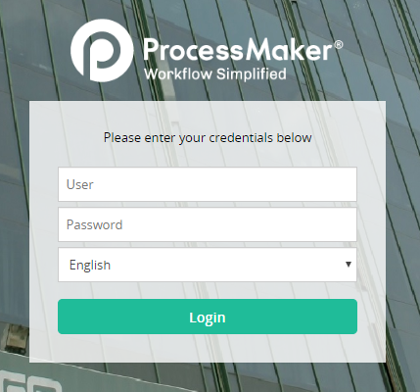

## Starting a case

* Select New Case
* Click on the Digital Account Opening Process or Marketed Account Opening Process (in case of marketed accounts)

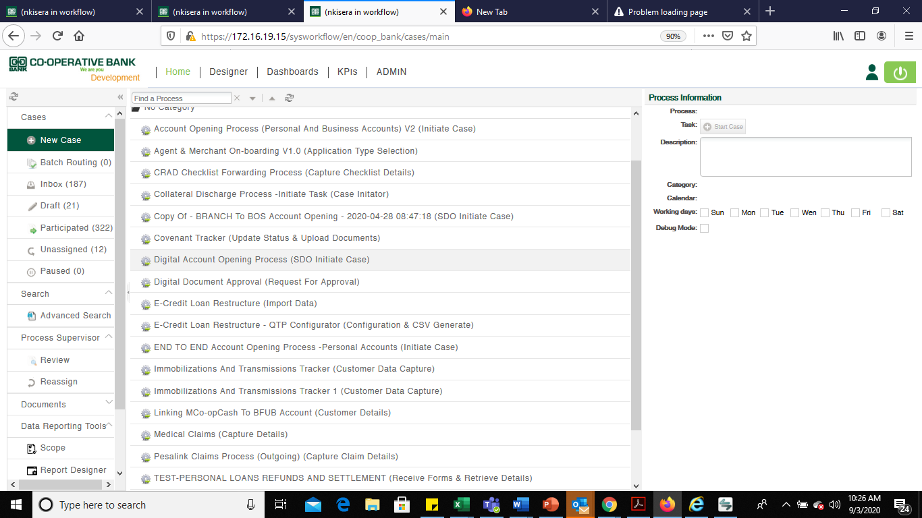

* Click on Start Case

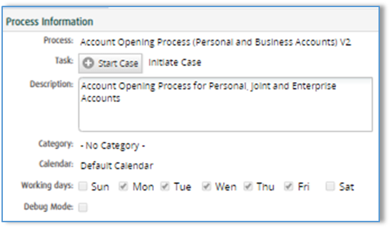

A new case is initiated. Each new case will have a unique case number

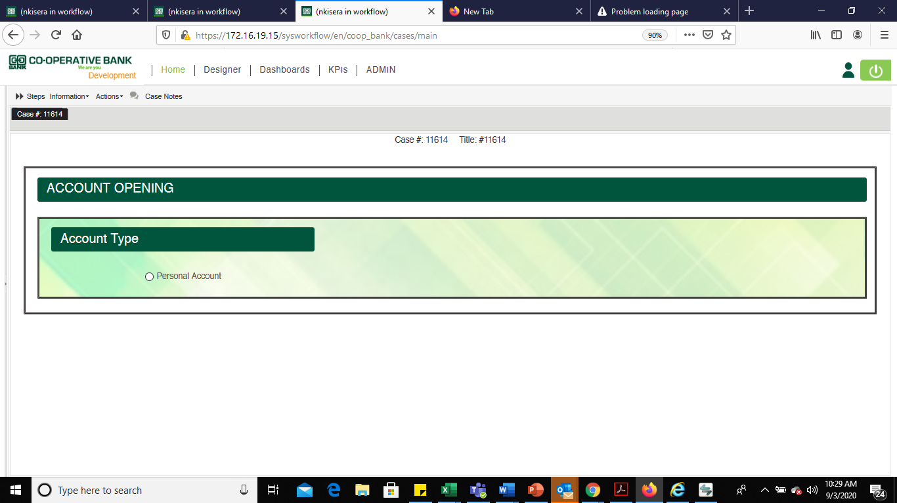

## Customer Type Selection

Select Personal from *Account Type*

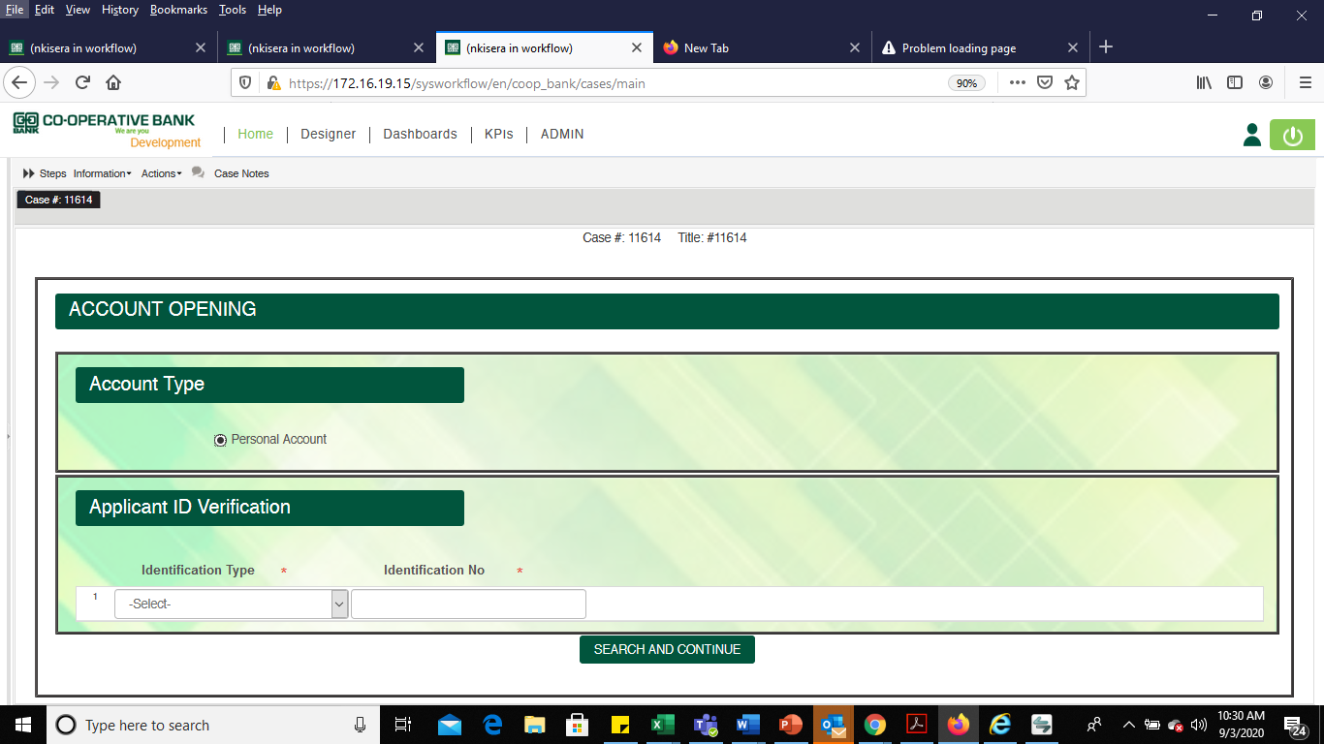

## Creation of Party ID for Marketed Accounts

Where the marketed accounts had pre-assigned CIF ID’s, the SDO shall first reserve them on Finacle before proceeding with account opening process on BPMS.

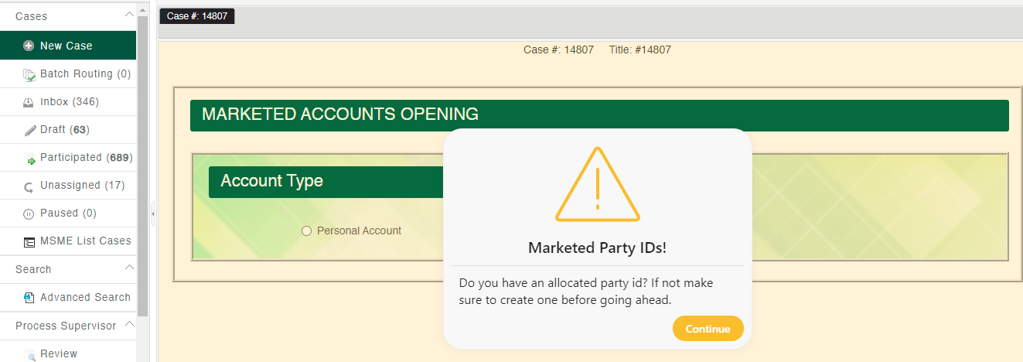

## Applicant Identification Document Verification

Capture the Identification Document Number as it appears on the document provided by the customer.

Where a customer has provided the National ID, Alien ID, Passport or Service ID, the SDO shall select an appropriate document type from the *Identification Type Menu*

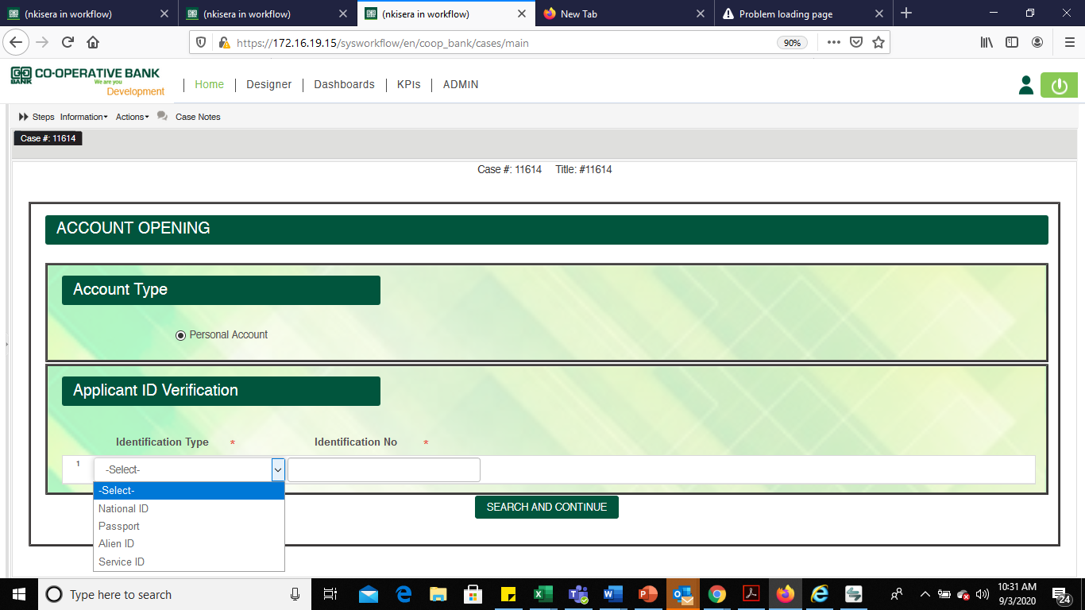

**The Input shall be done as follows:**

Under the Identification type

* Capture the following applicant’s details on the table *Applicant ID Verification*
* **Identification Type** – Select National ID, Passport, Alien ID or Service ID from the dropdown
* **Document Number** – Capture the document number
* Press the button below to continue



*These fields are mandatory where Passport or Alien ID is selected under Identification Type. They will be activated on the second screen*

* Document Expiry date
* Work permit Expiry date
* Visa Expiry date

Once the details above are captured, the next screen will display the KYC results for the identification document provided

## Verification Results

The search button will display the following 5 results in a single page:

1. Finacle Blacklist
2. IPRS Information
3. KRA PIN Information
4. Finacle existing accounts
5. Party relationship

### Finacle Blacklist Results

A blacklist check response is received.

**Yes**, for blacklisted applicants, and **No**, where the applicant is not blacklisted.

Where the blacklist results is **Yes**, the account opening process will be automatically terminated.

Document source with be auto populated

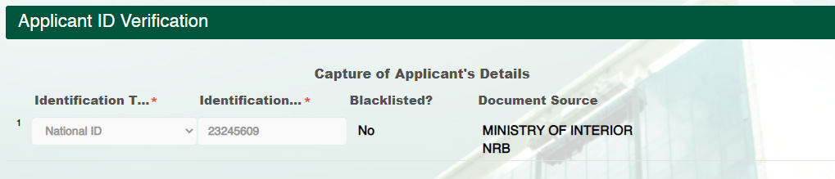

### IPRS Information

Where the details generated by IPRS match the details on the physical Identification document presented by the applicant, select **Yes** under *Details Match*.

Where the details do not match, select ***N****o*.

Where some details are missing, select the option ***missing*.**

Where some details are mismatched, select the option ***Mismatch*.**

Except where the details match, amend the details on the highlighted table (below) and capture the variation on the Mismatched/Missing details field (Any amendment of IPRS results will go the Branch Manager or service manager for approval.

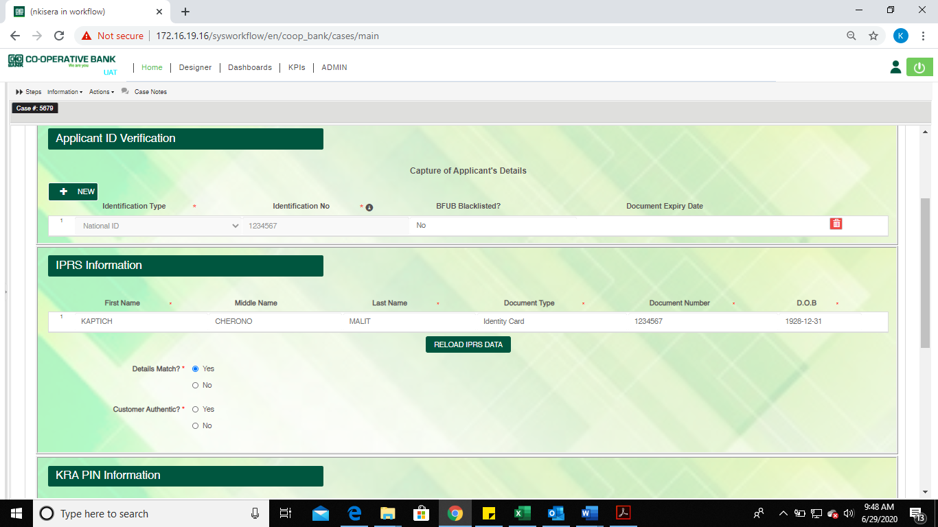

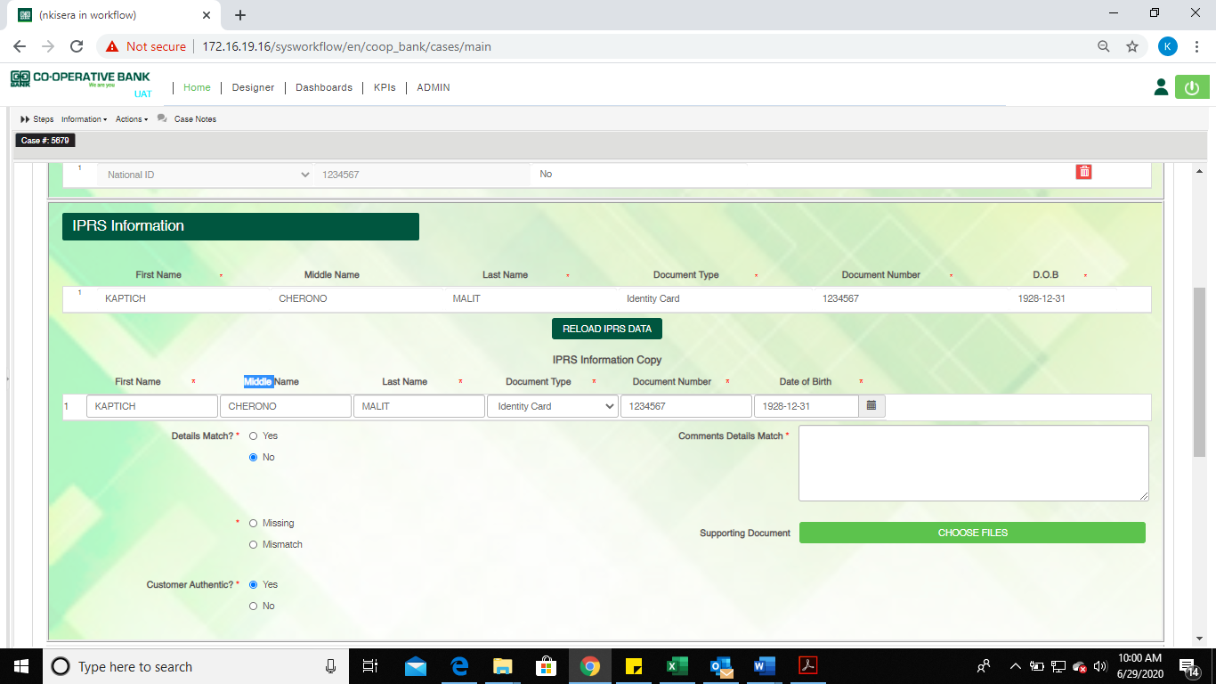

Where the applicant is authentic, select the option ***Yes.*** Where the customer is not authentic, select the option ***No***

Where **No** is selected, capture comments, and click on Continue. The case will be closed where the customer is not authentic.

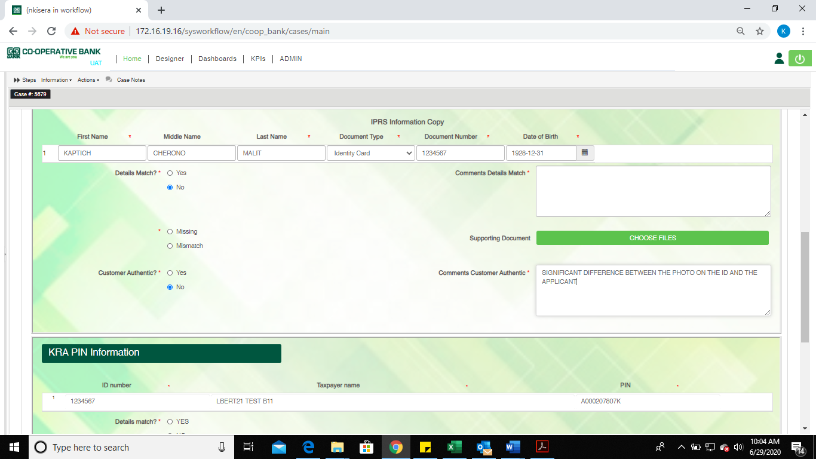

### KRA PIN information

KRA PIN certificate attachment shall NOT be required. The below shall apply:

* + Customers opening accounts where KRA PIN is automatically updated from KRA portal, will not be required to provide their KRA PIN number or Certificate.
  + Where the details match the KRA document presented by the customer, select **Yes** on *Details match* field

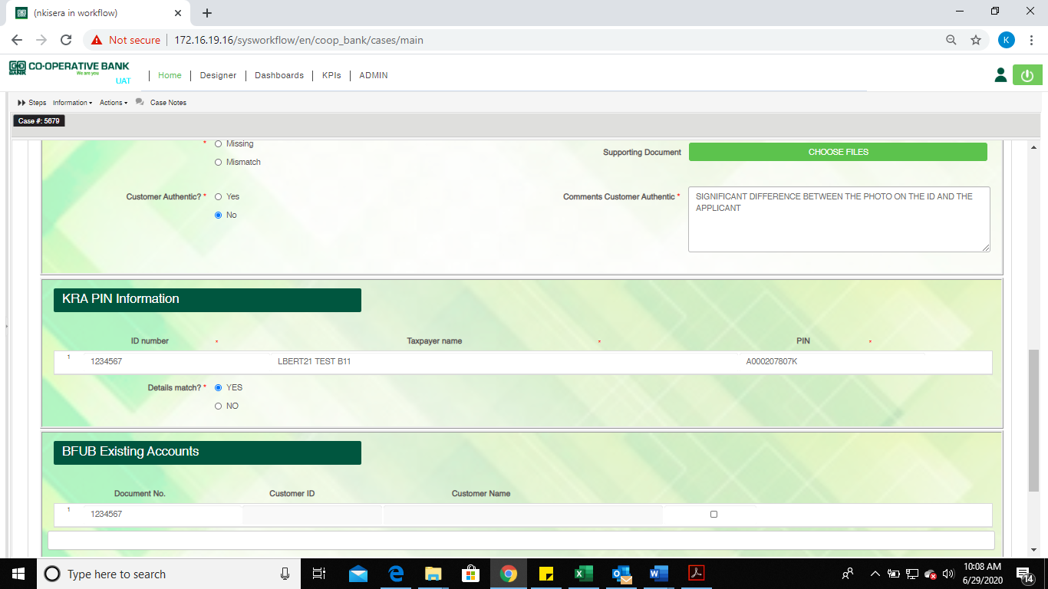

* + Where the Taxpayers Name and KRA PIN is different from that on the KRA document, select the option **No,** and capture the correct details while also indicating the reason.

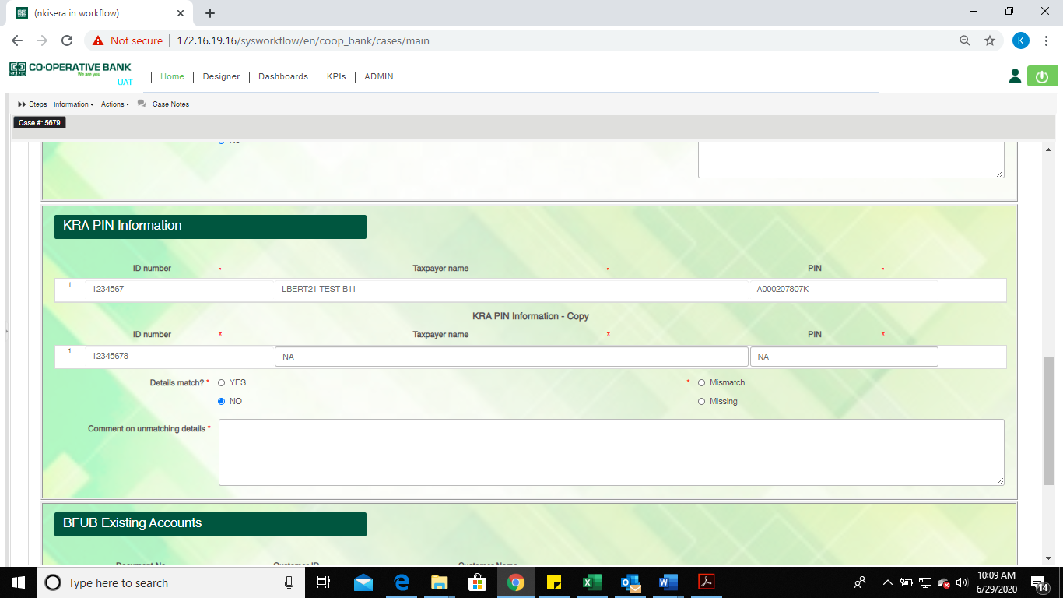

* + Customers opening accounts where KRA PIN is not automatically updated from KRA portal will be required to provide KRA PIN number. The provided PIN number shall be captured manually and validated on KRA PIN Checker Portal.
  + An email approval from the Regional Managers is required for customers opening accounts without KRA PIN numbers. The email shall be attached on BPMS.

### Finacle Existing Accounts

The verification search will also display the customers’ existing accounts.

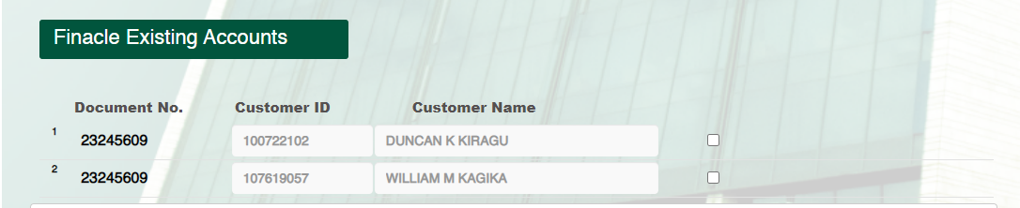

Where a customer has an ***Existing client ID*** the **customer ID** and **Customer Name** will be displayed

The SDO shall ensure that the customer’s Name displayed is similar the names on the customers Identification document.

Since BPMS fetches the customer record directly from Finacle, customer’s CIF details shall be amended from Finacle using **ERC** menu following the existing process for enrichment.

Where the customer is ***New***, the system will automatically assign a ***customer ID*** while the Customer’s Name will be missing.

Select 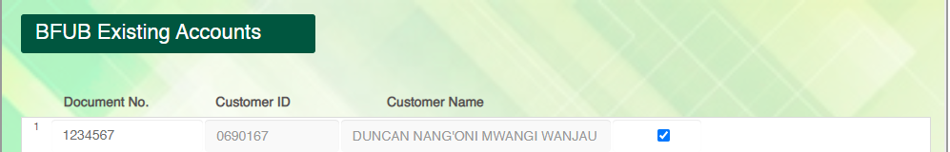the displayed account ID to proceed

### Party Relationships

The existing customer relationships will be displayed in the table below

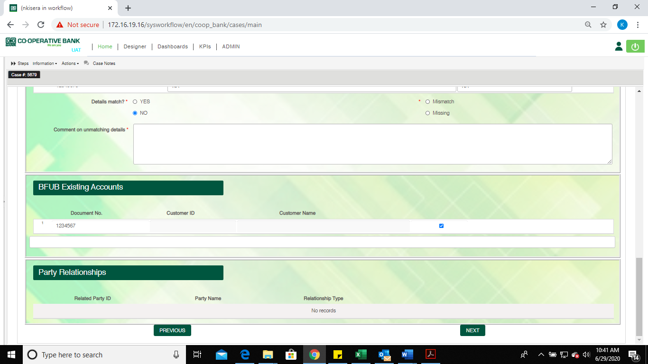

Select **Next** to move to the next screen i.e. capture of customers details

After verification of the results from the IPRS, Blacklist, KRA and Finacle, the next step will be to ***Capture customer details****.*

**Note:**

Some of the details from the IPRS search, KRA search and Finacle search will be auto populated in the *Customer Details Field.*

## Capture of Customers Details

### Customer Details

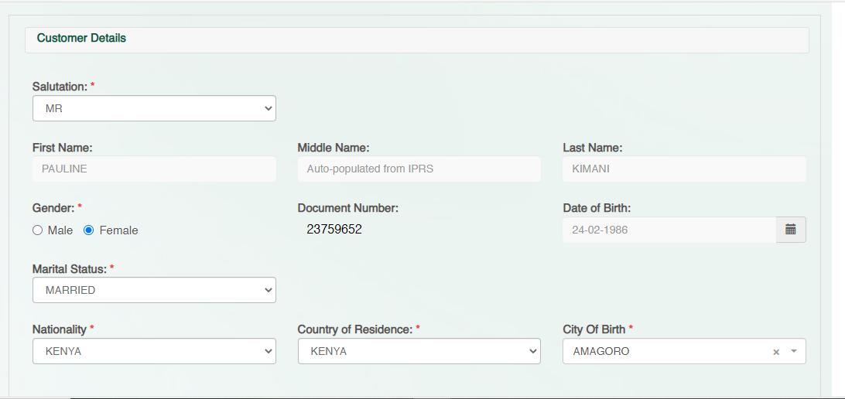

The details below will be auto populated on the *Customer Details* Field and are not editable.

* First name
* Middle name
* Last name
* Document number
* Date of birth
* KRA PIN Number

Capture the following details on the *Customers Details Field*

* **Gender** – Select Male or Female
* **Title (Salutation)** – Select suitable option from the dropdown
* **Nationality** – Defaults to Kenya. Select country where need be
* **Marital status** – Select one option: Single Married, Widowed or divorced
* **Nationality**
* **Country of residence** – Defaults to Kenya. Select country where need be
* **City of birth**- Defaults to Kenya. Select country where need be
* **Tax identification number** – Where Tax country selected is not Kenya, capture the tax identification number
* **Tax Indicator**- This is a drop down that defaults to ‘Liable for Tax’. This flag indicates that this customer is a taxpayer. The user can modify this selection by selecting ‘Not Liable for Tax’ where the customer is tax exempt (The SDO shall attach a tax exemption certificate)

### Party Address Details

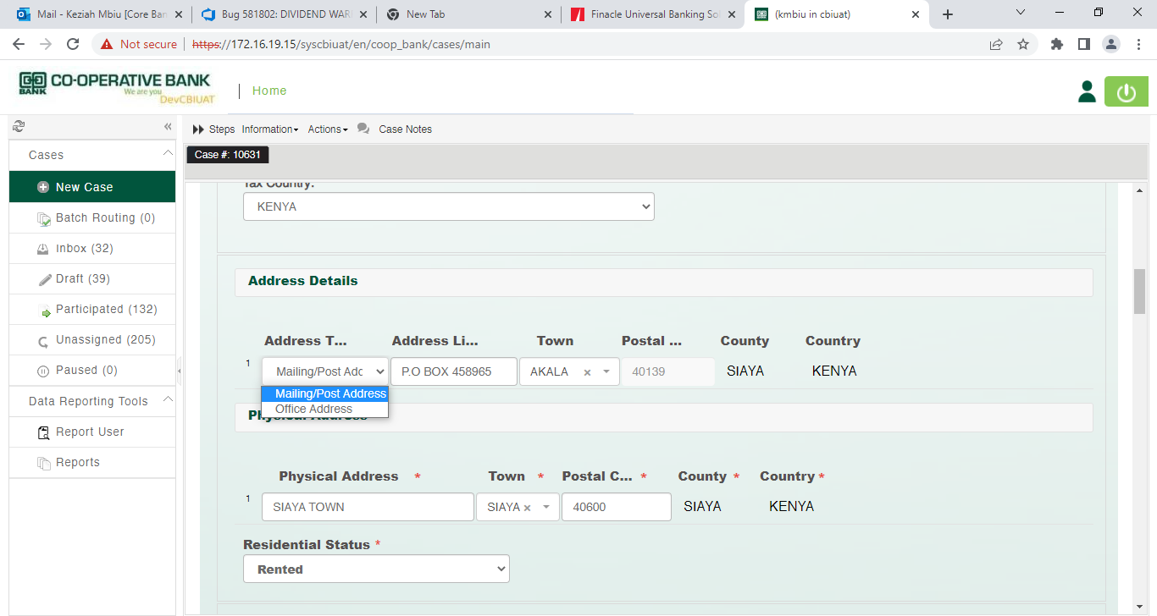

Capture the following details on the Party Address Section

* **Address Type**- select either Postal Address or office Address
* **Address Line** – The address shall be captured without a pre-fix P.O
* **Postal** **Town** – Select from a drop-down
* **Postal** **Code** – 5-digit postal code- Auto-populated based on the postal town captured above
* **County-** Auto-populated based on the postal town captured
* **Country**- Defaulted to Kenya. Select where need be

### Physical Address

Capture the following details on the Physical Address Section

* **Physical Address-** Capture specific location of customer
* **Town**- Type to choose from available towns
* **Postal Code -**5-digit postal code- Auto-populated based on the postal town captured above
* **County**- Auto-populated based on the postal town captured above
* **Country**- Auto-populated based on the postal town

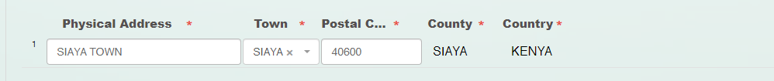

### Residential Status

Select the residential status from the drop down.

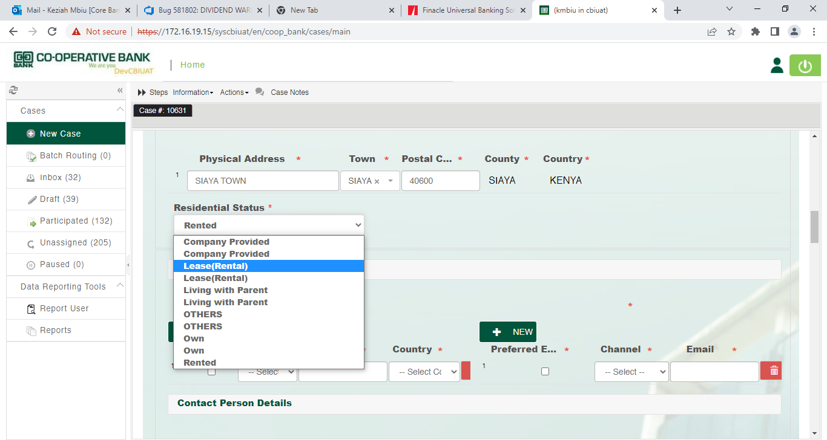

### Contacts Details

The SDO shall capture the following details:

* Select Preferred Channel
* Select Channel
* Key In Phone No
* Country
* Email Address

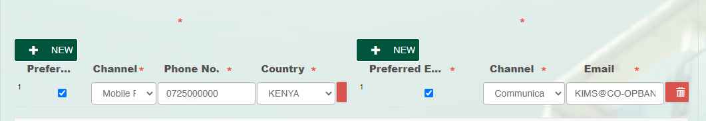

### Contact Person Details

The SDO shall capture the fields below on the Contact Person Details:

* First Name
* Middle Name
* Last Name
* Phone number
* Country
* Email address

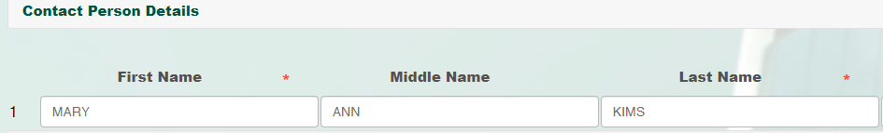

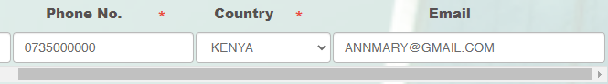

### Contact Preference

The SDO shall capture contact preference details:

* Default Channel
* Receive Marketing Messages
* Preferred Communication Channel

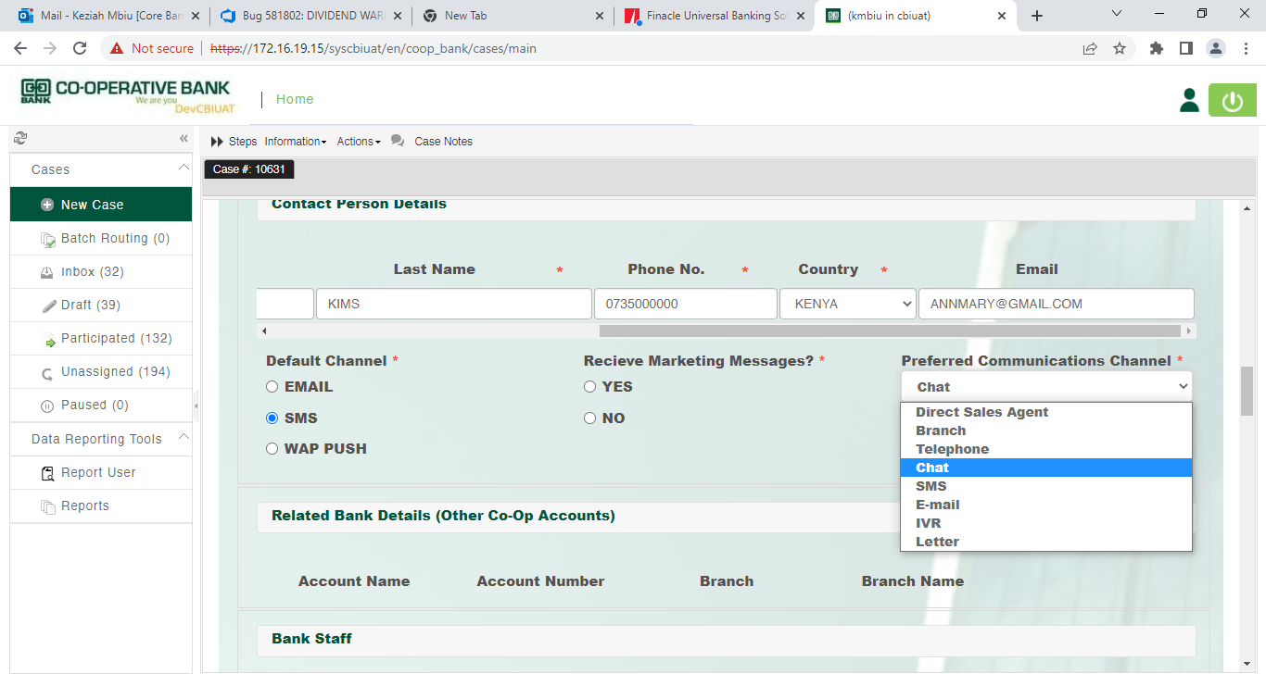

### Other Co-op Accounts

Where the applicant has other accounts at Co-op Bank, the details below will be auto populated on the table: Where the applicant has no account with Co-op, these details will be missing.

* Account Name
* Account Number
* Branch
* Branch Name

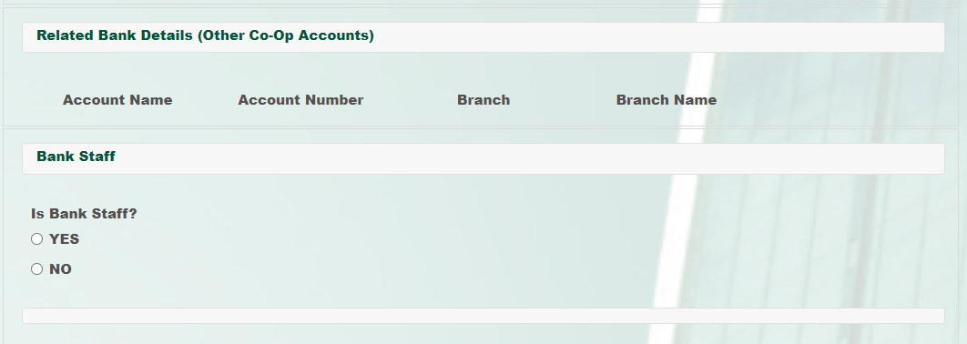

**Bank Employee Details**

For staff related account, SDO shall select the Option and key in the related staff ID

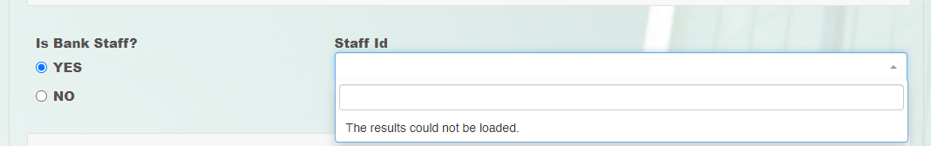

### Employment Details

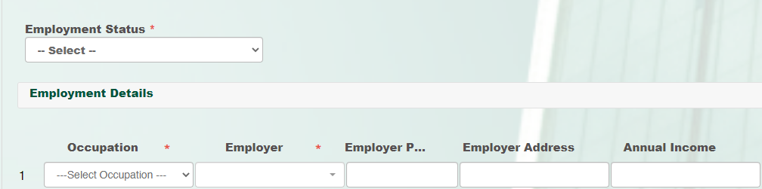

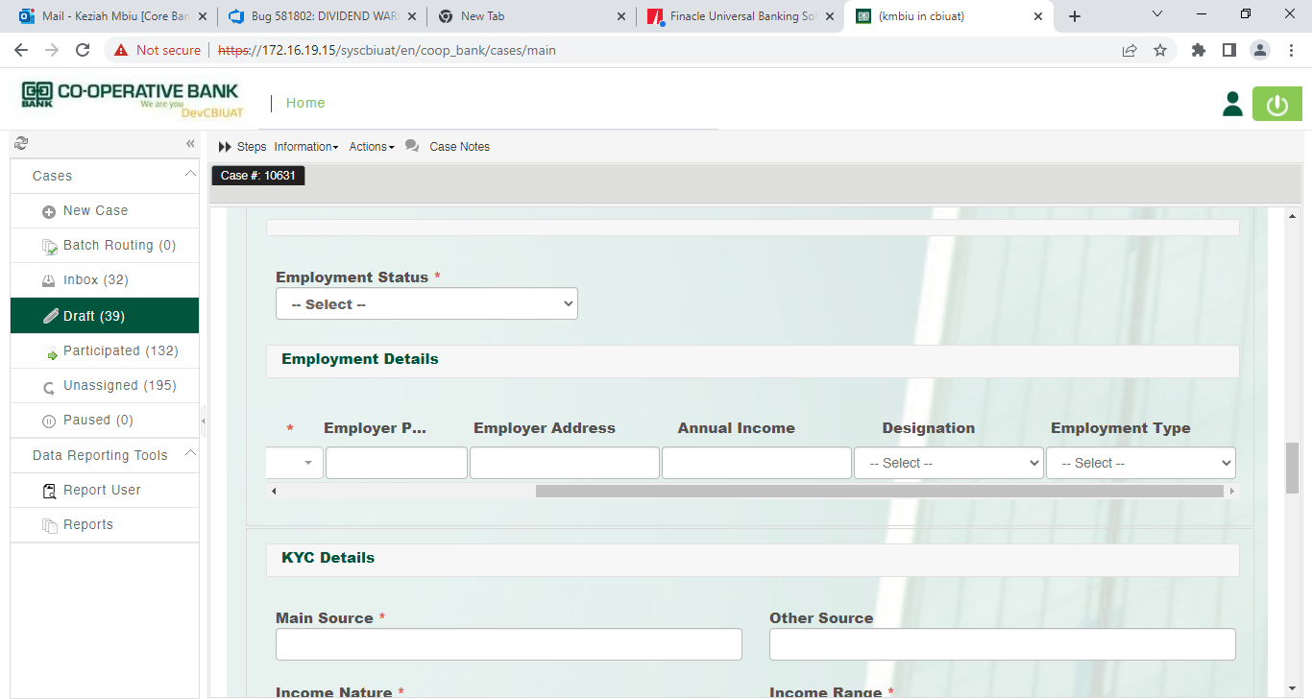

SDO Shall Fill in the following mandatory fields.

* **Employment Status**– Employed, Self-employed,

Student or Others

* **Occupation -** Drop down selection
* **Employer-** Drop down Selection. Select Others

*These fields are applicable where Employment status selected is Employment*

where the preferred

* **Employer’s Phone**
* **Employer address**
* **Annual income**
* **Designation**
* **Employment Type –** Drop down selection

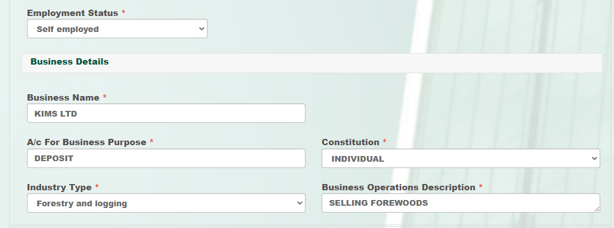

* **Business name**
* **A/c Business Purpose**

*These fields are applicable where employment status is Self-E****mployment***

* **Constitution**
* **Industry Type**

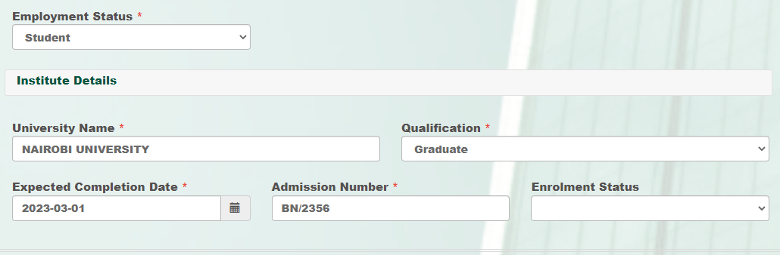

* **Name of University/College**
* **Qualification**

*These fields are applicable where* ***employment status*** *selected is Student*

* **Admission Number**
* **Expected Completion Date**
* **Est. Monthly Deposits-**Drop down selection

**Note**

Where the student admission number is missing, capture the **student ID** **Number** in the *Student admission field.*

### KYC Details

The SDO shall capture the fields below mandatory Fields

* Main Source- Key in
* Income Nature- Drop down selection
* Income Range- Drop down selection
* Credit Score - Drop down selection
* Insider to bank- Drop down selection
* Insider Role – required if insider to bank is selected as **“YES”**

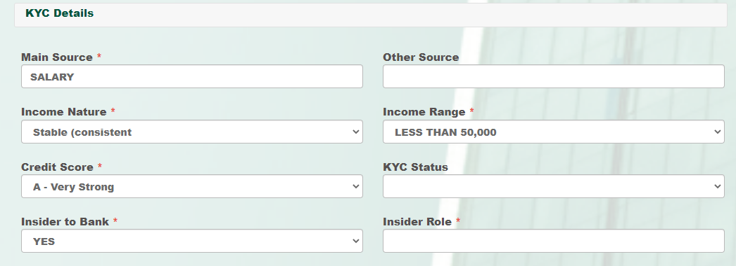

### Product Selection and AML Details

The SDO shall Select the appropriate product (Scheme Code) and Product Description (Scheme Name)

Account type shall be displayed depending on the product selected.

Currency will default to KES which can be amended to other currencies

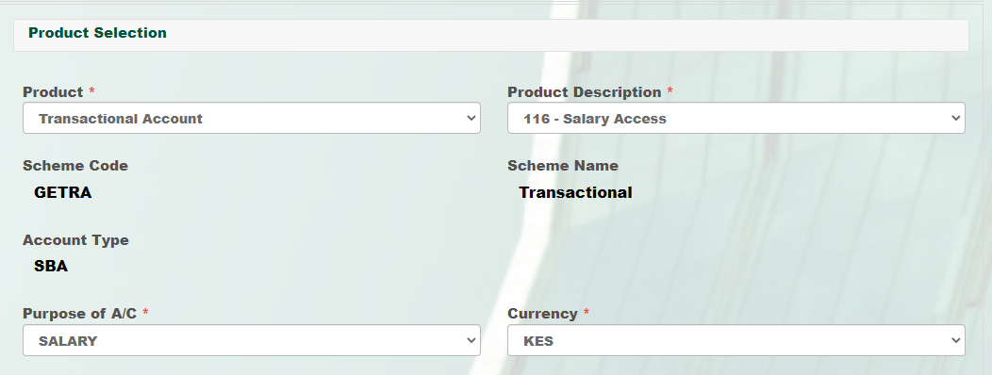

The SDO shall Capture the account to be opened and the AML details as indicated below

**Product Selection**

* Product ID
* Currency

*Select the option from the dropdown*

* Product
* Purpose of Account

**Pep Details**

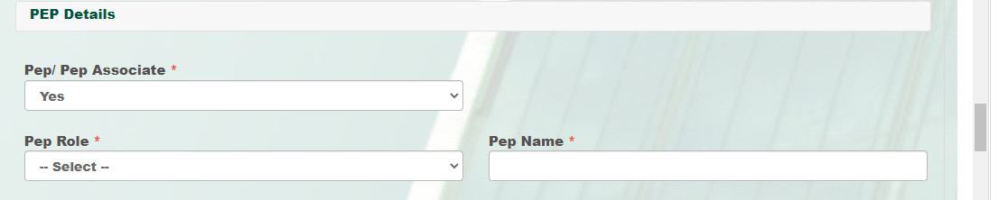

* Sector
* Sub-sector
* Corp Flag
* Customer Type
* AML Risk Rating – Auto-calculated

**Bank Taxonomy**

SDO shall select Sector code with related Sub- sector code

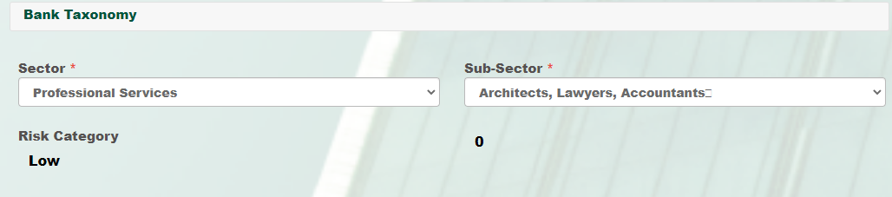

**CBK Sector**

SDO shall select Sector code with related Sub- sector code

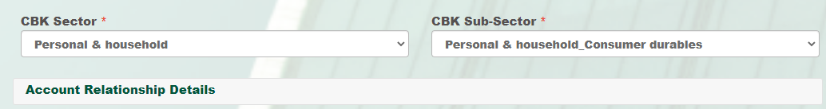

### AML Risk Calculation

To enhance the transactions monitoring platform, the Bank has adopted an automated AML Risk Level Customer Categorization process. This measure supports the continuous monitoring of the business relationship including transaction monitoring.

The risk levels are:

* High Risk
* Medium Risk and
* Low Risk

It is the responsibility of the SDO Officer to ensure that the correct customer category has been selected in the system

The risk level is determined by the customer category selection.

The 7 parameters used to calculate the risk rating include:

1. Sector
2. Customer Type
3. Turnovers
4. Corp-Flag
5. Country of Residence
6. Nationality
7. Products

All low and medium risk accounts shall be routed direct to BOS.

All High-Risk accounts shall be routed for Branch/Service Manager for Approval. The Branch/Service Manager shall review all the details captured before making their decision.

### Account Relationship Details

* **ARO code** – Capture the ARO code
* **DSO code** – Capture the DSO code

*These fields are auto-populated based on the ARO code and DSO code*

* **ARO name**
* **DSO name**

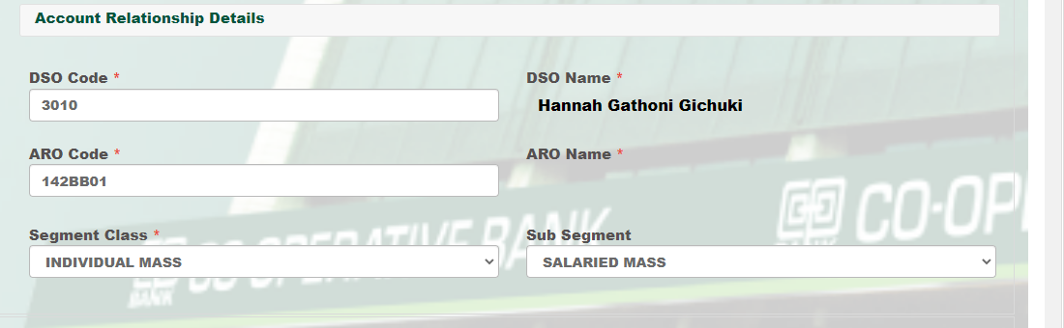

### Fatca Details

SDO shall select the Fatca Status. Where the account applicant is a US citizen/Resident, the mandatory fields shall be selected and W9/W8 form attached.

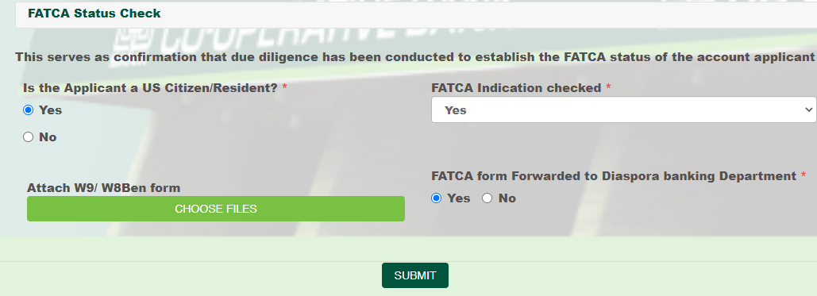

## Cross Selling

### My payments

Select Debit Card or Cheque book by checking from the list below:

* **Card Type**- Drop down selection
* **Cheque Type**- Drop down selection
* **Input the number of books required**
* **Number of leaves-** Drop down selection
* **Statement frequency-** Drop down selection
* **Statement Medium-** Drop down selection

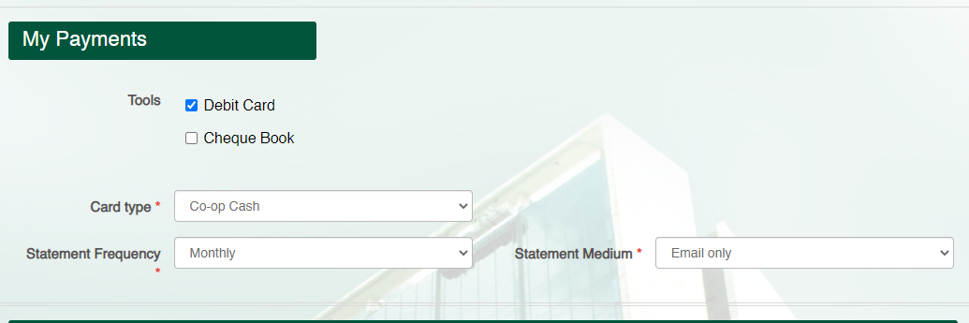

### Mco-op Cash and Online Banking

The mobile number is pre-populated from the initial captured details, and it is not editable. The account number assigned, will also be auto populated on the output form.

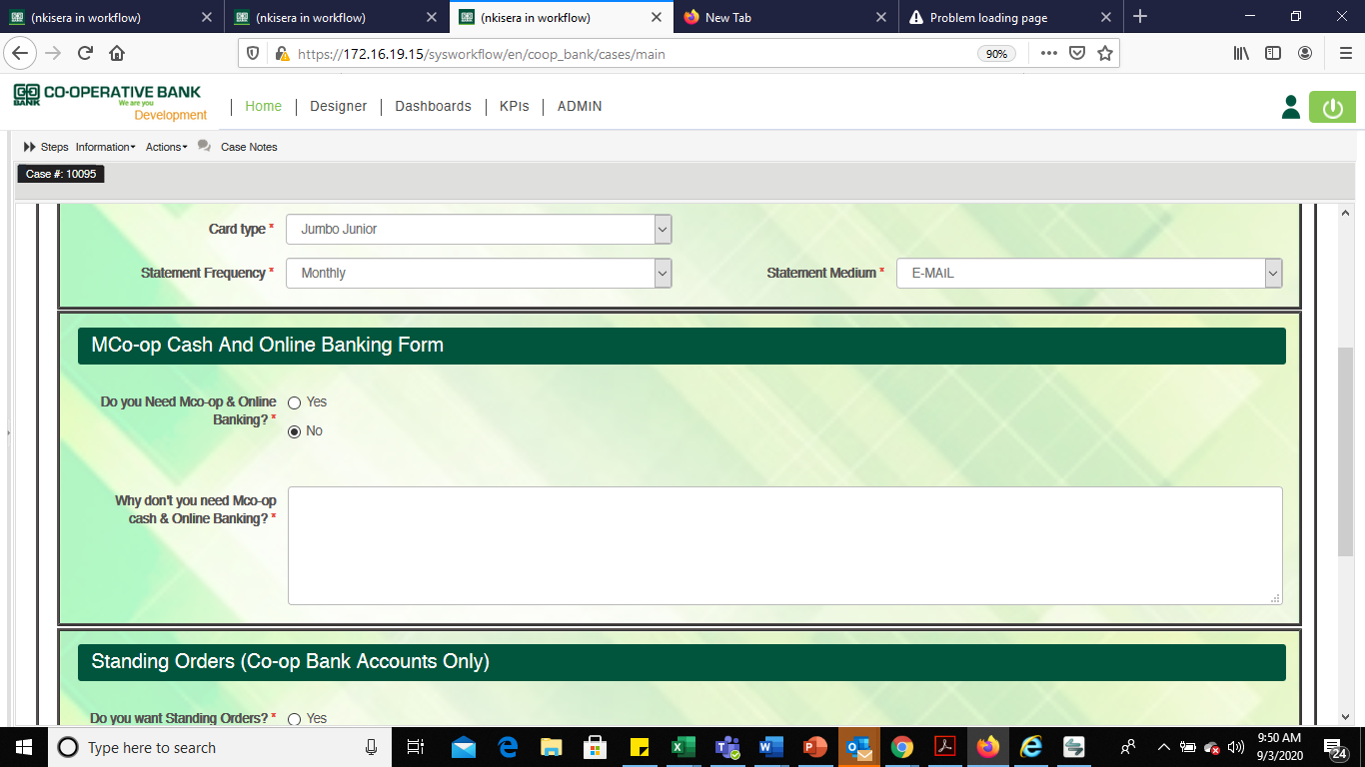

Where the customer is not interested in Mco-op cash and online banking, the SDO shall capture the reason.

### Alerts Subscription

For customer alerts subscription, where Enable Alerts Selected is **“YES” type of** alerts debit/ credit/ or both shall be selected.

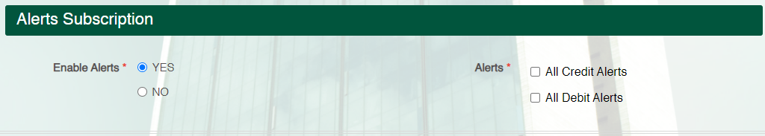

### Standing Order

Select Standing Order for Co-op Accounts Only by checking from the list below and capture the following details:

* **Account Number**- Auto-populated
* **Frequency**- Select from a drop-down menu
* **Beneficiary Name**
* **Beneficiary Account Number**
* **Amount**
* **Amount in words**- Auto-populated
* **Pay Type**- Select from a drop-down Menu
* **Effective date**- select the date

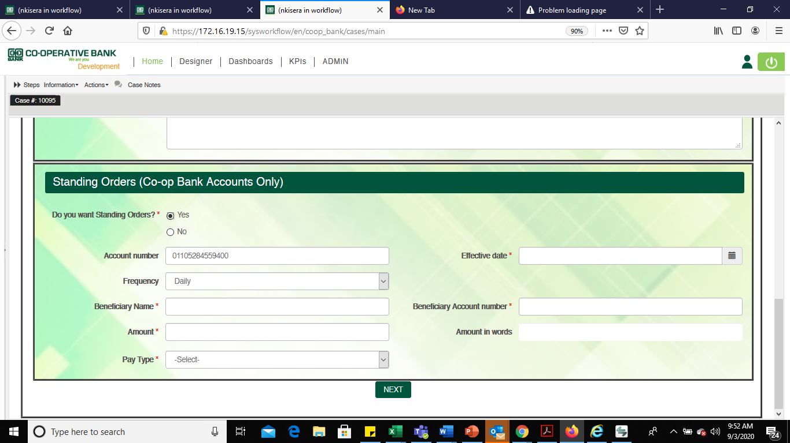

For standing order creation, the SDO shall scan the full electronic mandate and forward to COU for standing order creation.

## Capture of Customers Photo, ID Document Front and Back

### Walk In Customers

The customers **Photo, ID front** and **ID back** shall be captured using a **Webcam**.

Where either the customer Photo, ID front and ID back is skipped, the process will generate the error above.

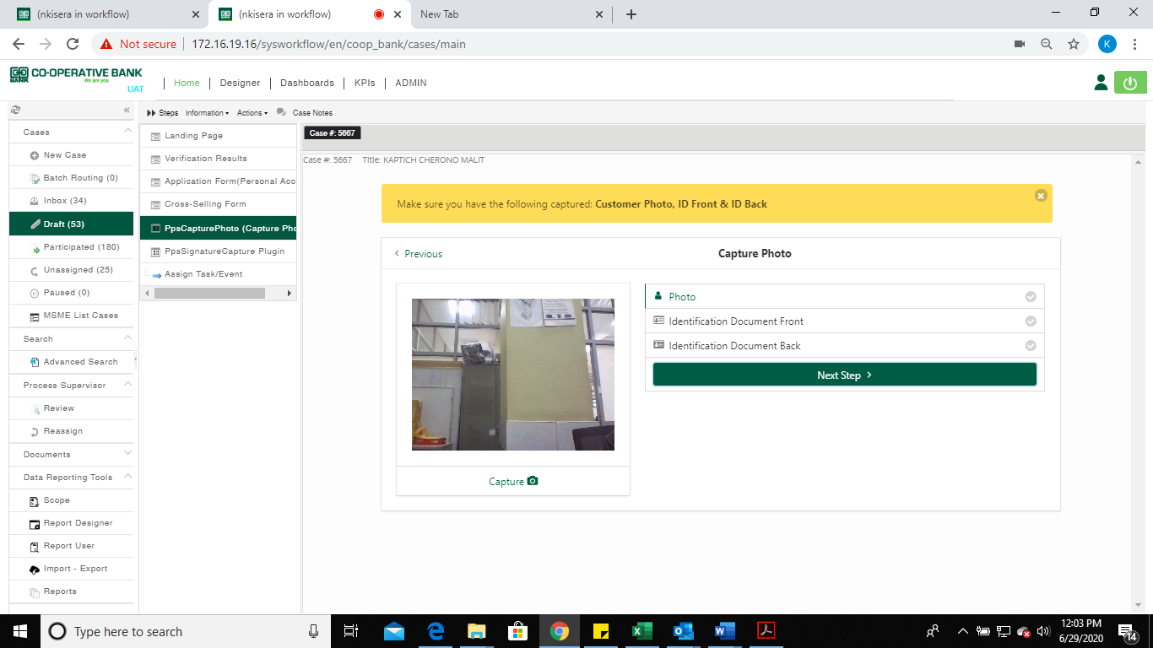

Press  to capture the customer’s signature using the signature pad.

### Marketed Accounts

For marketed accounts, the SDO shall capture the customers **Photo, ID front** and **ID back and Signature** using a Webcam. The captured images shall be very clear to avoid RTS.

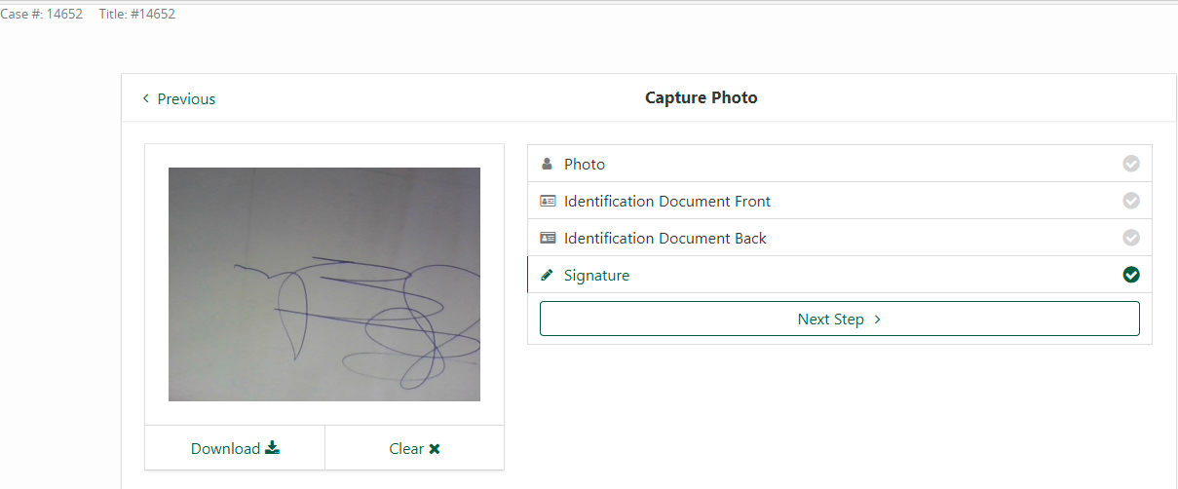

The SDO may take the ***ID front*** and ***Back ID*** images on the printed out copy of the ID. Where the copy of the ID is not clear, the SDO may upload the same.

## Select the Signature Type

The SDO shall select the signature type from the two options below for Walk In customers

1. **Signature** (To be captured by the applicant on the signature pad device)
2. **Thumbprint** (To be captured/ impressed on the generated physical mandate form for the applicant using vernacular signature)

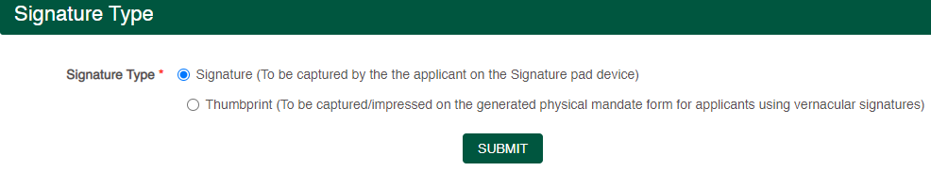

### Capture of Customers Signature

The SDO shall capture customer’s signature using the signature pad. The customer shall sign twice. The two-signature sample are for comparison purposes.

Where the signature differs, one can press on 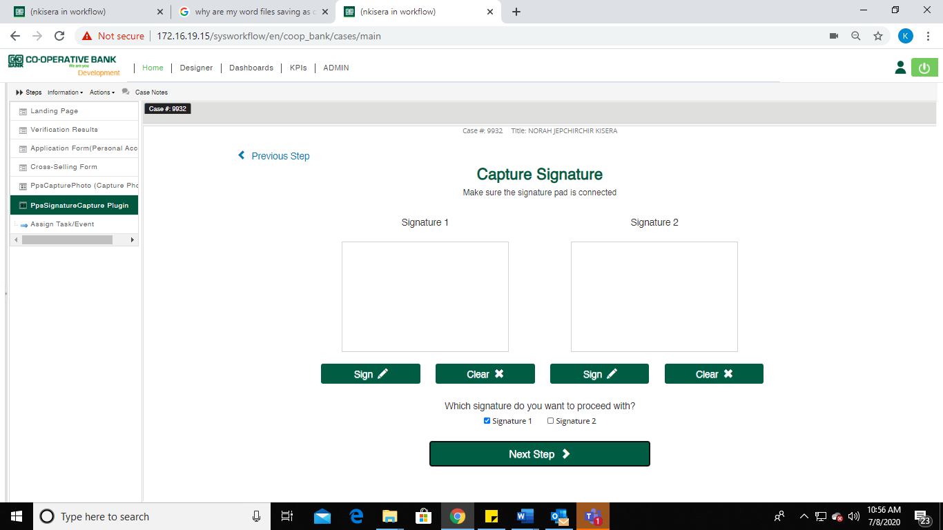 to re-capture the signature.



Select any of the signed signature after the customer has approved.

**Note:** The photos and the signatures will not need to be cropped.

It is at this stage that **High Risk Rated Accounts** and **Amended IPRS details** shall be automatically routed to Branch/Service Manager Approval.

The Branch/Service Manager will view all the details captured before making their decision.

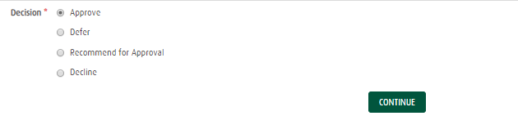

* **Approve** – Route the case back to SDO for account opening to be completed
* **Defer –** Capture comments and route to the SDO
* **Decline** – Capture comments and terminate the case

After the Branch Reviewer has approved the account, the SDO will receive an email notification. The case will also be available on the SDO’s inbox for completion of account opening process.

For a deferred case, the SDO will receive the case on their inbox with a deferral reason clearly indicated.

Press Next Step create the account.

Once the account number has been generated, the product summary details below will be displayed on the *View Account Details*

## View Account Details

The following account details can be viewed

* Account Number
* Account Name
* Product ID
* Account Currency
* Product
* Purpose of account

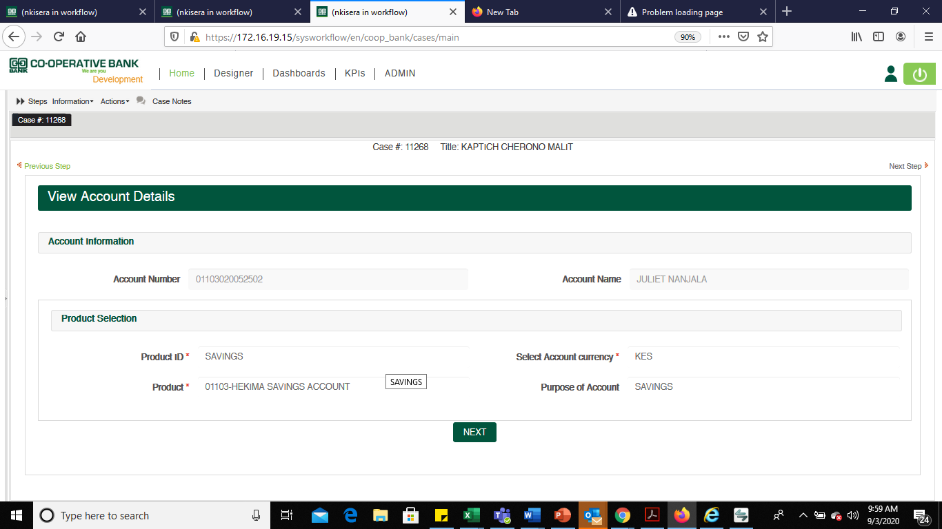

Press NEXT to generate an output document

## Opening of Multiple Accounts

To open more than one account, the SDO shall select among the 3 options as indicated below. The default option on the process will be **No.**

1. No
2. Yes- with similar product (version 01, 02 etc. of an account)
3. Yes**-** with New product (e, g hekima and salary)

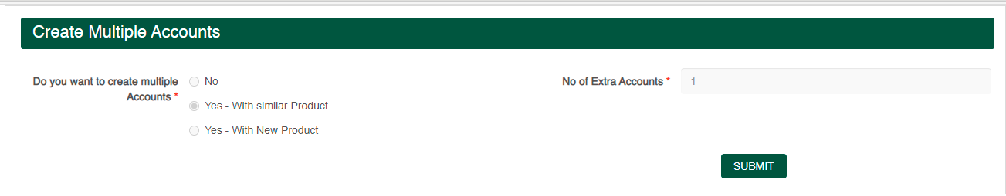

Where the SDO has selected the Yes option, they shall be required to indicate the number of Extra accounts they would want to create.

The SDO shall be presented with the dialogue box below according to the number of times they wish to create an account. The details on the dialogue box will be:

* **Product ID**
* **Product**
* **Purpose of Accounts**
* **Account currency**

The subsequent accounts will take on the details of the first account opened. In cases where the DSO of the second account is to be changed, the SDO shall start a new case and capture the new DSO and or ARO code.

**View additional accounts opened.**

Once all the accounts above are opened, the SDO shall view the accounts in one page before downloading the electronic form.

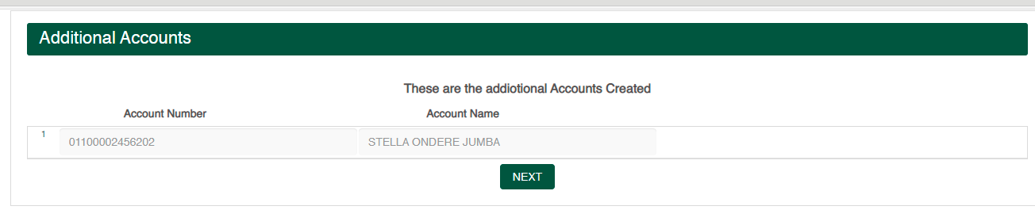

## Generating Documents (e-form)

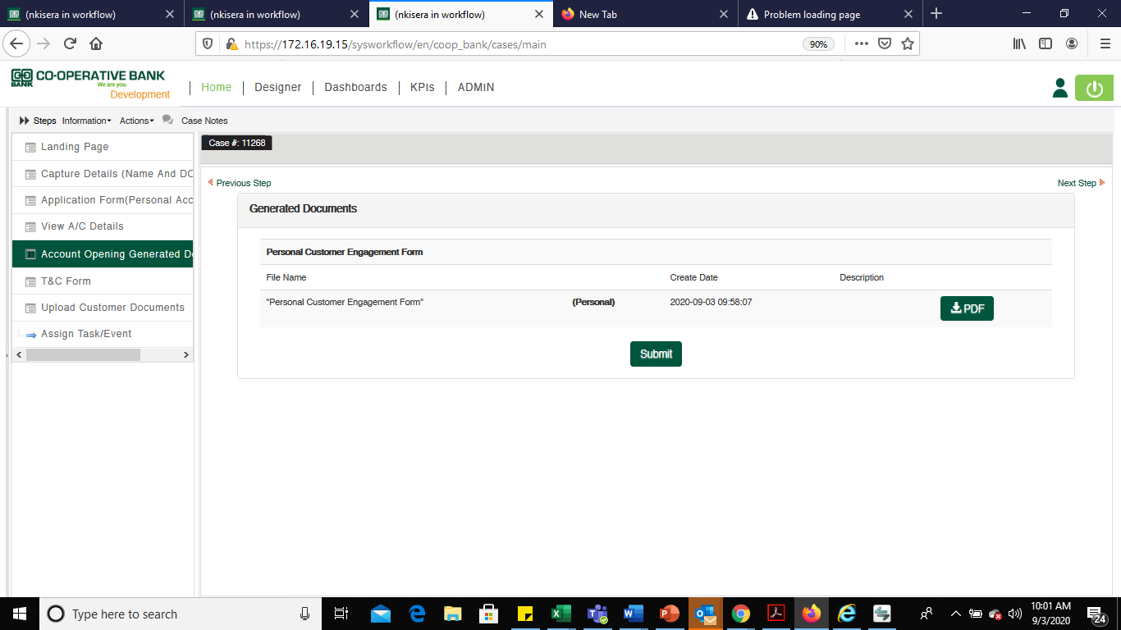

The SDO shall generate the output document by clicking on the.

Afterwards, print the form for the customer to confirm the details and append their signature on the terms and conditions section.

## Signing of Terms and Conditions

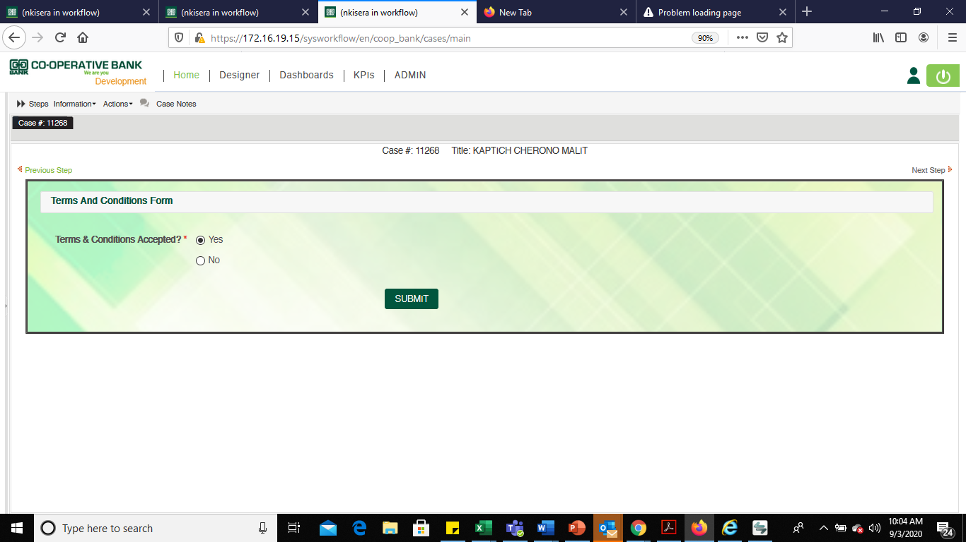

Once the customer signs on the Terms and Condition, select **Yes** and click **Submit**. This will take you to the next step of attaching KYC document e.g. Affidavit or license

**Note:**

* The printed mandate that has been confirmed and signed by the customer shall not be forwarded to BOS. The mandate shall be sent to documentation through the *Physical Mandate Dispatch Tracker Process* on BPMS.
* For marketed accounts, the staff who marketed the account shall perform the following checks:
  + Confirm validity of KYC documents.
  + Certify KYC documents as true copy of the original.
* For marketed accounts, the SDO opening the account on BPMS shall ensure completeness of the requirements as per existing policy.

Where the customer has not signed the T&C, select **No** and indicate your comment. This will terminate the account opening process.

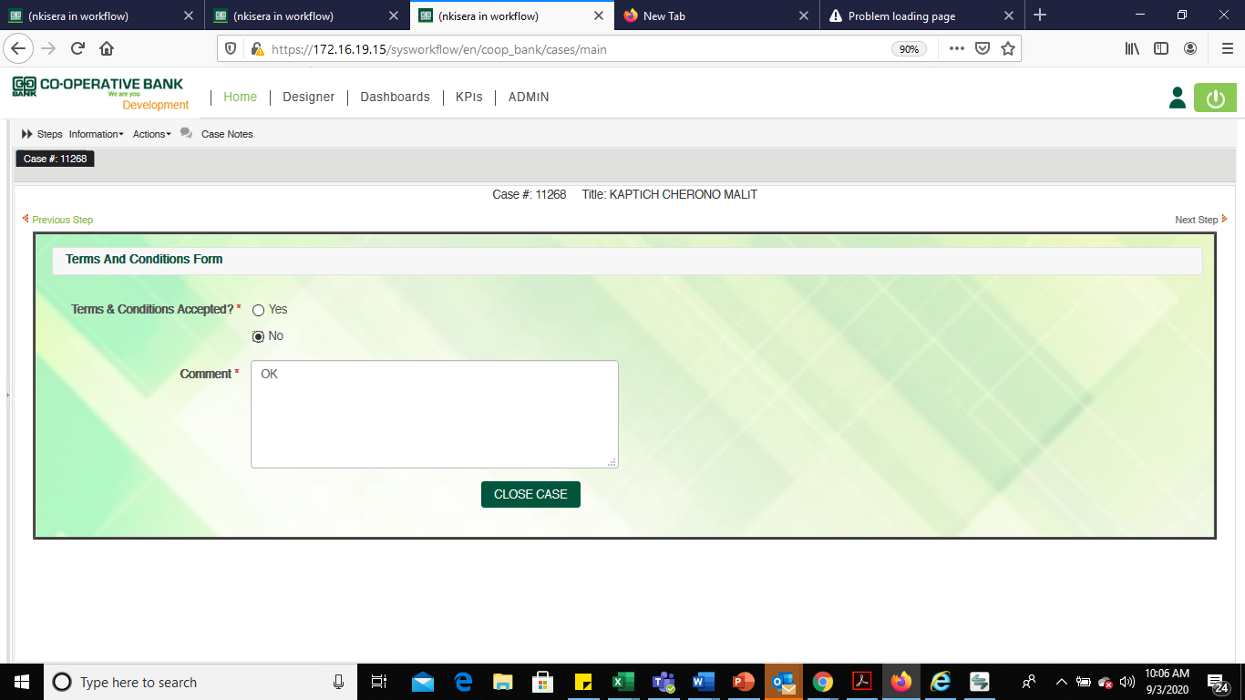

### Upload of Documents

### Saving of Documents

Save the documents that you intend to upload on a location in your computer. e.g., an affidavit saved on desktop as shown below.

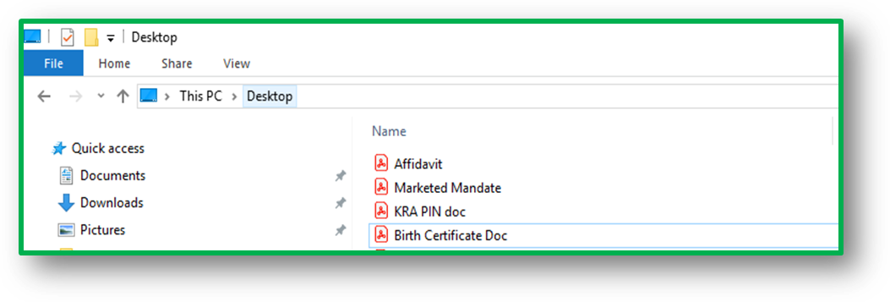

### Uploading of Documents

Choose the document you intend to upload from the appropriate Document Name.

Click on upload documents button.

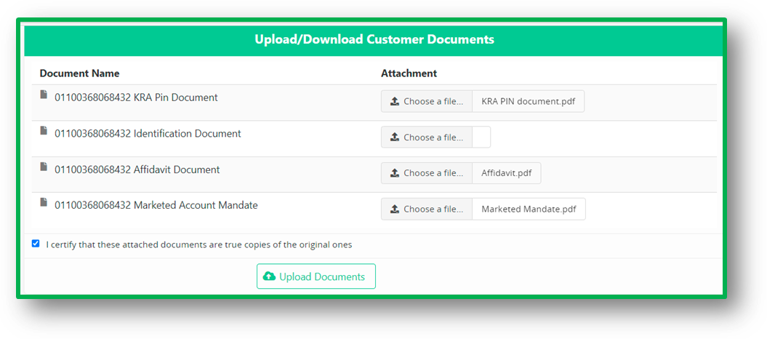

### RTS Cases for Wrong Attachment

The Bos verifier will RTS cases where document (s) attached do not match the *document name* as shown below:

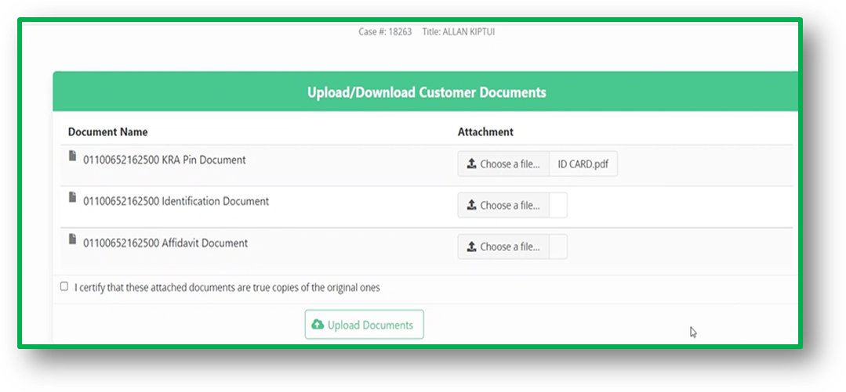

### Amendment Process

To amend, choose the correct file. This will automatically overwrite the previous file, and then click Upload *documents button* to upload.

Uploading of the KYC documents is done on this form

Upload each document on the appropriate field as labeled.

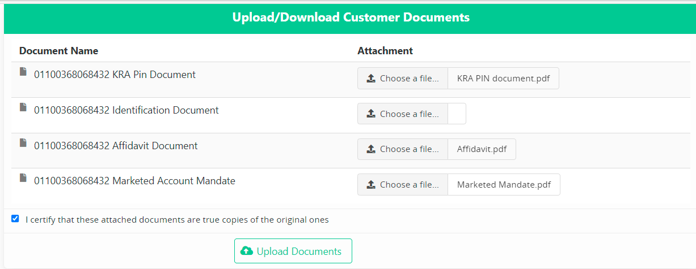

Upload documents

Select the option ***I certify that is a true copy of the original*** labelto confirm that the documents provided are true copies of the original.

Click on **CONTINUE** button

## Forwarding to BOS for Verification and Quality Assurance

Select continue for the workflow will move to BOS

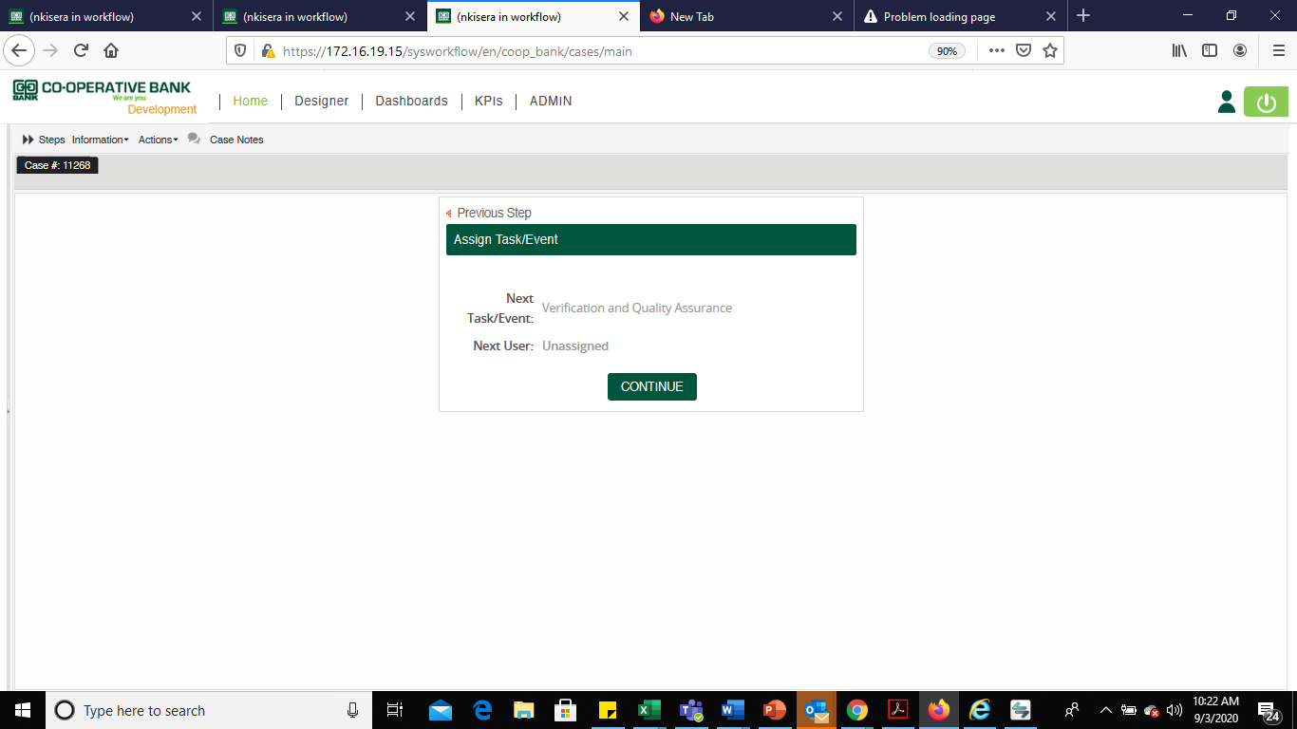

The customer will receive an SMS and email notification with the following details:

* Account Number
* Account Name
* Co-op Online link for self- registration

Before Submitting a Case to BOS, The SDO shall ensure that the documents meet all the requirements.

**Note**

* For any amendment on the existing customer’s details, the SDO shall be required to update the customers’ static details on Finacle before proceeding with the account opening process on BPMS.
* SDO shall not be required to update the mandate tracker for accounts opened on BPMS since they are electronically sent to BOS in real time.

## Deferred Case

When a BOS verifier defers a case, the SDO (Initiator) will receive an email notification indicating the reason for deferral.

Deferred cases will be routed to SDOs in an unassigned queue, where they will be required to claim a case before amendment.

The SDO shall claim the case on the unassigned queue and amend the correction as directed after which they forward the case by clicking on **Next Button** until the case ends up at BOS queue.

All cases shall be forwarded back to BOS on the same day the case is differed.

## Joint, Sole Proprietorship and Company Accounts Opening Process

This process shall be used to create the Customer Party and create the account at the Branch.

### Process Flow

The Checker (at the Branch) is not required to sign the account opening forms but shall give guidance to SDO (Maker) where need be.

The SDO is responsible for carrying out the account opening process end to end as detailed below:

| **ACTIVITY** | **DETAILS/ACTION** |
| --- | --- |
| **Interview** | Customer walks into the Branch and is interviewed by the Service desk officer as per the KYC policy.  The Service Desk Officer shall ensure that:   * The customer has selected the right product. * The relevant information pertaining to the product is well understood by the customer. * The customer meets the target group requirement for the selected product. * General terms and conditions read and understood by the customer.   All requirements must be met by the customer before a commitment is made to open the account. |
| **Fill Form** | Customer fills in the account opening form, provide all the account opening requirements and documents for certification by the account opening staff.  Data input information part must be input in consultation with the customer.  NB: If the customer is interested in more than one product, they can tick the respective products and be allocated account numbers accordingly |
| **Verify** | The Service desk officer shall confirm the completeness of the form and ensure that all requirements have been provided and certify the copies as true copies of the original.  All un-applicable parts must be cancelled |
| **Allocate Number** | If all requirements have been met, the Service desk officer shall allocate a customer number and sign on the "Account Opened by" part on the account opening application form as a proof that he/she has interviewed the customer and that the account is good to be opened. |
| **Take Digital Photo** | When the above requirements have been met, take a digital passport size photo of the customer. |
| **Create Customer.** | Create the customer register on the Branch Power system. |
| **Deposit cash** | Customer fills the cash deposit slip in duplicate and deposit cash on the Express counter retaining the duplicate cash deposit voucher. |
| **Forward Mandates** | The physical forms shall be forwarded to Documentation Centre within 1 month on BPMS |
| **Confirmation of Mandates** | E-mail notifications upon dispatch and receipt of physical mandates will be generated. |

## Alterations on the Account Opening Mandate

Alterations on the Account Opening Mandate must be countersigned. The Alterations are categorised into two:

1. **Alterations for details where verification can be done against attached documents**

This will include:

* Identification Number
* Date of incorporation/Registration
* Account Name
* Gender
* Certificate of Incorporation
* KRA PIN
* Date of Birth

1. **Alterations on details where there are No Documents attached**

This will include:

* Marital Status
* Mobile Number
* Email Address
* Specimen Signature
* Signature on the Terms & Conditions section
* Postal Address
* Postal Code
* Town

### Confirmation of the Alteration

Alterations shall be handled as follows:

1. **Alterations for details where verification can be done against attached documents**

The Branch shall authorize the amendment by signing and appending the per-pro stamp against the alteration.

1. **Alterations for details where there are No Documents attached**

The Alterations for details where there are no documents attached shall be effected as indicated below:

* Mobile Number - Customer to countersign
* Postal Address - Customer to countersign
* Postal Code - Branch to authorize
* Town - Branch to authorize
* Marital Status- Branch to authorize
* Specimen Signature – Customer shall fill in another form
* Signature on the Terms & Conditions Sections - if it does not tally with the specimen signature, customer to counter sign and branch to authorize for the counter signing.

**Note:**

* Branches append PER PRO stamp on the mandate for all the alterations not countersigned by the customer.
* White out shall NOT be used on the account opening mandates.

## Blacklist Enquiry

During the Customer Onboarding process in Finacle, several compliance checks are put in place:

* Perform Dedup
* Perform Negative List
* Perform blacklist
* IPRS Checks

The Dedup check establishes whether there are matching records for the identification document.

The Negative list Check displays results if the customer is listed negatively by the bank against the bank internal data base. i.e., has nonperforming loan or the customer is engaged in fraudulent activities.

The Blacklist Check is against external database, i.e., if the customer is a terrorist

IPRS checks on the identification on the Integrated Population registration system maintained by the Government.

# ACCOUNT OPENING PROCESS FLOW (FINACLE)

## Responsibility

The Branch maker is responsible for collecting accurate data while Branch checker is the authoriser and responsible for the overall data integrity.

The Service desk officer is responsible for carrying out the account opening process end to end as detailed below:

|  |  |
| --- | --- |
| **ACTIVITY** | **DETAILS/ACTION** |
| **Interview** | Customer walks into the Branch and is interviewed by the Service desk officer as per the KYC policy.  The Service desk officer shall ensure that:   * The customer has selected the right product. * The relevant information pertaining to the product is well understood by the customer. * The customer meets the target group requirement for the selected product. * General terms and conditions read and understood by the customer. * All requirements must be met by the customer before a commitment is made to open the account. |
| **CIF Creation** | SDO will create Customer CIF and ensure validity & completeness of customer Information. |
| **Verify** | The checker will verify the Customer Information file created by the SDO. |
| **Account Number Creation** | SDO will open customer accounts using the following menu.  Savings account under SBA scheme Type: OSA, CACOF and VSAO  Current Account Under CAA Scheme Types: OCA, CACOF and VCAO |
| **Take Digital Photo & Signature** | SDO will use Webcam & Signature pad to capture customer photo & Signature |
| **Generate & archiving mandate** | SDO will generate mandate using CACOF Menu.  The checker will authorize the generated mandate using CACOF menu and upload to EDMS |
| **Deposit cash** | Customer can now deposit money into the account |

**Note:** The transaction is considered complete once all the fields have been input in the system and verified.

## Retail CIF Process Flow

The process below will be used to open retail walk-in Customer & Marketed personal accounts

Note the Senior SDO is the Checker.





## Creating a Retail Customer Information File (CIF)

Maker shall log into Finacle with own credentials then:

* Select CRM solution On the Solution Tab
* On the Predictive Search Invoke **CERC** Menu

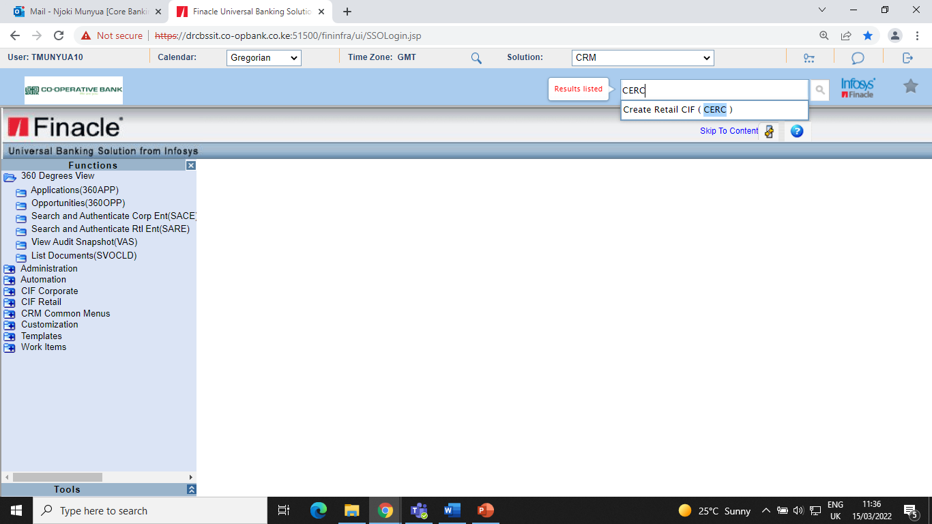

The Create Retail CIF screen appears and displays the Search for Matching Record Performed, Reason which are populated with default entries and CIF SubtypeCategory.

All the fields highlighted in red are mandatory.

## Selecting Customer Type

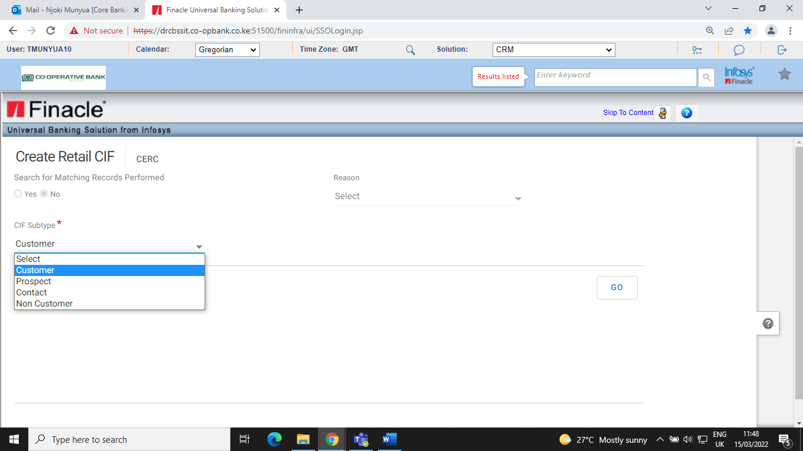

CIF Sub type Options are:

* Customer - Person ready to establish a business relationship with the bank.
* Prospect - A person who wants a relationship with the bank in the future
* Contact - A representative or Agent of an Account holder
* Non -Customer-This is a beneficiary of the customer e.g. suppliers or customers of the main customer.

The default subtype is Customer.

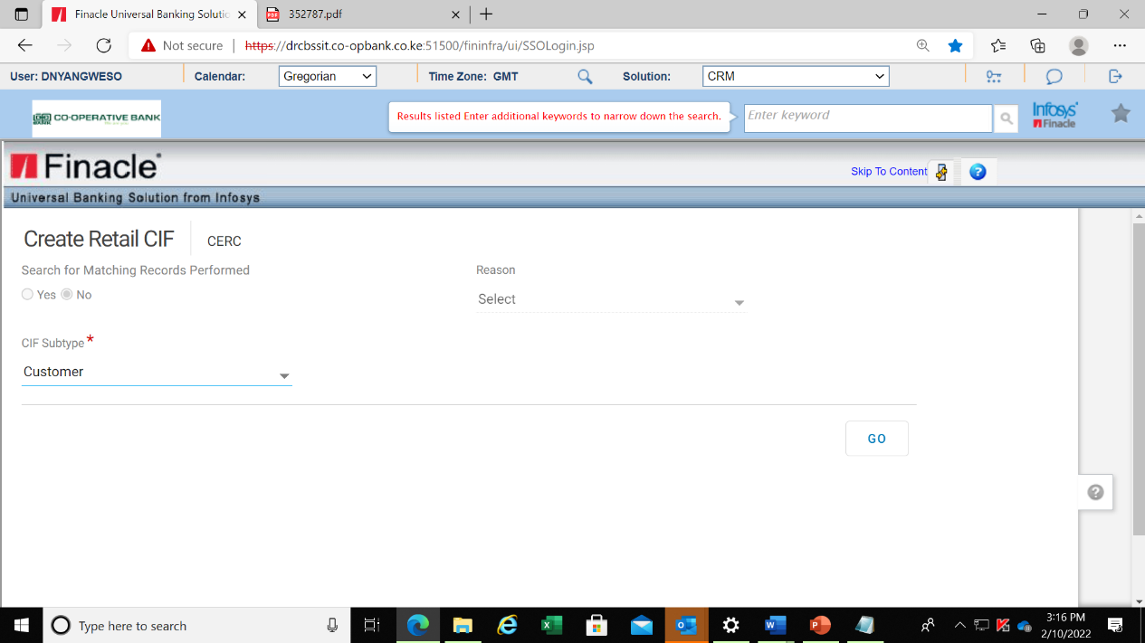

* Click **Go** and proceed to capture customer details

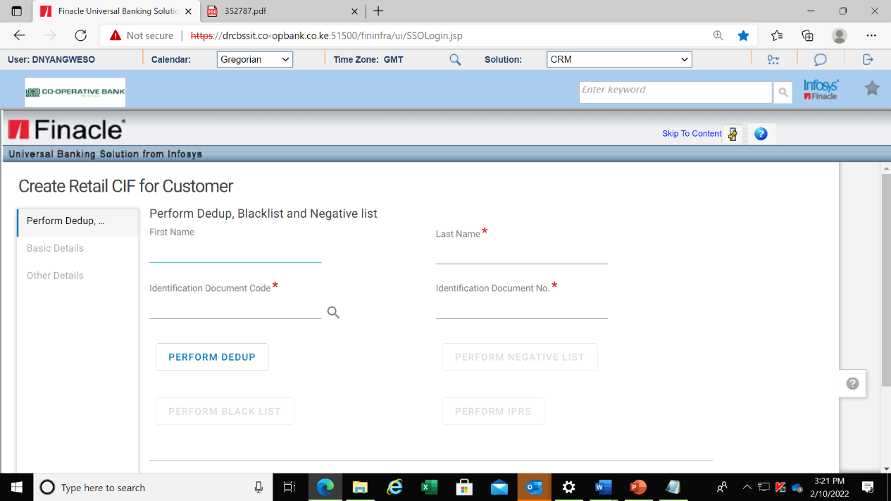

* Input First and last name
* From the Searcher, Select the Identification document code for example National ID maintained as NATID.

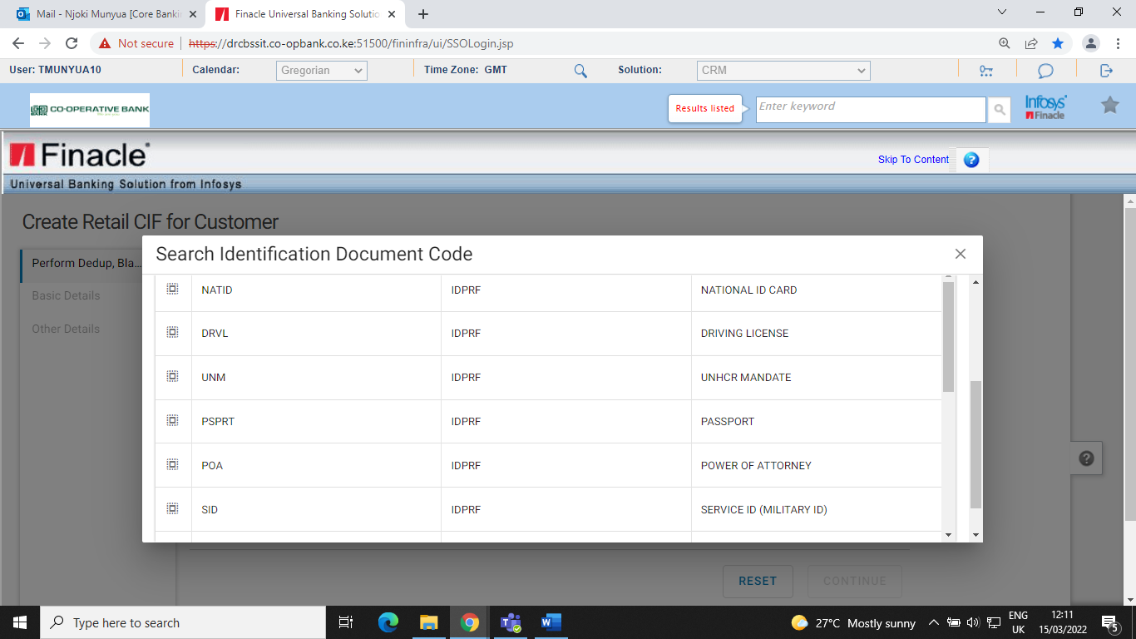

* Input Identification document number of the customer as below.

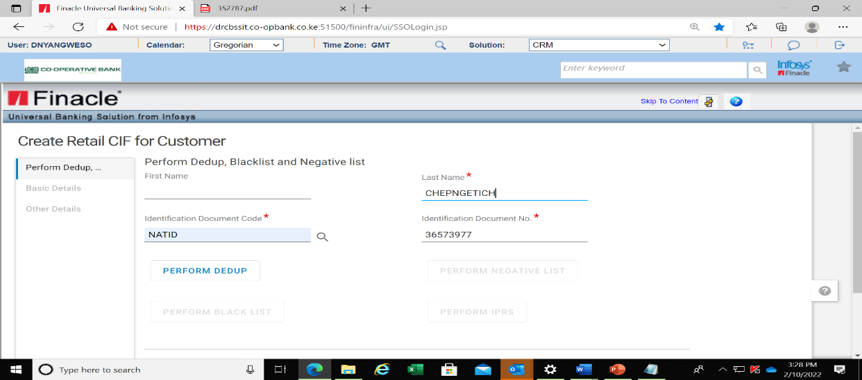

## Performing Dedup, Negative List, blacklist & IPRS Checks

* Click onPerform Dedup **-** The Dedup check establishes whether there are matching records for the identification document.

The Dedup Check displays a list of all the matching records with uneditable fields nominated by the bank for duplicate checks.

The fields displayed are:

* CIF ID
* First name
* Surname
* Document Code
* Document No.

In the event, the customer has another CIF ID, the system will prompt to Enrich

* Click Enrich CIF and proceed.

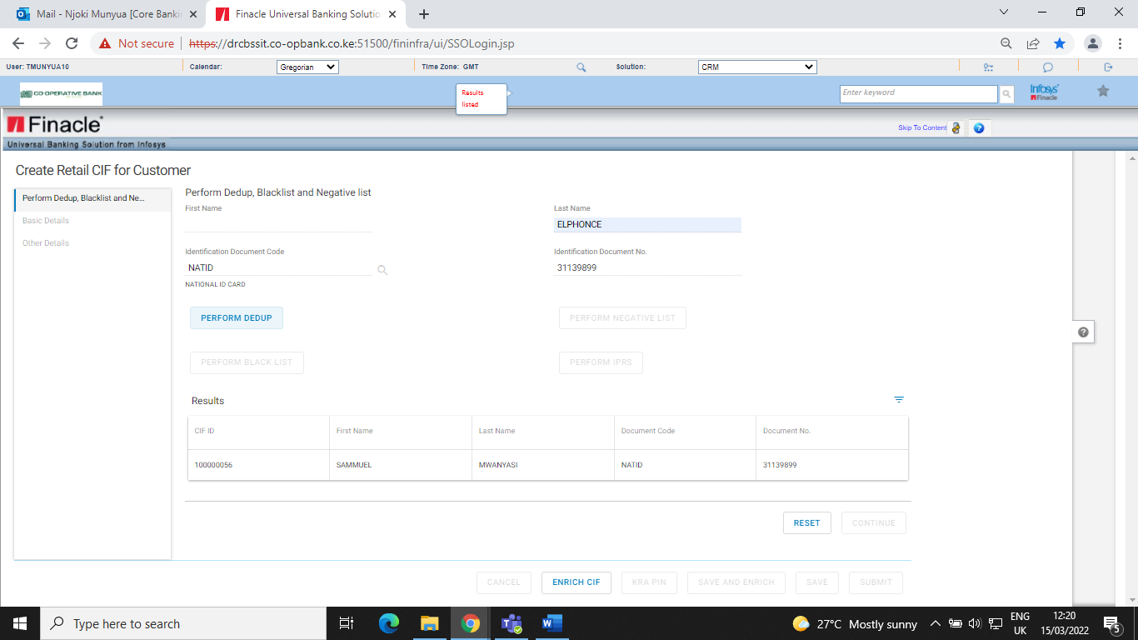

* In the event, the checklist results show no CIFs exist, the screen below will be displayed and perform negative list check is activated

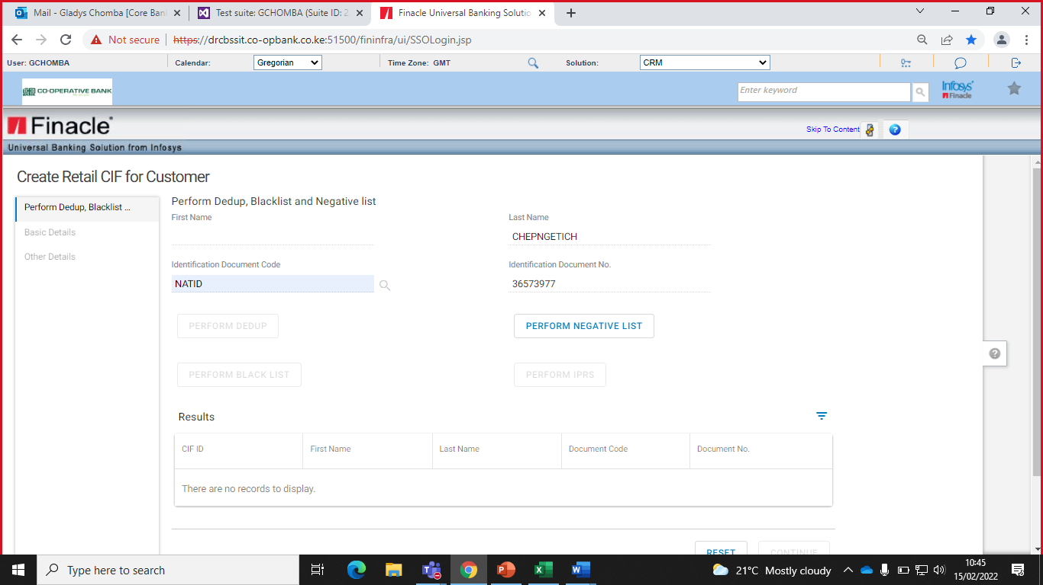

* Click on **Perform Negative** list.

In the event, the customer is negatively listed the below results will be displayed.

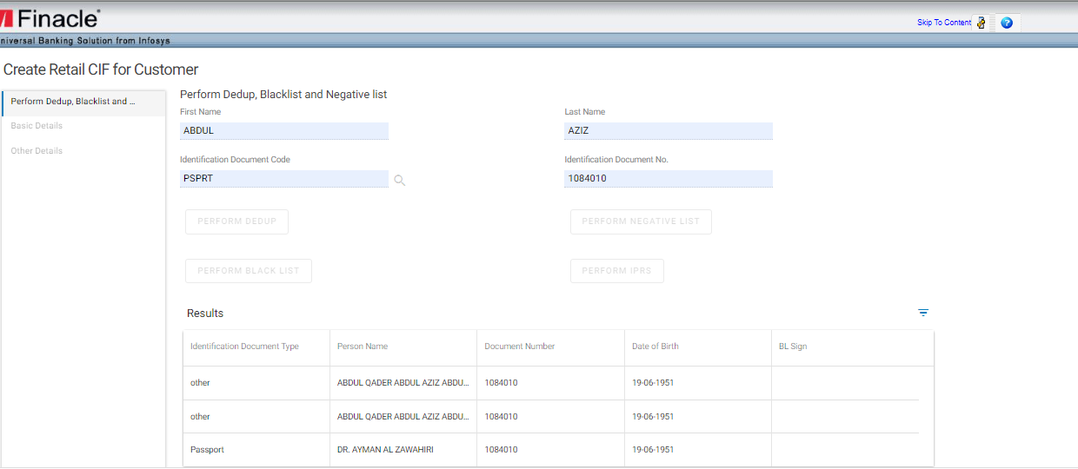

If the customer is not negative listed, the screen below will be displayed and PERFORM BLACKLIST button is activated

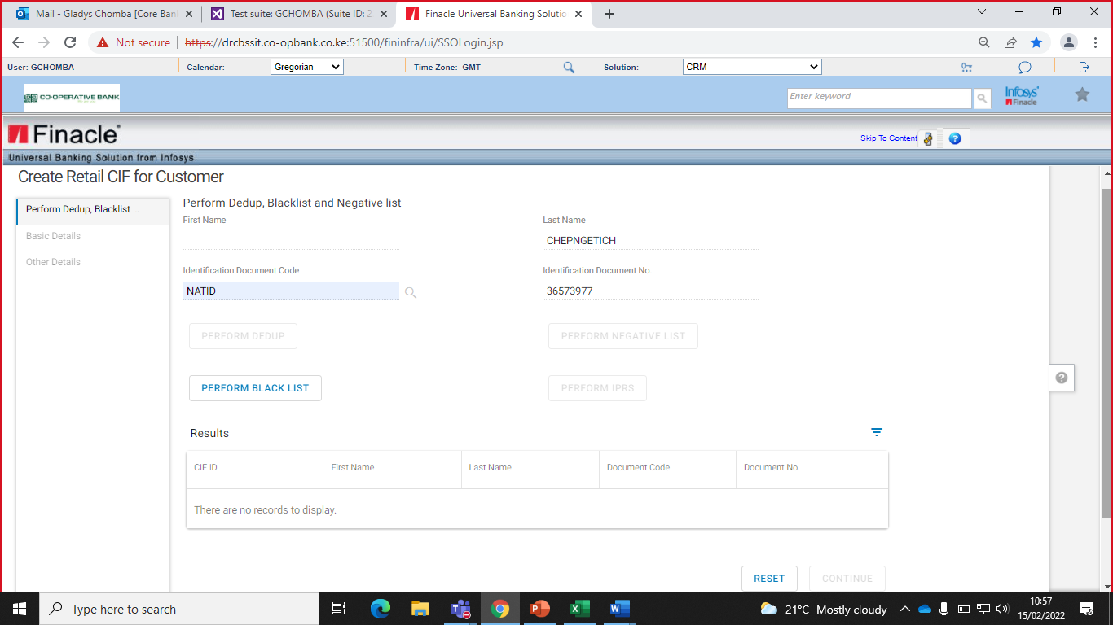

* Click on Perform Blacklist. The screen below will be displayed for non-blacklisted results.

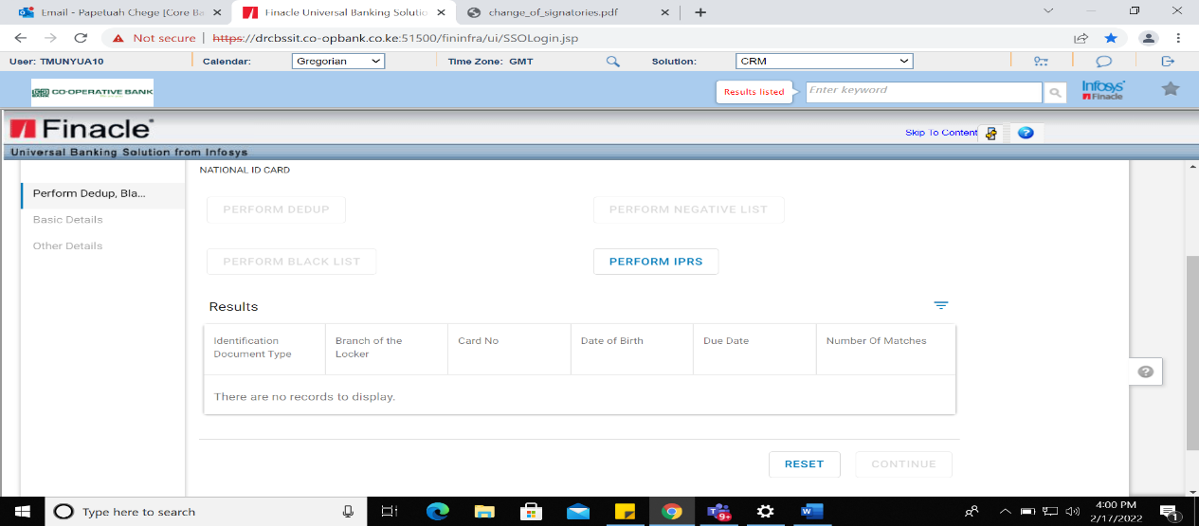

If the customer is blacklisted the records will be displayed with no option to continue.

* Click on **Perform IPRS.** The Party Check List screen is displayed.

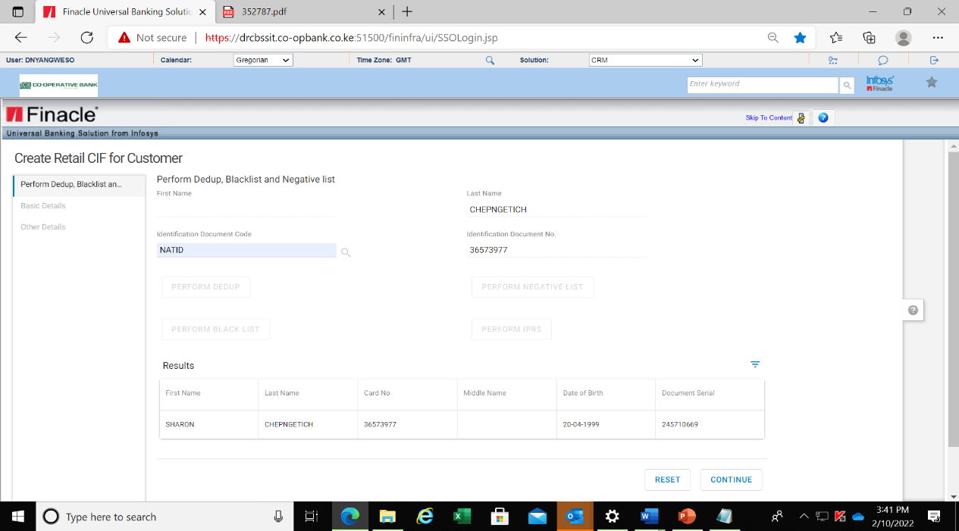

* Validate the customer details from IPRS in comparison with the identification document presented
* Click on continue button to the basic details page

## Capturing Basic Details

Based on the IPRS results, the First Name, Middle Name, Last Name, Short Name, Full name, and Date of Birth will auto-populate.

* Input the Salutation & Gender.
* Verify all mandatory details as displayed.

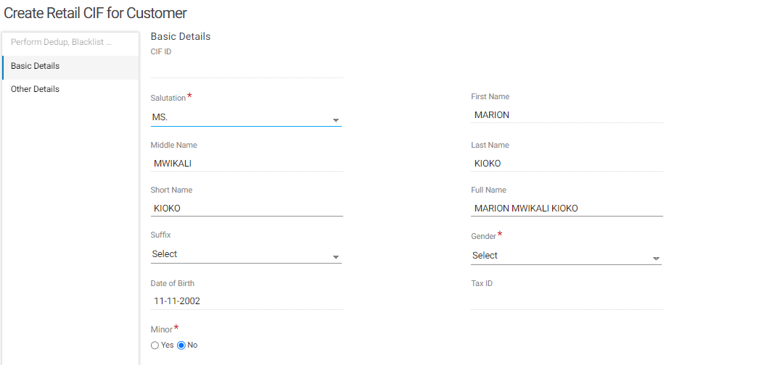

## Capturing Identification Document for a Retail CIF

### Identification Document Summary

This is a multi-record list in which different documents of the customer can be added. The main document shall be marked as preferred denoted with a Y and the rest shall be marked as N.

The documents can be linked that are uploaded and maintained in the DMS (Document Management System)

To add a record:

* Select the Mode as ADD (+).

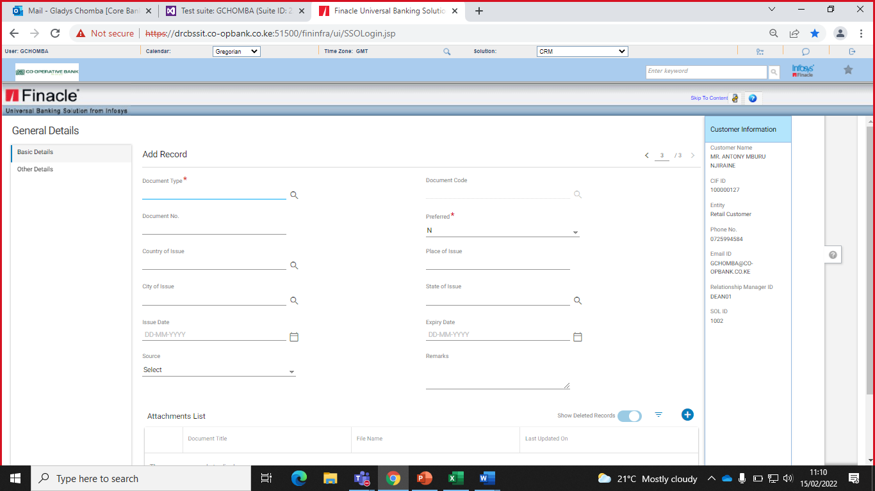

* Populate the document type as Identification Proof for Retail (IDPRF) and the Document code as maintained.

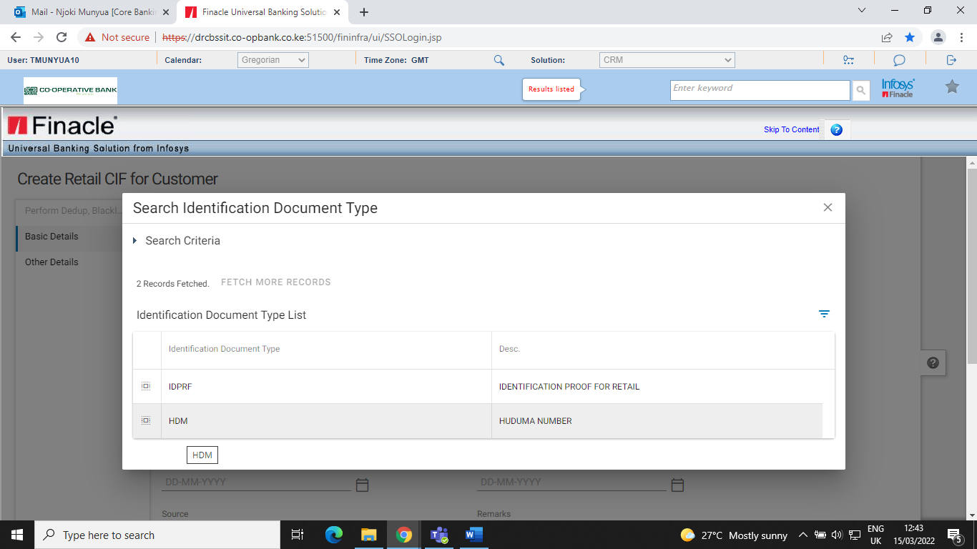

* Select the Document code from searcher as shown below

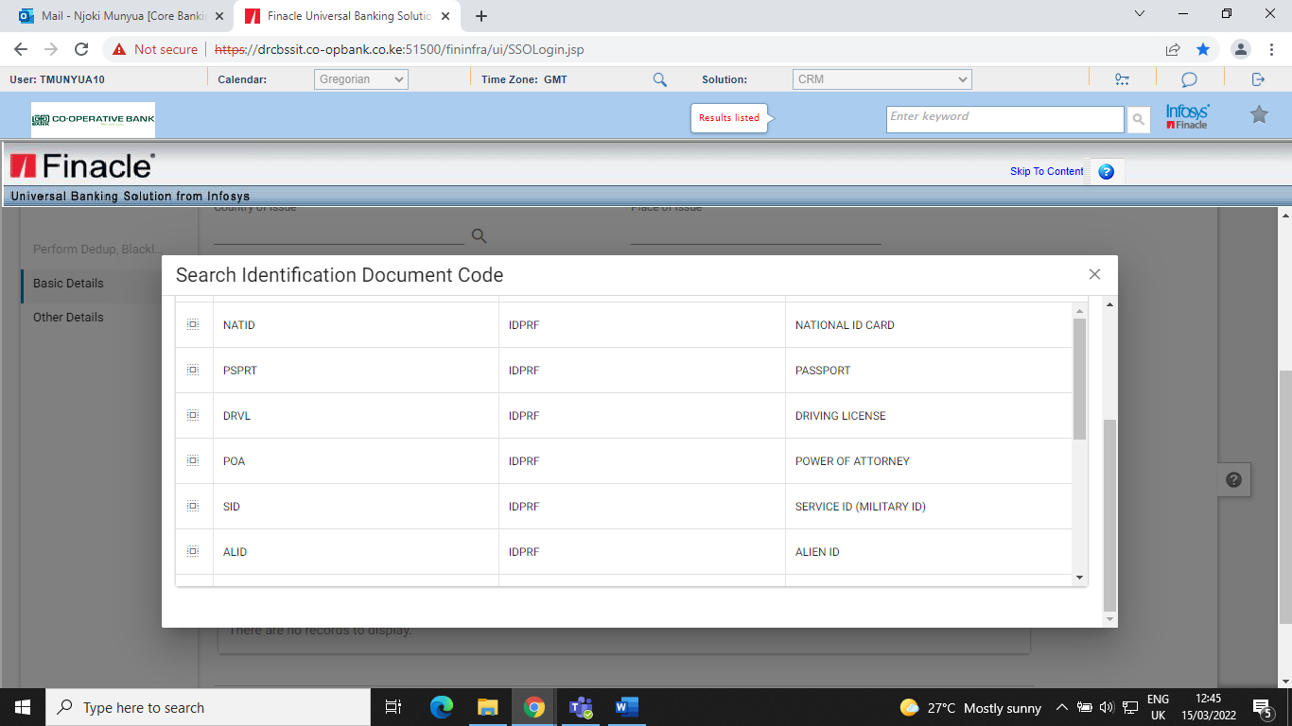

* Select the Preferred document as Y. This will auto-populate the details on Document No.
* Populate Place of issue and Issue date details for the presented identification document.

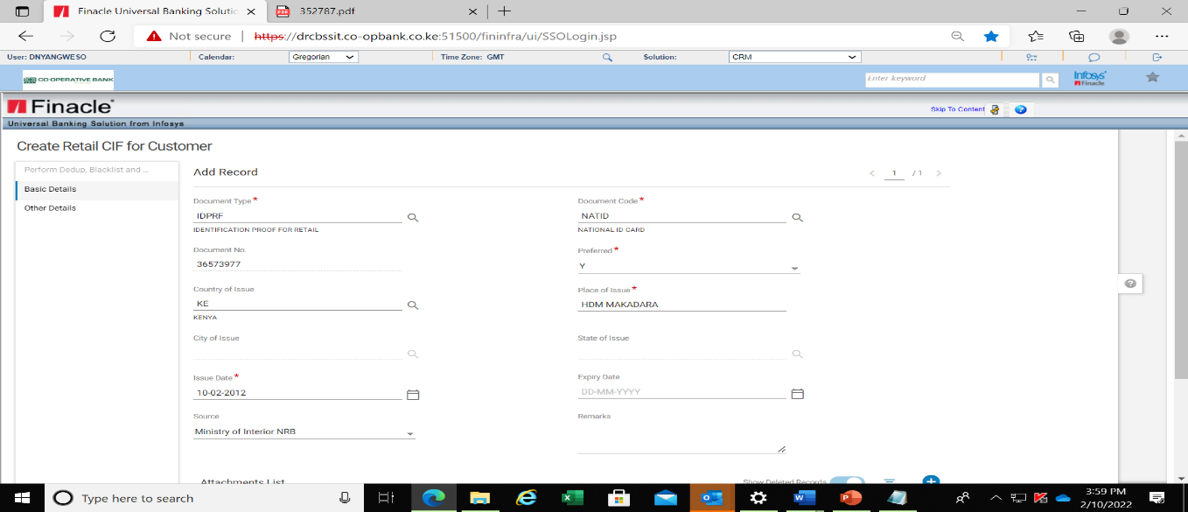

* Click the Add (+) button on the Attachments List tab. The screen below will be displayed

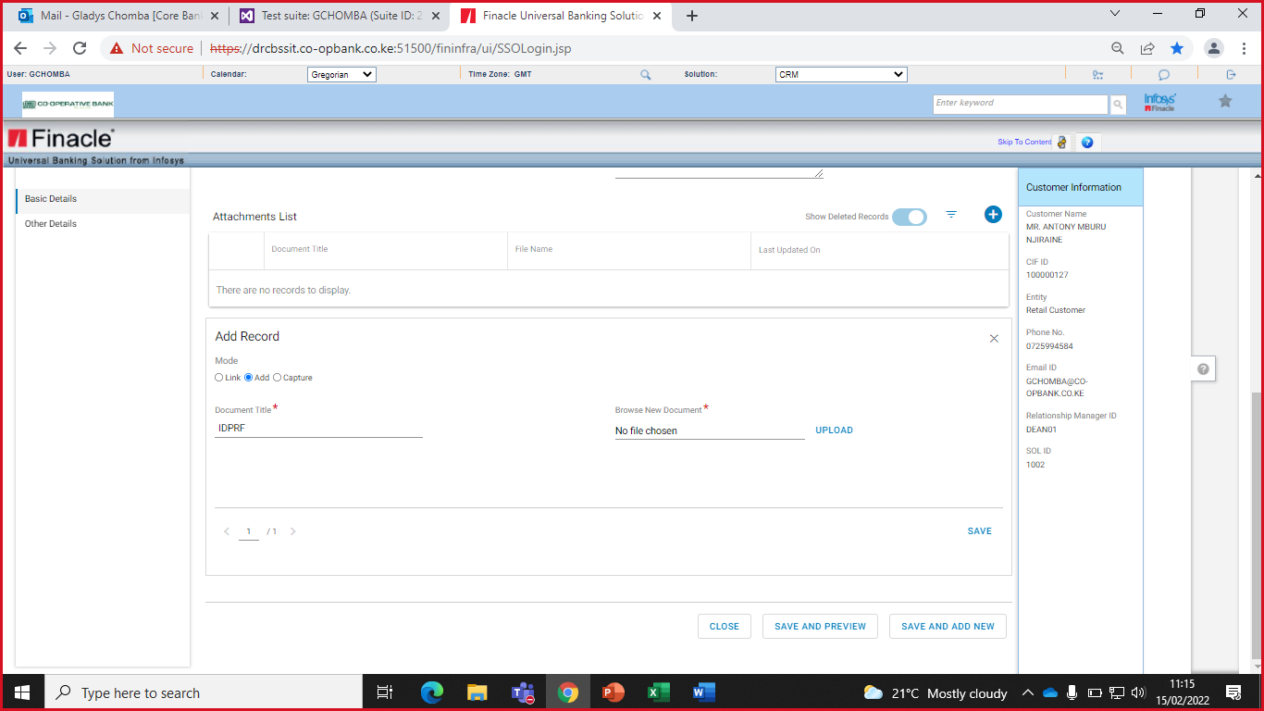

There are three modes of adding an Identification record:

1. Add-Used for scanned documents in PDF or JPEG formats.
2. Link-Used when customer has an existing CIF ID.
3. Capture-Used when capturing the document with a webcam.

### Adding a Saved Document using the Add Mode

* Browse new document from the computer
* Click on upload
* Click on Save as displayed below.

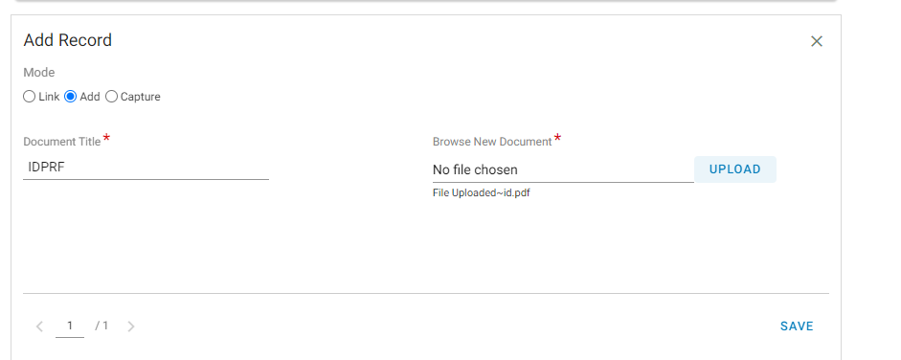

### Adding a Saved Document Using Link Mode

This is used attach a document from an existing CIF e.g. when creating a minor CIF one can link a document of the parent or guardian.

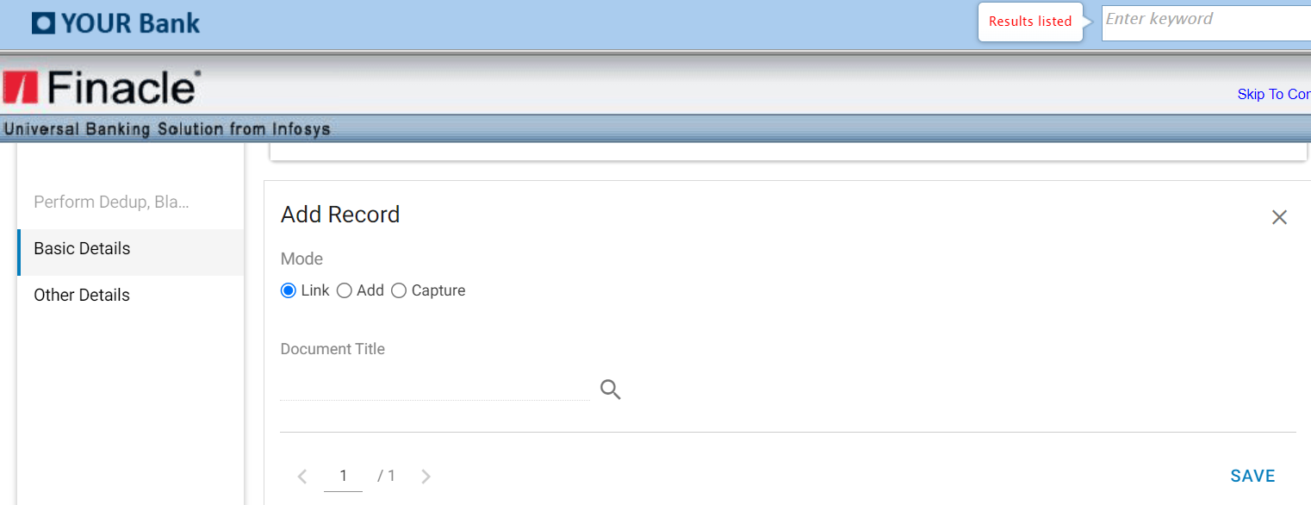

* Click on Document Title
* Select Entity Type as CIF
* Input the source CIF on CIF ID

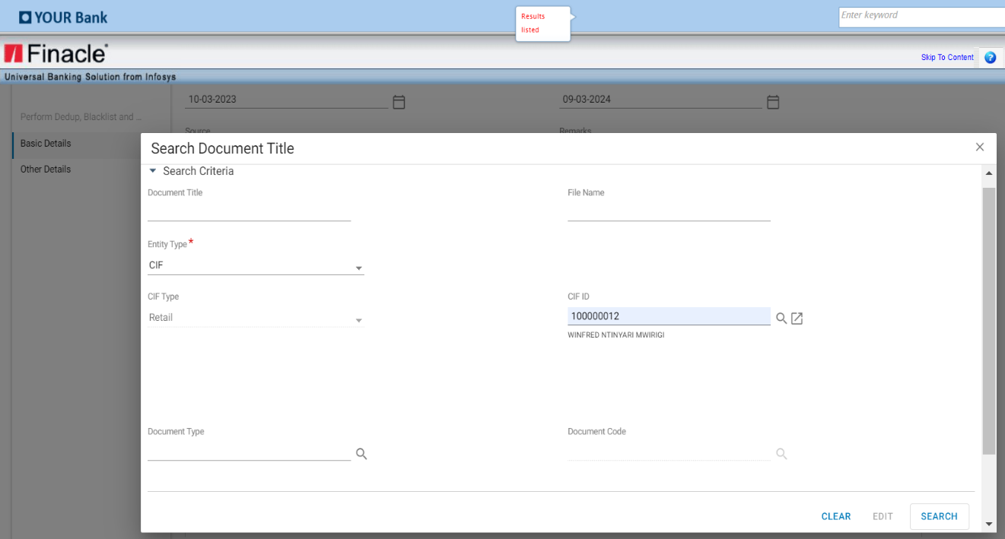

* Click on search

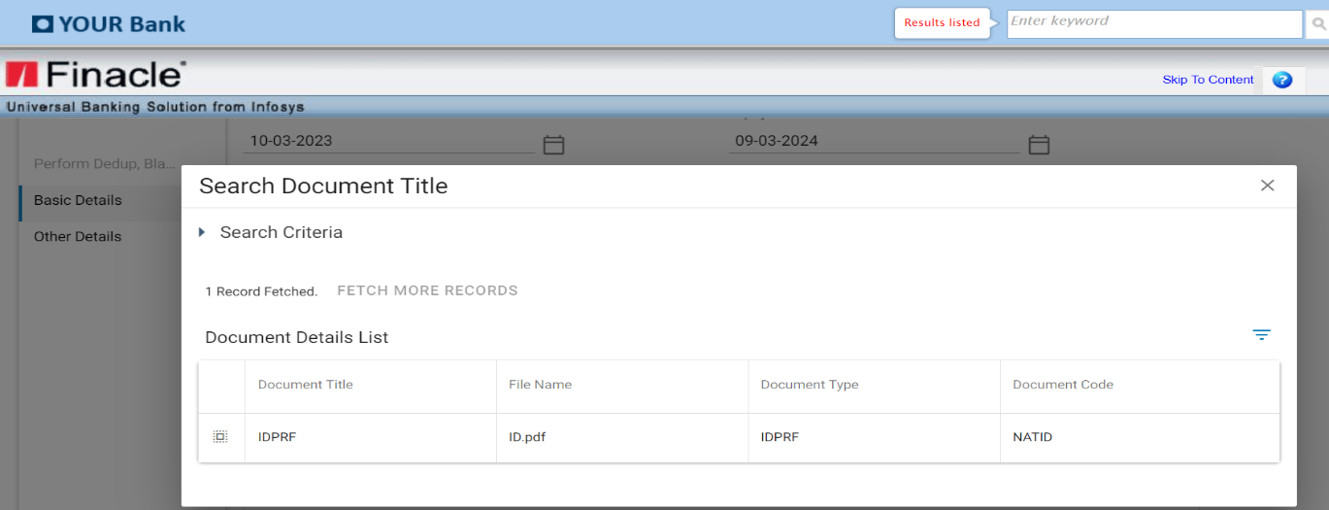

* Select the record

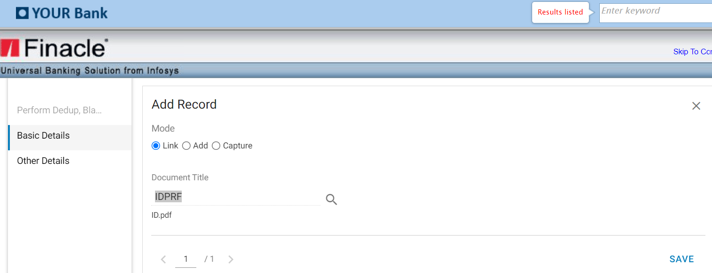

* Click on save

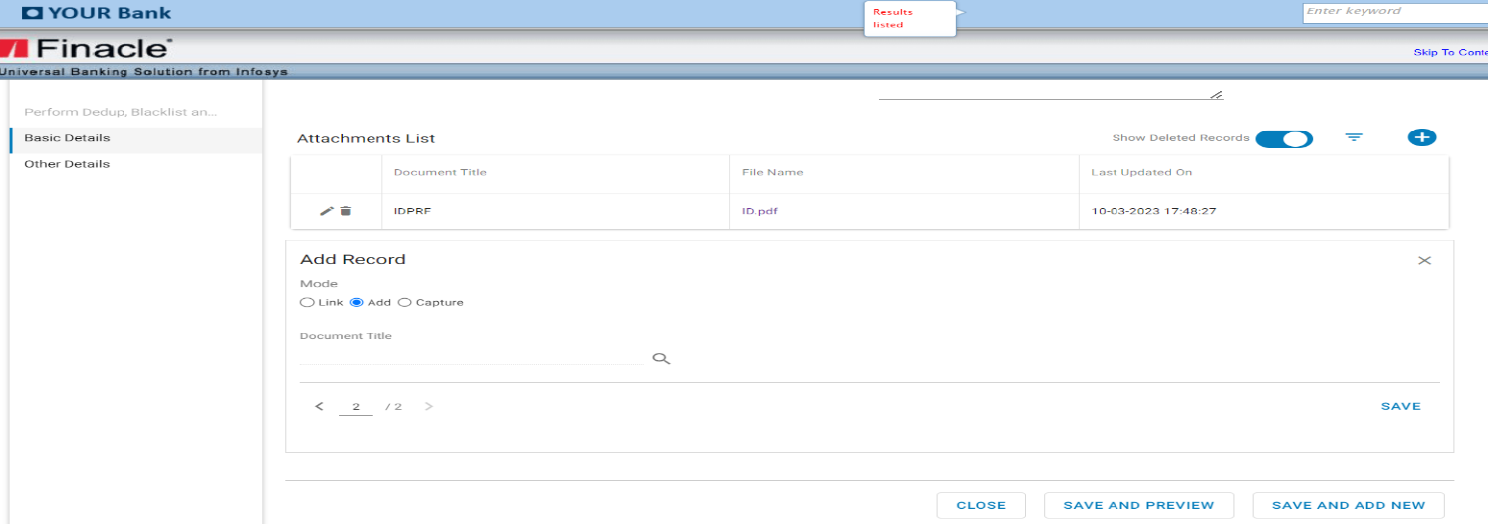

### Adding Document using Capture Mode

* Click on Capture Mode

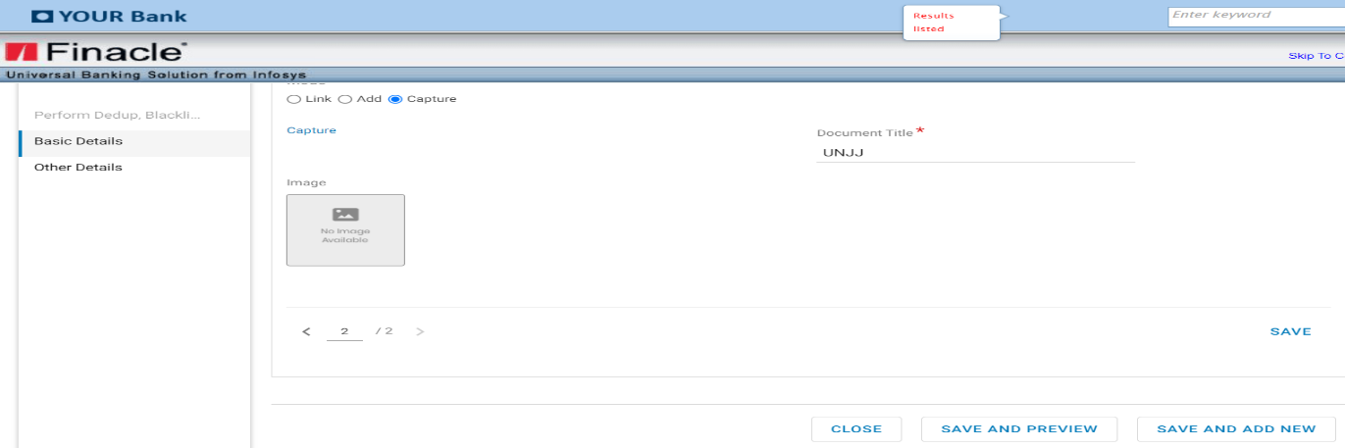

* Click on capture

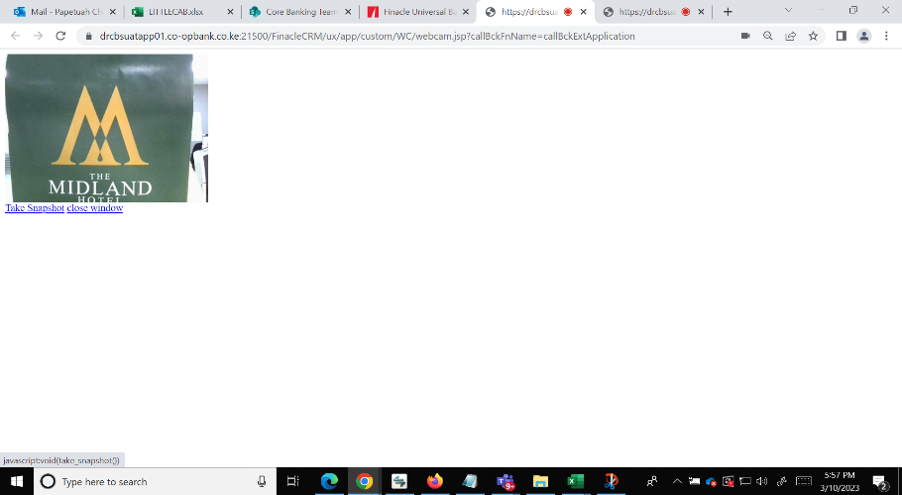

* Take snapshot of the document
* Click on close window

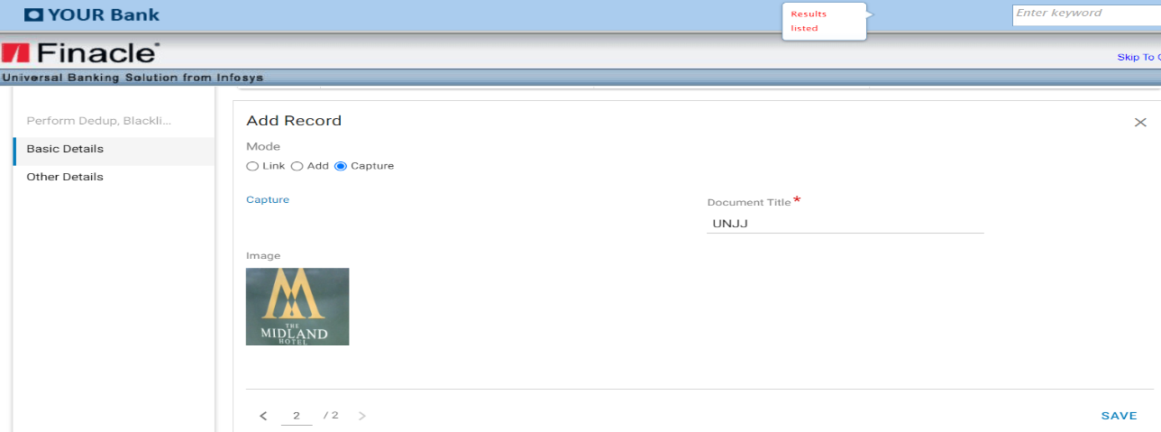

* Click on Save

After successfully attaching the document, the Save and Add New button is used in the event of adding another document.

The preference details for a secondary document shall have the preferred Field as N.

* Click Save and Preview tab when uploading only one document.

The screen below will be displayed.

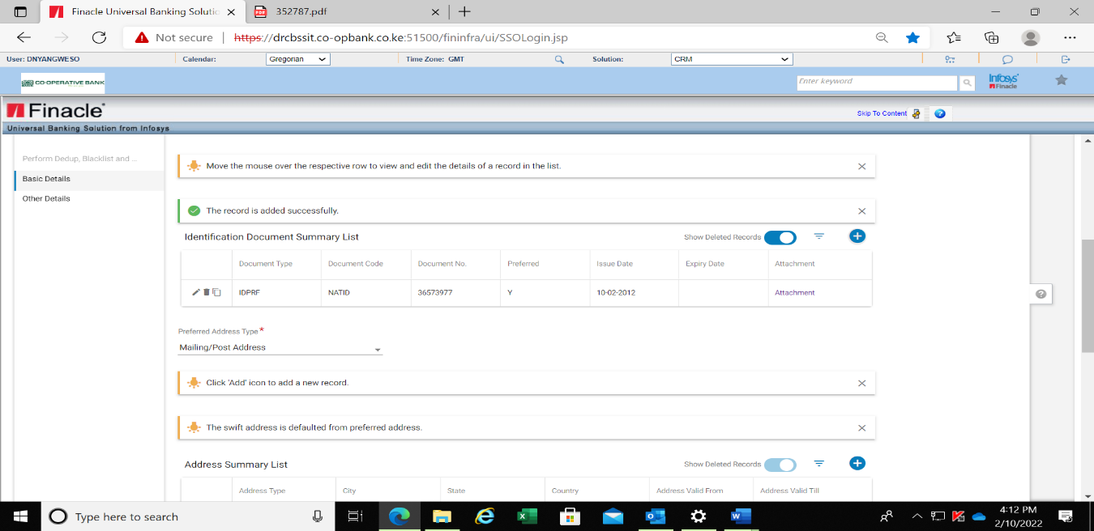

### Adding of Customers Address

Address Summary is a multi-record list in which different addresses of the customer can be added.

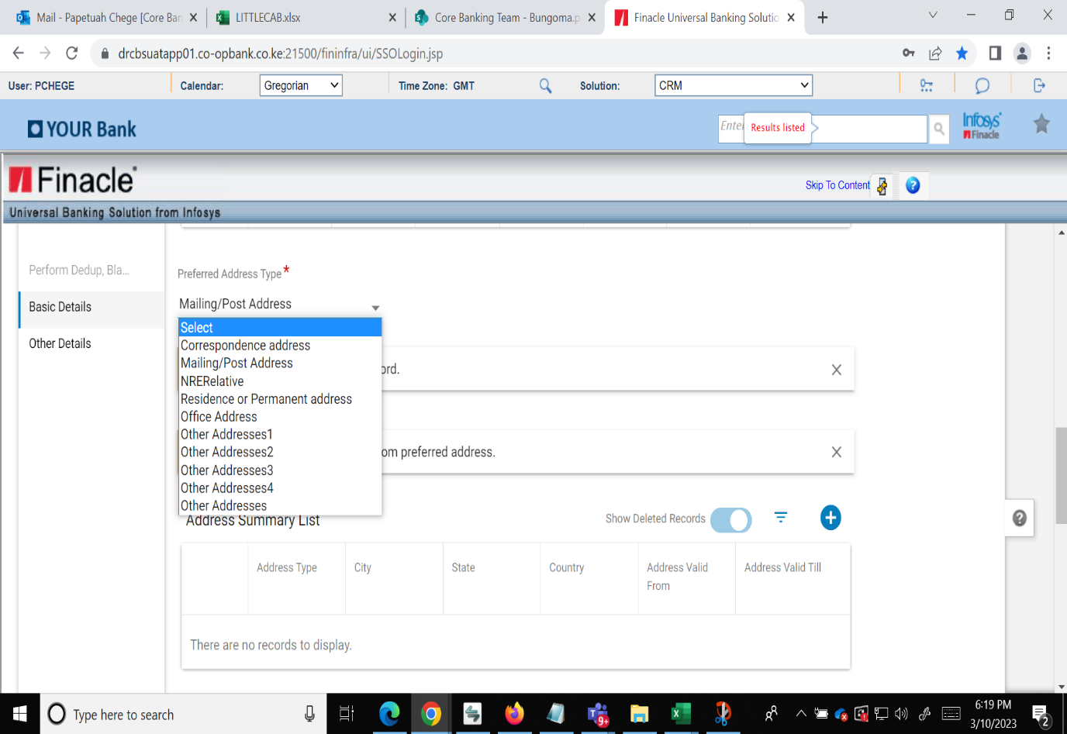

* On the Address summary list click on ADD+
* Select from the drop-down menu the list of addresses
* Click for example mailing and postal address.

The free text button will be activated.

* On selection of Postal code, the city, Town, County and Country will be populated. Input the address line 1 manually as displayed.

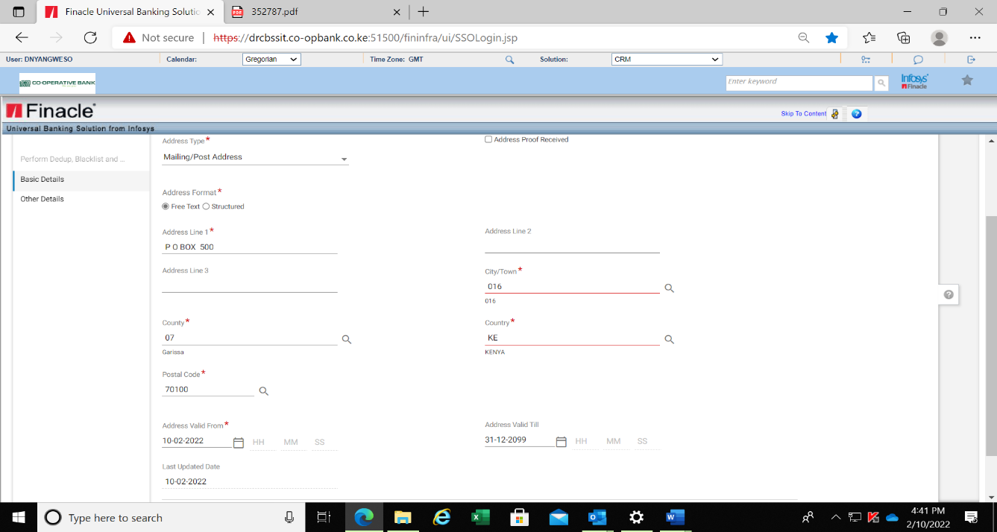

* Click on Save and ADD to add a new record

## Adding Residence/Permanent Address (Physical Address)

* Select Address Format as Structure
* Input the House no, Street no, Street Name manually
* Select postal Code. On selection of postal code, city/town county and country will be populated
* Click Save and Preview button.

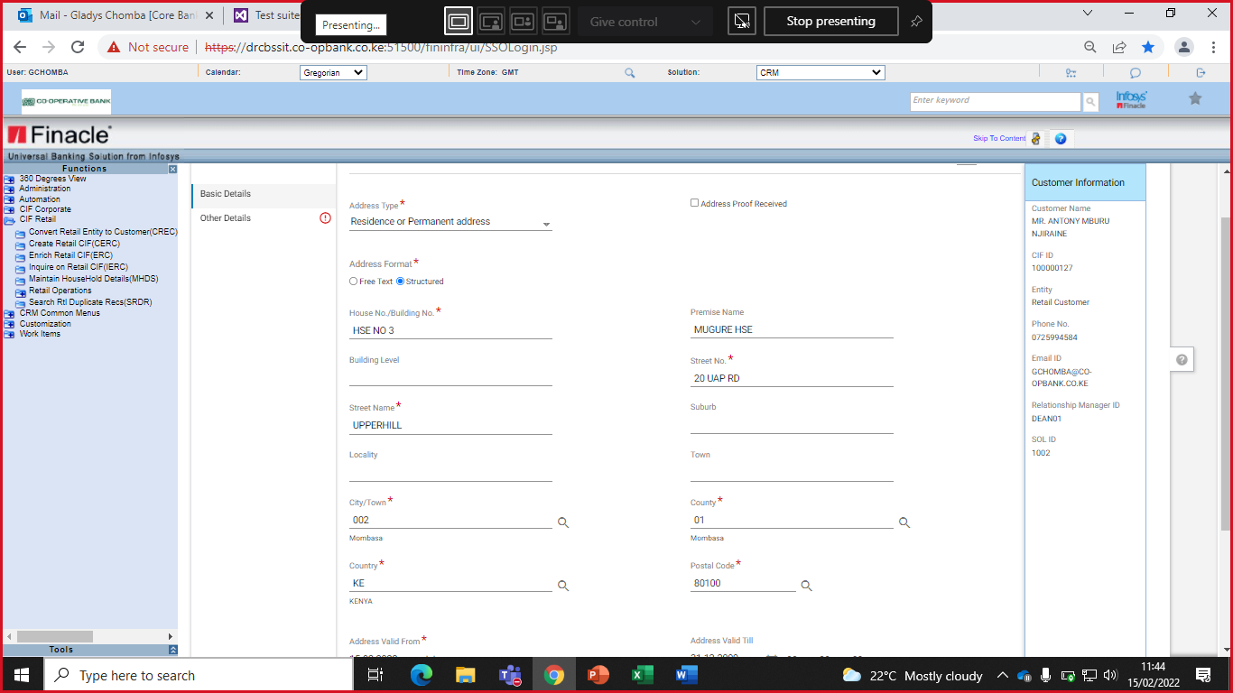

## Capturing of Diaspora Accounts Address

For Address type:

* Select NRERelative
* Select Structured on address format
* To input House No./Building No, Street No, Street Name, City/Town-Diaspora, Postal Code
* Select County as Diaspora (code 48) as shown below:

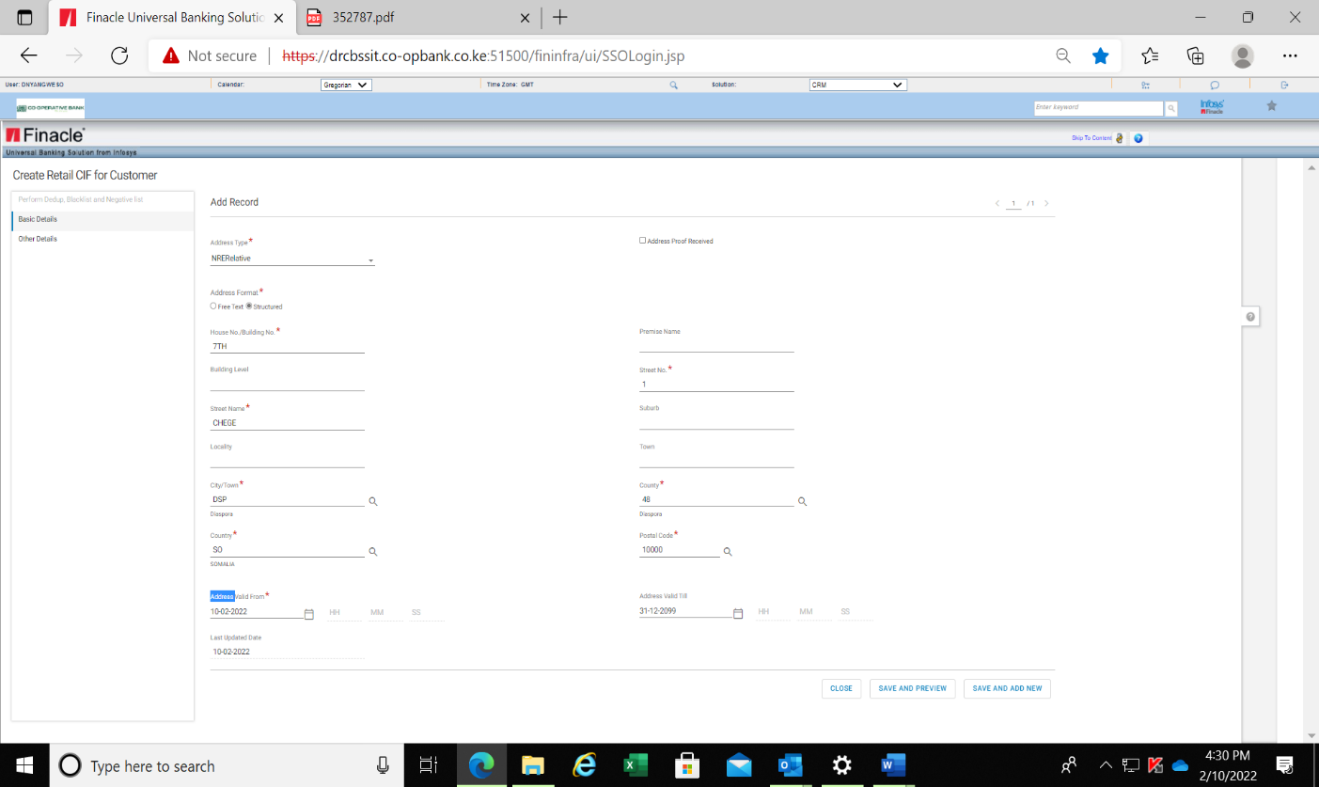

* Click on Save and Preview to display the address summary as below.

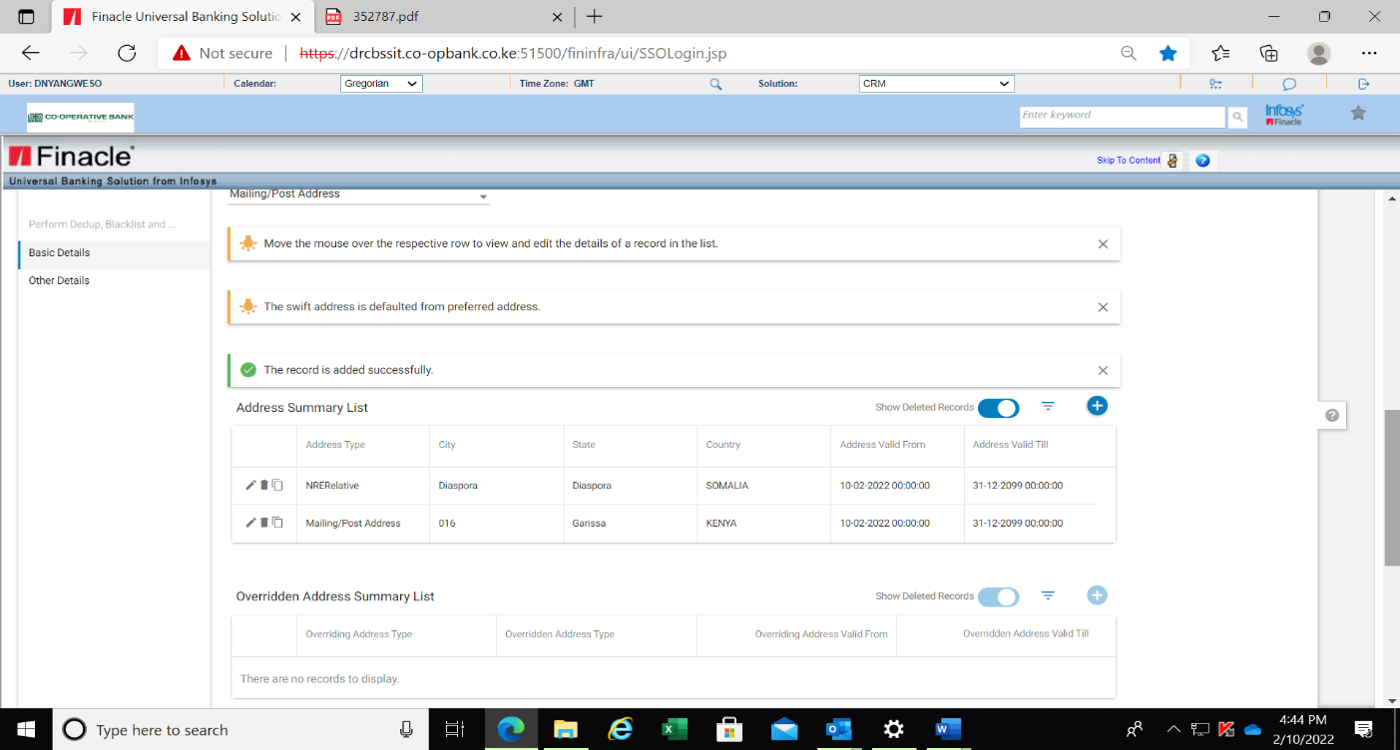

## Capturing Contact Details

From the drop-down menu:

* Select the Preferred Phone Type and Preferred Email as shown below:

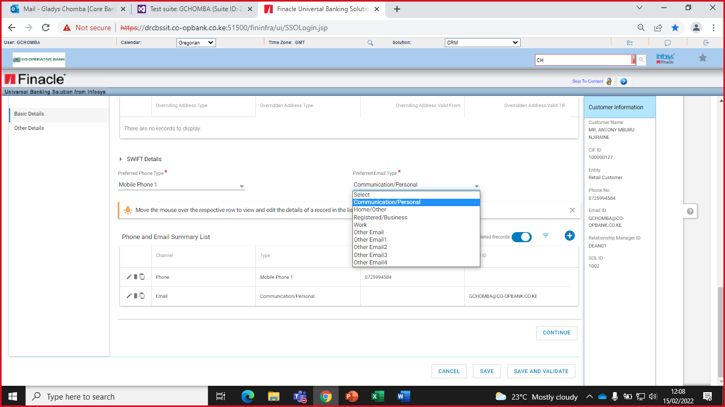

* Click on add. (+)
* Select the country from the searcher to populate the country code
* Capture the customer’s Phone number
* Click on Save and ADD New to input the email details as below;

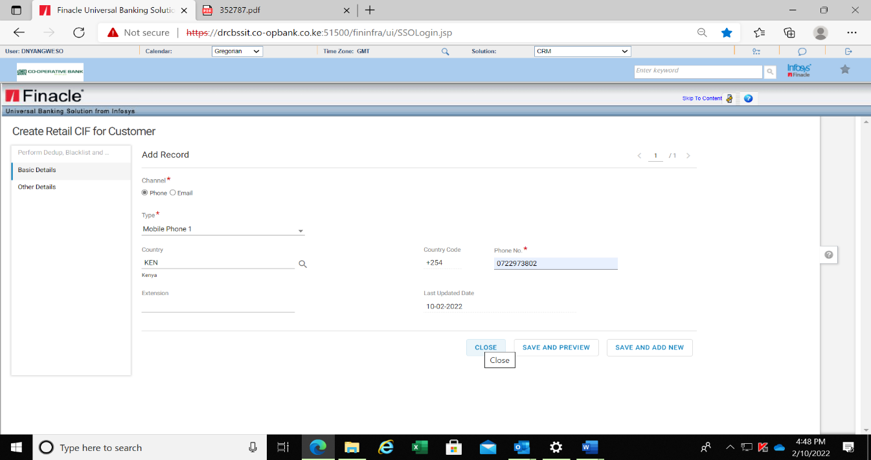

* Click on Save and ADD New to input the email address
* Select Email from Channel
* Input email address on Email ID

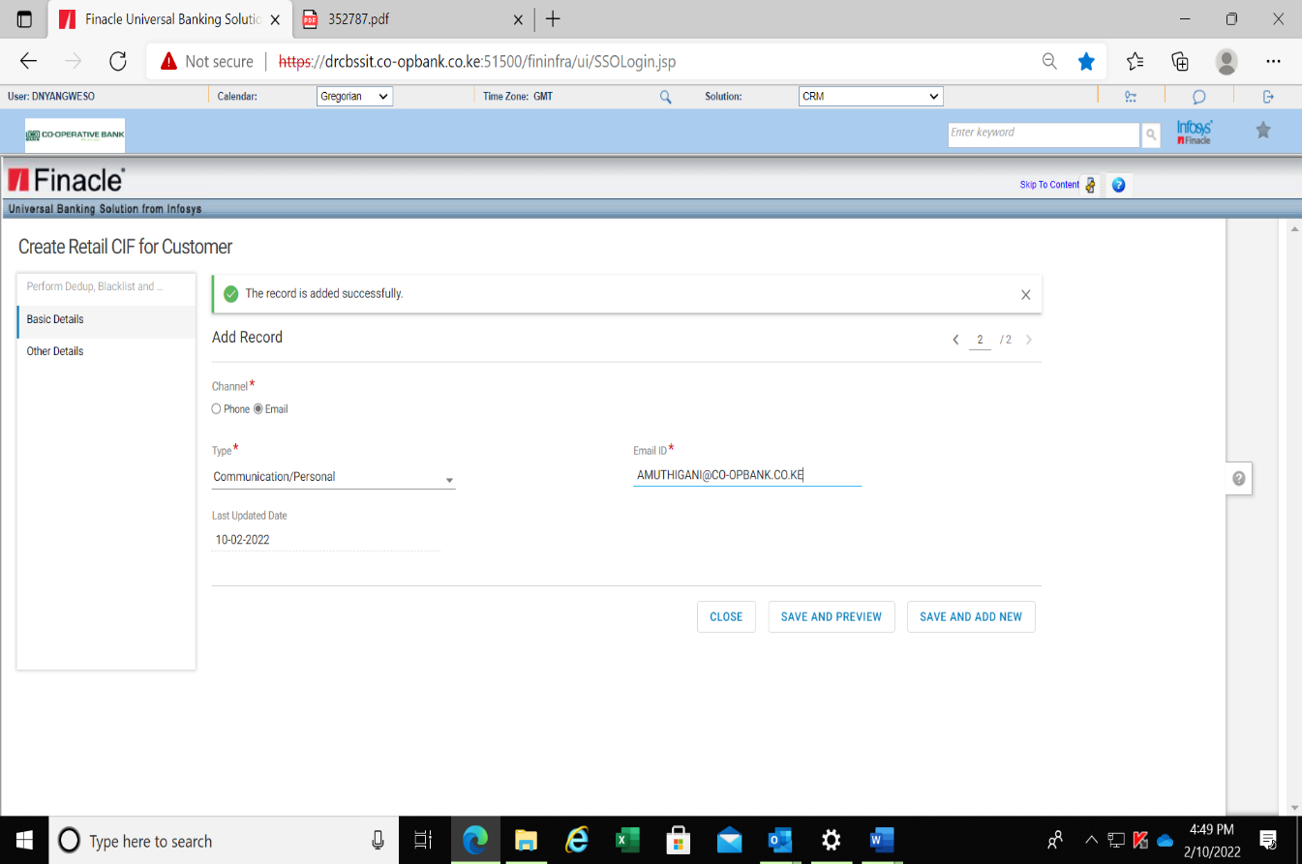

* Click on the Save and Preview button

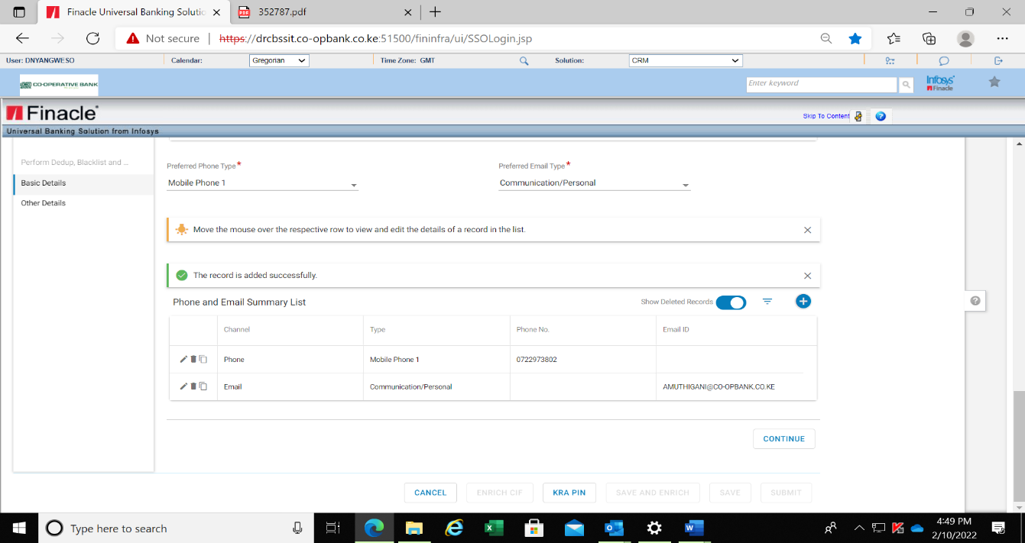

* Click on Continue button

## Capturing Other Details

This tab contains miscellaneous information Marital Status, Residence Status, employment details, primary SOL ID, primary RM ID, Country of Residence and Town of Birth.

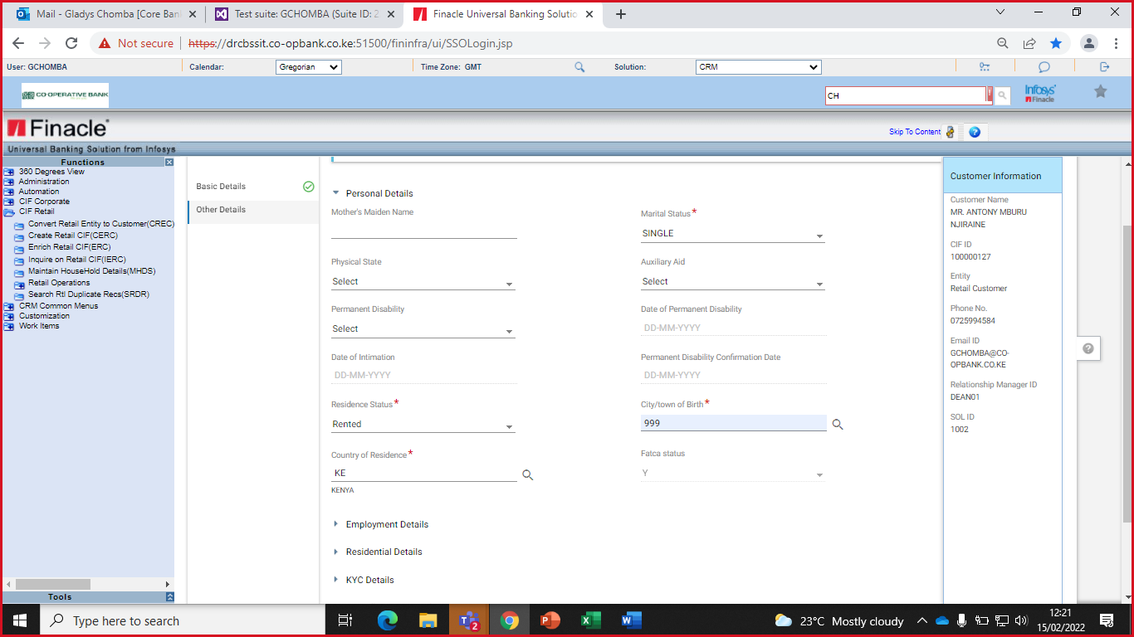

* Select the marital status from the drop down

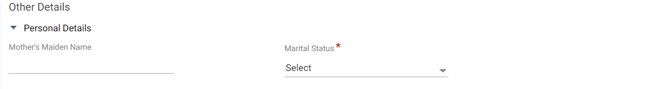

* Select the Employment Status and the Occupation from the drop down.

If the customer is a Co-operative bank employee, select YES on Bank Employee field and select the PF number on Bank Employee ID

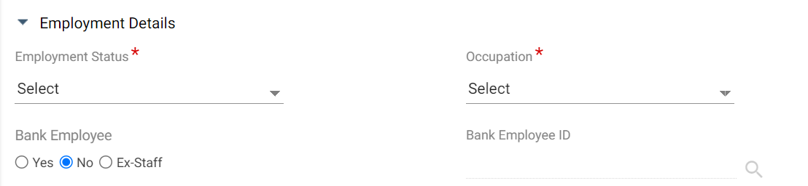

## Capturing the Residential Details

* Select the Nationality and the Country of Citizenship from the searchers. The non-resident Indicator shall be N for resident and Y for a non-resident.

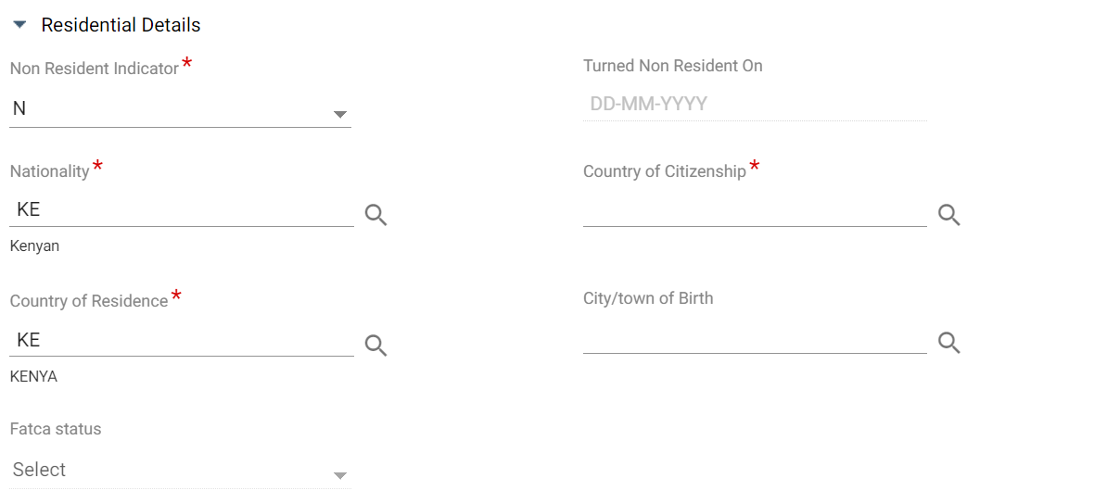

When the Non-Resident Indicator is Yes, input the date when the customer became a resident on Turned Non Resident On field, input Country of Citizenship and Country of Residence.

## Capturing Miscellaneous Details

* Input username of a relationship manager who has an ARO code on Primary Relationship Manage ID
* Select Segment from the searcher.

**Note**: The ARO code will automatically populate once the username of the relationship manager in input

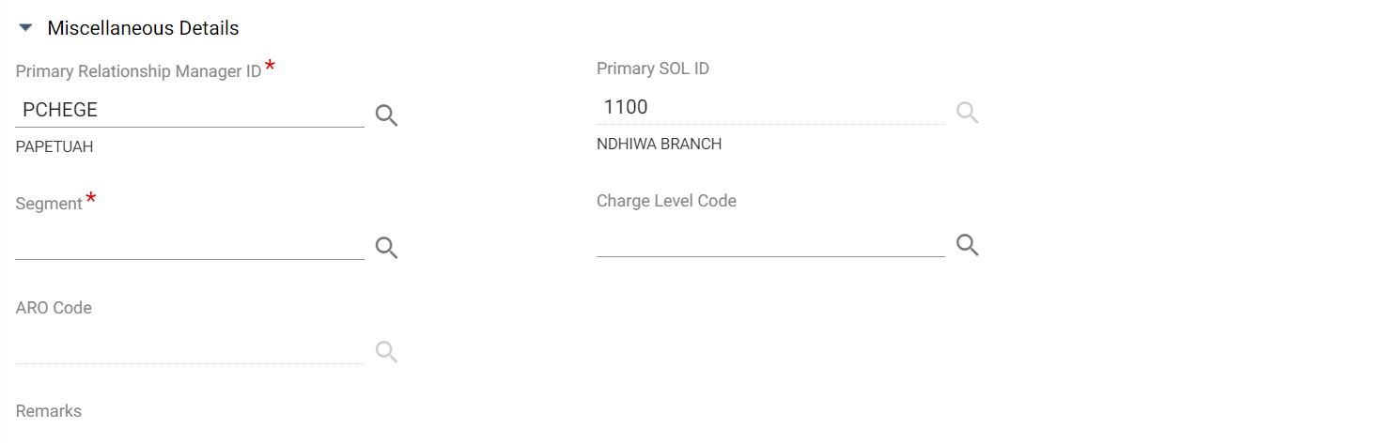

## Capturing Currency Details

This section entails a multi-record list of currencies in which the Bank can open accounts for the customer. The Base Currency Details will default to KES in the list.

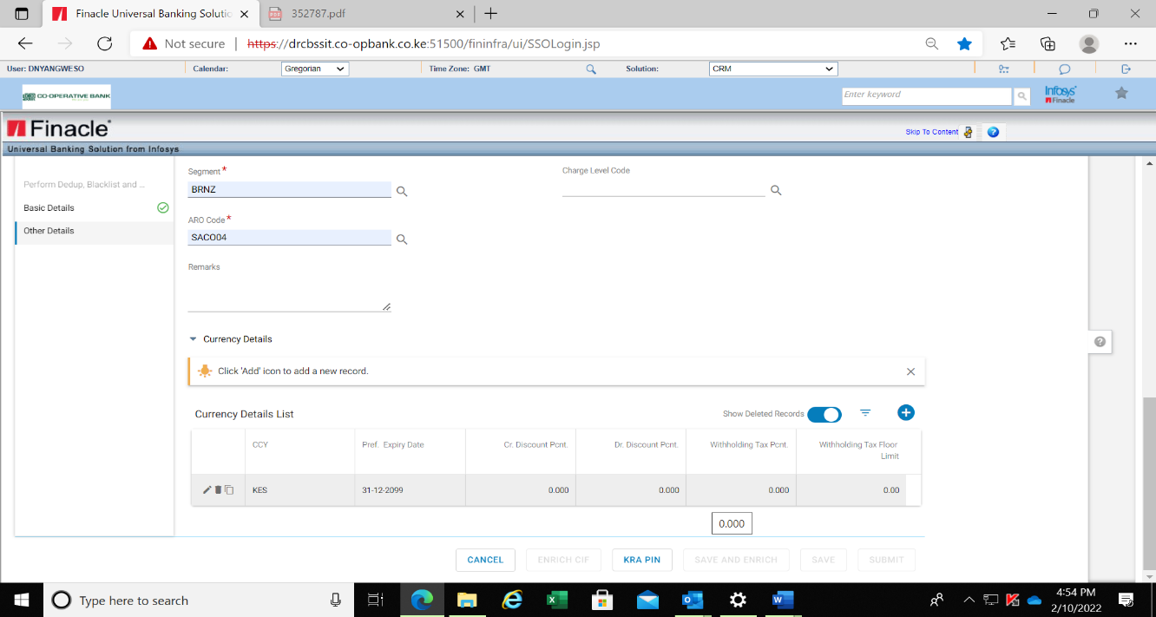

* Click the ADD (+) button to input additional currency.
* Search the currency from the CCY searcher
* Click Save and Preview to continue.
* To add an additional currency, Click on Save and Add New.

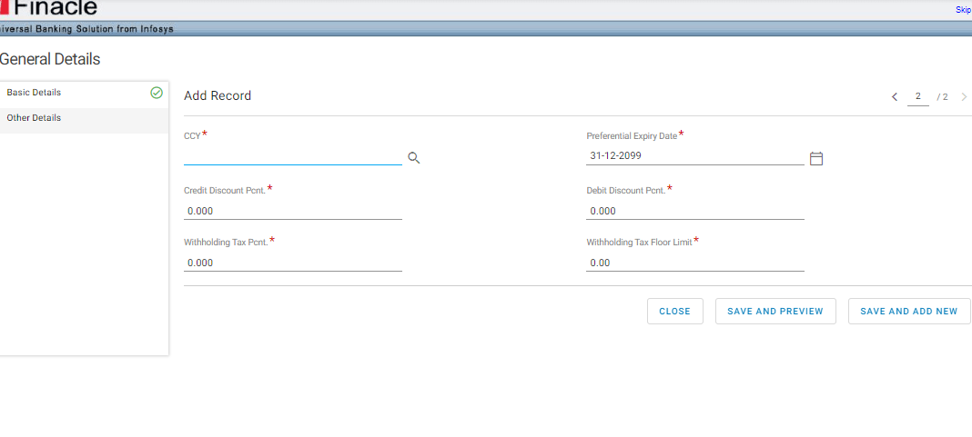

## Generating KRA Details:

* Click on the KRA button.

If Kra pin is generated successfully, the KRA pin number will be displayed. If the Kra pin generation is not successful in the case of Kra systems being down, there will be an error message generated and the KRA pin will be manually input in Additional Details.

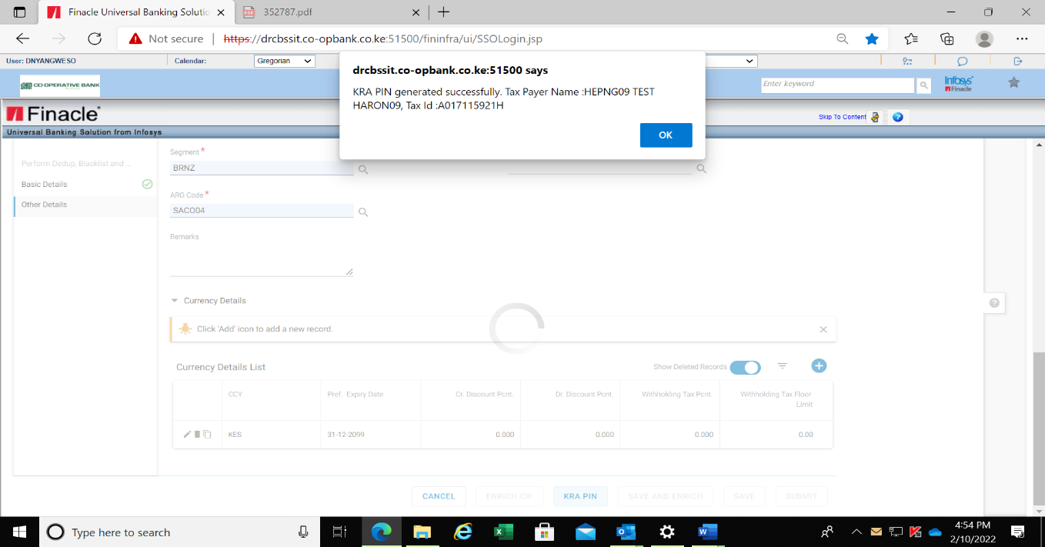

* Click Continue. The following fields will activate.
* **Save and Enrich** – Use this option to save CIF as a draft while proceeding to specify remaining details in the CIF. After enriching the CIF, the customer can submit the CIF for approval.
* **Save** - Use this option to save CIF as a draft. The details are not updated to the database. Since the CIF record is saved, it remains in the user’s self-tray. The CIF can be accessed only by the maker through menu MSCDS (Maintain Saved Cif Details) or the enrichment menus ECC(Enrich Corporate CIF) in case of a corporate CIF and ERC(Enrich Retail CIF ) in case of a retail CIF.
* **Submit** - Use this option to save CIF details into the database, the selected process is used for CIF approval and the status of the CIF is changed to ‘Under Verification’ status.
* Cancel- Deletes all the details input during CIF creation.
* Click on the **Save and Enrich**.

Note that a CIF ID is generated.

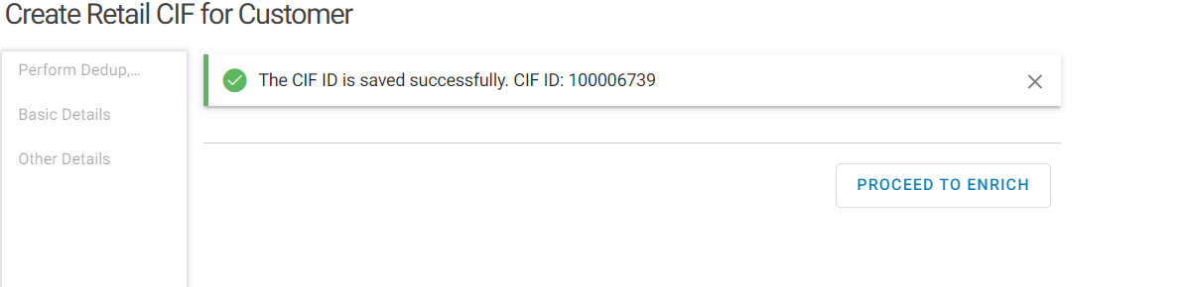

* Click **PROCEED TO ENRICH** button

# CIF ENRICHMENT (FINACLE)

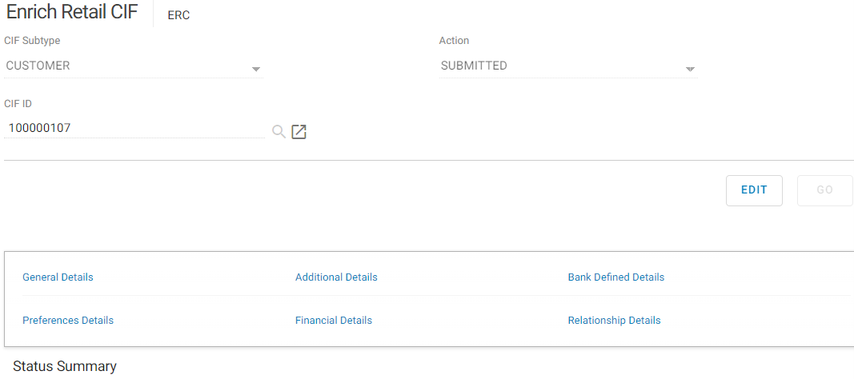

## Additional Details

Click on Additional Details.

This section is used to record the academic, career profile, financial and other demographic details of the new entity. The subsections within Additional Details are:

* Additional Details
* Qualification Details
* Employment Details
* Reporting and References Details
* Background Check Details
* Details of Business Entities
* Relationship Details with other Banks
* Group and Household Details
* Preferences in Bank services
* Customer Mapping Details

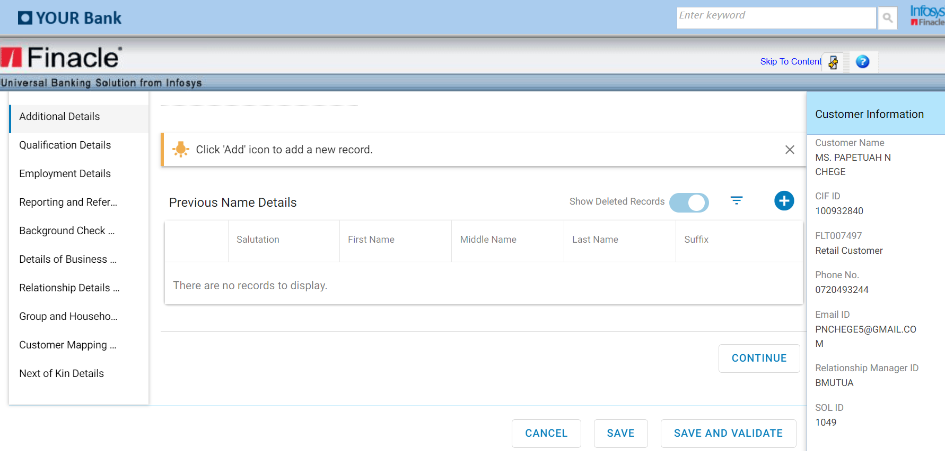

## Previous Name Details

This is a multi-record list containing details of all past official names of the customer. Any changes shall be accompanied by a valid certification.

The system allows a maximum of three different records to the list.

* Click Add button to add a record
* Enter Salutation, First Name, Middle and Last Name
* Click Save and Preview to save the record

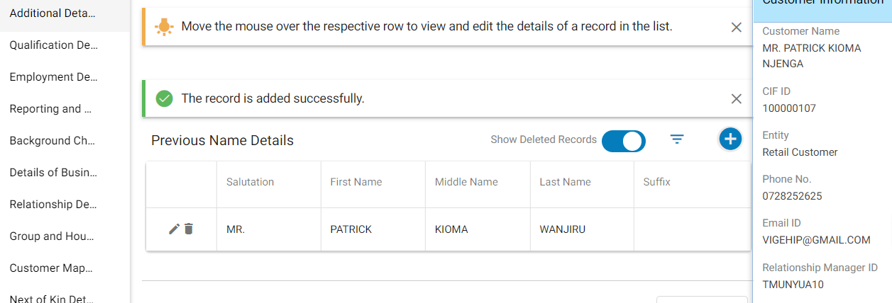

* Click on Continue
* Qualifications Details.

## Qualification Details

Qualification summary is a multi-record list containing details of all the educational qualifications as declared by a customer. It is a mandatory field if the customer is a student.

* Click on Add New Record on Qualification Summary
* Select the highest of the customers on Qualification drop down
* Input the Institute/University
* Input Student Registration No. If the student has not yet been issued with a registration number.
* Select Enrolment status
* Course Start Date
* Course End Date
* Certification Date

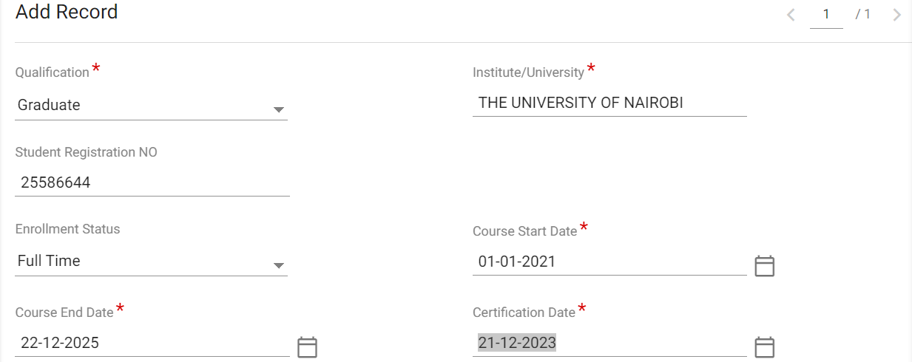

* Click on Save and Preview

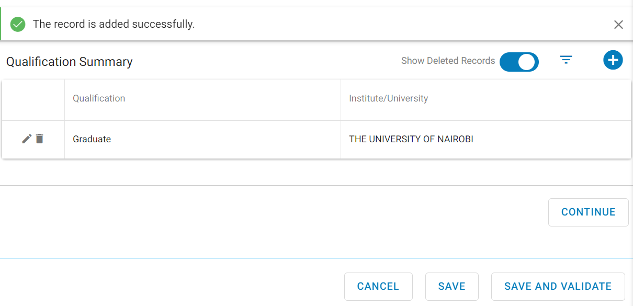

* Click on Continue
* Employment Details.

## Employment details

This option is used to record the employment details of the CIF entity such as designation, employment type, nature of income, payment mode and employment ID.This field is mandatory if the CIF entity is employed

* Click Add record on Employment Details Summary
* Select Employment Type
* Select Nature of Income
* Select Industry Type>Occupation>Employee ID.

If customer does not have an employment Id, input the identification number.

* Select Designation>Employer Name>Employer Phone Number
* Click save and Preview

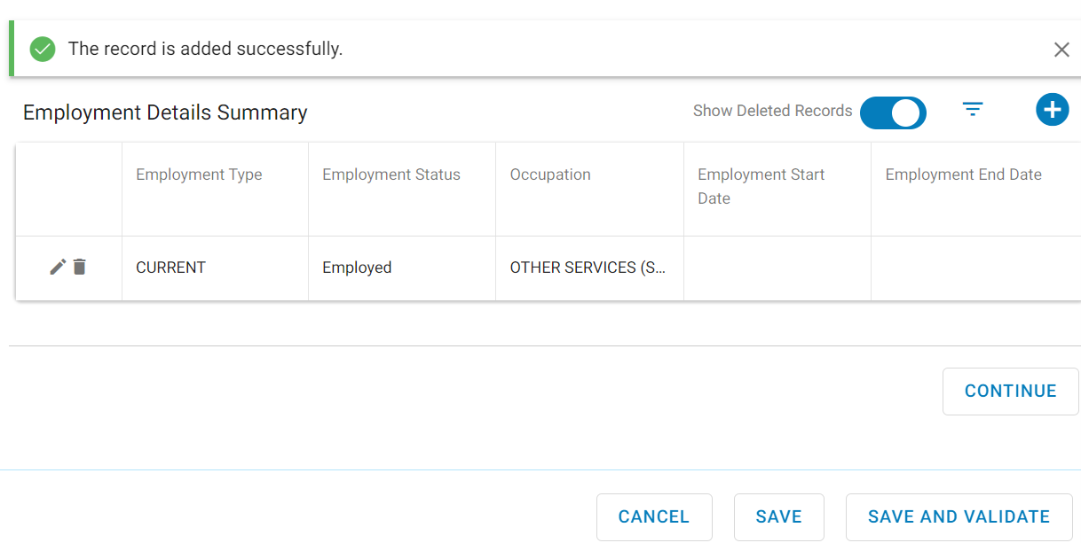

* Click on Continue> Reporting and References

## Reporting and References Details

This section is used to record details used for reporting purposes.

* Select Sector>Sub sector>CBK Sector>CBK Sub sector>
* Select affiliate to Bank. Affiliated is the case of subsidiaries to the bank such as Kingdom Securities Ltd, Jamii Bora Bank etc.
* Select Insider to bank. Insider is in the case of Director, CEO, Significant Shareholder.

If the customer is an insider, the insider role must be selected.

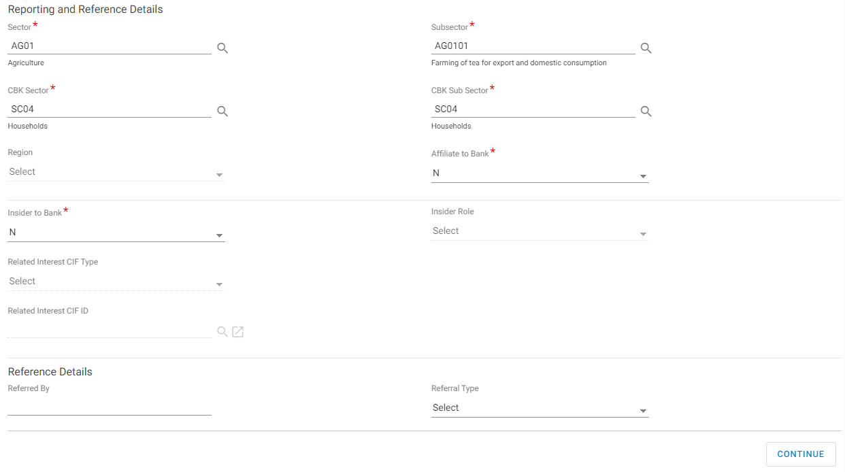

* Click on Continue> Bank Defined Details

# bank defined details

This is where details of the entity’s background are recorded. The Bank may require these details for many purposes like marketing, financial analysis and KYC compliance.

* Input Main Source of Funds>Tax ID if the KRA pin check was not successful>Tax Country

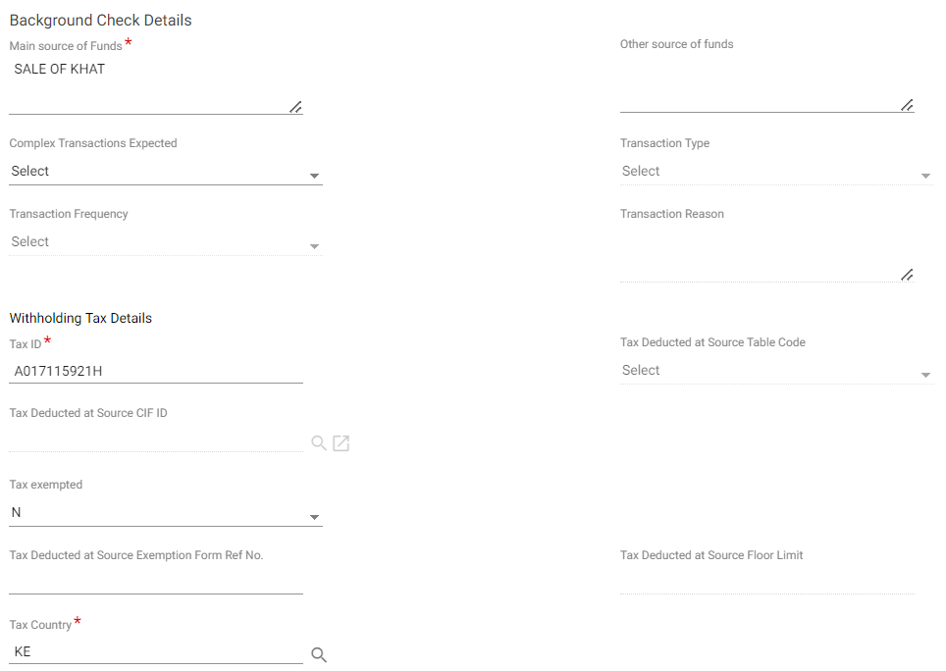

## Foreign Account Tax Details/FATCA

This section is used to record tax details for US locale only.

Fatca identification, requirement and process is covered in details on Fatca Identification Requirements and Process

Foreign A/c Tax reporting required field will be applicable for US citizen otherwise the default status will be N

For US citizen or US resident, Select Yes on the Foreign A/c Tax reporting

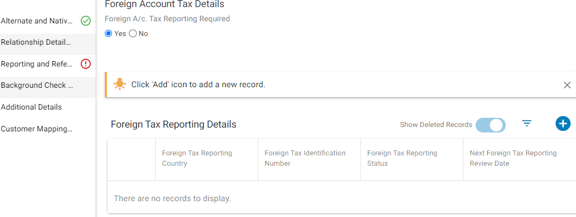

* Click the + button on Foreign Tax Reporting Details

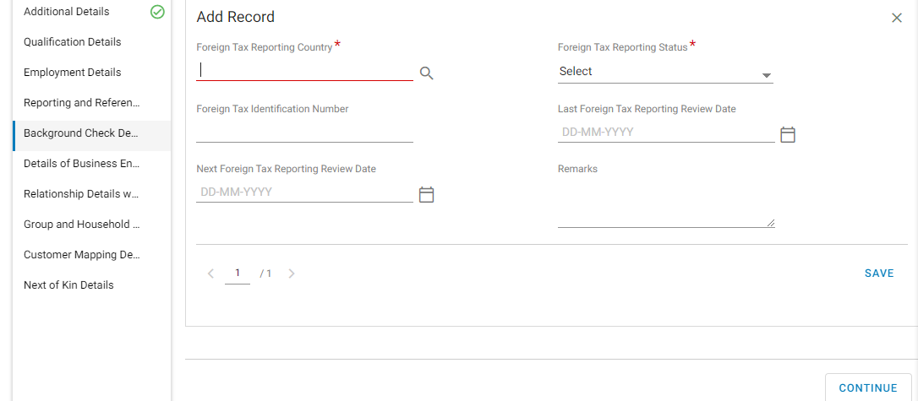

* Select the foreign tax reporting country
* Select Foreign Tax Reporting status
* Input Foreign Tax Identification Number
* Select the Last Foreign Tax Reporting Review Date
* Select the Next Foreign tax Reporting Review date
* Click on Save
* Click on Continue> Details of Business entities.

## Details of Business Entities

This section involves specifying details of businesses that the entity is involved in. If the entity is self-employed, the name of the business shall be specified with other relevant details such as Constitution or Business purpose.

* Select Constitution
* Select A/C used for business purpose as Y (YES)
* Input the Business Name>Input Business Start Date
* Input Business Operation Description
* Input Major Suppliers
* Select Industry List.

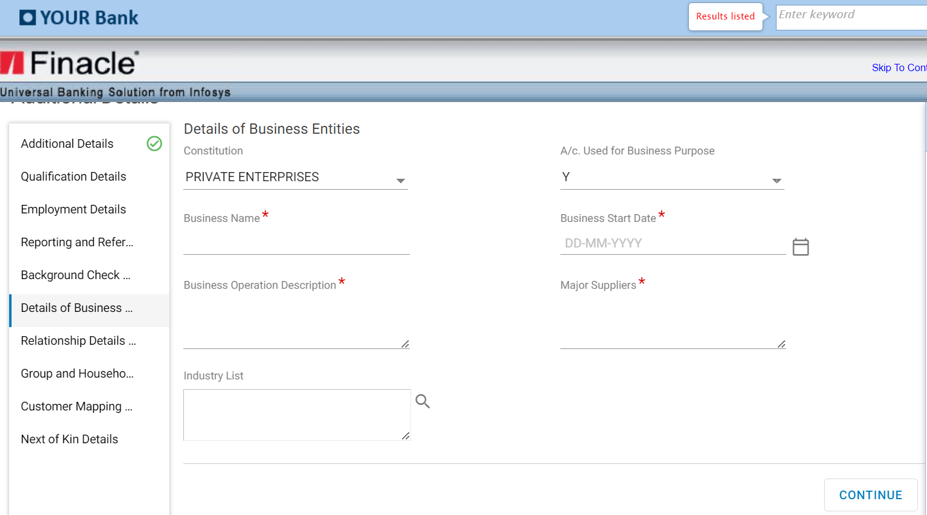

* Click on Continue>Relationship Details with other banks.

## Relationship Details with other banks

Banking specifics of an entity are recorded here. Multiple records on any existing bank accounts and credit card details.

* Click on the + button on Other bank details

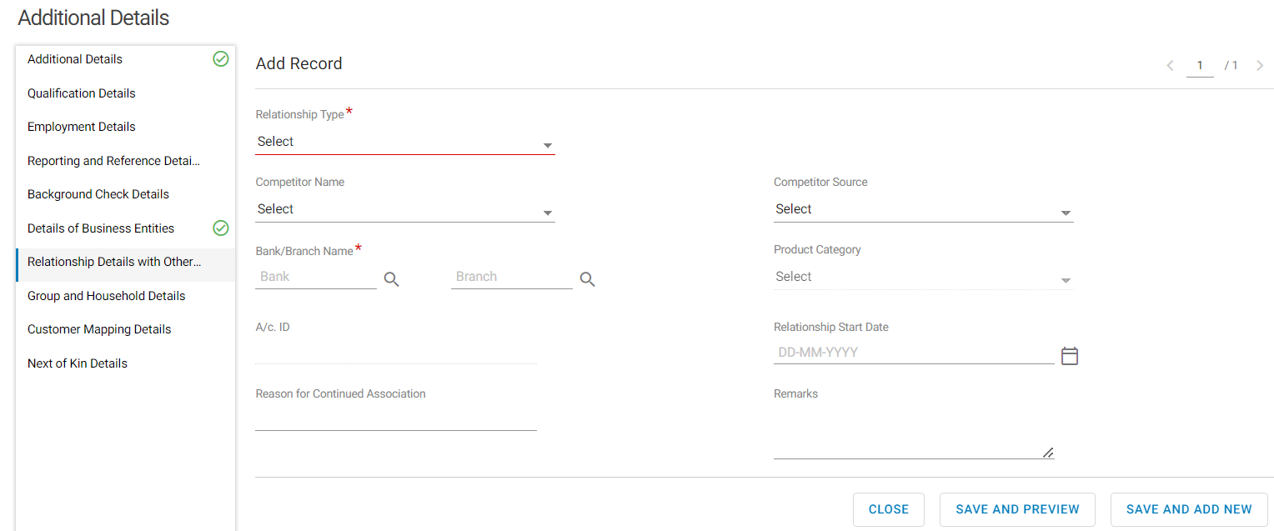

* Select Relationship Type>Input Bank/Branch Name>Click on Save and Preview
* Click on the + button on Credit card details

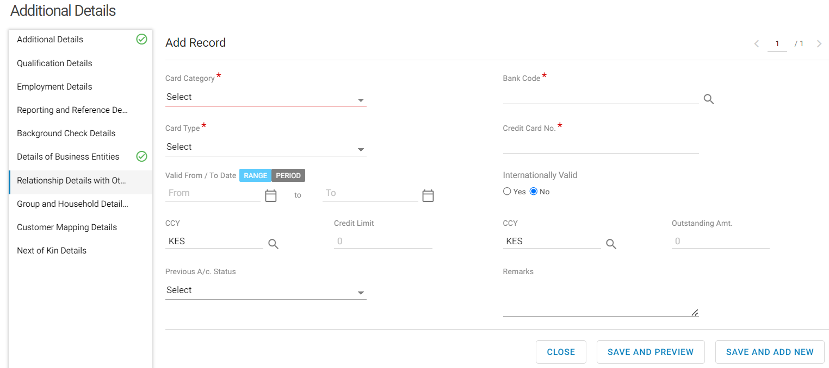

* Select Card Category>Bank Code>Card Type>Credit Card No
* Click on Save and Preview.
* Click on Continue> Group and Household Details

## Group and Household Details

This is a multi-record list that is used to link the entity to existing groups or households.

If the entity is operating as a partnership, limited company then the authorized signatory, corporate representative is linked to the parent group while if the entity is retail it is linked to household ID. The entity is therefore shown as a related party for the linked group.

* Click on the + button on Group and Household Details List
* Select the Linkage type as Household
* Select Household name
* Click on Save

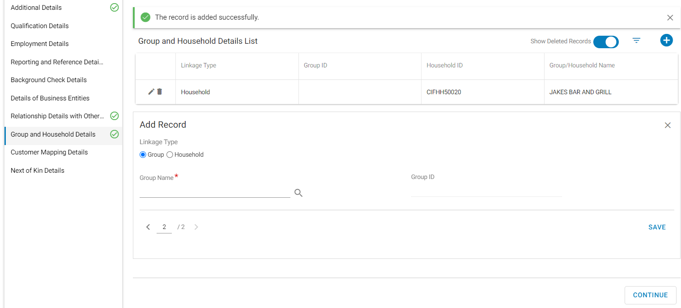

* Click on Continue> Customer Mapping Details

## Customer Mapping Details

Customer mapping is used to support backend systems. It is used to create the mapping information of the CIF on CRM application to have a wholistic view of the entity’s relationship. It also supports the purpose of uploading and downloading of data between backend systems and CRM system.

This section is not a mandatory field:

* Click Continue to move to the next section

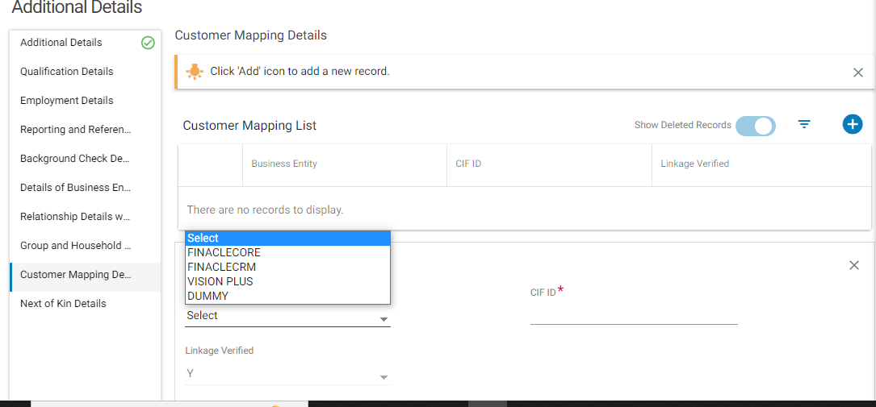

* Click on Continue> Next of Kin Details.

## Next of kin Details

This section is used to capture the details of next of kin and is not mandatory

For further guidelines on next of kin details, refer to section on ‘Customer Engagement Forms’-Critical Data Elements-removal of requirement for next of kin details

* Input Next of Kin Name>Next of Kin Identification No>Next of Kin Phone>Next of Kin Postal/Mailing Address>Next of Kin Email Address>Relationship With Next of Kin

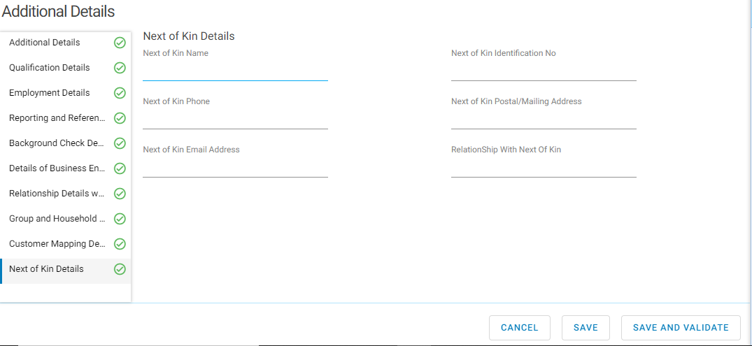

* Click on Save and Validate.

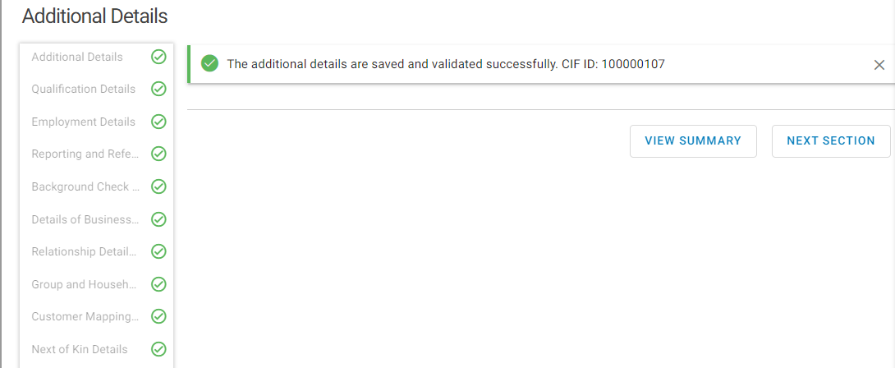

Additional details shall be successfully saved and validated.

* Click Next section. Bank Defined Details is the next section to enrich.

## Bank Defined Details

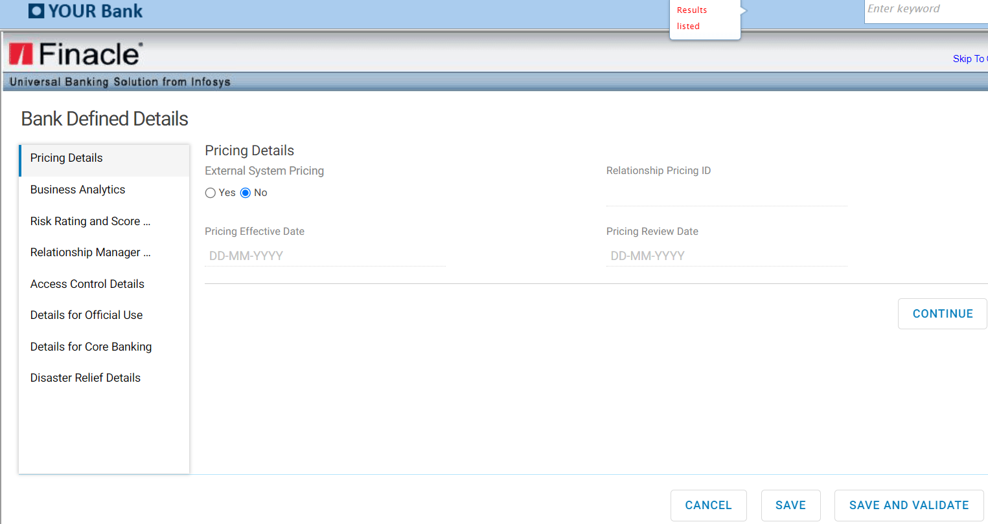

### Pricing Details

The different products offered by the bank that the entity chooses are recorded here. The External System Pricing shall always be **NO.**

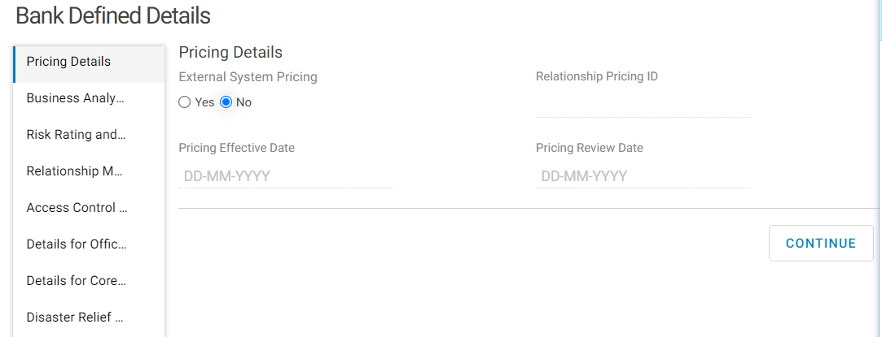

* Click on Continue to proceed to the next section, Business Analytics.

### Business Analytics

Details of any business analysis done on the customer’s profile are displayed here. This analysis is generally done by business intelligence tools deployed by the bank.

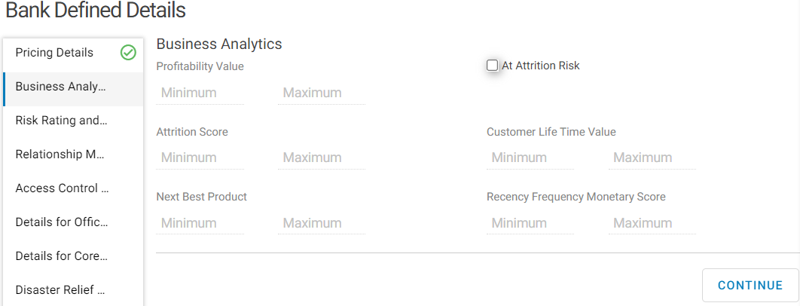

* Click on Continue >Risk Rating and Score Details

### Risk Rating and Score Details

Risk rating profile for the entity is created here. The risk profile helps the bank on making timely decisions on risk analysis and prevention, PEP management, prevent fraud incidences or make decisions on the different services or offerings an entity can take.

* Select Customer Rating
* Select PEP/PEP Associates as N for an entity that is not a Pep or a Pep associate
* Click on Continue

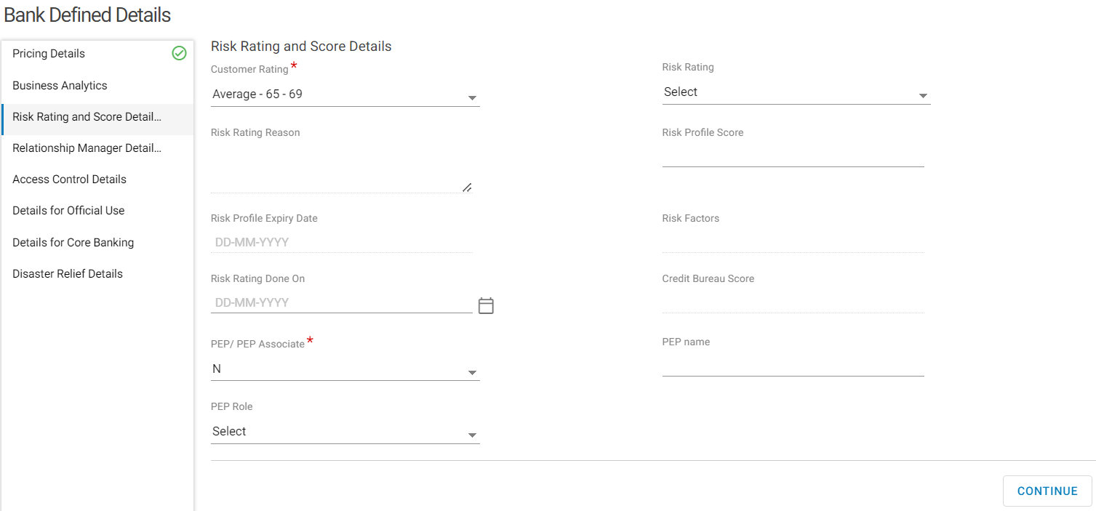

* Select PEP/PEP Associates as Y for an entity that is a Pep or a Pep associate
* Input the PEP Name
* Select the PEP Role

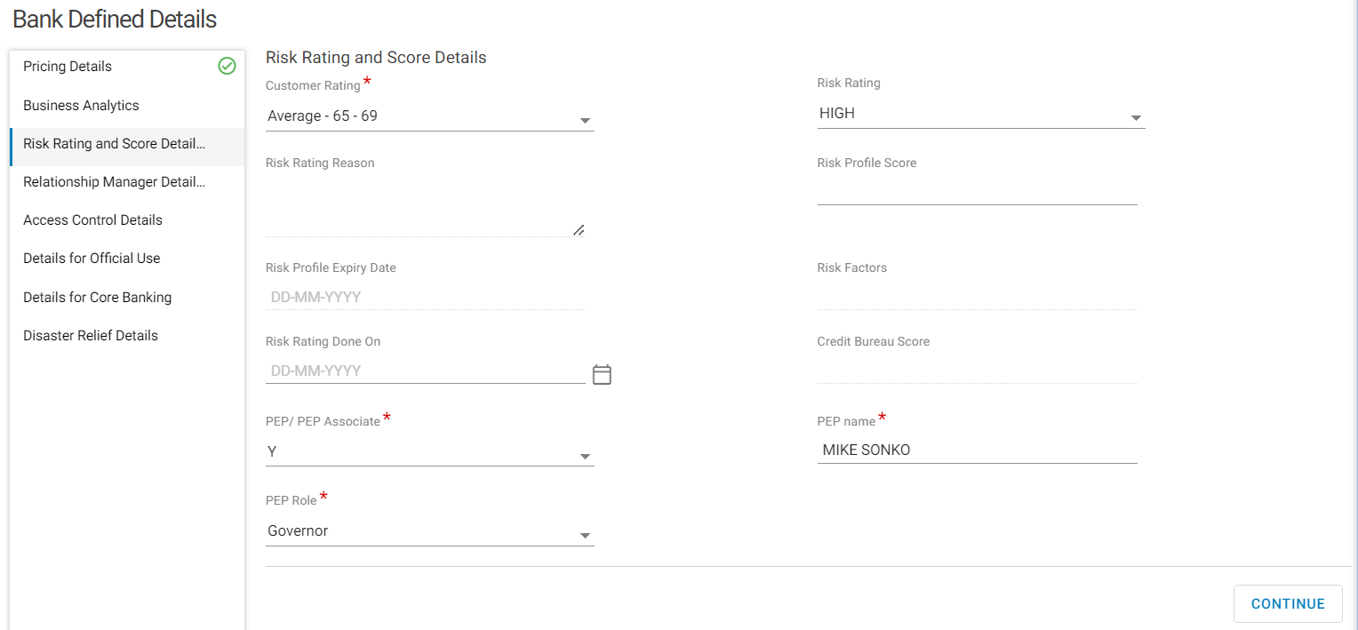

* Click on Continue> Relationship Manager Details

### Relationship Manager Details

The relationship managers managing the entity’s portfolio are recorded here.

The Primary Relationship Manager defaults to the one input on Other Details. Relationship Created By defaults to the user creating the CIF.

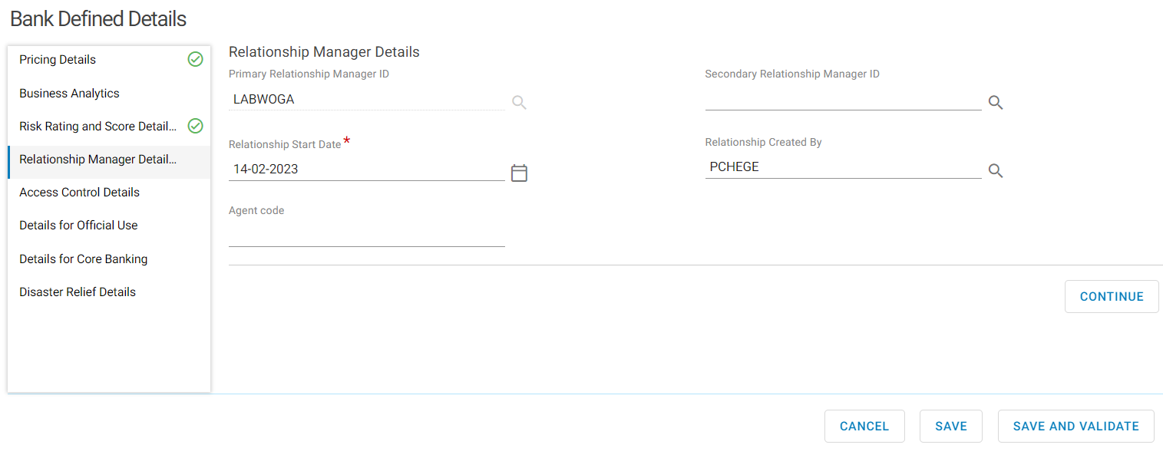

* Click on Continue>Access control Details

### Access Control Details

This section is used to feed Finacle CRM on which users shall be able to access the entity’s CIF. Only the users in the access control can access the entity’s CIF. Access Control has the following attributes.

* Access owner Group-This is Business group. The system defaults to General Banking
* Access Owner Segment-This is the Access Owner and Access Segment, and it defaults to Preferential Banking

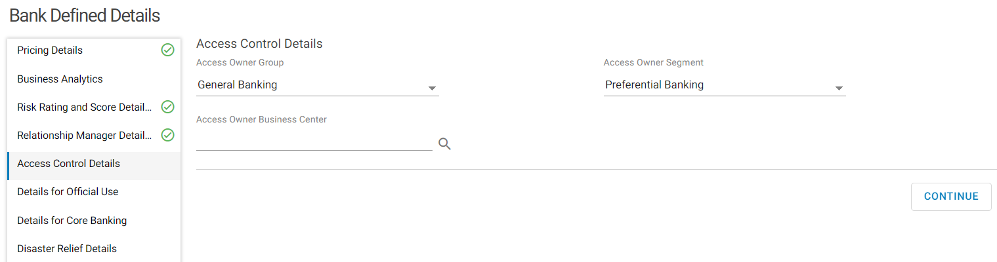

* Click on Continue> Official use.

## Details for Official Use

Details on occurrence of certain event are recorded here.

* Select INDIVIDUAL on Customer Type
* Select ACTIVE Status

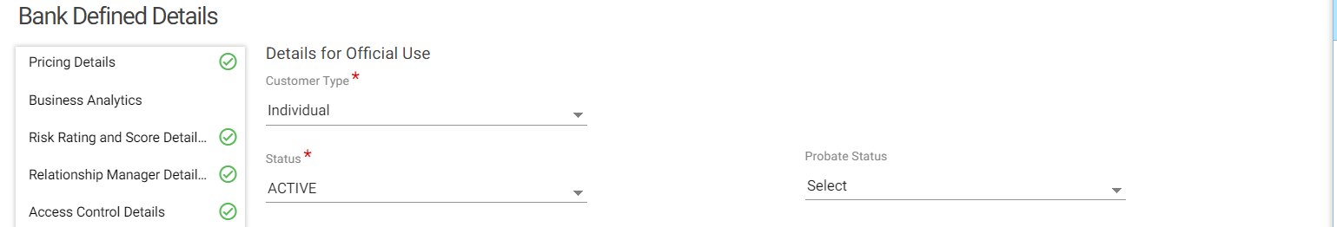

* Select Segment
* Select Secondary segment
* Select Classification

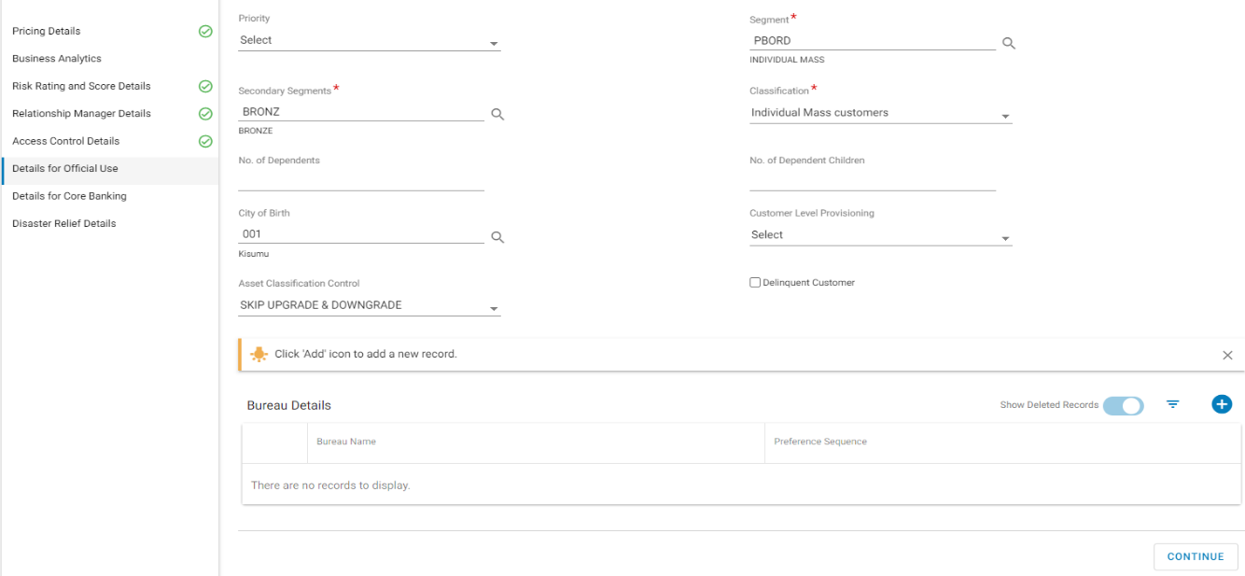

* Click on Continue> Details for Core banking

## Details for Core Banking

Details related to funds transfer through SWIFT, treasury services, bankruptcy application and trade finance services are recorded here.

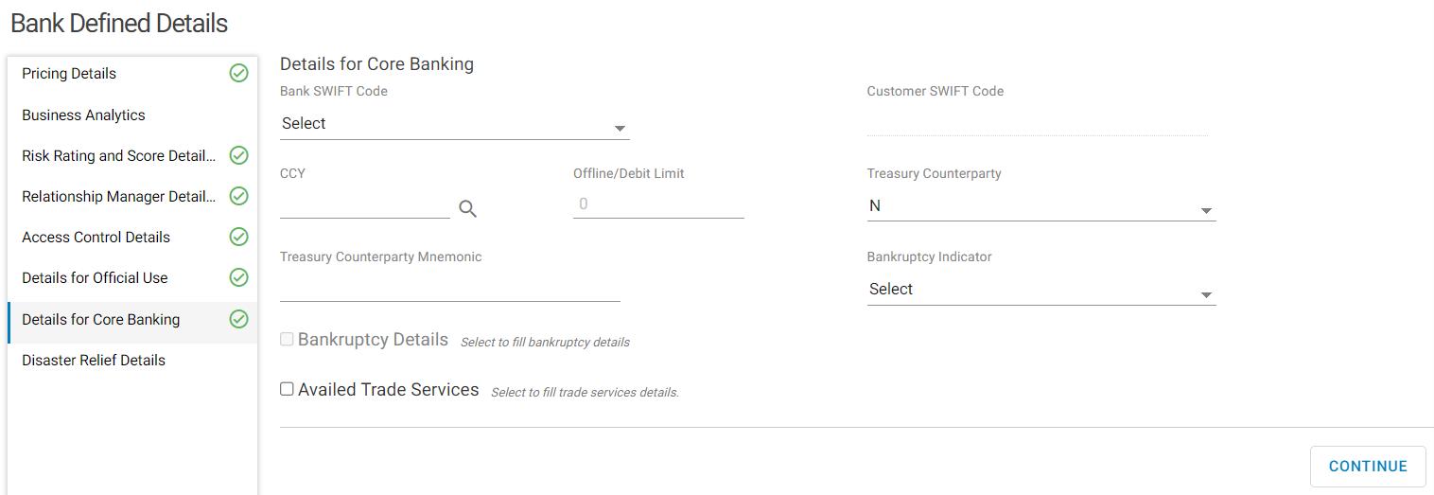

* Click Continue >Disaster Relief Details

## Disaster Relief Details

Details related to disaster relief program in which the customer maybe involved in are recorded here.

This is not a mandatory section.

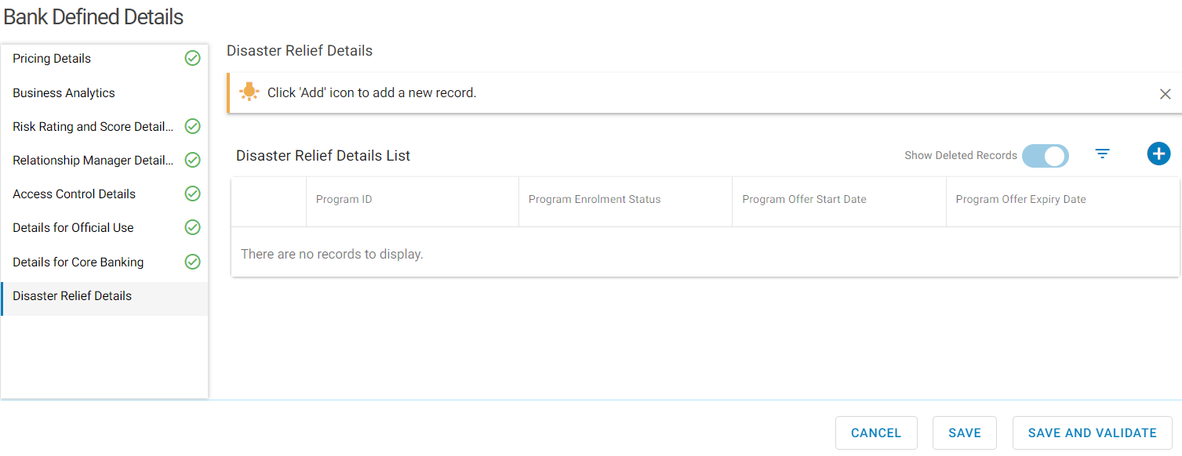

* Click on Save and Validate.

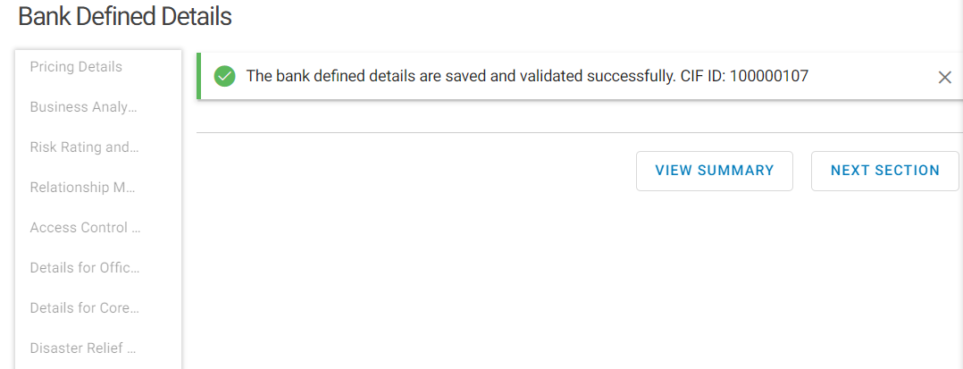

Bank Defined details shall be successfully saved and validated.

* Click Next section. Preference Details is the next section to enrich.

# Preference Details

This section records customer’s information on their preferences on social profile, bank services, product offerings and the mode of communication with the bank.

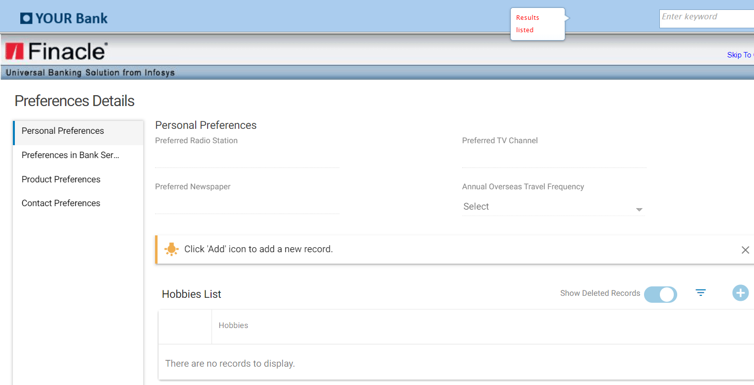

## Personal Preferences

This section records the selected traits of the new entity required in enhancing the customer’s experience with the bank.

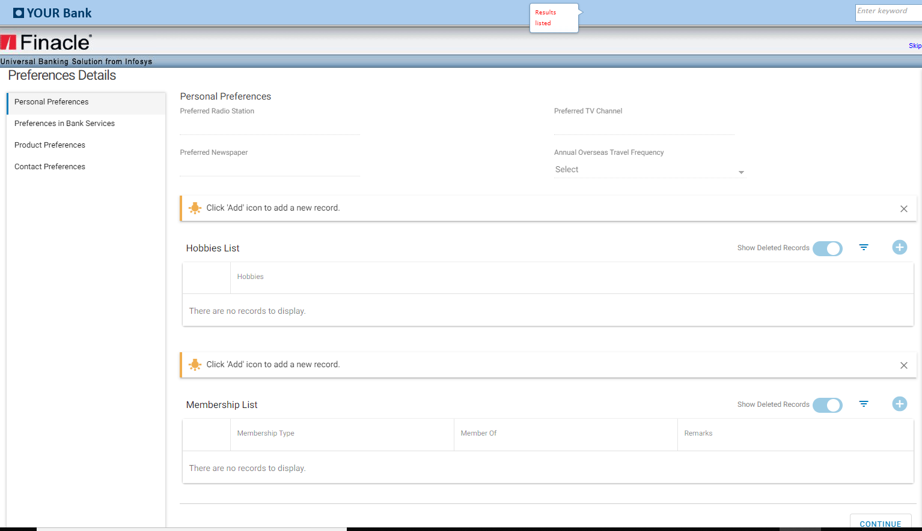

* Click on Continue>Preferences in Bank Services

## Preferences in Bank Services

Customer’s banking preferences like base currency, enable alerts and E-banking an alert management are recorded here.

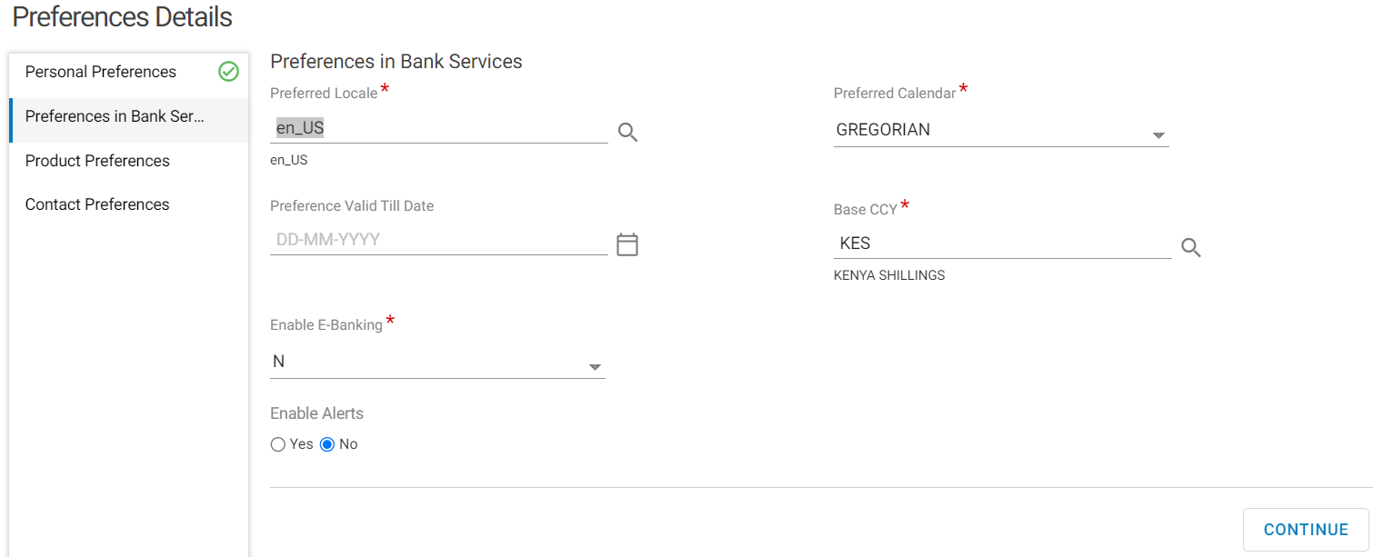

* Click on Continue >Product preferences

## Product Preferences

The range of bank products chosen by the customer are recorded here.

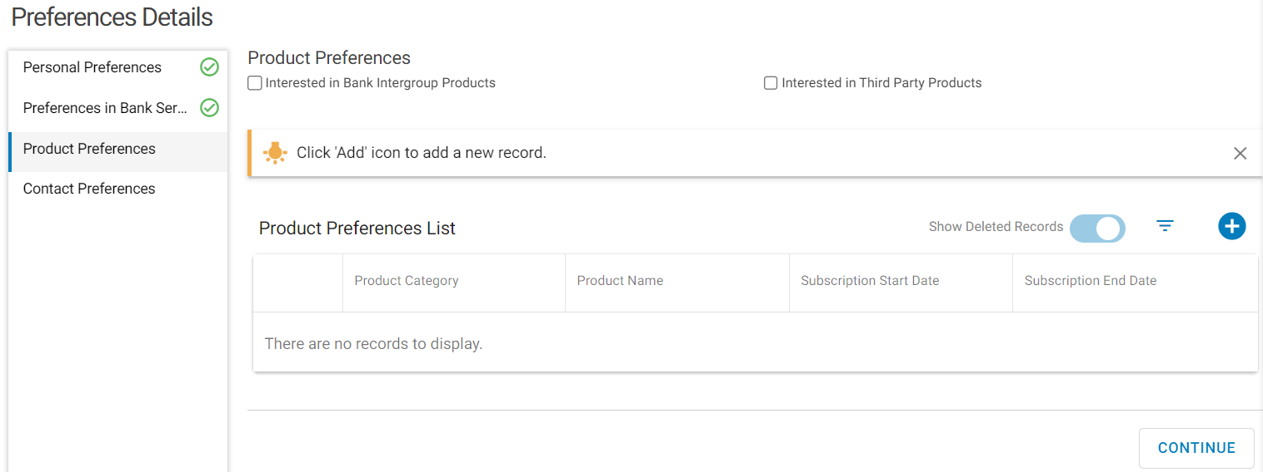

* Click Continue> Contact Preferences

## Contact Preferences

This is a multi-record list of how the customer prefers to be contacted by the bank for marketing purposes.

* Click on channel for communication searcher

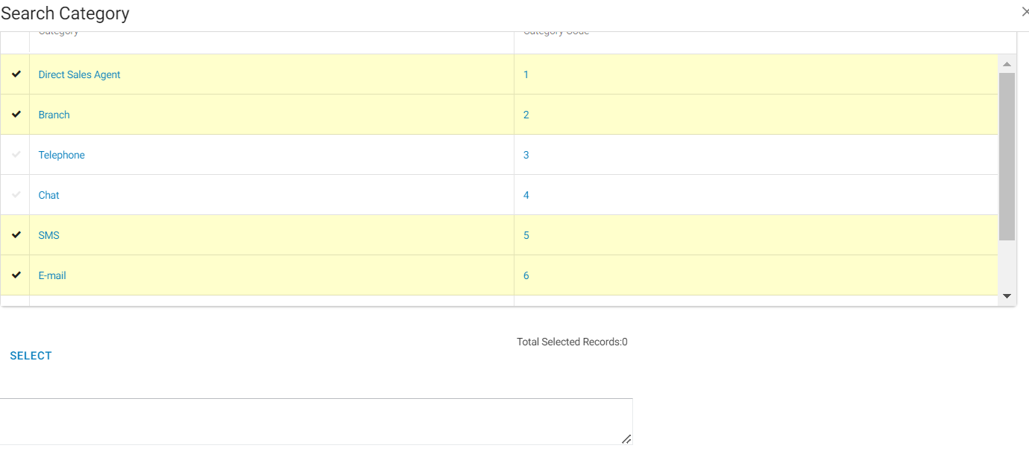

* Click on select

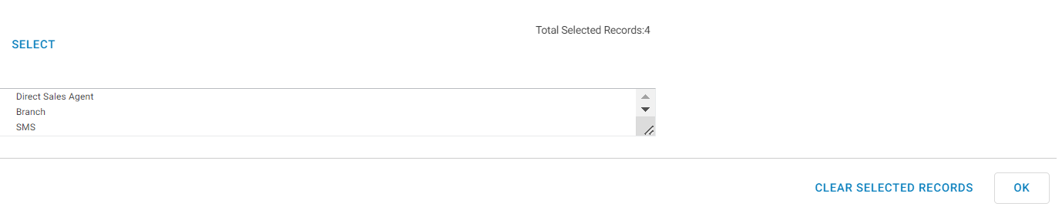

* Click OK and Input the Contact Person Name, Phone number and Email
* Select Yes (Y) on Contact for Marketing Purpose for customers who want to be contacted

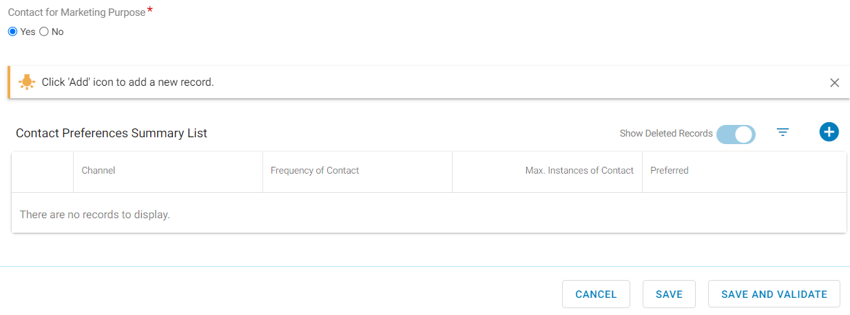

* Click on + button on contact preferences Summary List.
* Select the channel>Preferred as Y

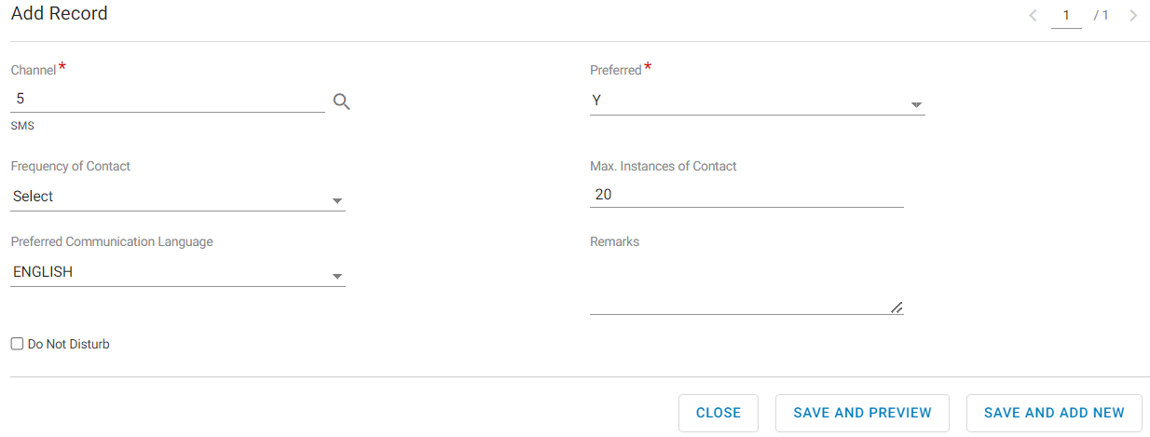

* Click on Save And Add New to add another channel. When adding another channel, the preferred field will be N.
* Click on Save and Preview once done adding the required channel/channels.

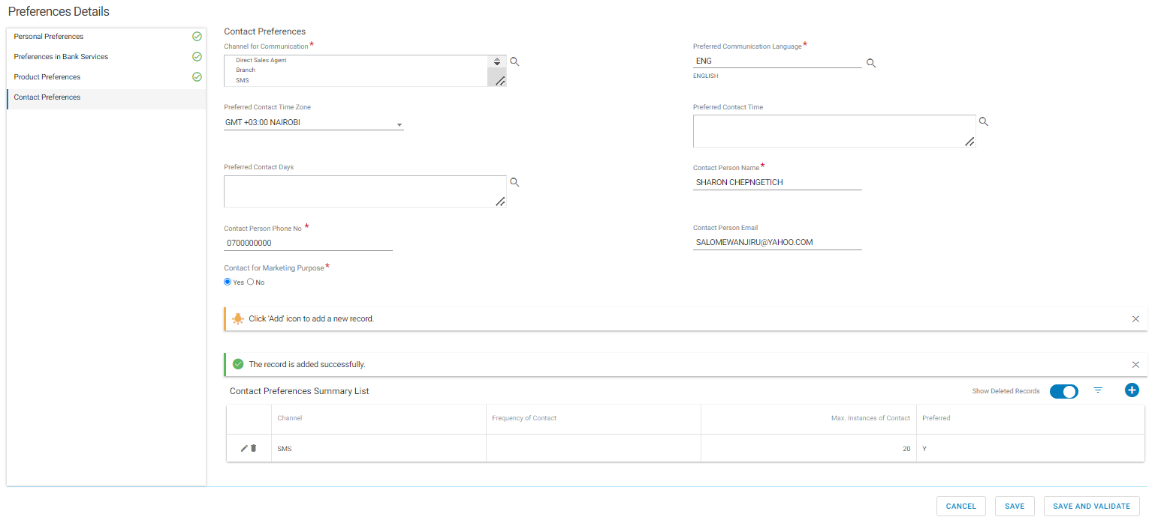

* Click on Save and Validate

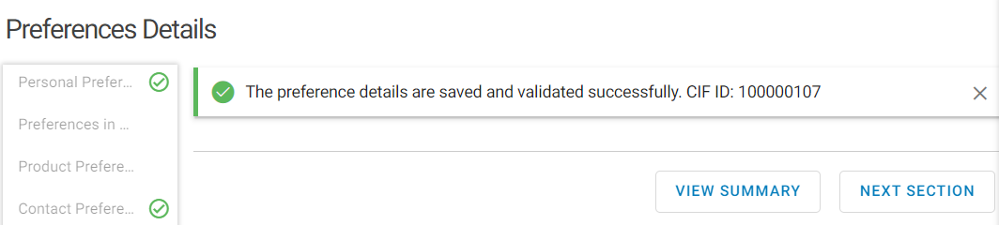

* Click on Next Section>Financial Details

# Financial Details

Details related to the entity’s assets, income and expenditure and the charge details of the entity are recorded here.

## Asset and Charge Details

Use this option to specify information about all assets owned by the entity. In addition, this sub-section helps to collect information on any charge, encumbrances, hypothecation or mortgage existing over an asset.

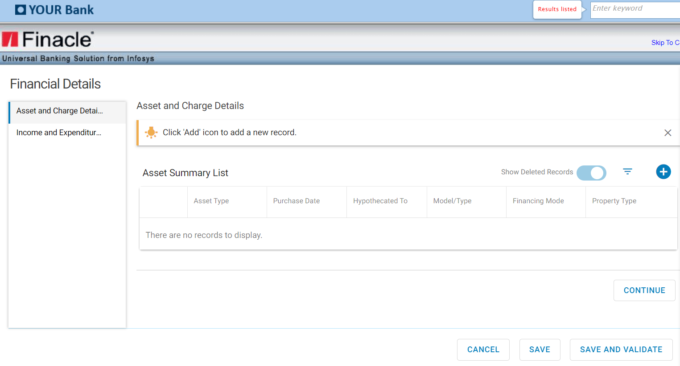

* Click on Continue

## Income and Expenditure Details

This option is used to include details on income generated from different sources and the expenses incurred for various purposes.

Select Income Range (monthly income range)

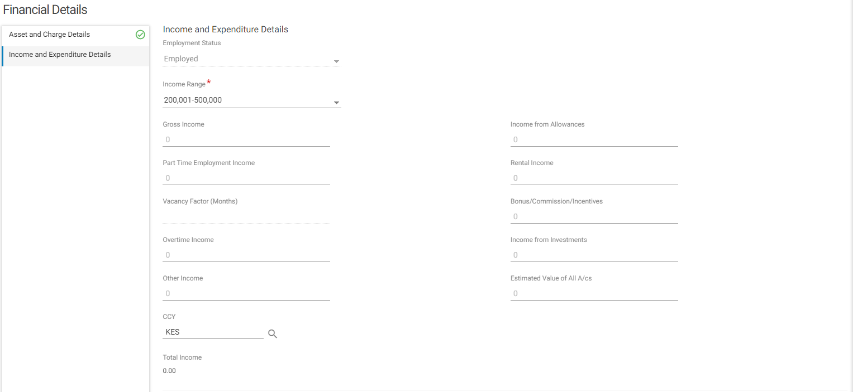

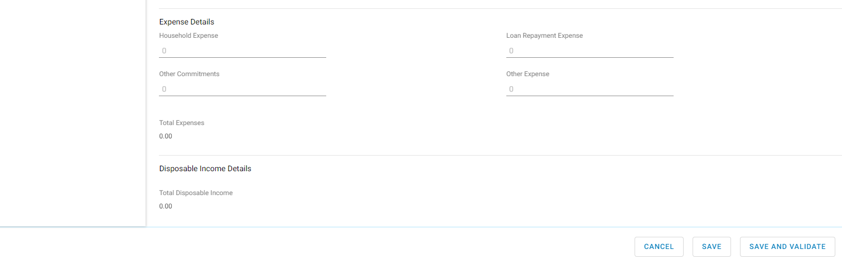

* Click on Save and Validate

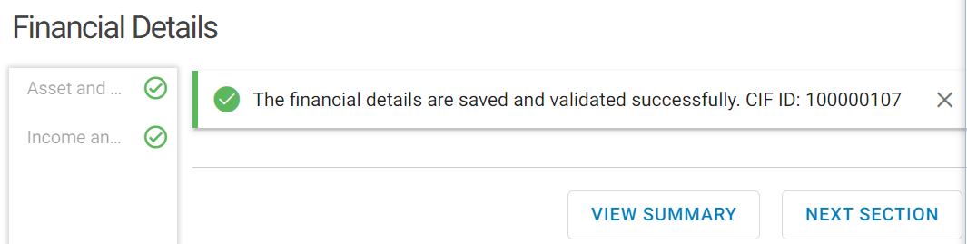

* Click on Next Section>Relationship Details

# RELATIONSHIP Details

Relation of the entity with other entities is captured on this section. This section has two important attributes.

## Social and Banking relationship List

This list displays the relationship under the categories Banking and Social. Joint Holder’s CIF, Parent or Guardian Details for Minor Accounts, will also appear as a relationship on Social and Banking Relationship List.

* Click on + button

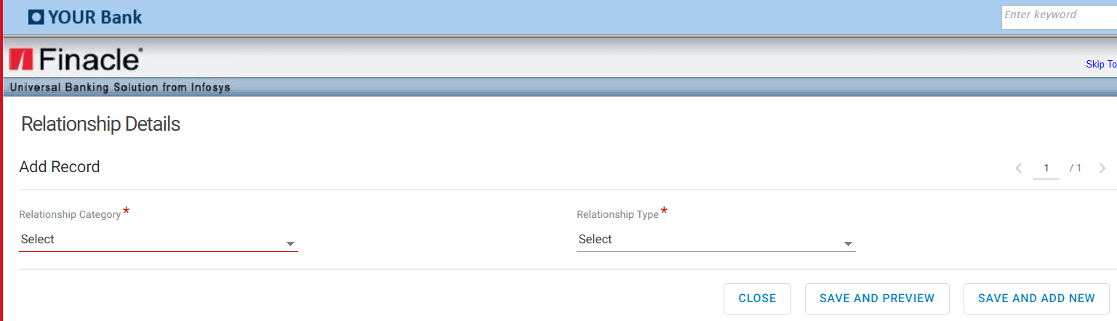

* Input Relationship category
* Input Relationship Type
* Click on Save and Add New to add a new record
* Click on Save and Preview after adding a record/records

## Corporate Relationship List

This list displays the details of Corporates to which the selected CIF is related to.

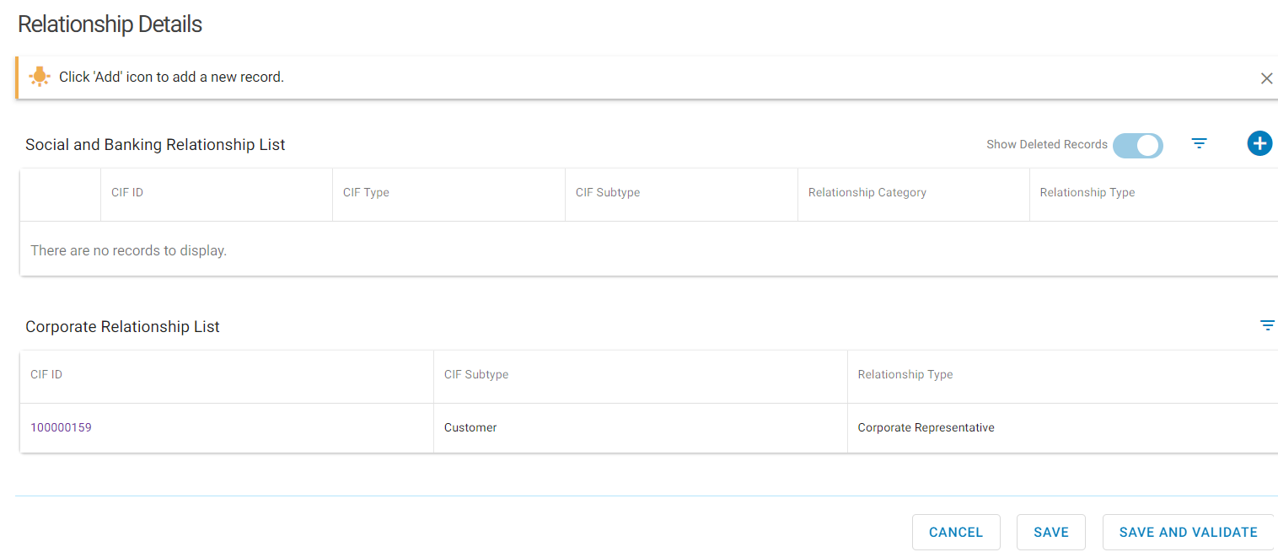

* Click on Save and Validate, to display the below screen

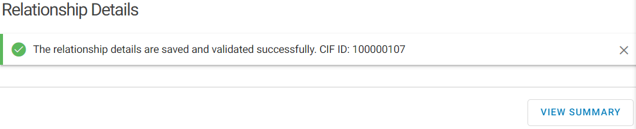

* Click on View Summary
* Confirm all the fields are validated.

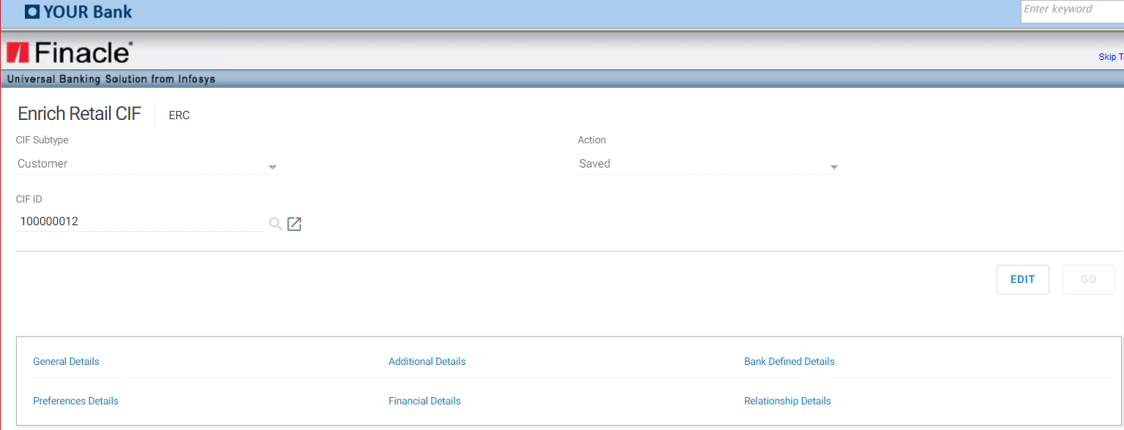

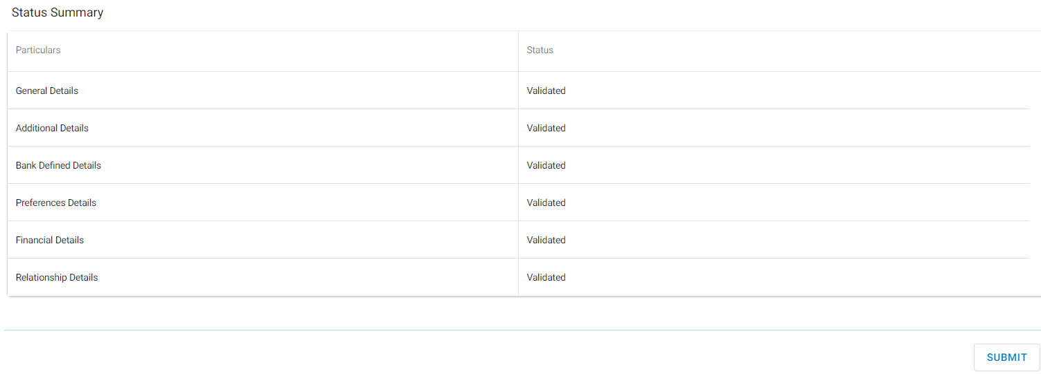

* Click on Submit to submit the CIF for approval

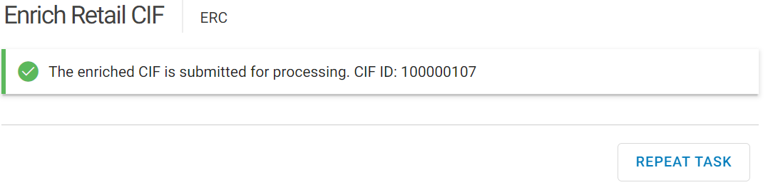

# Verifying Retail Customer INFORMATION File (CIF)



* Invoke RCCAT Menu> Select Retail CIF Type

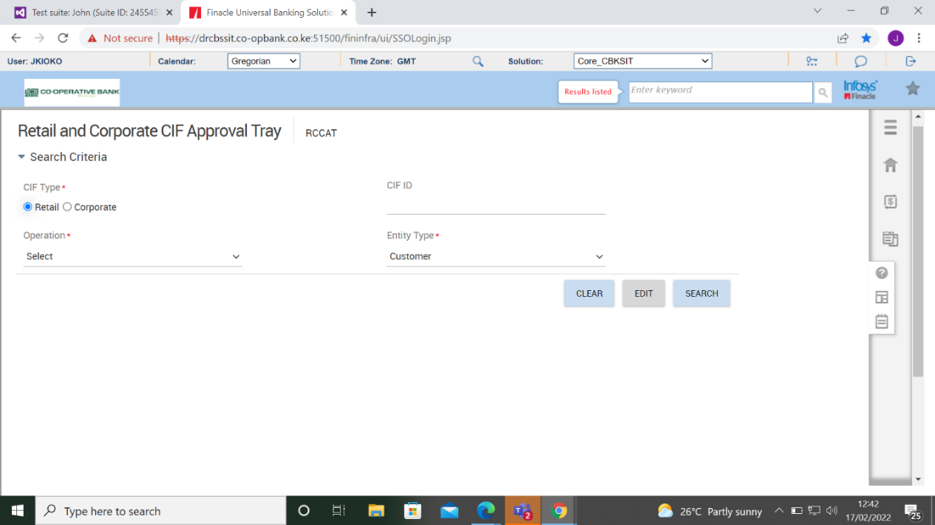

* Select Operation Approve the drop-down menu

The Entity Type defaults to Customer. Change to Contact, Non Customer or Prospect depending on the CIF subtype created.

* Click on Search.

All the Retail CIFs for the SOL awaiting approval will be displayed as shown below.

The tray will contain the following columns.

* CIF ID
* CIF SOL ID
* Customer Name
* CIF Sub Type
* Availability Reason- Created (new CIF),
* Edited(enriched CIF),
* Start Date,
* Maker ID-Assigned To-The approver user assigned to verify,

If blank then all the assigned approvers at the branch can verify.

* Action and Release-Used when the approver wants to free up the CIF to be worked on by another user.

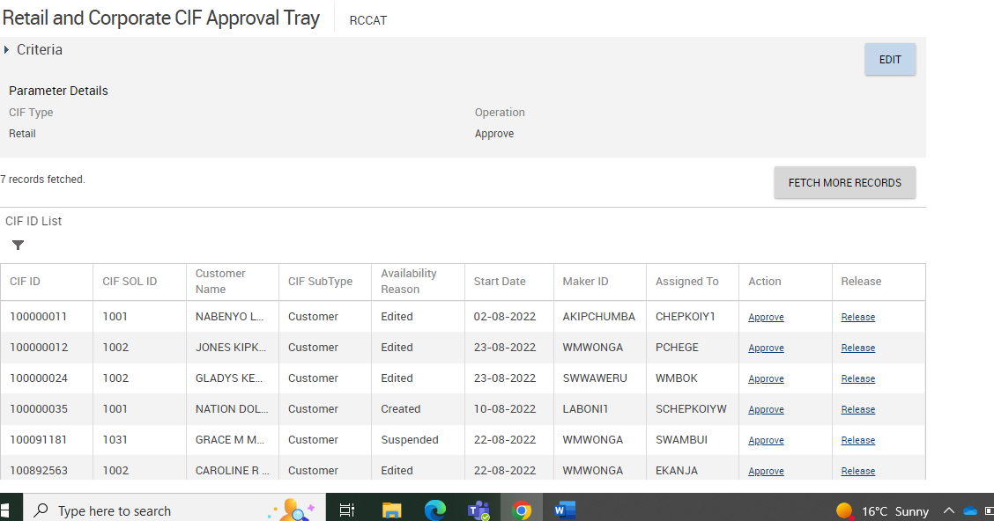

* Click on Approve on Action column for the desired CIF. The below screen will be displayed.

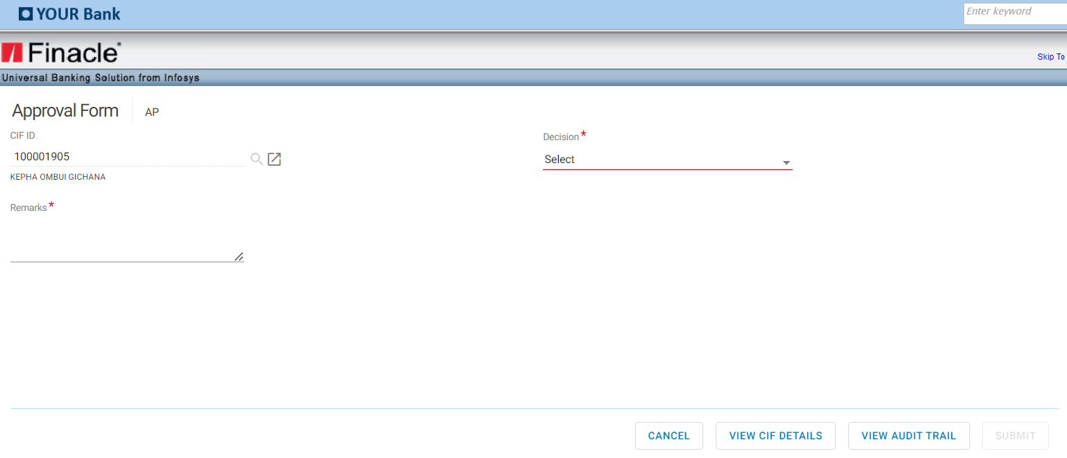

* Click on View Audit Trail

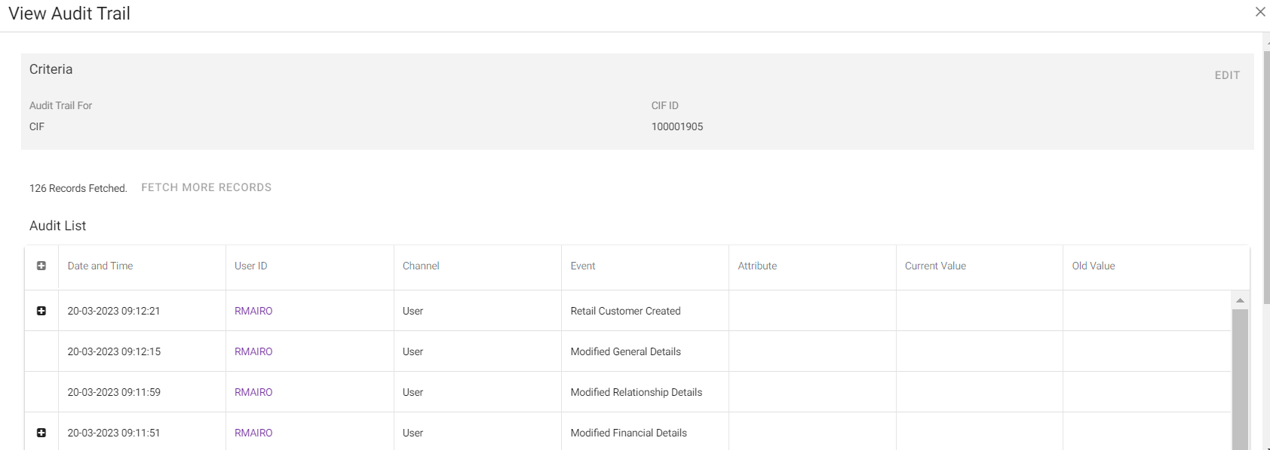

* Click on + button to view more details

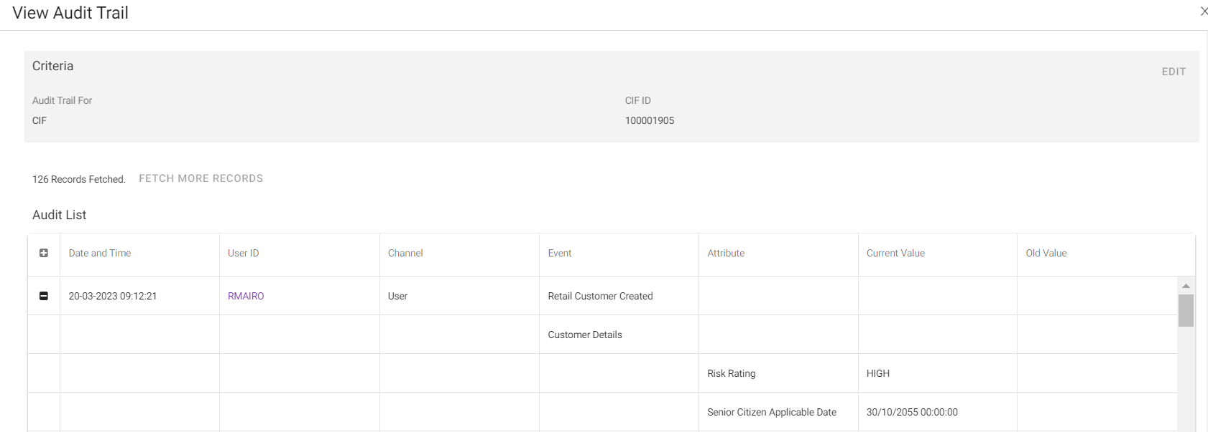

* Click on close after viewing

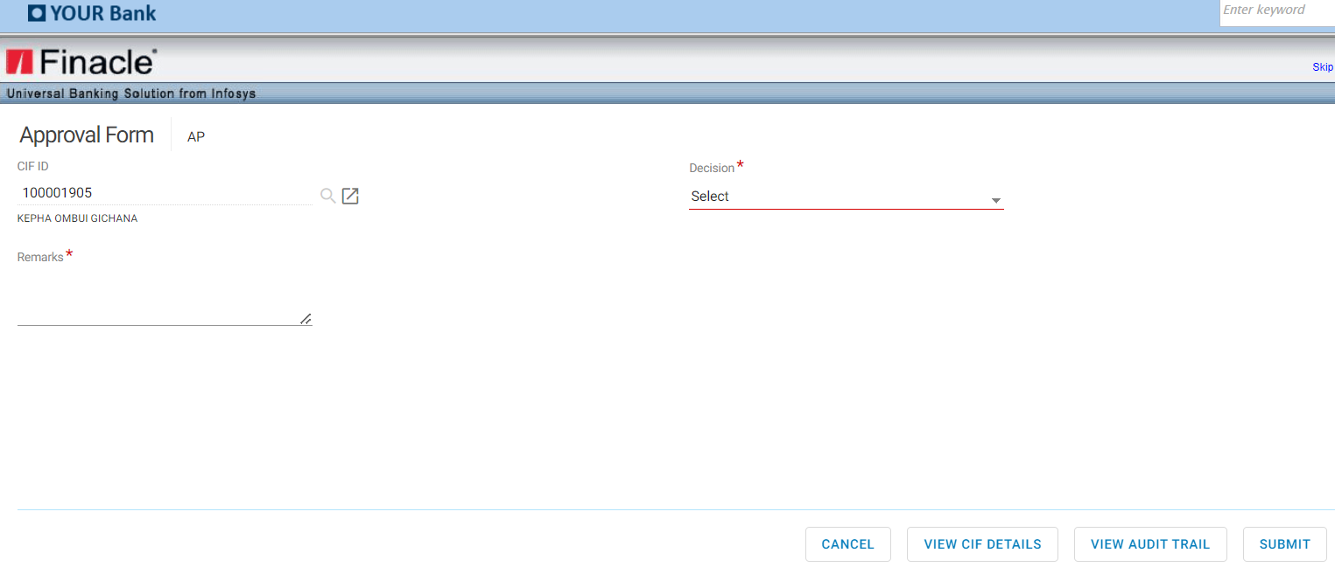

* Click on View CIF details >defaults to menu **IERC** Inquire on Retail CIF
* Click on all the tabs to view

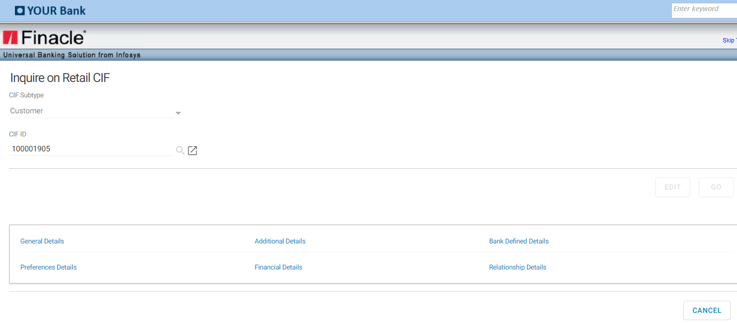

* Click cancel button
* Select on Decision from the drop down as Approve, Close, Rework.

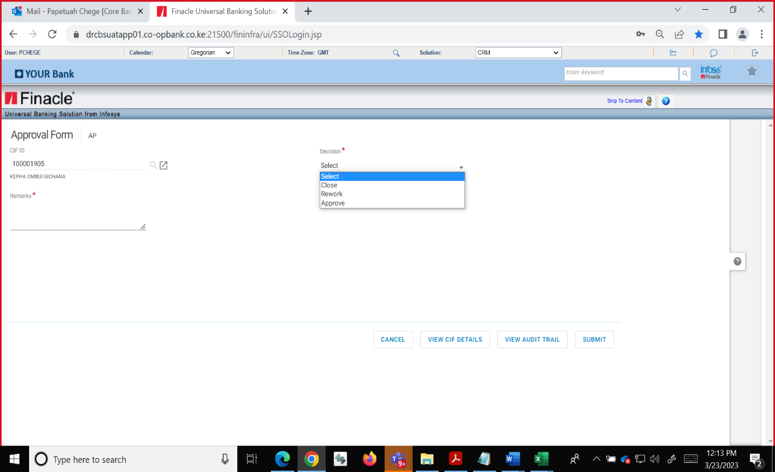

## Approve

If the checker is satisfied with all the details viewed, they can approve the created CIF.

* Select Approve on Decision
* Input Remarks

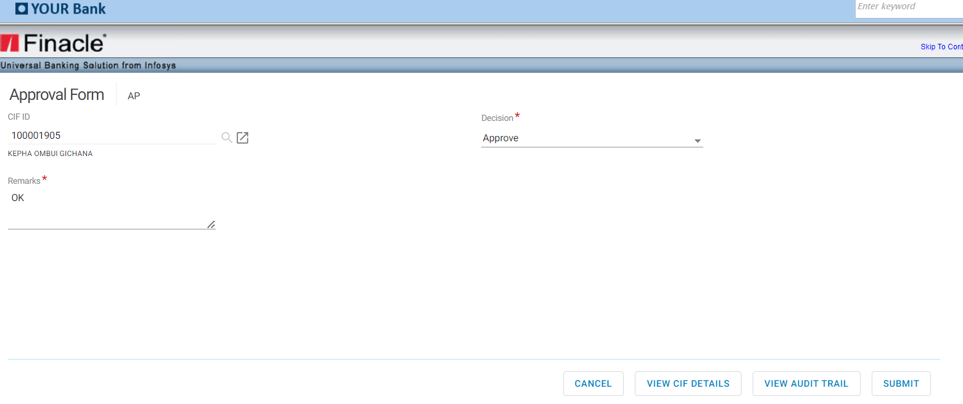

* Click on Submit button

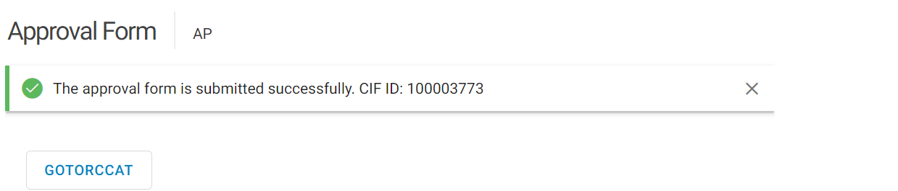

* The created retail CIF is approved successfully.

## Rework

When the checker has viewed all the details and is not satisfied with the data captured, they shall select this option to return to the maker for amendment.

* Select Rework on Decision
* Input Remarks-Reason for return.

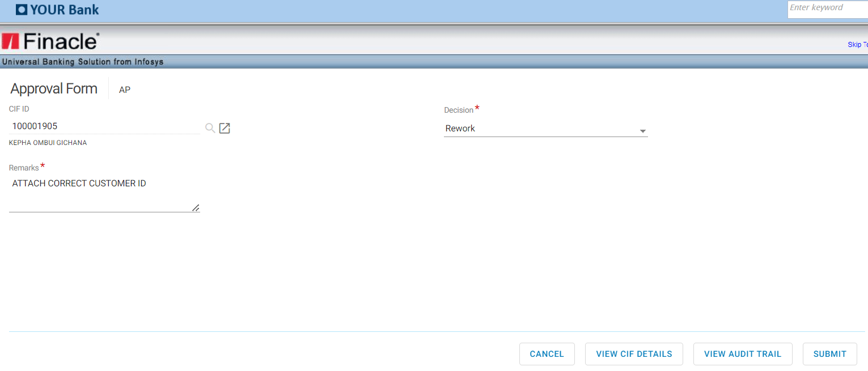

* Click on Submit

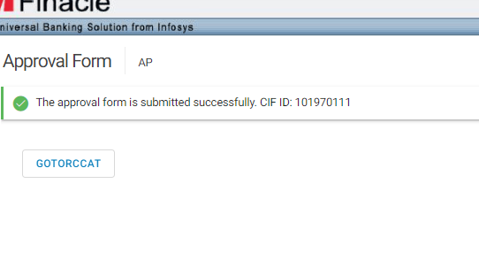

## Close

This option is used to delete the CIF from existence.

* Select Close on Decision
* Input Remarks-Reason for deleting

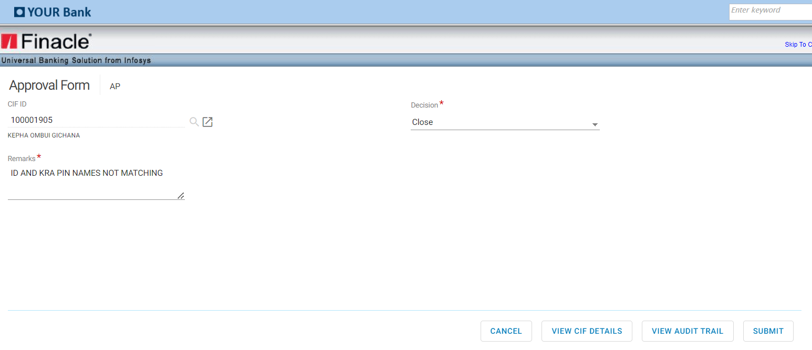

# Account Opening Individual Retail customer

The table below illustrates the account Opening process in Core (Note: Senior SDO is the Checker).



## Introduction

Accounts in Finacle are classified as either SBA (Savings Bank Account) or CAA (Current Account).

The scheme codes under SBA are:

|  |  |
| --- | --- |
| **SCHEME CODE** | **SCHEME DESCRIPTION** |
| CNRST | CONTRACT STAFF SALARY ACCOUNT |
| CPSAL | CO-OP SALARY ACCESS |
| DIMIN | DIASPORA MINOR |
| DITRA | JAMHURI TRANSACTIONAL |
| EPTRA | EXECUTIVE PLUS TRANSACTIONAL |
| ERTRA | EXECUTIVE TRANSACTIONAL A/C |
| GETRA | TRANSACTIONAL (BODAA, CLUB SPECIAL, FREE EDUCATION, SAVINGS ACCOUNT-BANK) |
| GLTRA | GOLDFISH |
| HATRA | HABA NA HABA |
| INSTR | INSTANT ACCESS MIN BAL |
| MINOR | JUMBO JUNIOR |
| SAVGS | HEKIMA SAVINGS |
| SSTRA | SOCIAL SERVICES |
| STTRA | STAFF ACCESS |
| YETRA | YEA ACCOUNT |

The scheme codes under CAA are:

|  |  |
| --- | --- |
| **SCHEME CODE** | **SCHEME DESCRIPTION** |
| AGSTL | AGENT SETTLEMENT |
| CBRNZ | MSME BRONZE |
| CCHWR | CHEQUE WRITING |
| CEXEP | EXECUTIVE PLUS C/A |
| CEXER | EXECUTIVE CURRENT ACCOUNT |
| CGOLD | MSME GOLD |
| CSILV | MSME SILVER |
| CURNT | CUSTOMER SETTLEMENT |
| CUSTL | EX-STAFF CURRENT ACCOUNT |
| EXSTC | CUSTOMER SETTLEMENT |
| LARIB | LARIBA |
| SASTL | SACCO SETTLEMENT |
| STCUR | STAFF CURRENT |

## Account Opening Menus

Service Desk Officer (SDO) shall invoke account opening menus as follows:

* Savings Account opening – Open Savings Account (OSA)
* Current Accounts opening- Open Current Account (OCA)

## Opening a Retail Account

SDO shall invoke account opening Menu as per (Ref 16.2) and input a Valid enriched CIF ID on the CIF ID field.

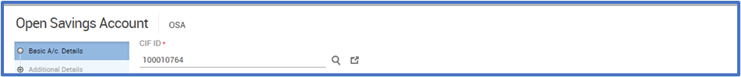



* Select the scheme code from the searcher

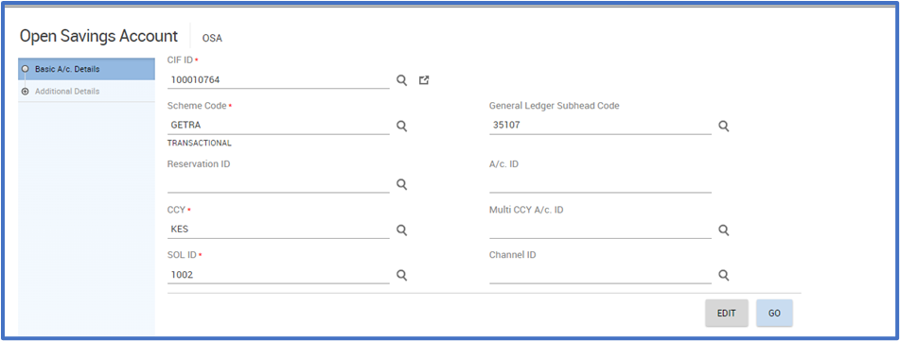

* Select the currency. It defaults to KES and can be amended
* Click Go button
* Select the following fields appropriately
  + Statement frequency,
  + Dispatch Mode

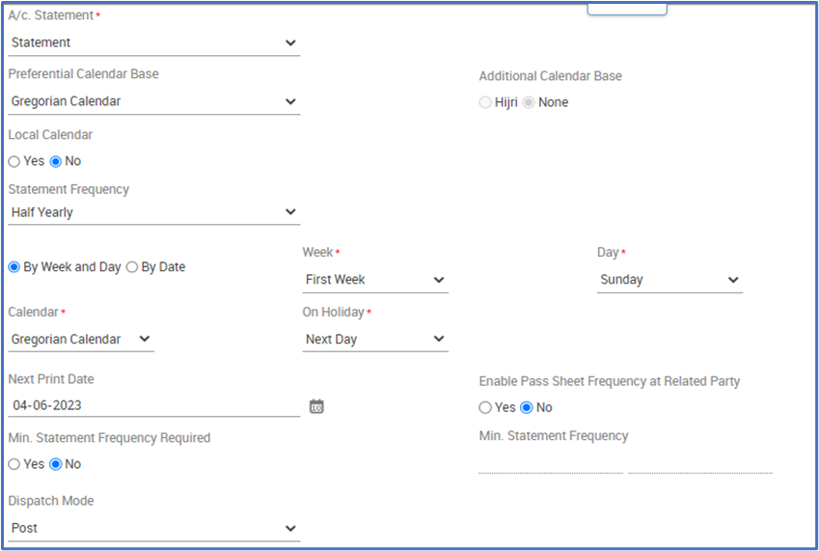

* + Alert Registration Required * if yes select alert type (Credit , Debit or Both)
  + Premium Banking A/c for executive banking services

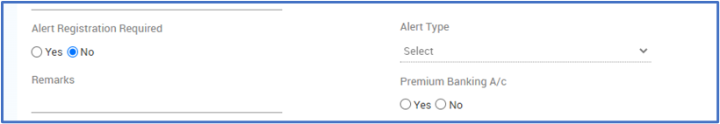

* + Channel Registration (Omni Retail, Mobile Banking or Both)

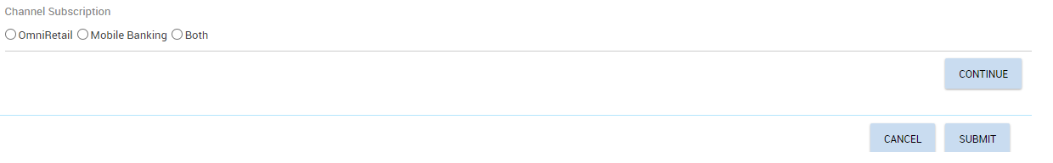

* Click On Continue Button> Additional Details

## Additional Details

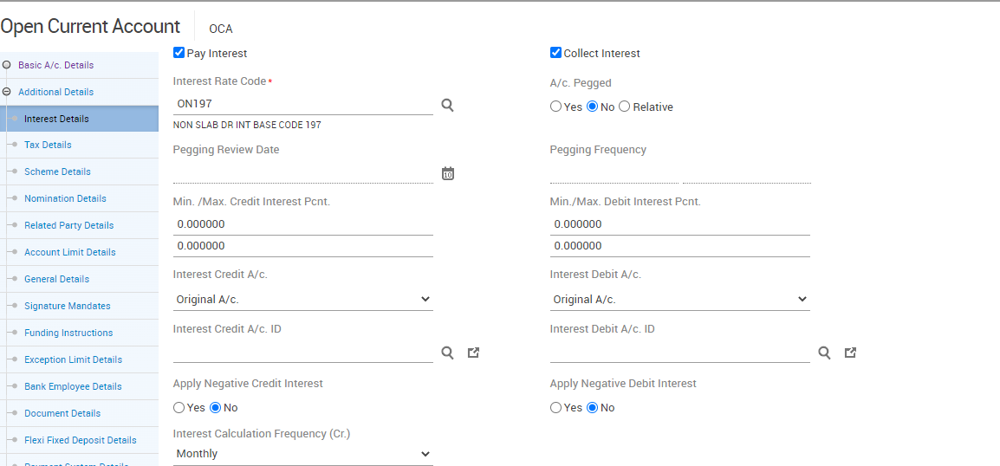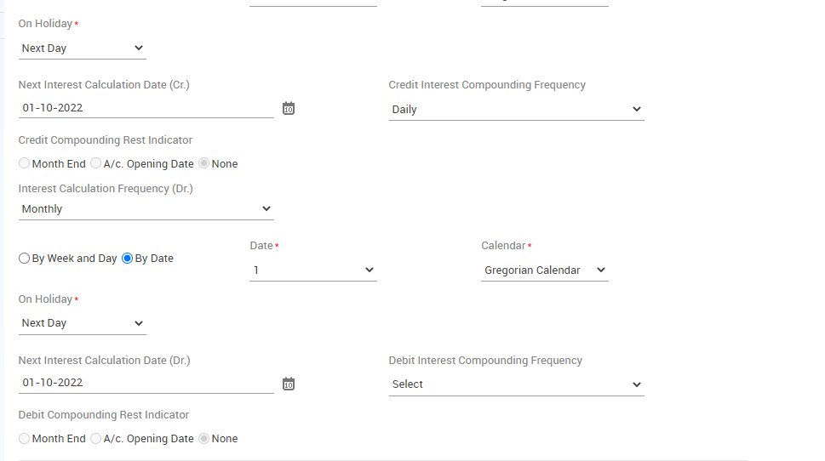

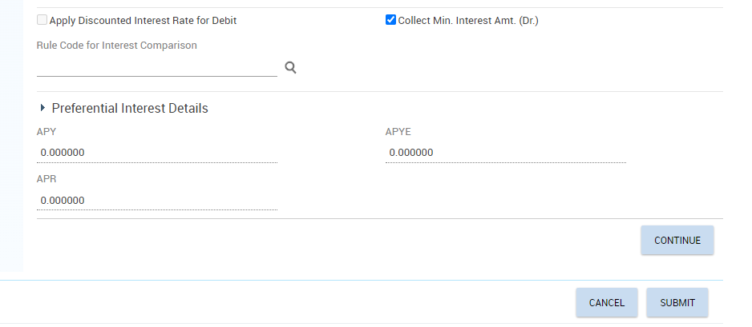

**Interest Details page (Not mandatory)**

This field is default, populated with the value specified at scheme level. Specifies information (all interest and tax related parameters information) in the Interest Details.

**Pay Interest** - This field indicates if interest must be paid to the account. The valid values are: Yes or No.

**Collect Interest** - This field indicates if interest must be collected from the account. The valid values are: Yes or No.

**Credit Interest % min. /max**. - This field indicates the minimum and maximum interest percent payable to the account.

**Allow Negative Credit Interest** field would determine whether negative interest will be applied for account or not. The default percolation would happen from scheme level. If Allow Negative Credit Interest is yes at the scheme level, then P&L Placeholder and Negative Payable Placeholder exist at the scheme level.

**If “Allow Negative Credit Interest” indicator is Yes** at scheme level and changed to No at A/c. level or vice versa, Default parameter overridden exception is shown to user.

**Debit Interest % min. / max**. - This field indicates the minimum and maximum interest percent to be collected from the account.

**Customer Preferential Interest (Cr)** - This field indicates the preferential interest (positive percent) set at the customer level which is applicable to the account. The value is defaulted from the value set at CIF level.

**Customer Preferential Interest (DR)** - This field indicates the preferential interest (negative percent) set at the customer level which is applicable to the account.

**A/c Preferential Interest (Cr) -** This field indicates the preferential interest (positive percent) set at the account level which is applicable to the account. This field will be hidden for the accounts opened under negotiated interest type of product.

**A/c Preferential Interest (Dr) -** This field indicates the preferential interest (negative percent) set at the account level which is applicable to the account. This field will be hidden for the accounts opened under negotiated interest type of product.

**Interest Credit A/c.** - This field indicates the account to which interest rate must be credited. The valid values are: Operative account, original account and Payment system.

**Interest Debit A/c.** - This field indicates the account to which interest rate must be debited. The valid values are: O - Operative account, S - Original account and T - Payment system.

**Interest Debit A/c ID -** This field indicates the ID of the account to which interest must be Debited. The system allows you to specify the Int. Dr. A/c ID whose currency is different from the account currency.

**Interest Credit A/c ID -** This field indicates the ID of the account to which interest must be credited. The system allows you to specify the Int Cr. A/c ID whose currency is different from the account currency.

**Interest Rate Code -** This field indicates the code of the interest rate table to be used for calculation of interest. This field is default populated with the value specified at scheme level. This can be modified. This field will be hidden for the accounts opened under negotiated interest type of product.

**Account Pegged –** This field indicates if the interest rate applicable to the account must be pegged to the account and be kept constant for a specific period. The valid values are: Yes and No. Any change in the interest rate is not applicable to those accounts for which the value of the field account pegged is set as Yes and for which a pegging frequency is specified. All such accounts must be reviewed on the review date else the interest calculation would not go through for these accounts. This field will be hidden for the accounts opened under negotiated interest type of product.

**Pegging Review Date -** This field indicates the date until which the account is pegged. Finacle automatically reviews the pegged interest rate for the account on this date. This field will be hidden for the accounts opened under negotiated interest type of product.

**Pegging Frequency –** This field indicates the frequency in months and days for pegging interest rate to the account. This field will be hidden for the accounts opened under negotiated interest type of product. This field will be hidden for the accounts opened under negotiated interest type of product.

**Interest Calculation Frequency Credit -** This field represents the frequency at which the interest must be calculated. The value in this field is default populated from the scheme level. This can be modified.

**Next interest calculation date (Cr)** - This field indicates the next interest calculation date.

**Interest Calculation Frequency (Dr) -** This represents the frequency at which the interest must be calculated. The value in this field is default populated from the scheme level. This can be modified.

**Next Interest Calculation Date (Dr) -** This field indicates the next interest calculation date.

**Interest Compounding Frequency (Dr) -** This indicates the frequency at which the debit interest must be compounded. For example, it could be ‘Daily’.

**Credit Compounding Rest Indicator -** This indicates the compounding rest used for compounding the interest.

**Apply Discounted Interest Rate (Dr) -** This field indicates whether discounted interest rate must be applied for calculating the interest. This field is applicable to loan accounts when the bank wishes to recover interest upfront during disbursement of the loan. The bank also pays interest on a deposit account at discounted rate of interest instead of the contracted rate if the interest is paid before the specified interest flow date. The bank applies a discounting factor to the original interest if the customer requests payment of interest before the normal interest payable date.

* Click on Continue>Tax Details

## Tax Details

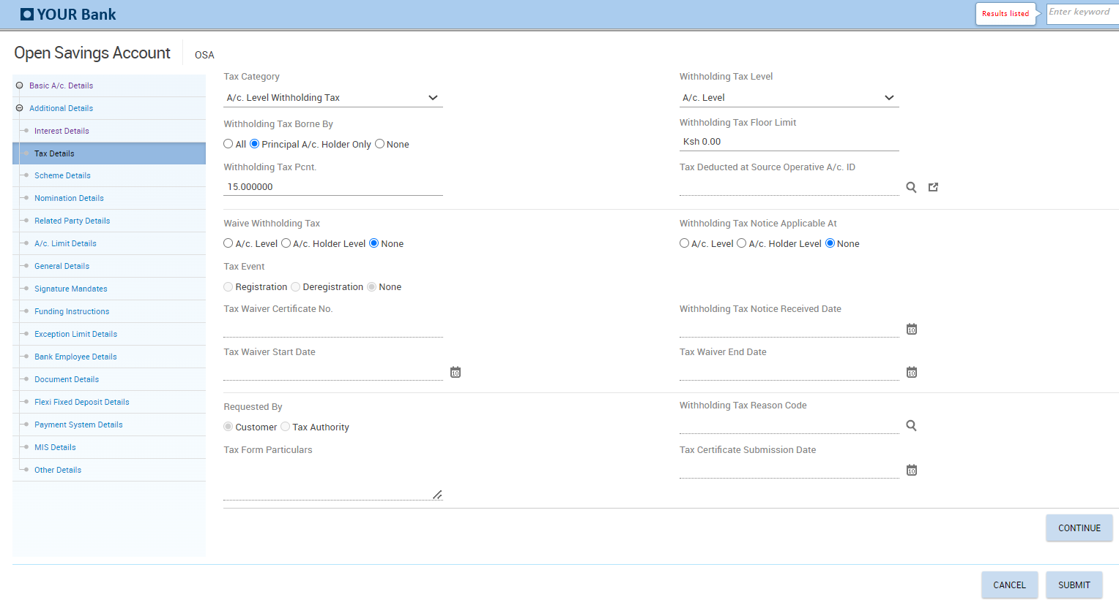

**Tax Details Fields**

**Tax Category -** This field indicates the category of the tax to be collected. The valid values are Account Level withholding Tax, Customer Tax Deducted at Source, Eligible for Tax Deduction at Source and No Tax.

**Withholding Tax Level -** This field indicates the level from which the tax parameters for tax calculation must be picked up. The valid values are Scheme level, Customer Level and Account level.

**Withholding tax floor Limit -** This field indicates the withholding tax floor limit applicable for tax calculation.

**Withholding Tax % -** This field indicates the percentage of the interest amount which is payable as withholding tax. It defaults to 15% for residents.

**Withholding tax borne by -** This field indicates the person who must bear the tax. The valid values are None, All and Principal A/c. holder only.

For customers who are exempted from paying withholding tax such as SACCOs, this field shall be NONE

**Tax Deducted at Source Operative A/c. ID -** This field indicates the ID of the account from which the tax is to be recovered.

**Waive Withholding Tax -** This field indicates if withholding tax must be applied at the account level, account holder level or none. This filed is applicable if the **Tax Category** field is ‘A/c. Level Withholding tax’.

**Withholding Tax Notice Applicable At -** This filed indicates if the notice is applicable at the account level or account holder level.

**Withholding Tax Notice Received Date -** This date is used in calculating the withholding tax along with the Withholding Tax Notice Period field.

Tax certificate Number, Tax Waiver Start Date, Tax Waiver End date, Tax Certificate Submission Date and Tax Form Particulars – These fields are used to capture the tax details and are applicable where withholding tax is waived.

* Click on Continue> Scheme details

## Scheme Details Field

The following information is displayed in the Scheme Details tab which its set up is done at the product level.

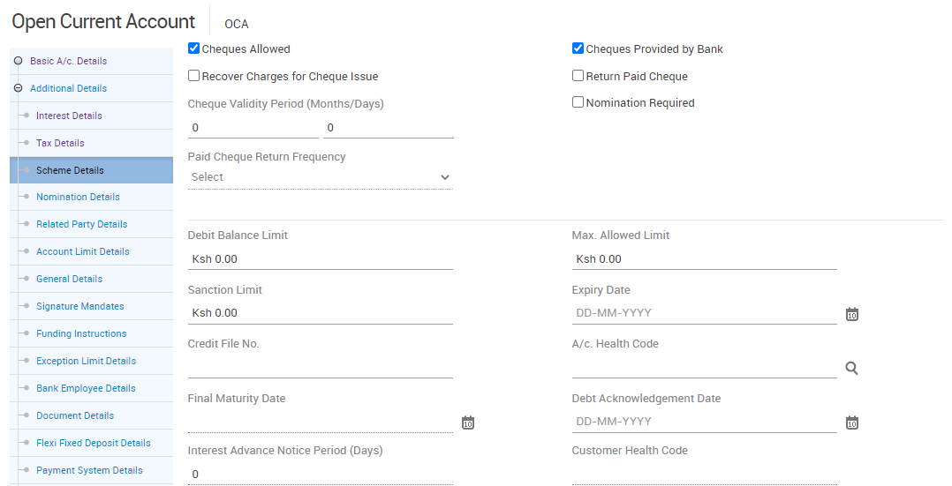

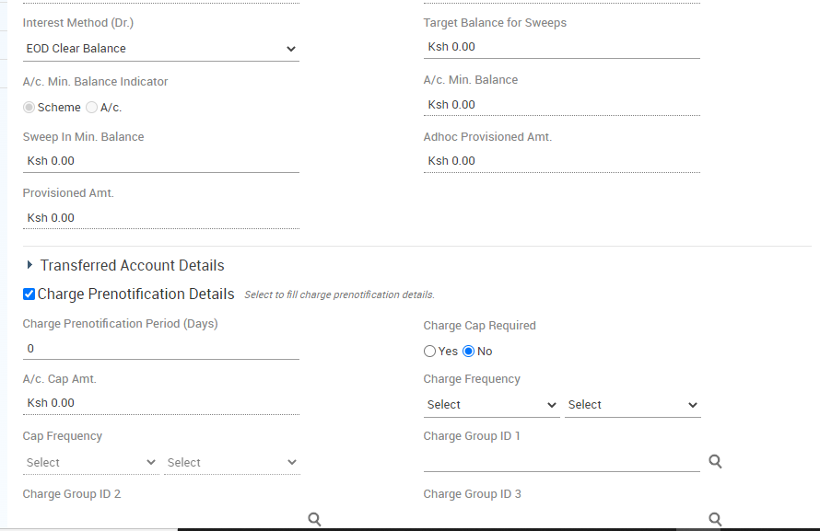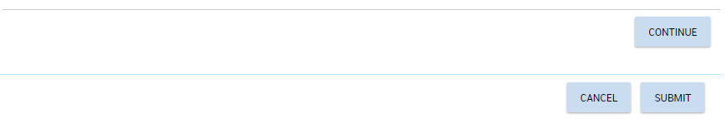

* Click on Continue>Nomination Details

## Nomination Details Field

This is a non-mandatory screen which is only used if the nomination indicator is set as Yes in the scheme details. Nomination is shall always be NO.

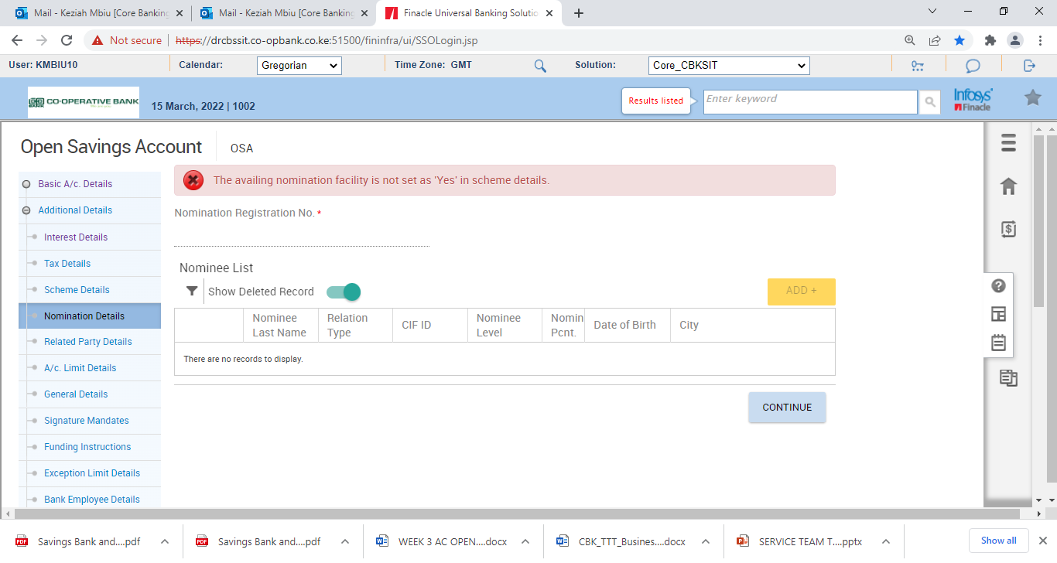

* Click on Continue button>Related Party Details

## Related Party Details

This section allows you to capture the power of attorney holder information, letter of authority information, joint holder information, Guardian Cif for minor account and authorized signatories information.

The first record in Related Party details is populated from the CIF ID of the main Account holder. All other holders for an account can be added

In case of a minor account, add the parent or guardian.

* Click on the Add button on Document List
* Select the Relation type as Authorized Signatory and Select the Relation Code as parent/guardian

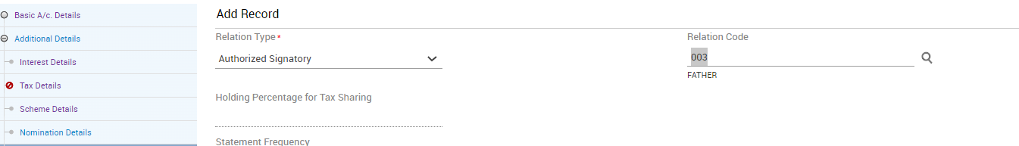

* Input the CIF of the parent/guardian

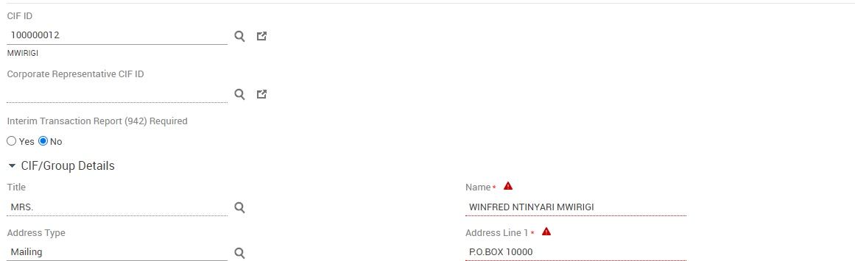

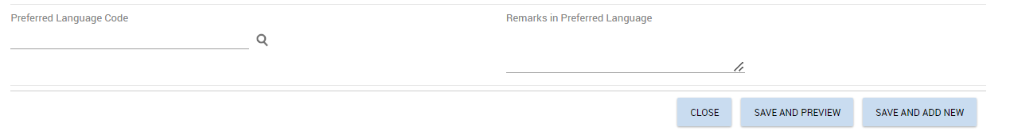

* Click on Save and Preview

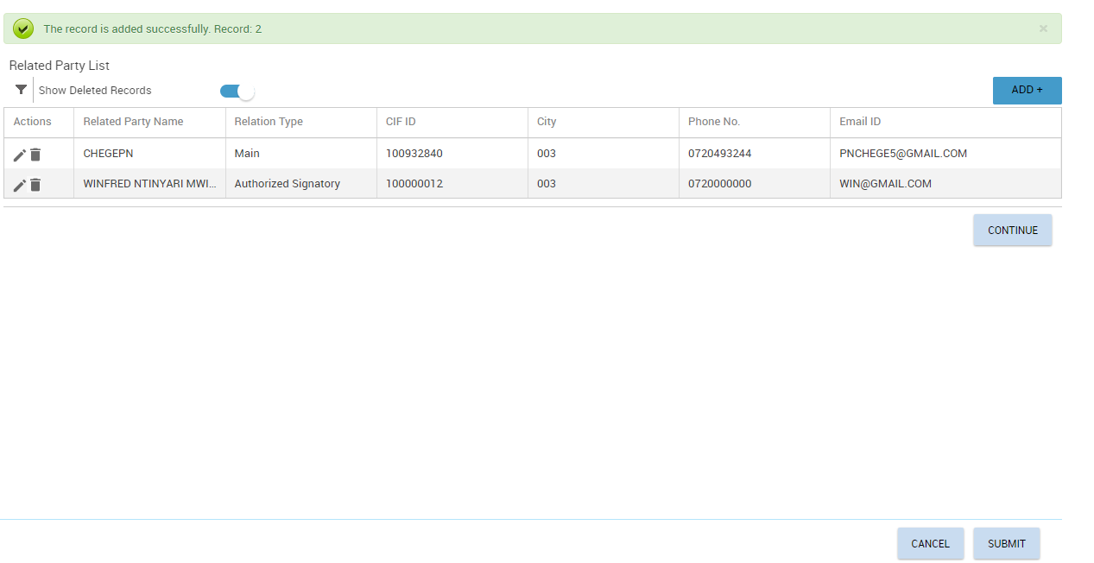

The record will be added.

* Click on Continue>Account Limit Details

## Account Limit Details

This section shall be used to set limit at account level

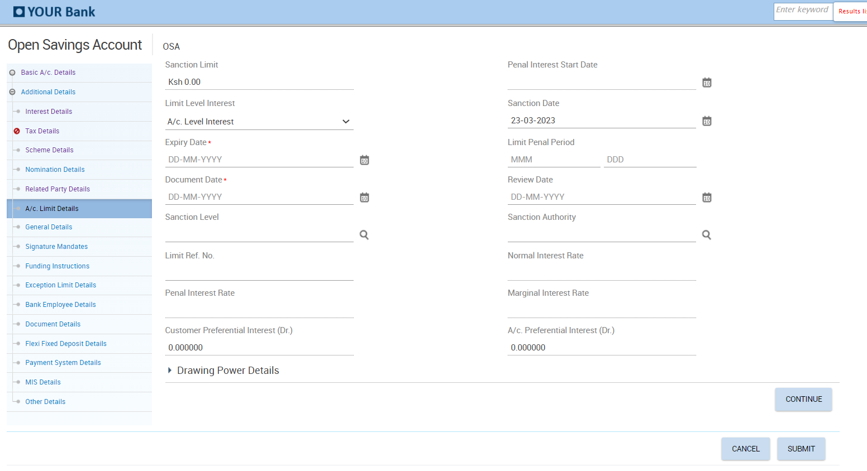

* Click on Continue>General Details

## General Details

This section is used to set overdraft limits, language and cheque limit details, fetches details from scheme level.

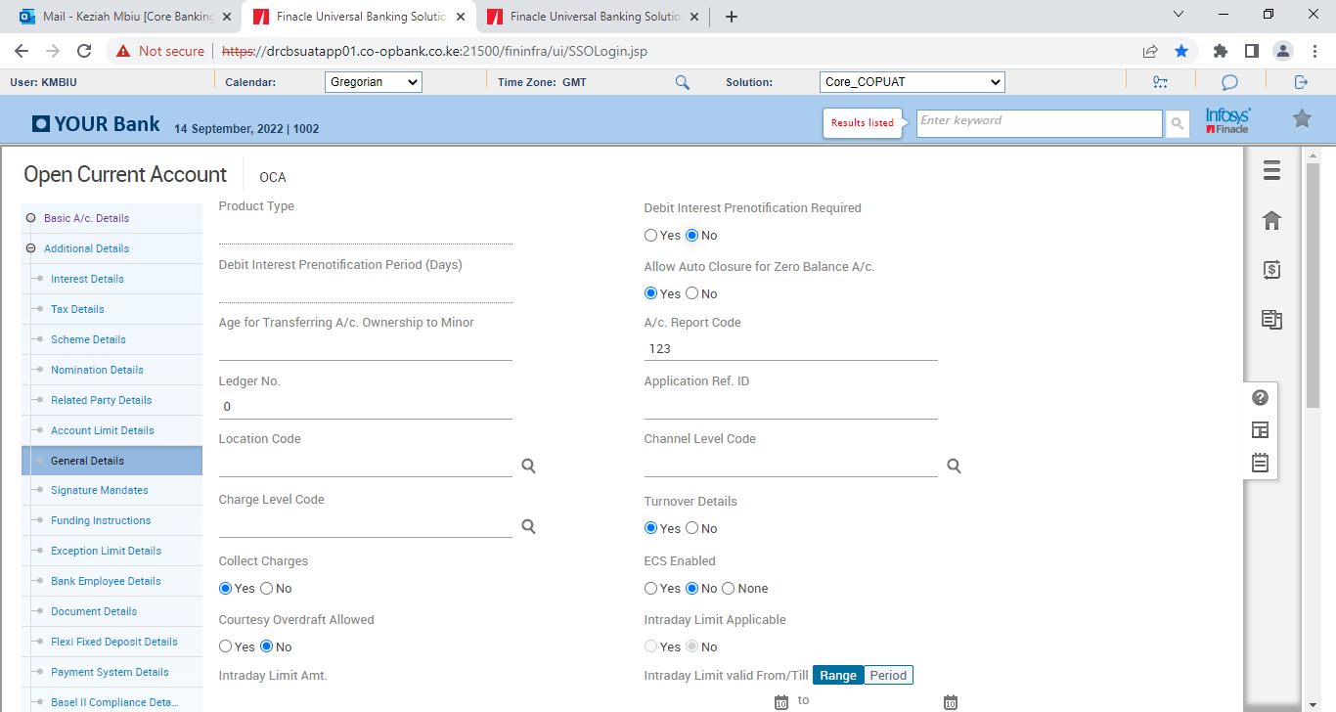

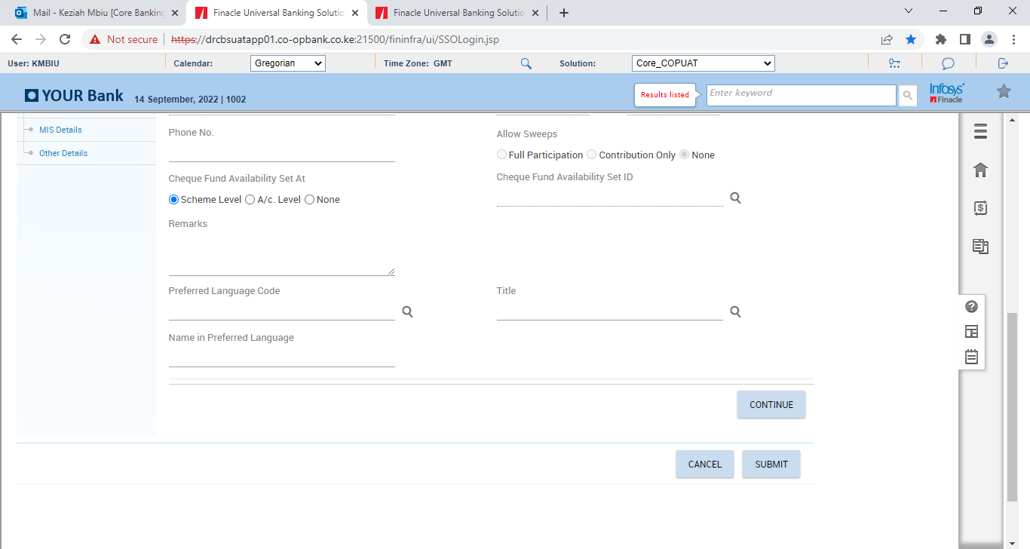

* Click on Continue>Signature mandates

## Signature Mandates

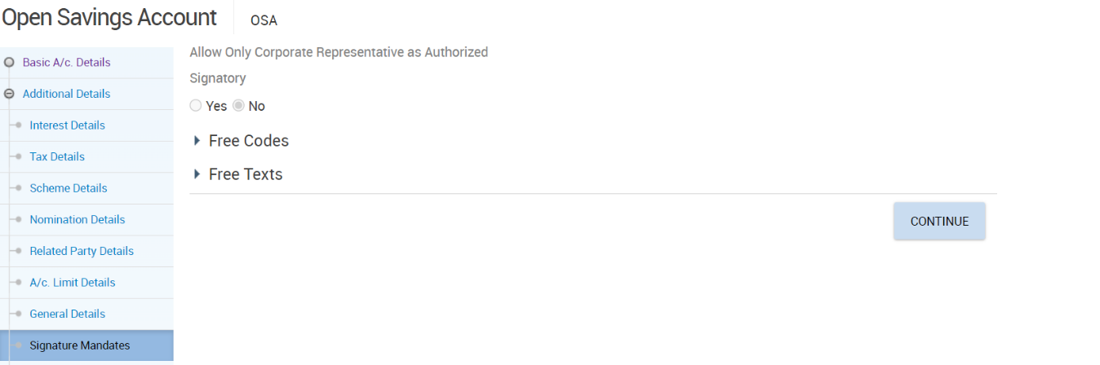

* Click continue button>Funding Instructions

## Funding Instructions

Used when a customer wishes to fund account through transfer from an existing account.

* Select Transfer on Transaction Type
* Input currency of the funding account on CCY
* Input the amount to transfer on Transaction Amt
* Input funding account on Debit A/C ID.

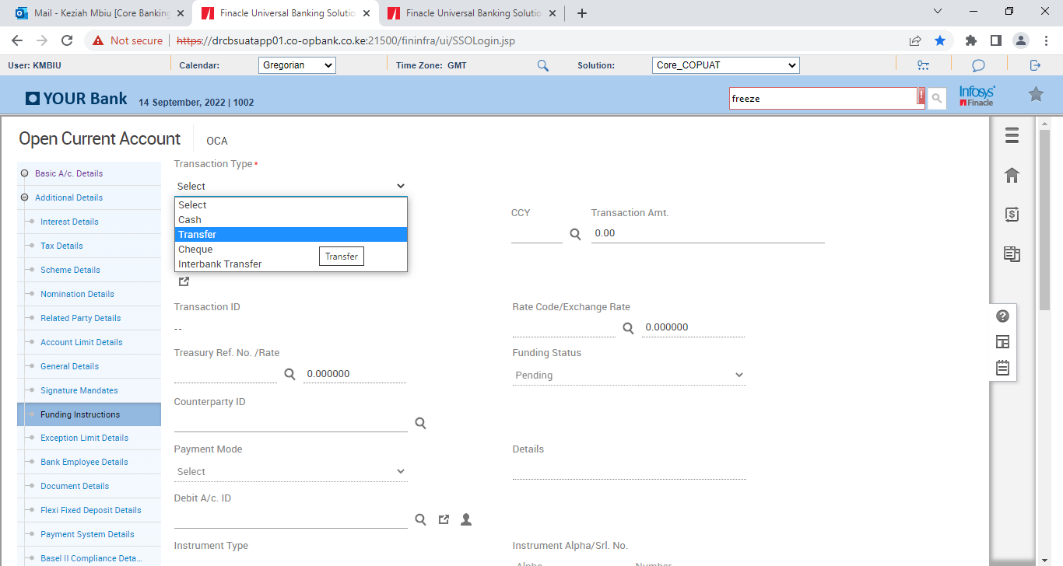

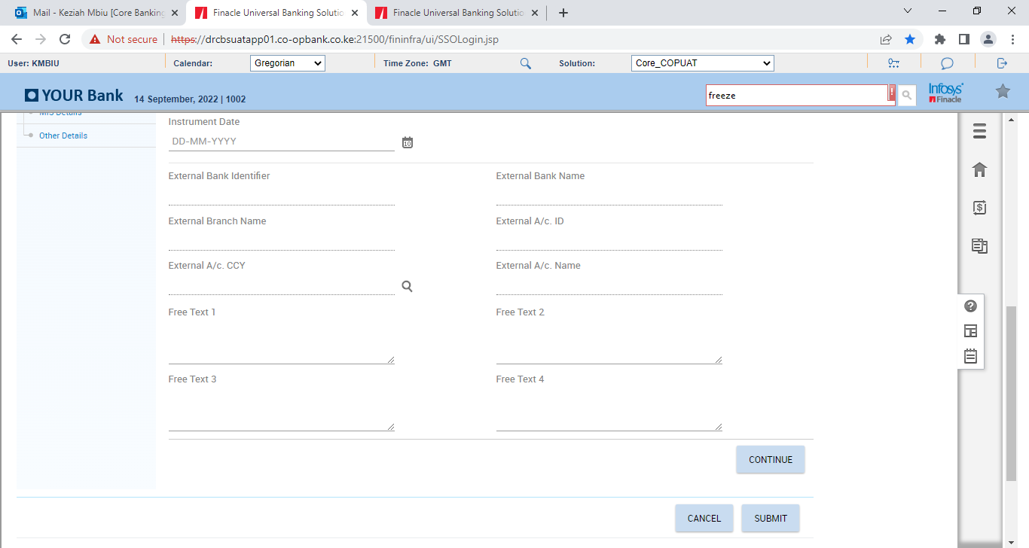

* Click continue button>Exception Limit Details

## Exception Limit Details

Used to capture Limits pertaining to cash, clearing and transfer the limits set during CGSP are defaulted here.

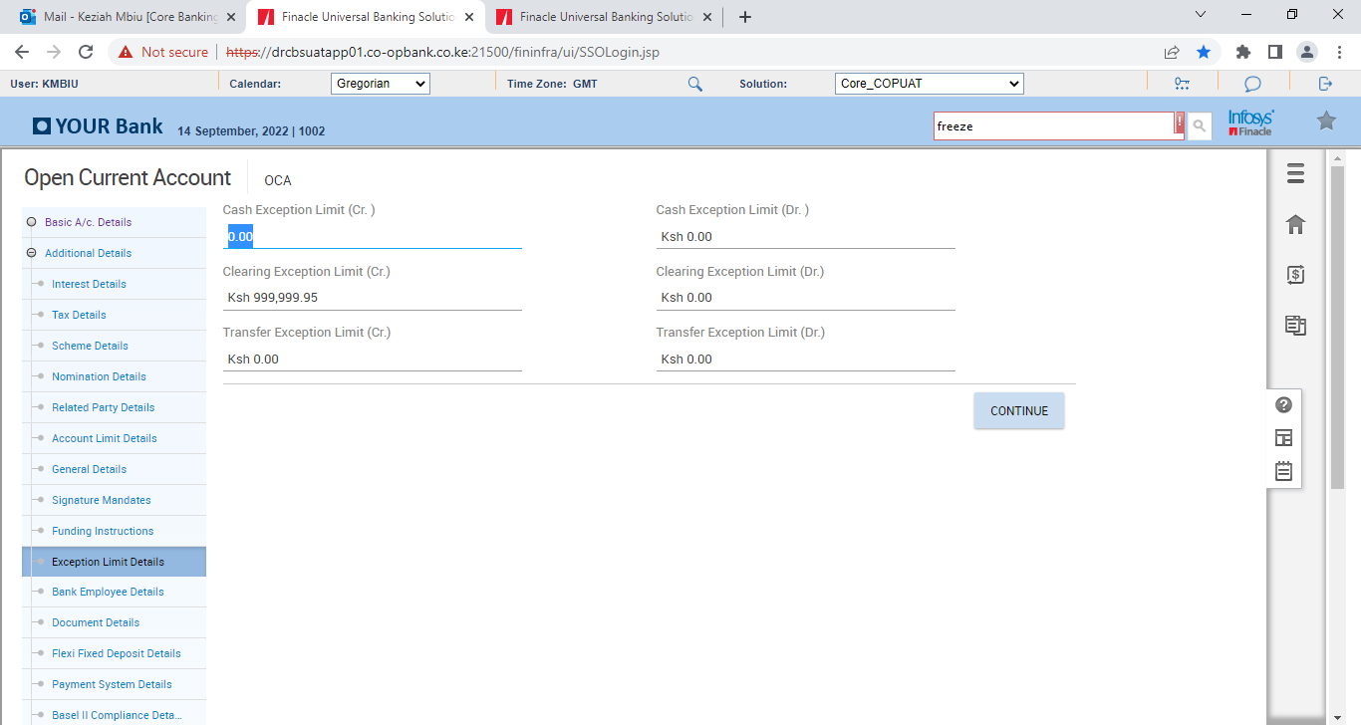

* Click continue button>Bank Employee Details

## Bank Employee Details

The relationship manager details captured from the CIF level will be displayed on this page and its editable if the relationship manager at CIF level is different with account relationship manager for account.

If the account holder is a relative of an employee, then those details shall be captured on this page under related Bank Employee details.

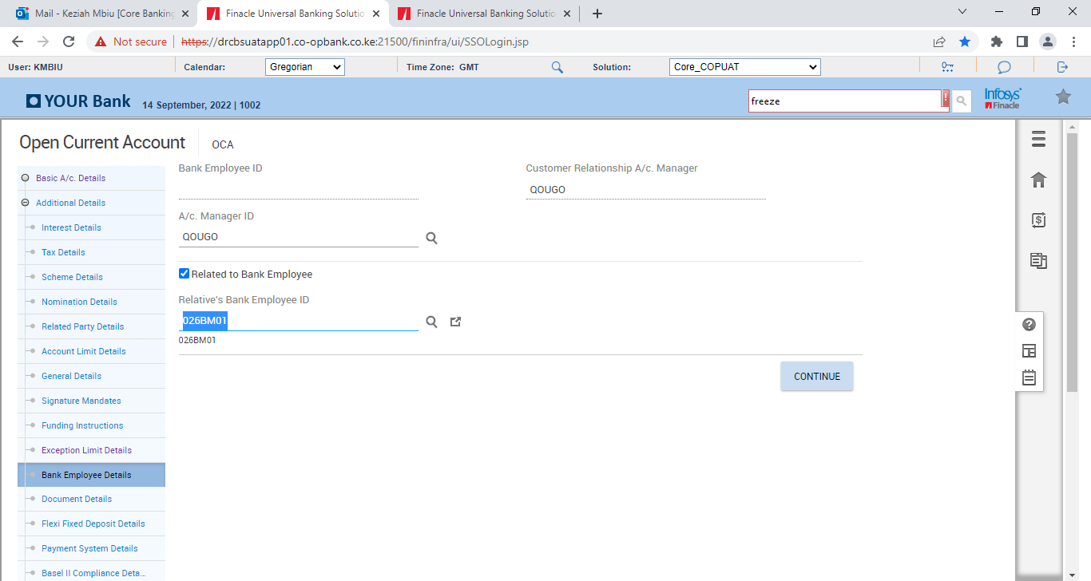

* Click Continue button>Document details

## Documents Details

You can upload various scanned documents collected for the account opening in this section.

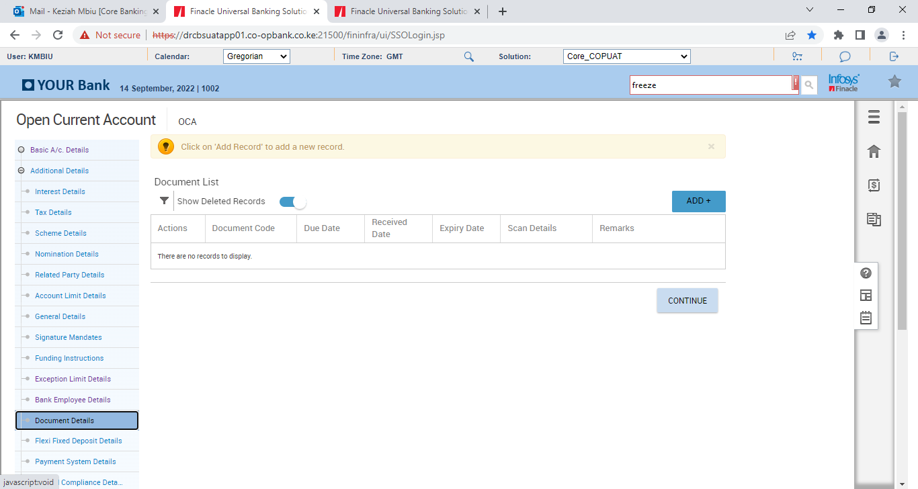

* Click on the ADD button

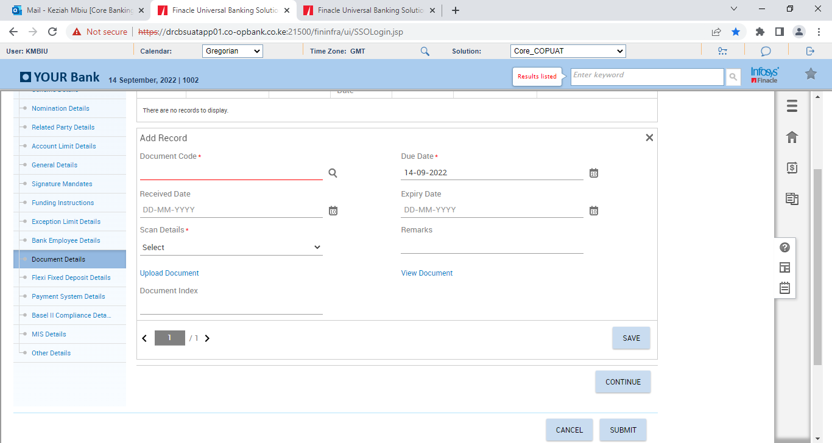

* Select Document Code>Due Date: The date before which the document must be submitted to the bank>Received Date: The date on which the document is received by the bank > Expiry Date: The expiry date of the documents received by the bank
* Click on Upload document to attach the desired report.
* Click on Save
* Click on Save and Add new to attach another document
* Click on Save and Preview after uploading the desired documents
* Click on Continue>Flexi Fixed Deposit Details

## Flexi Fixed Deposit Details

Finacle supports Flexi Fixed Deposit facility which customer has the option to choose for making deposits under specified scheme for specified period when the balance in the operative accounts exceeds specified threshold limit.

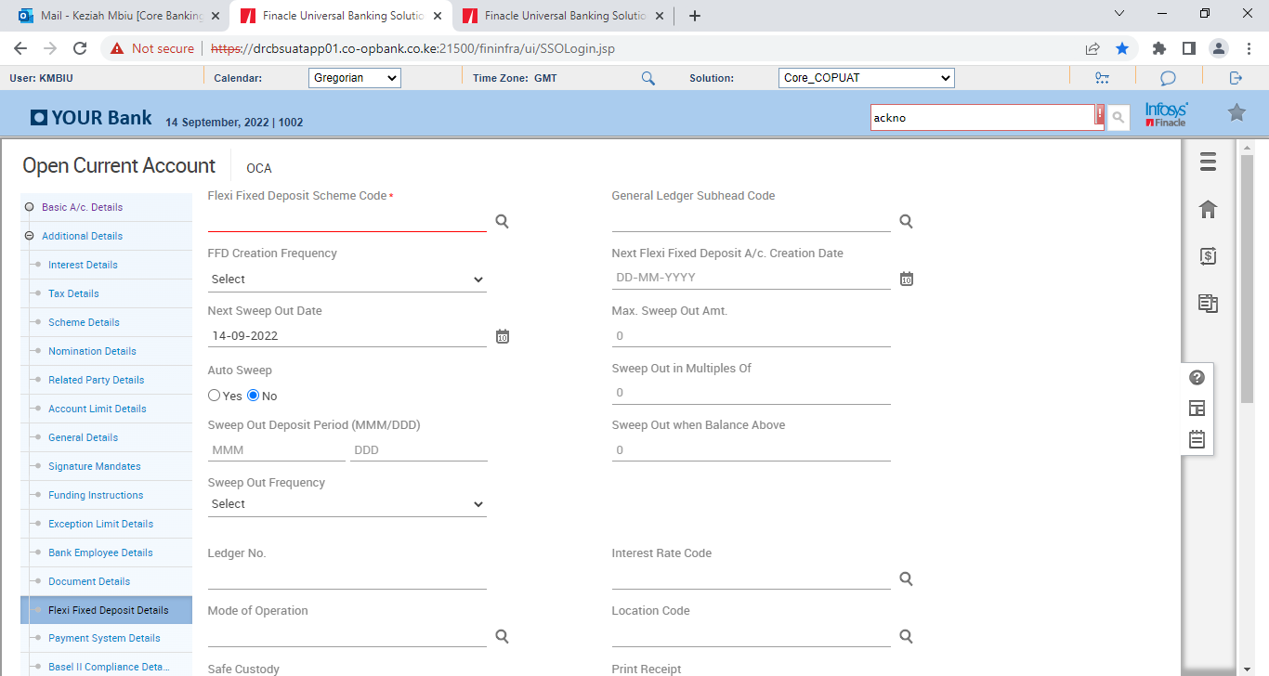

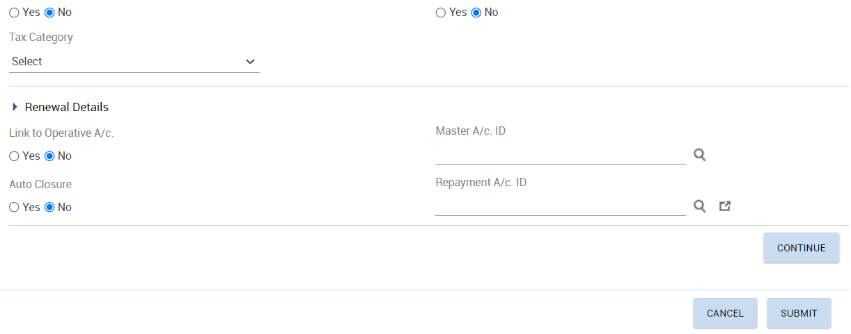

* Click on Continue>Payment System Details

## Payment System Details

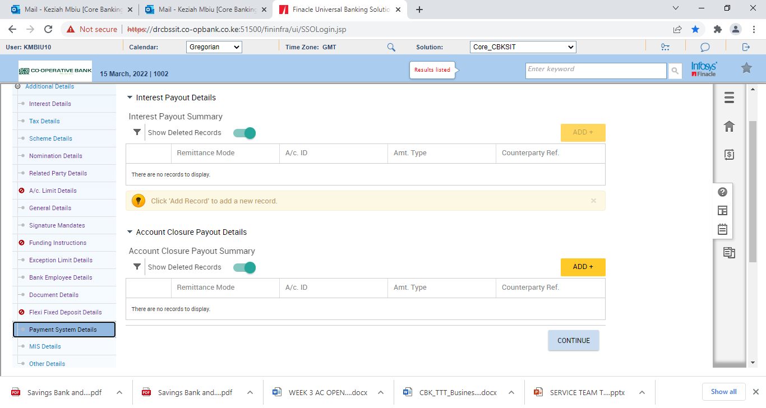Used to capture the payment system details if the Interest Credit indicator is set as payment system in the interest Details Screen

* Click Continue button>Base II Compliance Details

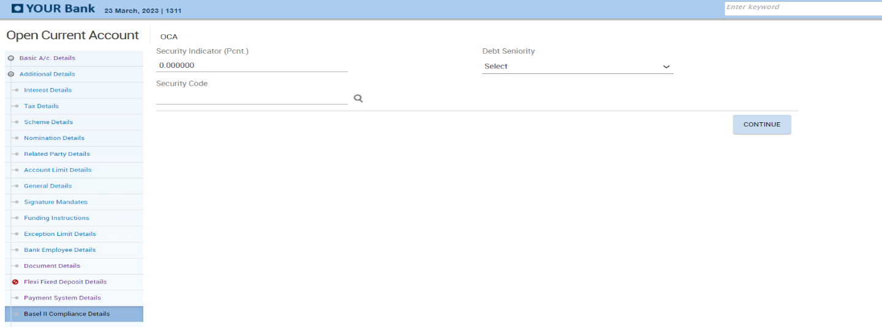

* Click Continue button>MIS Details

## MIS Details

Mandatory field where MIS codes for the accounts opened will be captured. Entry of details is done through the codes. The entry of appropriate codes is useful for generating various MIS reports.

* Select Sector Code and Subsector Code.



* Click Free codes
* Select DSO Code
* Select Business Economic Activity Code
* Select Product Segment if applicable

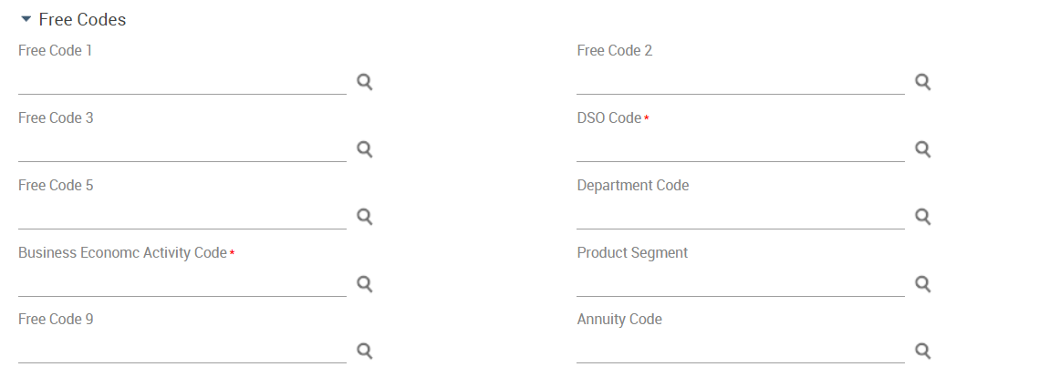

* Click Free Text
* Input Purpose of Account
* Input Source of funds
* Select Bank Specific Sector Code
* Select Bank Specific Sub-Sector Code

Note that ARO code will be auto populated

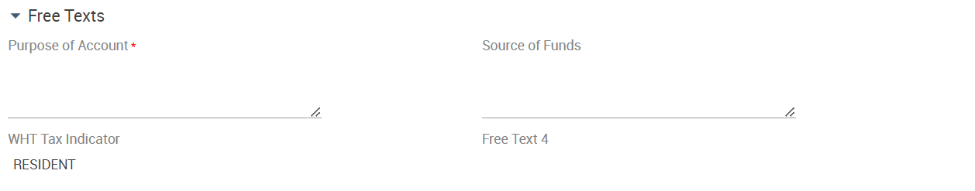

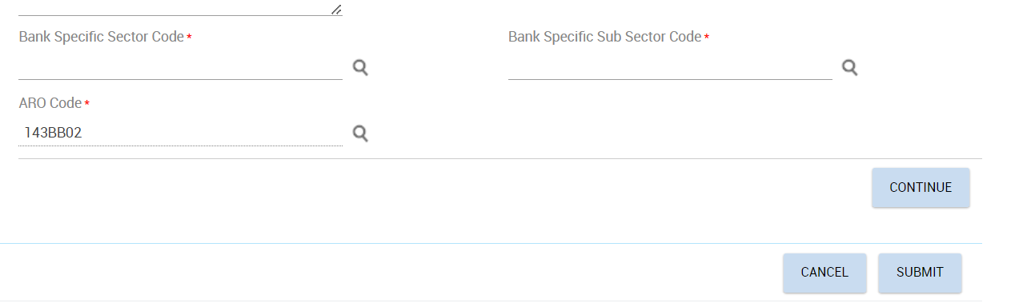

* Click Continue button>Other details

## Other Details

This is a non- mandatory section used for capturing details pertaining to applicability of Payment system, DSA Details and Account label details.

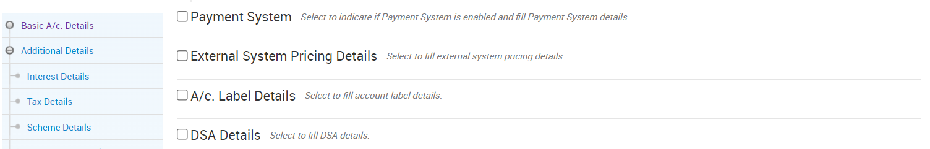

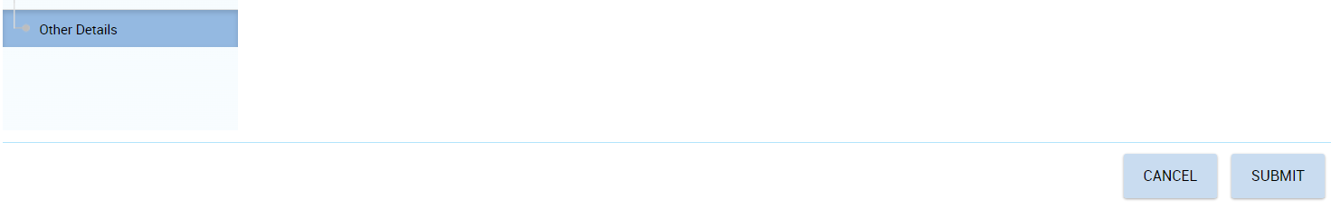

* Click Submit button

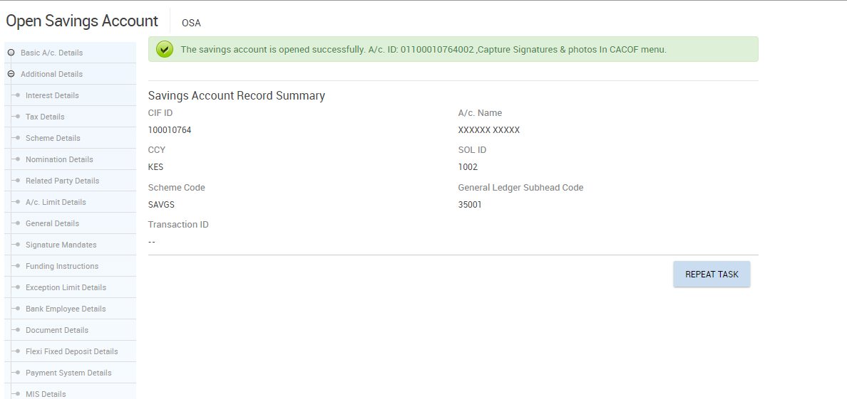

# Capture Of Customers Photo, Signature for Individual Retail Account

SDO will use menu CACOF to capture photo and Signature using Webcam and Signature pad respectively.

It is a Maker-Checker Process with two Functions:

1. Maker shall Generate Form
2. Checker shall Authorize Form

## Generate Form

* SDO shall invoke CACOF menu and select the Generate Form function

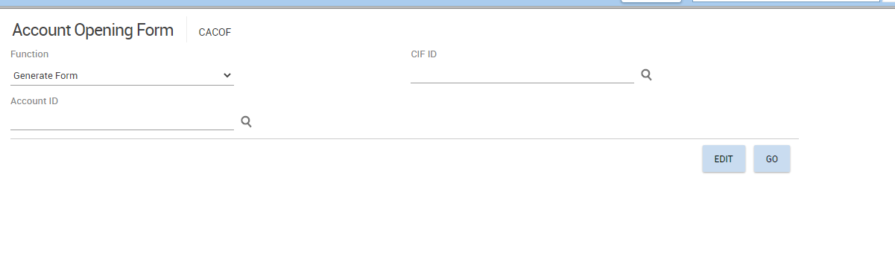

* Input account ID >Select CIF ID from searcher

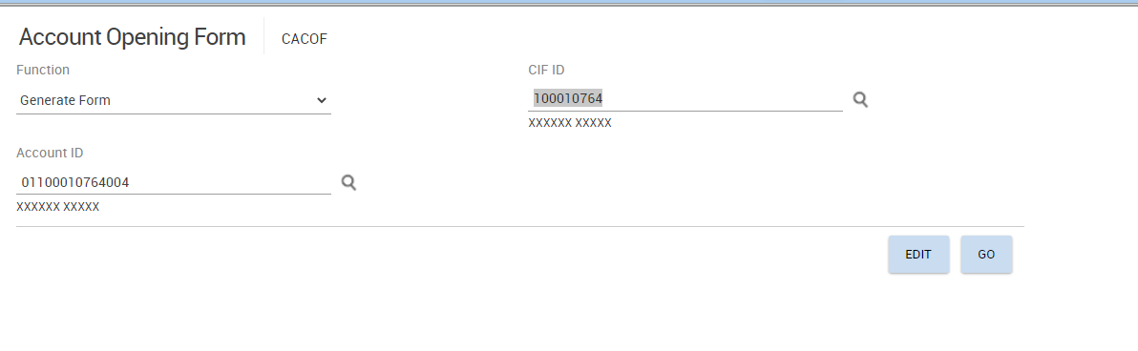

* Click Go Button
* Capture Photo
* Capture Signature (Capture from Signature pad or Webcam)
* Capture ID Front
* Capture ID Back
* Capture Remarks-Customer Name, Id No and Signing Mandate as Sole Signatory.

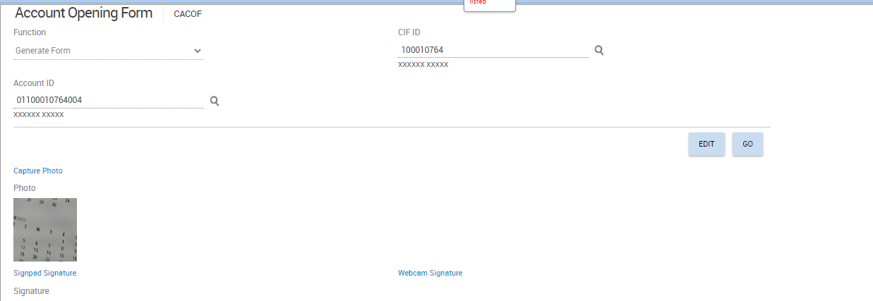

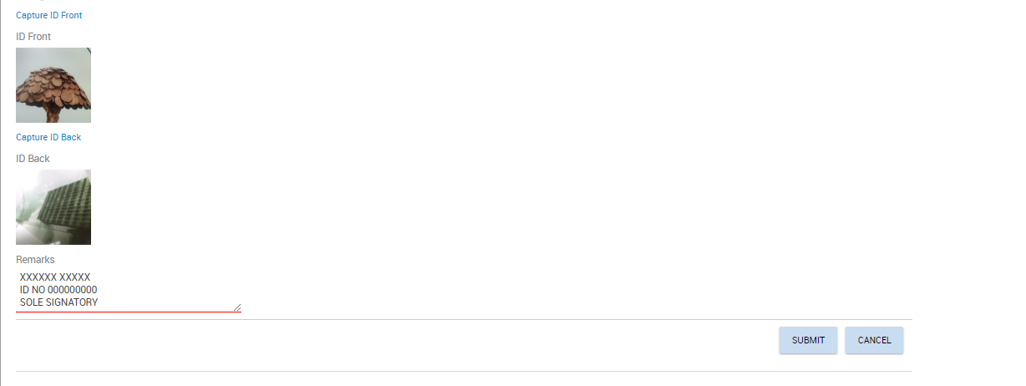

* Click submit button**.**

## CACOF Verification for Individual Retail Account

* Invoke CACOF (Account Opening Form) Menu
* Select Authorize Form Option from function Field
* Select Account ID from the searcher
* Click GO Button
* Click View Button to generate account opening form.

Checker shall review the account opening form and confirm customers details captured are accurate.

* Click on the Upload button to upload the generated mandate on EDMS.

Uploaded mandate shall have document index number displayed on Document Index Field

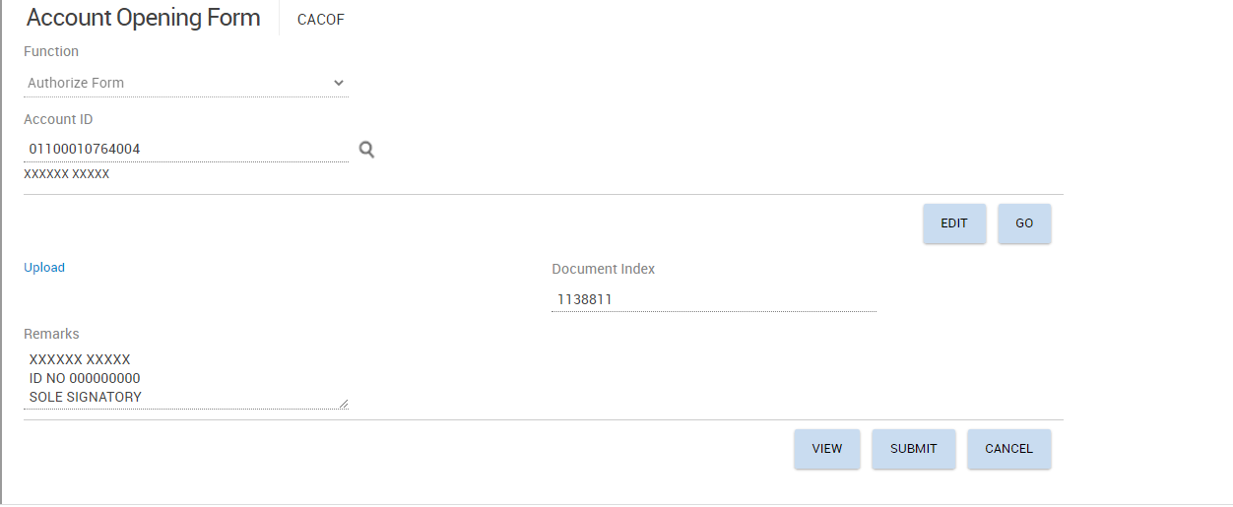

* Click Submit Button

## Modifying Account Before Verification

* Invoke menu MOSAV (Modify Opened Savings Account before Verification) to modify savings account or menu MOCAV (Modify Opened Current Account before Verification) to modify current account

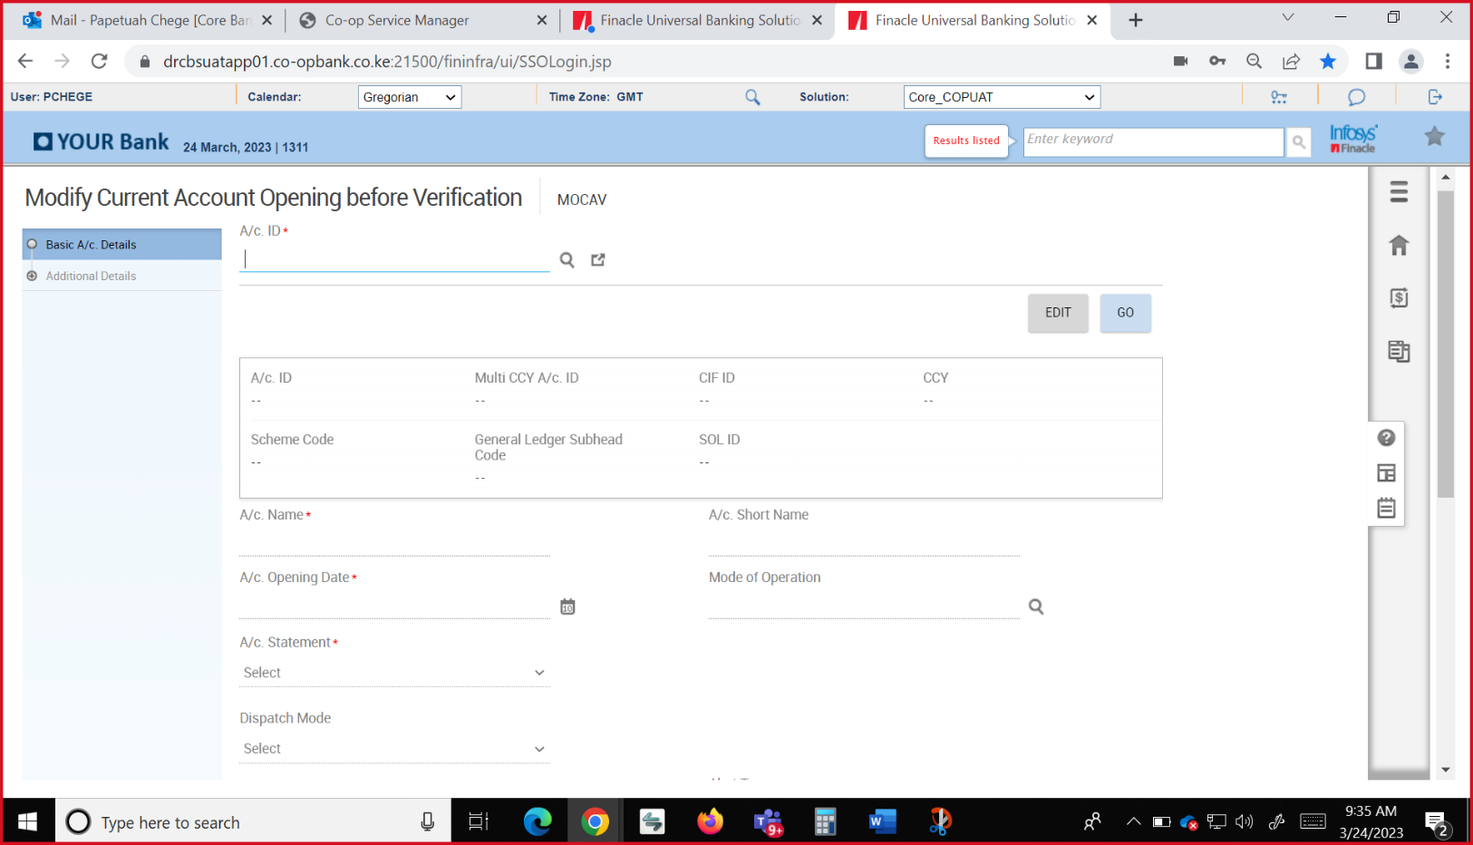

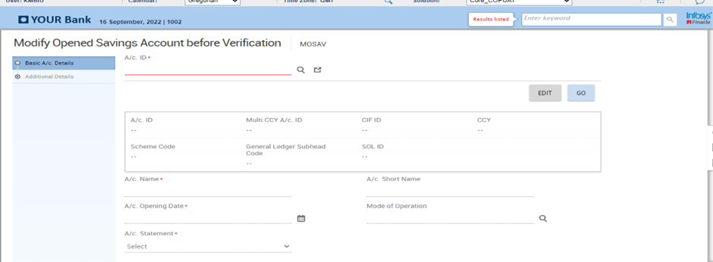

* Input account number and click on Go

The details that can be amended on this page are Account Statement, Statement frequency, Dispatch Mode, Alerts Registration Required, Premium Banking Account and Channel subscription

* Click on Continue
* Visit the Interest Details, Tax Details, Scheme Details, Nomination Details, Related Party Details, A/C Limit Details, General Details, Signature Mandates, Funding Instructions, Exception Limit Details, Bank Employee Details, Document Details, Flexi Fixed Deposit Details, Payment System Details, MIS Details and Other Details tabs and amend the desired fields
* Click Submit button

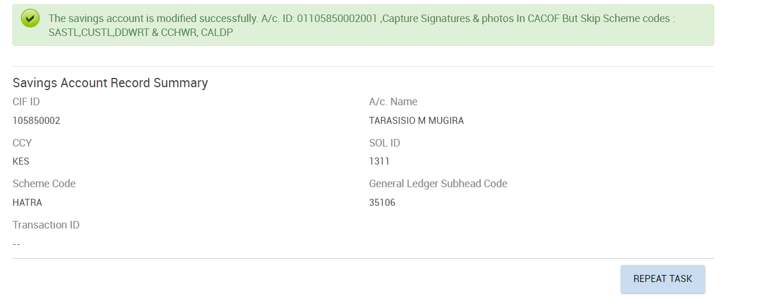

## Account Opening Verification

* Invoke menu VSAO (Verify Savings Account Opening) to verify savings account or menu VCAO (Verify Current Account Opening) to verify current account.

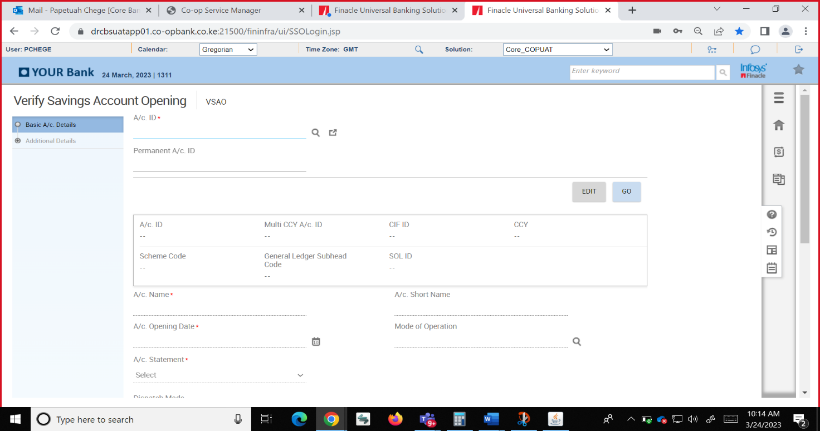

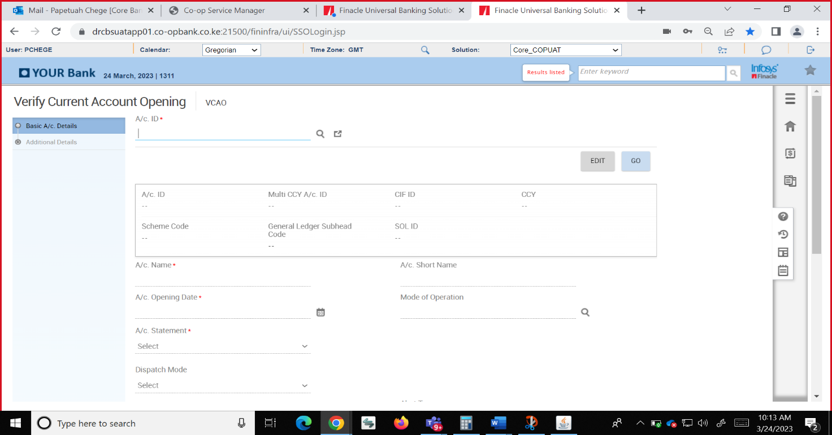

* Input account number or select from the account Id searcher>Click Go button
* View Basic Details and Click on Continue
* Visit the Interest Details, Tax Details, Scheme Details, Nomination Details, Related Party Details, A/C Limit Details, General Details, Signature Mandates, Funding Instructions, Exception Limit Details, Bank Employee Details, Document Details, Flexi Fixed Deposit Details, Payment System Details, Mis Details and Other Details tabs and to view details captured during account opening

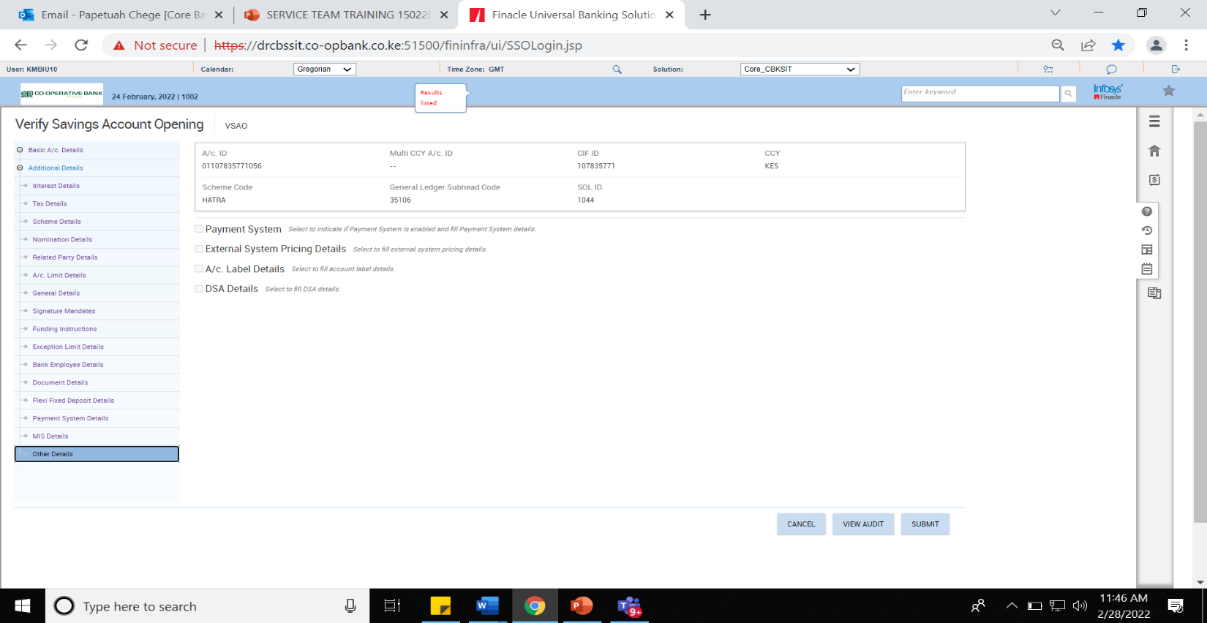

* From Other Details tab, Click Submit button

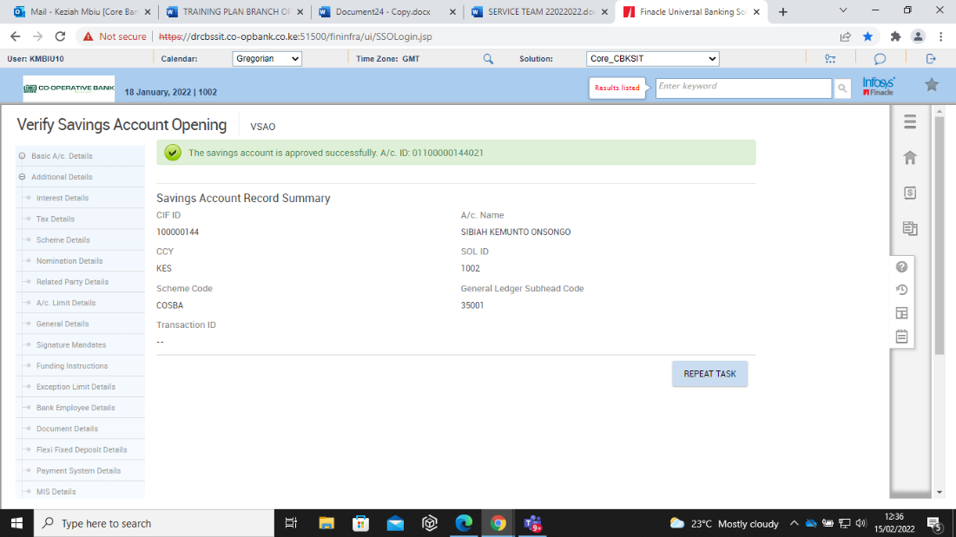

# Joint Account Opening



## Introduction

To open joint accounts in Finacle, the joint account holders must have a CIF. For the joint account holders without a CIF, first create retail CIFs as Contact as per Ref 8.1.2.

When opening a joint account use one of the CIFs as the main CIF to proceed.

## Joint Account Opening

* Invoke menu OSA (Open Savings Account) to open savings account or menu OCA (Open Current Account) to open a current account**.**





* Input the CIF of the main joint holder on CIF ID field
* Select the Scheme Code
* Select Currency
* Click Go button.

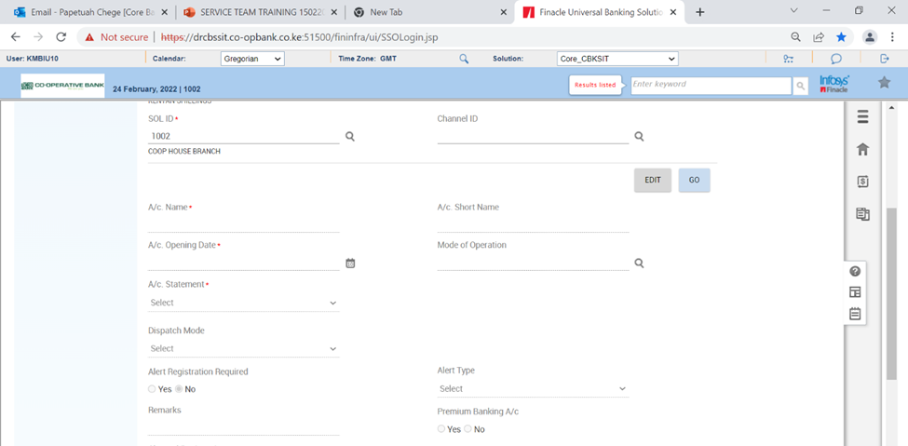

The Account Name will default to the name of the main CIF.

* Amend the account name to the names of the joint holders

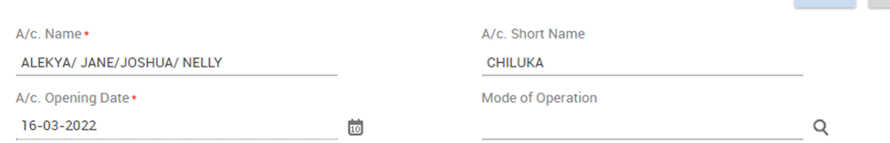

* Input Statement frequency>Dispatch Mode>Select Yes on Enable Pass Sheet Frequency at Related Party



* Alert Registration Required * if yes select alert type (Credit, Debit or Both)
* Premium Banking A/c for executive banking services



* Channel Registration (Omni Retail, Mobile Banking or Both)



* Click On Continue Button> Additional Details

## Additional Details





**Interest Details page (Not mandatory)**

This field is default, populated with the value specified at scheme level. Specifies information (all interest and tax related parameters information) in the Interest Details.

**Pay Interest** - This field indicates if interest must be paid to the account. The valid values are: Yes or No.

**Collect Interest** - This field indicates if interest must be collected from the account. The valid values are: Yes or No.

**Credit Interest % min. /max**. - This field indicates the minimum and maximum interest percent payable to the account.

**Allow Negative Credit Interest** field would determine whether negative interest will be applied for account or not. The default percolation would happen from scheme level. If Allow Negative Credit Interest is yes at the scheme level, then P&L Placeholder and Negative Payable Placeholder exist at the scheme level.

**If “Allow Negative Credit Interest” indicator is Yes** at scheme level and changed to No at A/c. level or vice versa, Default parameter overridden exception is shown to user.

**Debit Interest % min. / max**. - This field indicates the minimum and maximum interest percent to be collected from the account.

**Customer Preferential Interest (Cr)** - This field indicates the preferential interest (positive percent) set at the customer level which is applicable to the account. The value is defaulted from the value set at CIF level.

**Customer Preferential Interest (DR)** - This field indicates the preferential interest (negative percent) set at the customer level which is applicable to the account.

**A/c Preferential Interest (Cr) -** This field indicates the preferential interest (positive percent) set at the account level which is applicable to the account. This field will be hidden for the accounts opened under negotiated interest type of product.

**A/c Preferential Interest (Dr) -** This field indicates the preferential interest (negative percent) set at the account level which is applicable to the account. This field will be hidden for the accounts opened under negotiated interest type of product.

**Interest Credit A/c.** - This field indicates the account to which interest rate must be credited. The valid values are: Operative account, original account and Payment system.

**Interest Debit A/c.** - This field indicates the account to which interest rate must be debited. The valid values are: O - Operative account, S - Original account and T - Payment system.

**Interest Debit A/c ID -** This field indicates the ID of the account to which interest must be Debited. The system allows you to specify the Int. Dr. A/c ID whose currency is different from the account currency.

**Interest Credit A/c ID -** This field indicates the ID of the account to which interest must be credited. The system allows you to specify the Int Cr. A/c ID whose currency is different from the account currency.

**Interest Rate Code -** This field indicates the code of the interest rate table to be used for calculation of interest. This field is default populated with the value specified at scheme level. This can be modified. This field will be hidden for the accounts opened under negotiated interest type of product.

**Account Pegged –** This field indicates if the interest rate applicable to the account must be pegged to the account and be kept constant for a specific period. The valid values are: Yes and No. Any change in the interest rate is not applicable to those accounts for which the value of the field account pegged is set as Yes and for which a pegging frequency is specified. All such accounts must be reviewed on the review date else the interest calculation would not go through for these accounts. This field will be hidden for the accounts opened under negotiated interest type of product.

**Pegging Review Date -** This field indicates the date until which the account is pegged. Finacle automatically reviews the pegged interest rate for the account on this date. This field will be hidden for the accounts opened under negotiated interest type of product.

**Pegging Frequency –** This field indicates the frequency in months and days for pegging interest rate to the account. This field will be hidden for the accounts opened under negotiated interest type of product. This field will be hidden for the accounts opened under negotiated interest type of product.

**Interest Calculation Frequency Credit -** This field represents the frequency at which the interest must be calculated. The value in this field is default populated from the scheme level. This can be modified.

**Next interest calculation date (Cr)** - This field indicates the next interest calculation date.

**Interest Calculation Frequency (Dr) -** This represents the frequency at which the interest must be calculated. The value in this field is default populated from the scheme level. This can be modified.

**Next Interest Calculation Date (Dr) -** This field indicates the next interest calculation date.

**Interest Compounding Frequency (Dr) -** This indicates the frequency at which the debit interest must be compounded. For example, it could be ‘Daily’.

**Credit Compounding Rest Indicator -** This indicates the compounding rest used for compounding the interest.

**Apply Discounted Interest Rate (Dr) -** This field indicates whether discounted interest rate must be applied for calculating the interest. This field is applicable to loan accounts when the bank wishes to recover interest upfront during disbursement of the loan. The bank also pays interest on a deposit account at discounted rate of interest instead of the contracted rate if the interest is paid before the specified interest flow date. The bank applies a discounting factor to the original interest if the customer requests payment of interest before the normal interest payable date.

* Click on Continue>Tax Details

## Tax Details



**Tax Details Fields**

**Tax Category -** This field indicates the category of the tax to be collected. The valid values are Account Level withholding Tax, Customer Tax Deducted at Source, Eligible for Tax Deduction at Source and No Tax.

**Withholding Tax Level -** This field indicates the level from which the tax parameters for tax calculation must be picked up. The valid values are Scheme level, Customer Level and Account level.

**Withholding tax floor Limit -** This field indicates the withholding tax floor limit applicable for tax calculation.

**Withholding Tax % -** This field indicates the percentage of the interest amount which is payable as withholding tax. It defaults to 15% for residents.

**Withholding tax borne by -** This field indicates the person who must bear the tax. The valid values are None, All and Principal A/c. holder only.

For customers who are exempted from paying withholding tax such as SACCOs, this field shall be NONE

**Tax Deducted at Source Operative A/c. ID -** This field indicates the ID of the account from which the tax is to be recovered.

**Waive Withholding Tax -** This field indicates if withholding tax must be applied at the account level, account holder level or none. This filed is applicable if the **Tax Category** field is ‘A/c. Level Withholding tax’.

**Withholding Tax Notice Applicable At -** This filed indicates if the notice is applicable at the account level or account holder level.

**Withholding Tax Notice Received Date -** This date is used in calculating the withholding tax along with the Withholding Tax Notice Period field.

Tax certificate Number, Tax Waiver Start Date, Tax Waiver End date, Tax Certificate Submission Date and Tax Form Particulars – These fields are used to capture the tax details and are applicable where withholding tax is waived.

* Click on Continue> Scheme details

## Scheme Details Field

The following information is displayed in the Scheme Details tab which it’s set up is done at the product level





* Click on Continue>Nomination Details

## Nomination Details Field

This is a non-mandatory screen which is only used if the nomination indicator is set as Yes in the scheme details. Nomination is shall always be NO.



* Click on Continue button>Related Party Details

## Related Party Details

This section allows you to capture the power of attorney holder information, letter of authority information, joint holder information, Guardian CIF for minor account and authorized signatories information.

The first record in Related Party details is populated from the CIF ID of the main Account holder. All other holders for an account can be added

In case of a minor account, add the parent or guardian.

* Click on the Add button on Document List
* Select the Relation type as Authorized Signatory



* Input the CIF joint account holder





* Click on Save and Add New to add the other joint account holders
* Click Save on Preview

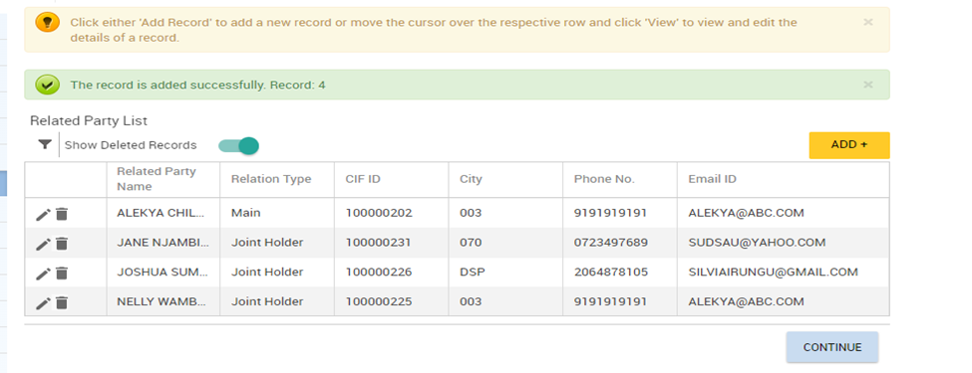

* Click on Continue>Account Limit Details

## Account Limit Details

This section shall be used to set limit at account level



* Click on Continue>General Details

## General Details

This section is used to set overdraft limits, language and cheque limit details, fetches details from scheme level.





* Click on Continue>Signature mandates

## Signature Mandates

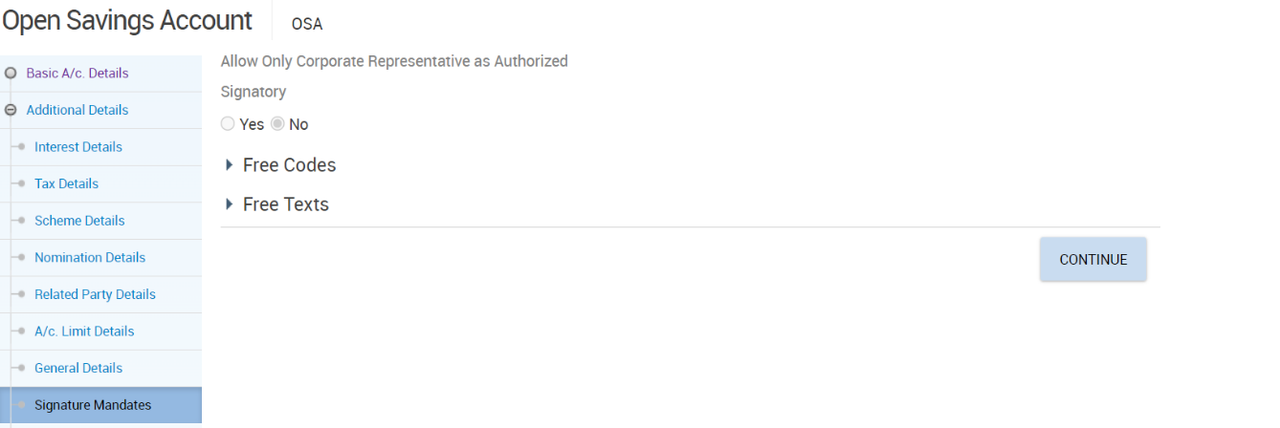

* Click continue button>Funding Instructions

## Funding Instructions

Used when a customer wishes to fund account through transfer from an existing account.

* Select Transfer on Transaction Type
* Input currency of the funding account on CCY
* Input the amount to transfer on Transaction Amt
* Input funding account on Debit A/C ID.





* Click continue button>Exception Limit Details

## Exception Limit Details

Used to capture Limits pertaining to cash, clearing and transfer the limits set during CGSP are defaulted here.



* Click continue button>Bank Employee Details

## Bank Employee Details

The relationship manger details captured from the CIF level will be displayed on this page and its editable if the relationship manager at CIF level is different with account relationship manager for account.

If the account holder is a relative of an employee, then those details shall be captured on this page under related Bank Employee details.



* Click Continue button>Document details

## Documents Details

User can upload various scanned documents collected for the account opening in this section.



* Click on the ADD button



* Select Document Code>Due Date: The date before which the document must be submitted to the bank>Received Date: The date on which the document is received by the bank > Expiry Date: The expiry date of the documents received by the bank>Click on Upload document to attach the desired report.
* Click on Save
* Click on Save and Add new to attach another document
* Click on Save and Preview after uploading the desired documents
* Click on Continue>Flexi Fixed Deposit Details

## Flexi Fixed Deposit Details

Finacle supports Flexi Fixed Deposit facility which customer has the option to choose for making deposits under specified scheme for specified period when the balance in the operative accounts exceeds specified threshold limit.





* Click on Continue>Payment System Details

## Payment System Details

Used to capture the payment system details if the Interest Credit indicator is set as payment system in the interest Details Screen

* Click Continue button>Base II Compliance Details

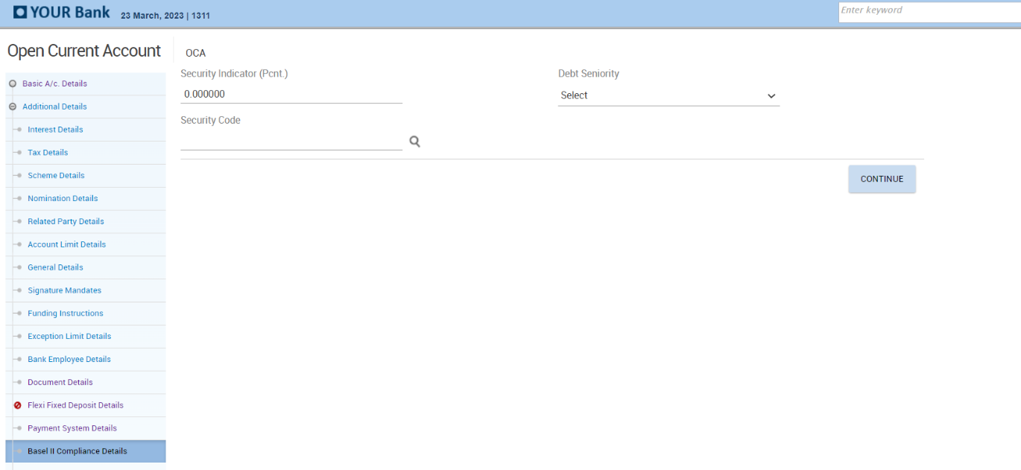

* Click Continue button>MIS Details

## MIS Details

Mandatory field where MIS codes for the accounts opened will be captured. Entry of details is done through the codes. The entry of appropriate codes is useful for generating various MIS reports.

* Select Sector Code and Subsector Code.



* Click Free codes
* Select DSO Code
* Select Business Economic Activity Code
* Select Product Segment if applicable



* Click Free Text
* Input Purpose of Account
* Input Source of funds
* Select Bank Specific Sector Code
* Select Bank Specific Sub-Sector Code
* Note that ARO code will be auto populated





* Click Continue button>Other details

## Other Details

This is a non- mandatory section used for capturing details pertaining to applicability of Payment system, DSA Details and Account label details.





* Click Submit button

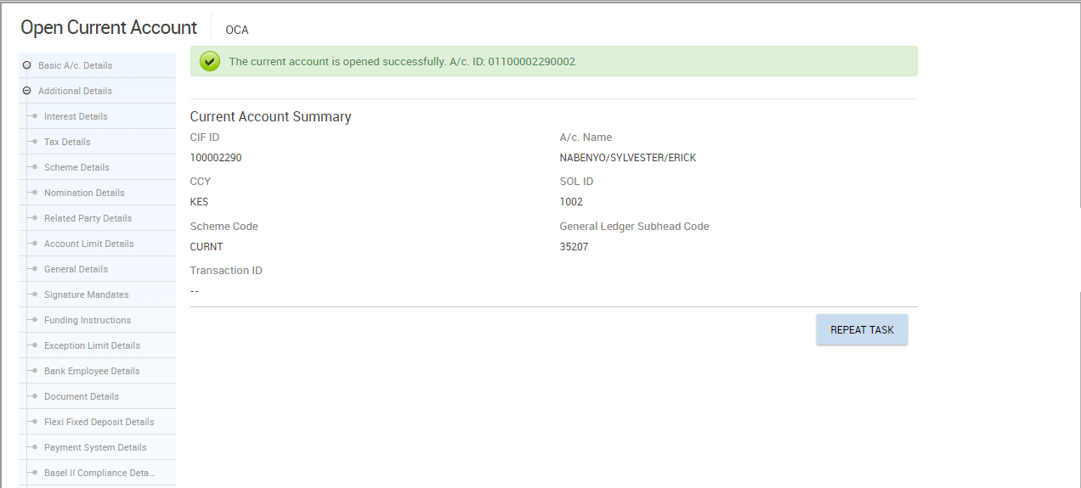

## Joint Account Opening Photos & Signature Joint Account

Account opening officer shall capture photo & signatures for all joint holder members including the main Joint holder.

* Invoke menu CACOF (Account Opening Form)
* Select Generate Form from Function
* Input account number or select it from the searcher

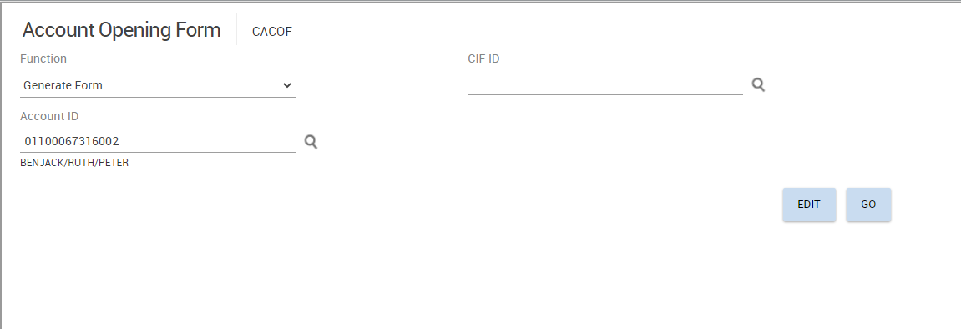

* Select the related party CIF from the CIF ID searcher

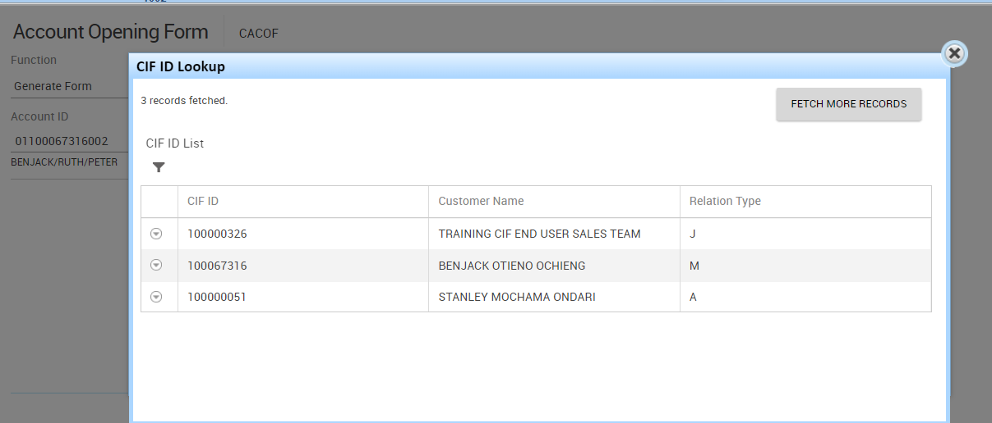

* Capture photo & Signature of joint holder

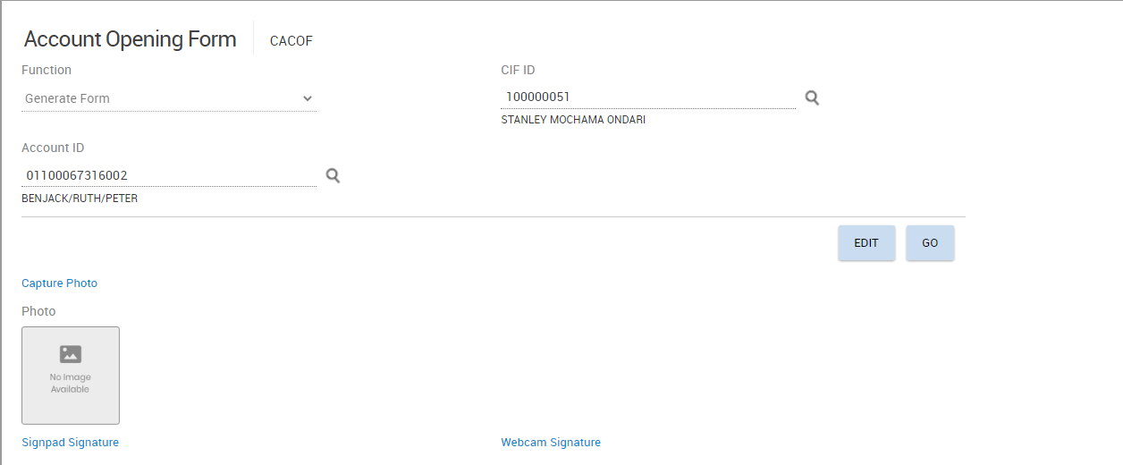

* Input Customer Name, ID Number, Designation i.e Secretary on Remarks field

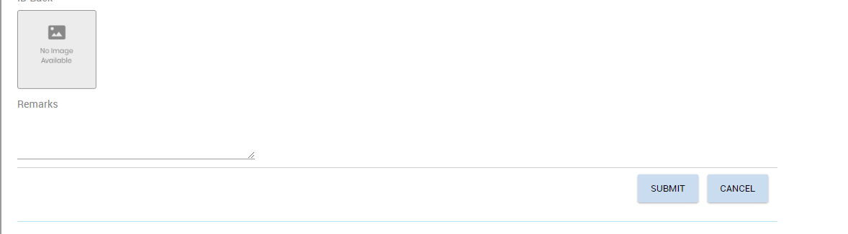

* Click submit button
* Repeat capturing of photo & signatures for other joint holders and main joint holder

## Verification of Joint Account Opening

Refer to Account Opening Verification section

# Corporate Account Opening Process



## Creating a Corporate Customer Information File

The following process shall be followed to create a corporate Customer Information File.

* Invoke menu CERC (Create Corporate CIF)

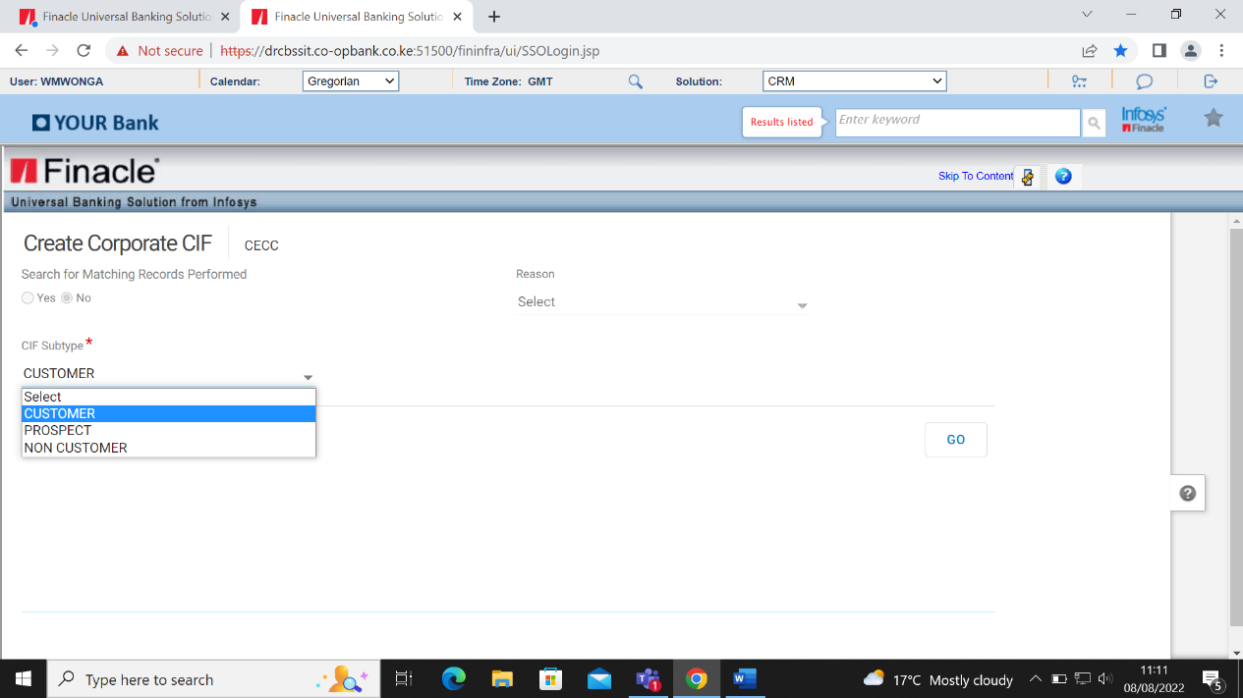

* Select Customer on CIF subtype > Click GO button**.**

Note.

* **Customer-** This is the entity which is starting a new business relationship with the bank
* **Prospect-**This is the entity which the bank intent to start a future business relationship while
* **Non customer -**This is the entity that does not have any current business relationship with the bank but has a business relation with one of the customer to the bank.

See additional notes on creation of Prospect and Non customer CIF subtypes.

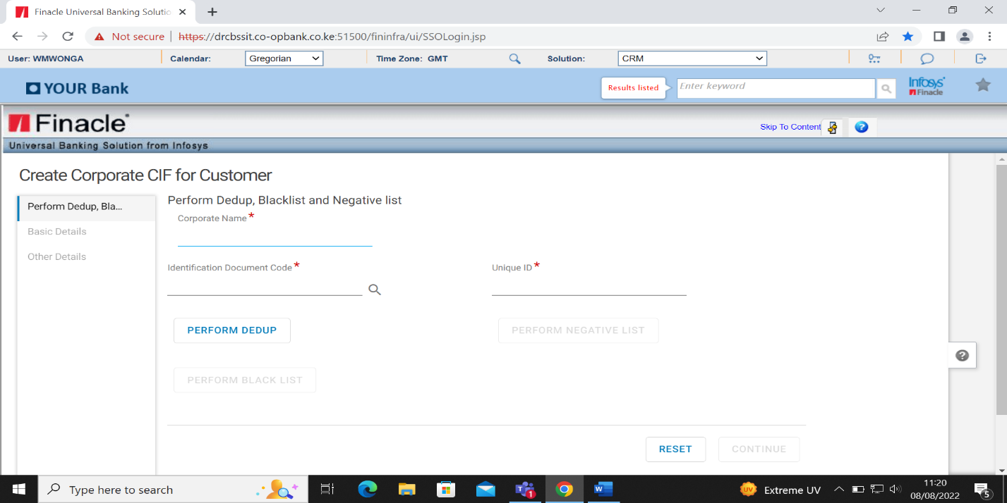

* Input Corporate Name
* Select identification document from Identification Document Code searcher
* Input registration number on Unique ID
* Click Perform Dedup.
* The Deduplicate check establishes whether the CIF already exists in the database or not to avoid creation of duplicate CIFs.

For potentially matching corporate CIF, the enrich button will be activated for one to enrich.

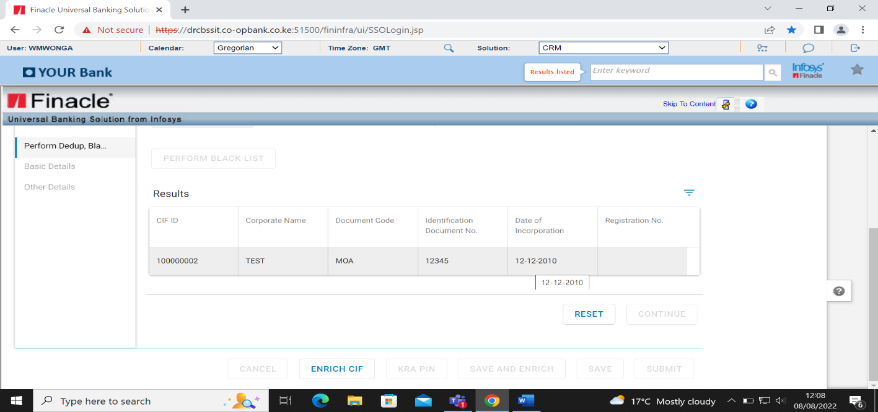

If the entity does not exist, the screen below will be displayed

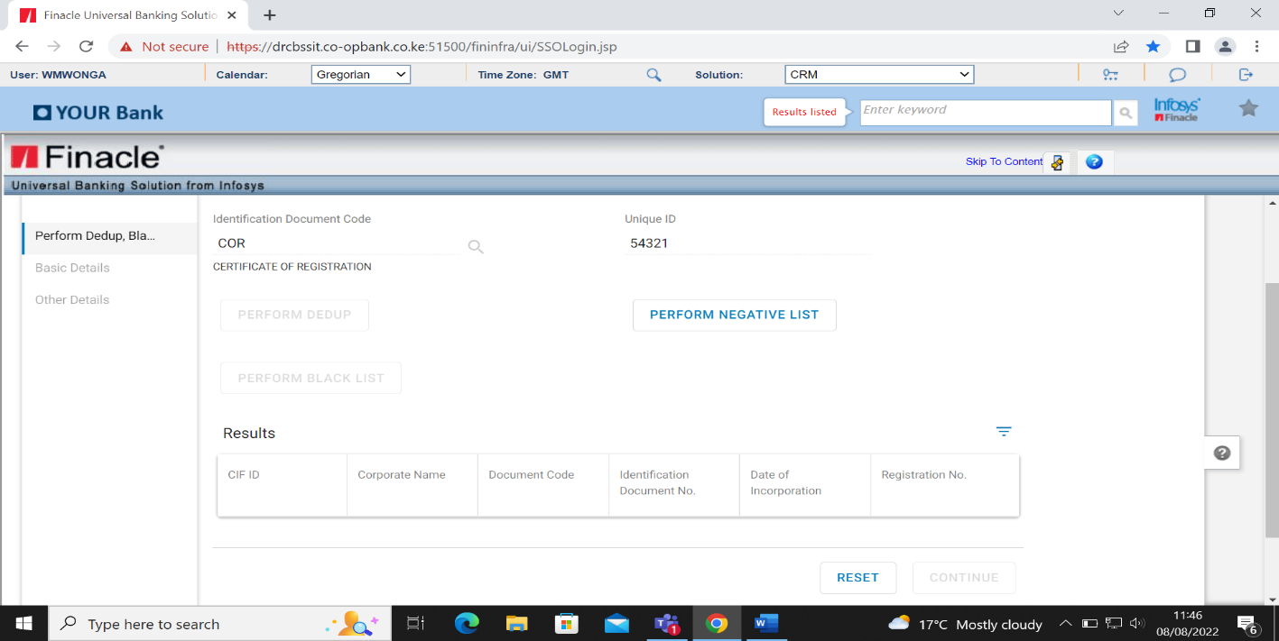

* Click on Perform Negative List. This checks whether the entity is negatively listed internally

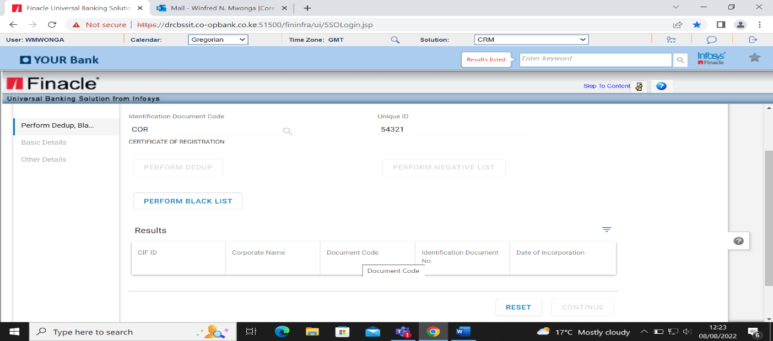

* Click on Perform Blacklist. This operation checks whether the entity is blacklisted externally

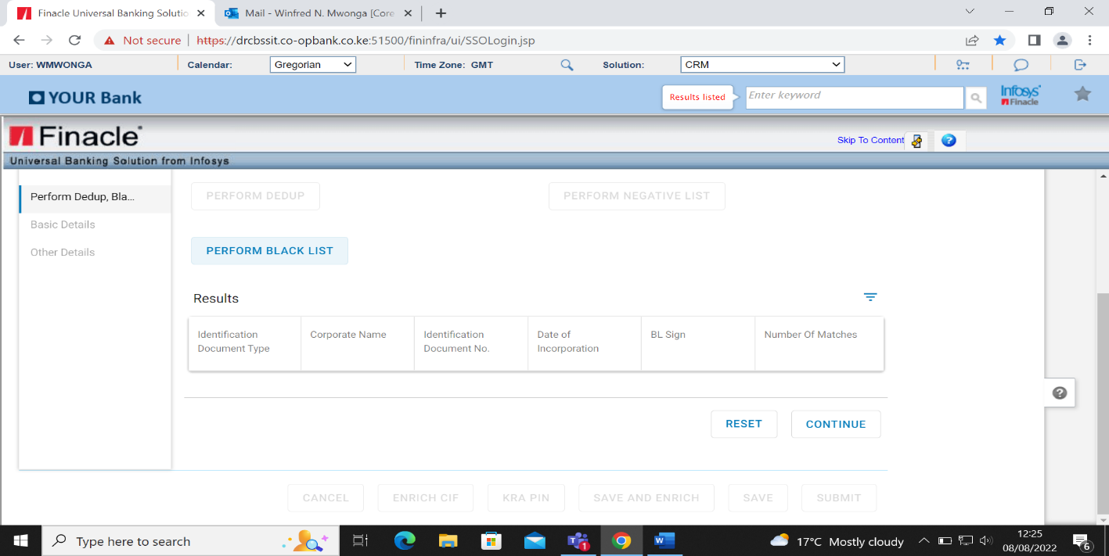

* Click continue button>Basic Details

## Basic Details

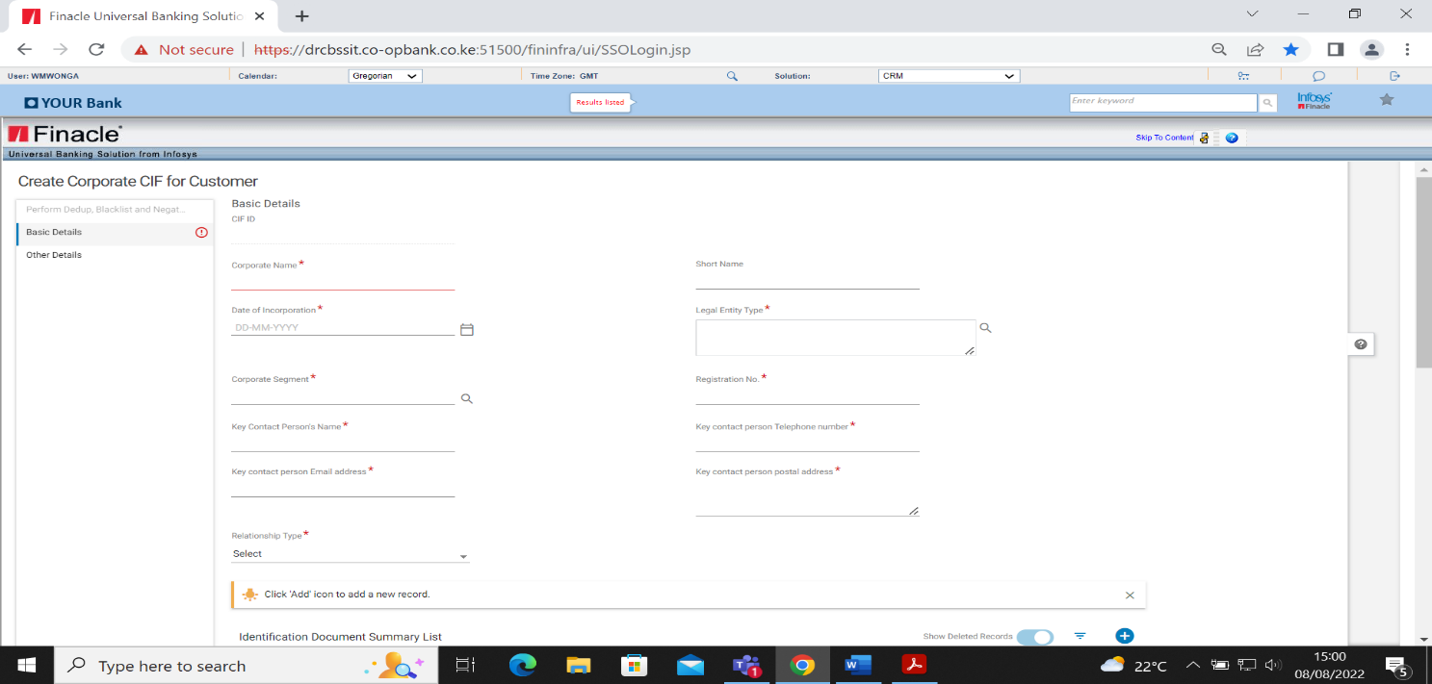

* Input Corporate Name>Date of Incorporation
* Select Legal entity type

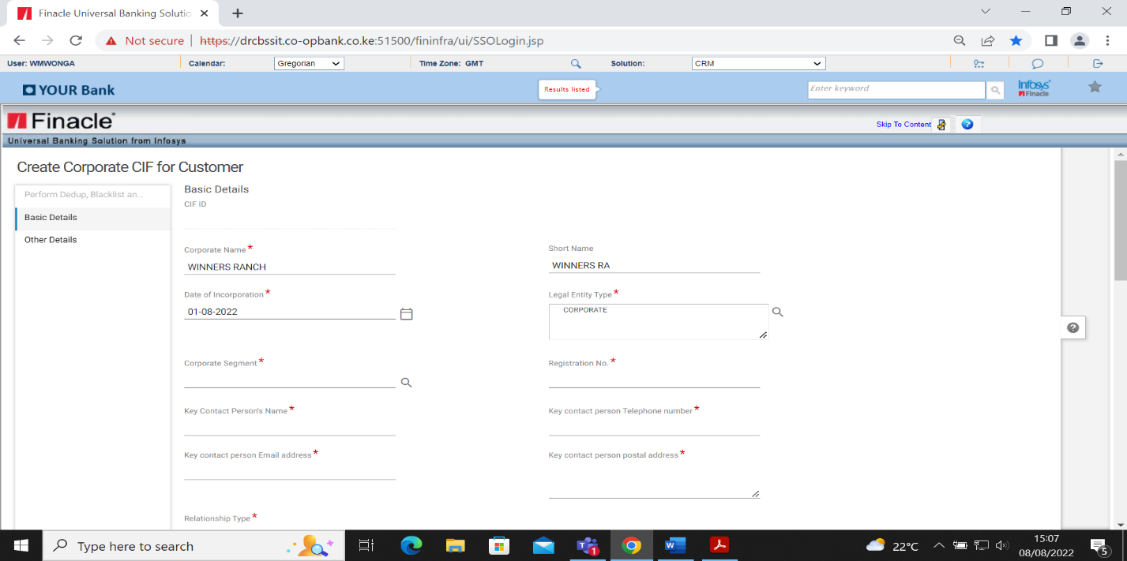

* Select Corporate segment
* Input the Registration number
* Input Key contact person’s name
* Input Key Contact person telephone number
* Input Key contact person email address
* Input Key contact person postal address

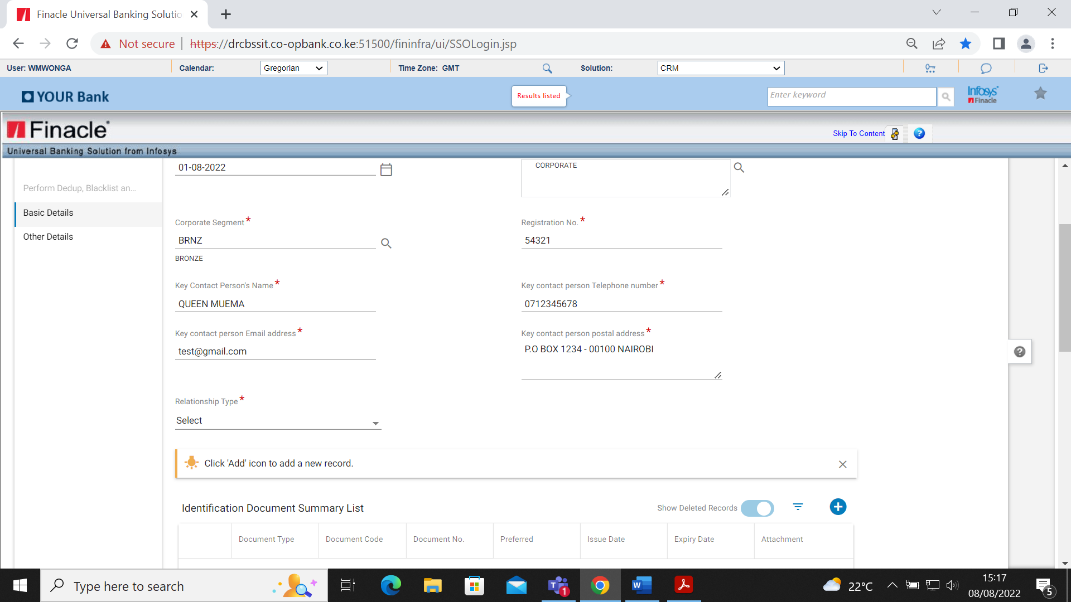

* Select on the relationship type as:
* **New-** for a newly formed/incorporated entity
* **Merge**r- for combination of two corporates
* **Amalgamation -**for combination of more than two corporate entities

## Capturing of Identification Document for a Corporate CIF

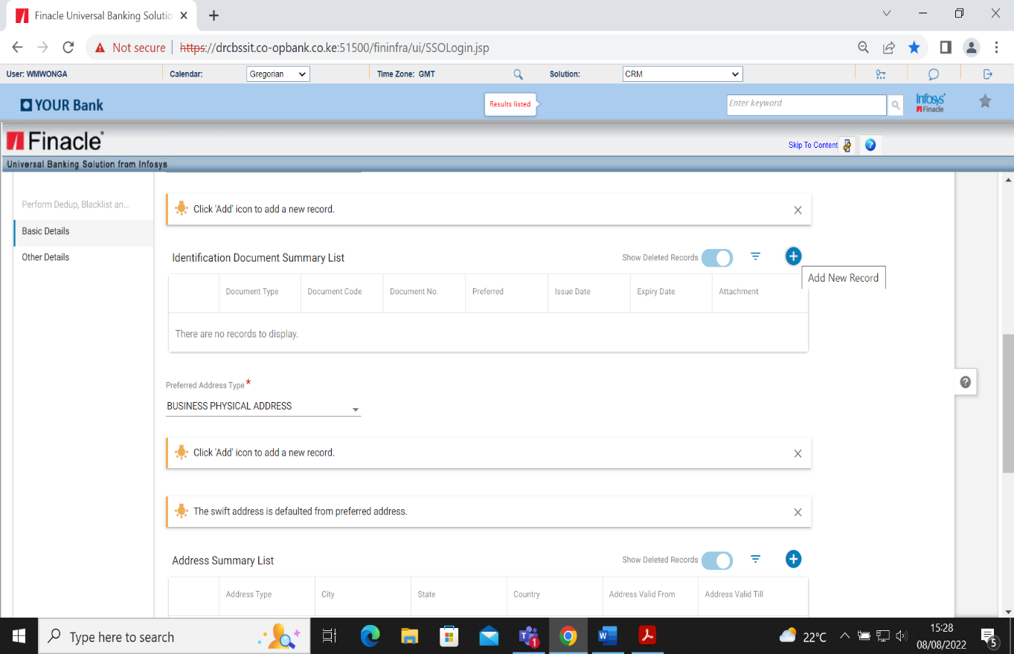

* Click on the add (+) on the Identification summary list table

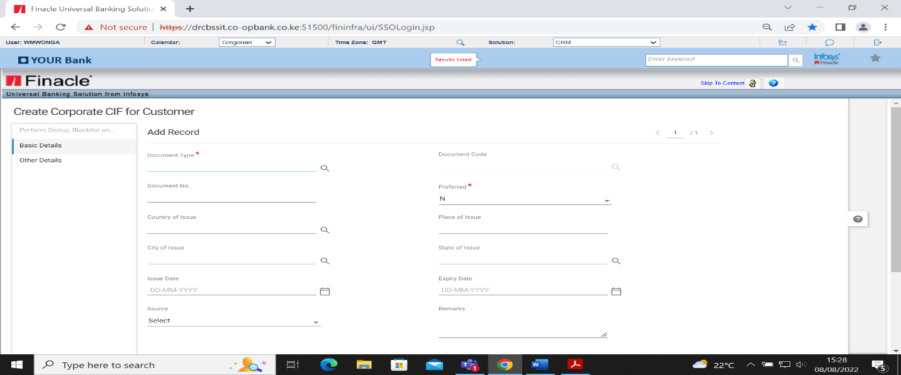

* Select the Document Type from the searcher as IDPRFC (Identification proof of corporate)
* Select the document code from identification document code list
* Input Document number (registration number)
* Select Preferred

Where more than one document is required, the mandatory and preferred document must be preferred status Y and any other subsequent document preference status shall be N.

* Select Country of Issue
* Input the issue date as per the registration document
* Source will autopopulate.

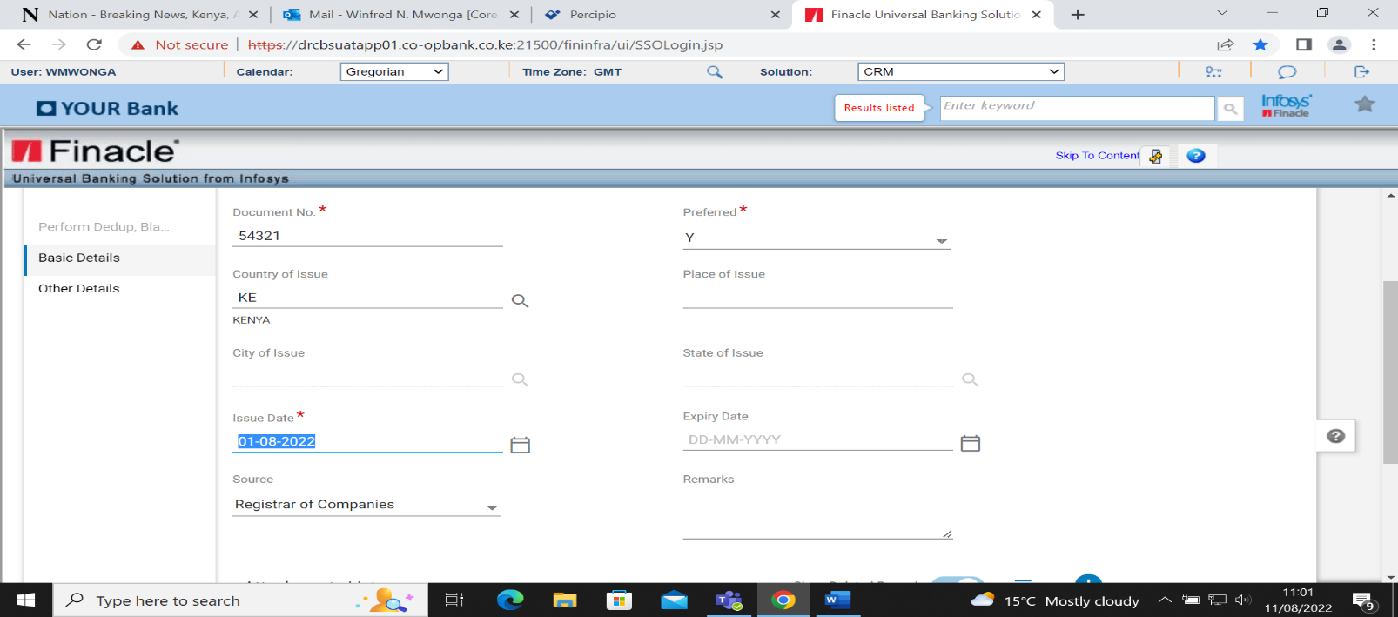

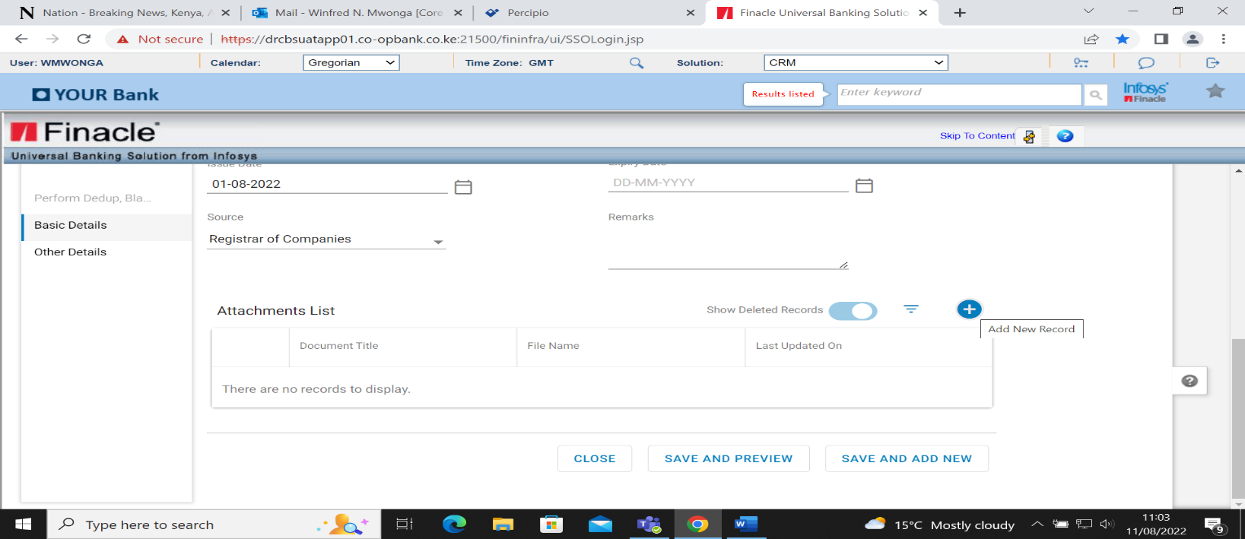

* Click the add button (+) on the attachment list to attach a document

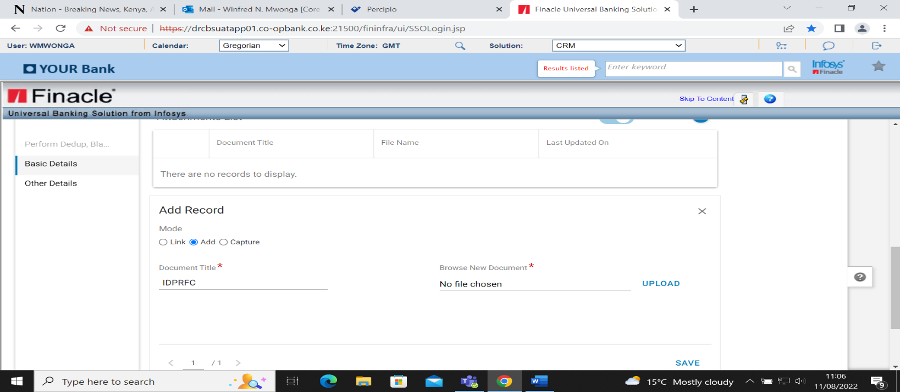

* On Add record mode, there are the following modes
* Link: Used when the document is being retrieved from an existing CIF.
* Add: Used when the document is being derived from save documents.
* Capture: Used when the document is to be captured using web cam
* Select Add mode>Document title automatically populates as IDPRFC
* Browse new document by choosing from file
* Click on upload
* Click Save button

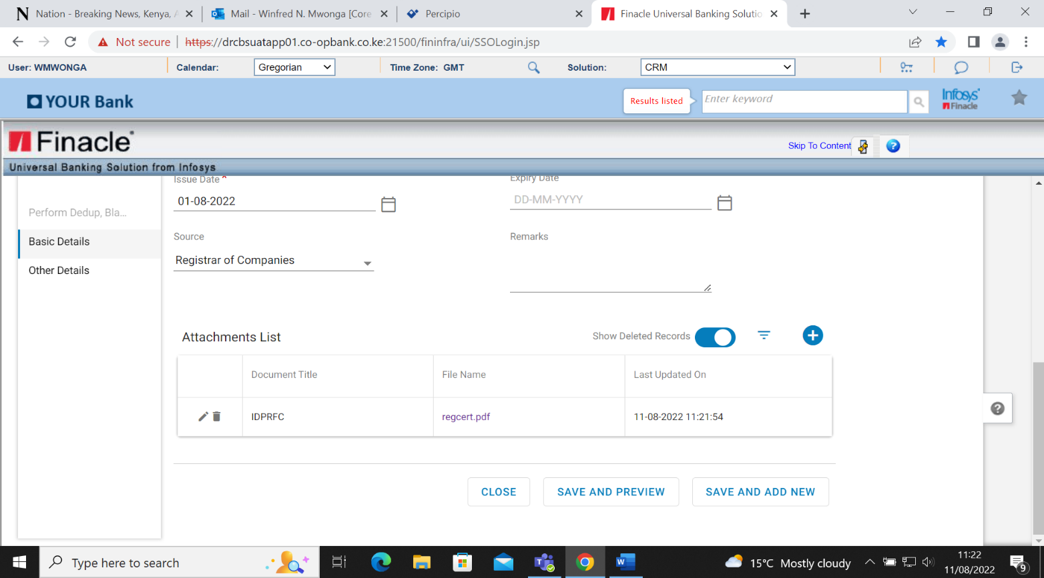

* Click Save and Add New to add more than one document>Click Save and Preview after attaching documents.

## Adding Address for Corporate CIF

**Postal Address**

* Select preferred address type from the drop-down list as postal address
* Click the (+) button on address summary list

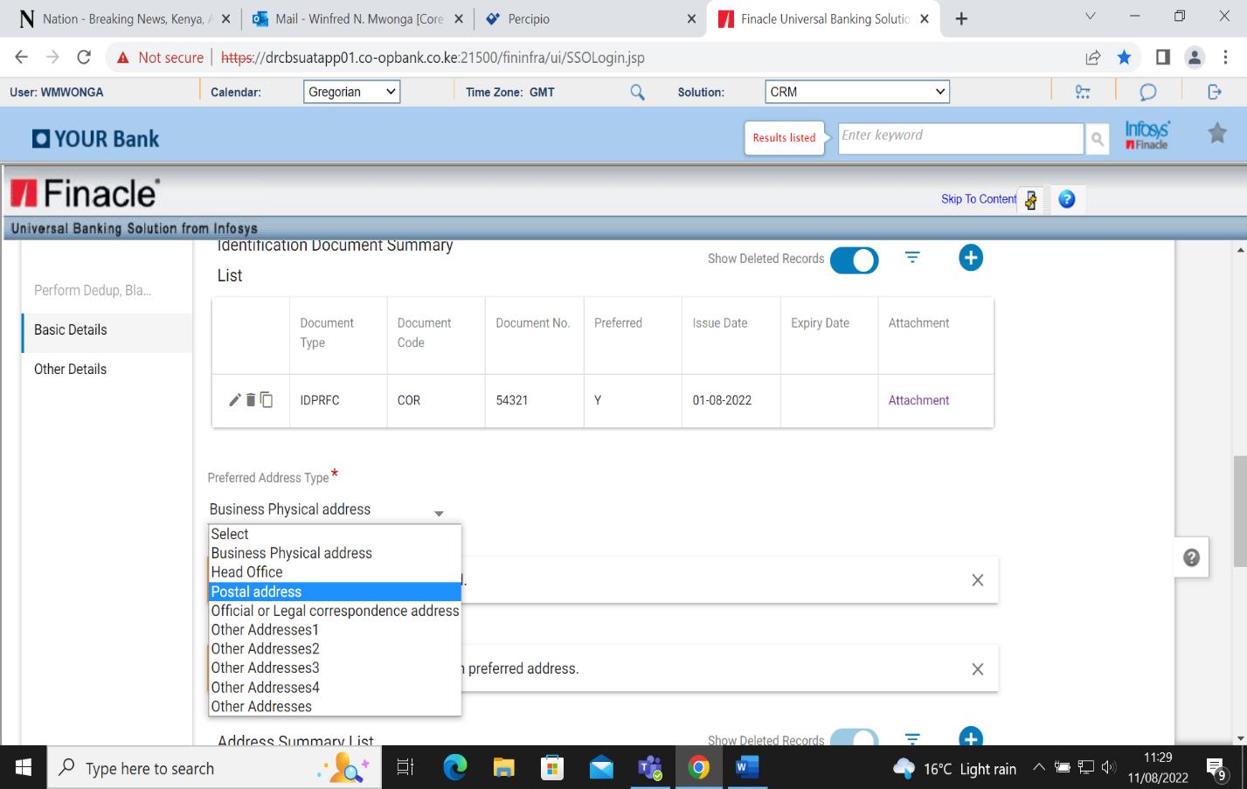

* Select the Address Type-Postal address
* Address format -Free text
* Input address on Address Line 1
* Input postal code or select from searcher-City/Town, County and Country fields auto populate once the postal code is input. Address valid date default to BOD

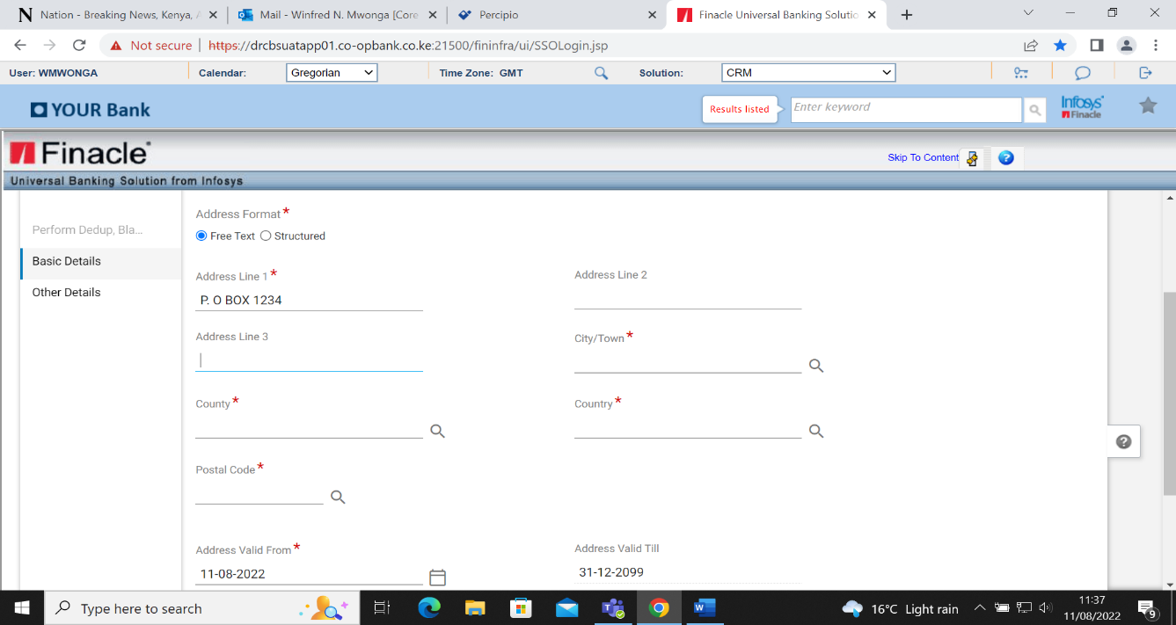

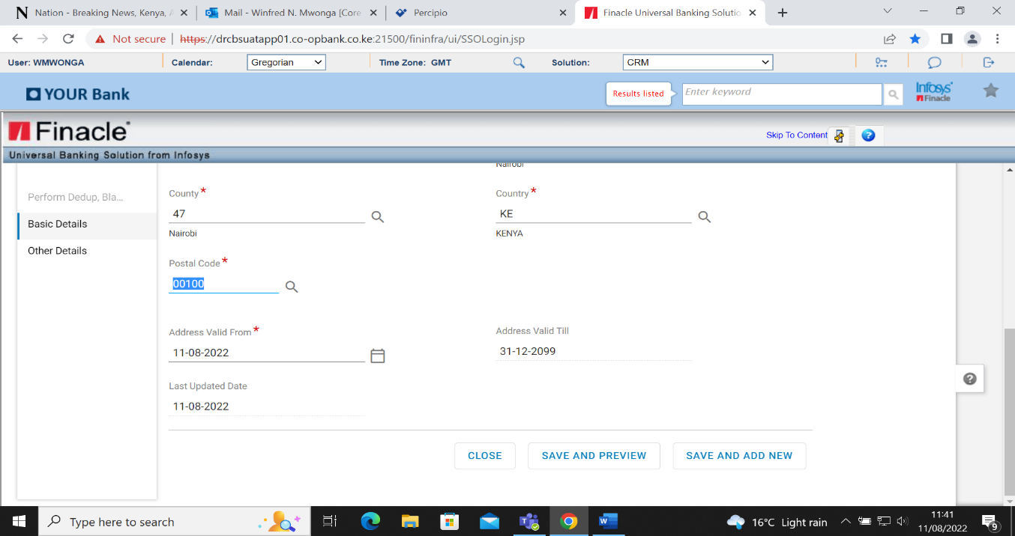

* Click on Save and Add New to add physical address.

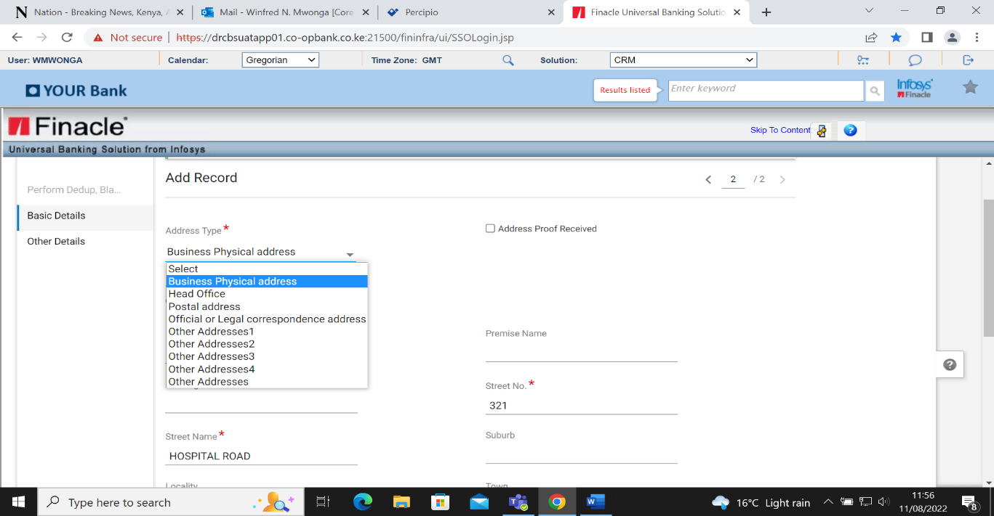

* Select Business Physical address from Address Type
* Select Address Format- Structured
* Enter the house no./Building no.
* Enter street no.
* Enter street name

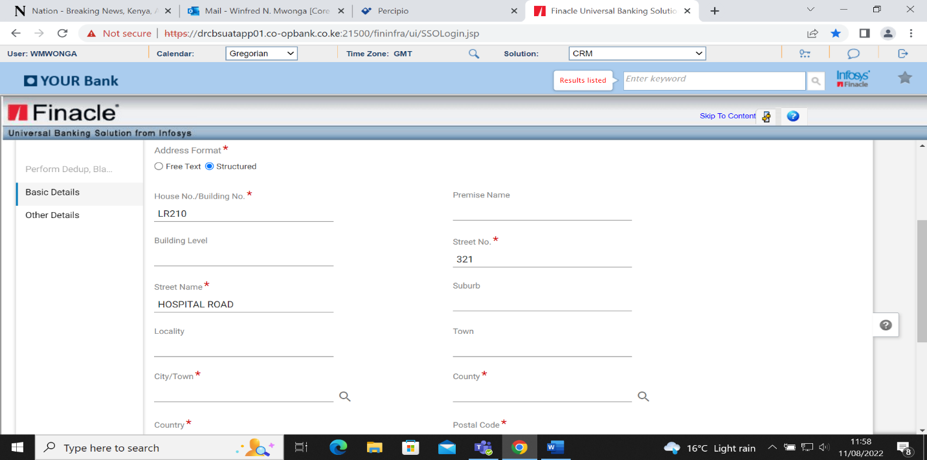

* Input postal code or select from the searcher-City/Town, County and Country fields auto populate once the postal code is input
* Click Save and Preview button.

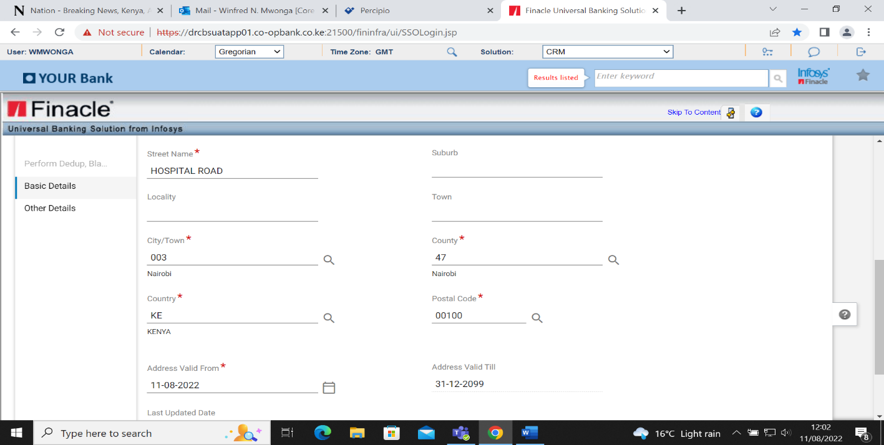

* The record is added successfully

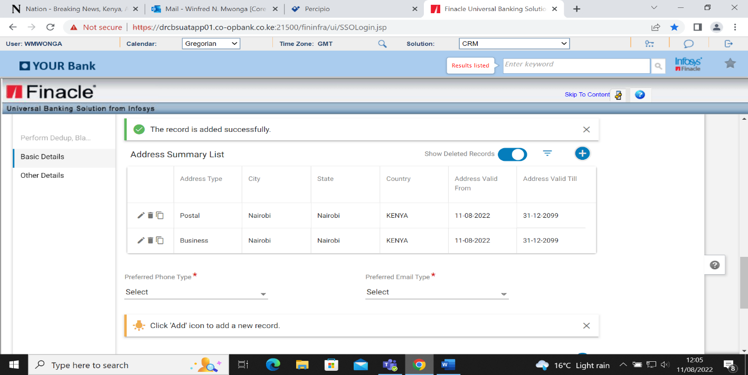

**Adding Phone and Email details for Corporate CIF**

* Select the preferred phone type
* Select preferred email type

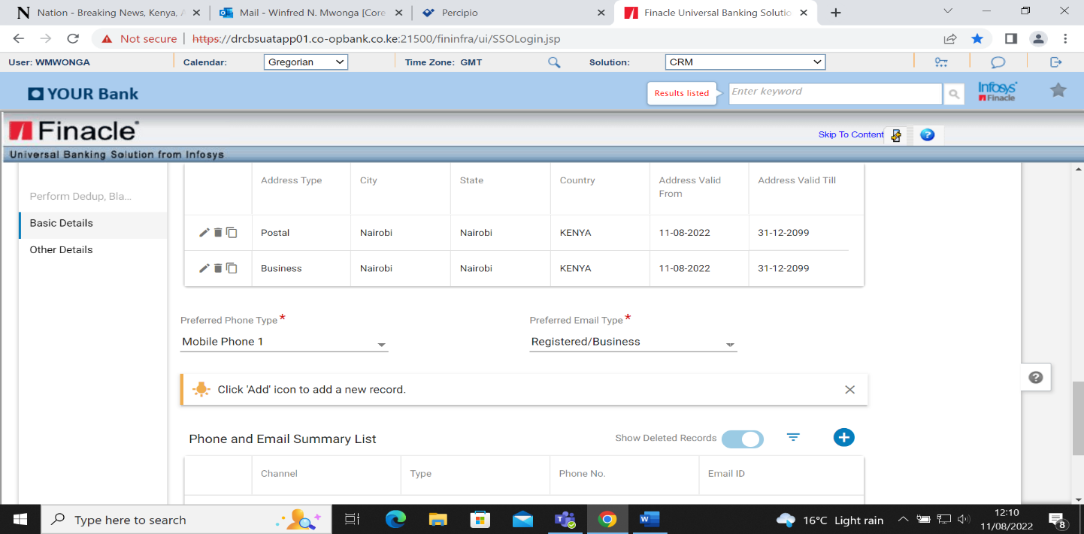

* Click add button (+) on phone and email summary list
* Select channel as phone
* Select the type from drop-down menu
* Select Country
* Country code will auto populate
* Enter the phone no.

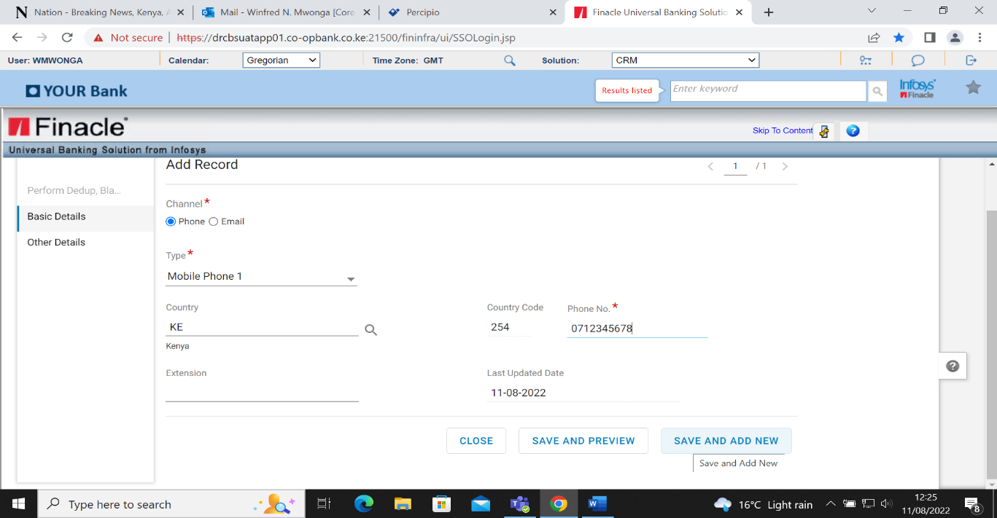

* Click Save and Add button
* Select the channel as email
* Select the type from the drop-down menu
* Enter the email address.

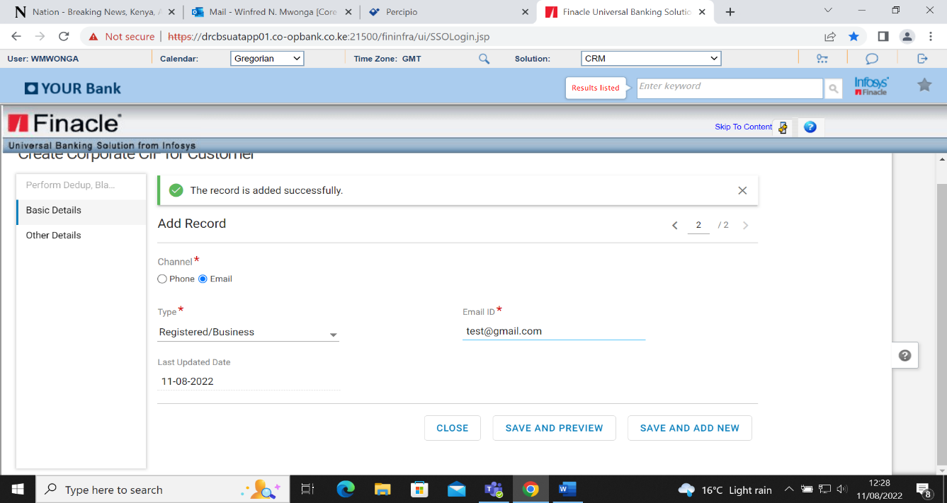

* Click Save and Add Preview.

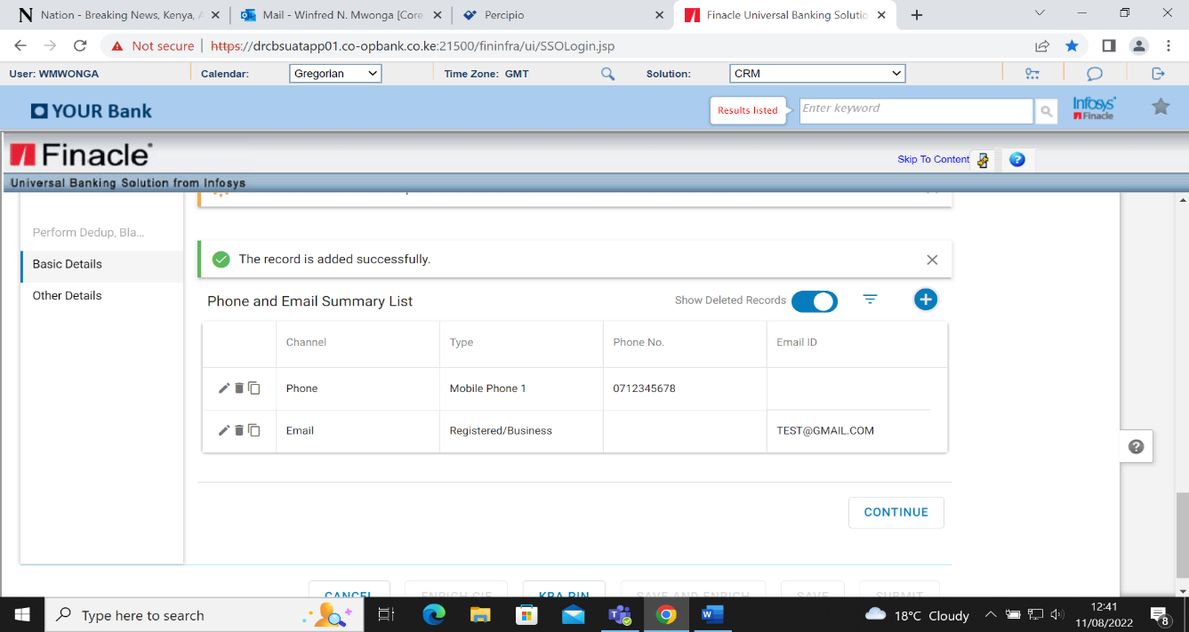

The record is added successfully

* Click continue button.

## Capture Other Details

* Select country of registration
* Select Industry Type
* Select country of operation
* Select business type
* Select classification

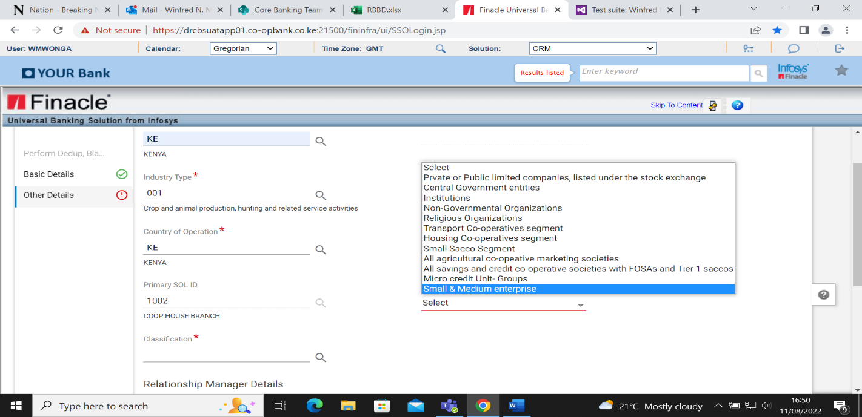

The primary relationship manager ID defaults to the user creating the CIF.

* Amend and input the user of a Relationship manage with an ARO code. The ARO code will auto populate.

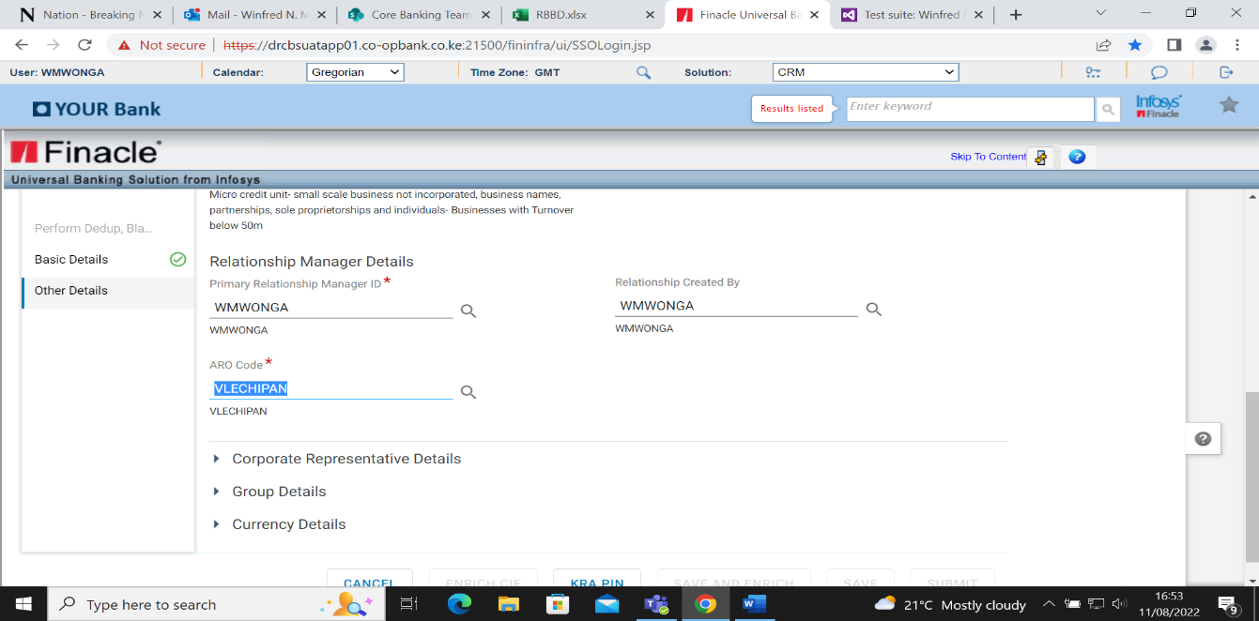

* Click on corporate representative details
* Select Customer on Bank Relation Type
* Input retail CIF ID for the representative
* Select Retail on Address mode
* Select Mailing on Address type.

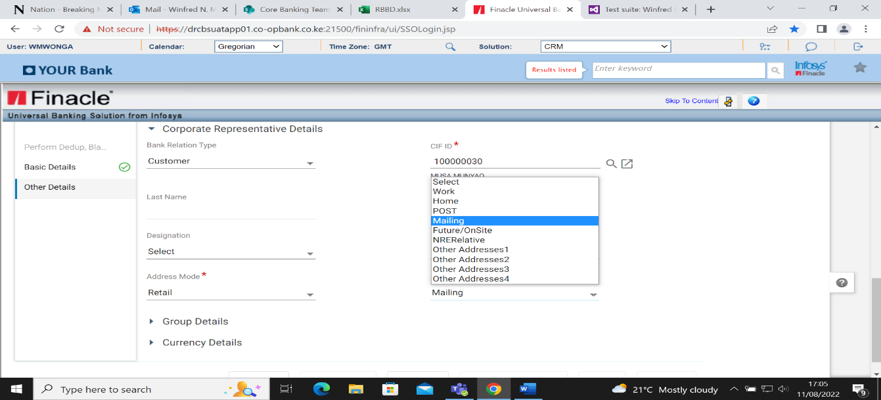

* Click Currency
* Click on the add button (+) on currency detail list
* Select the currency code-CCY from the searcher
* Save and preview to complete or Save and Add new to add another currency.

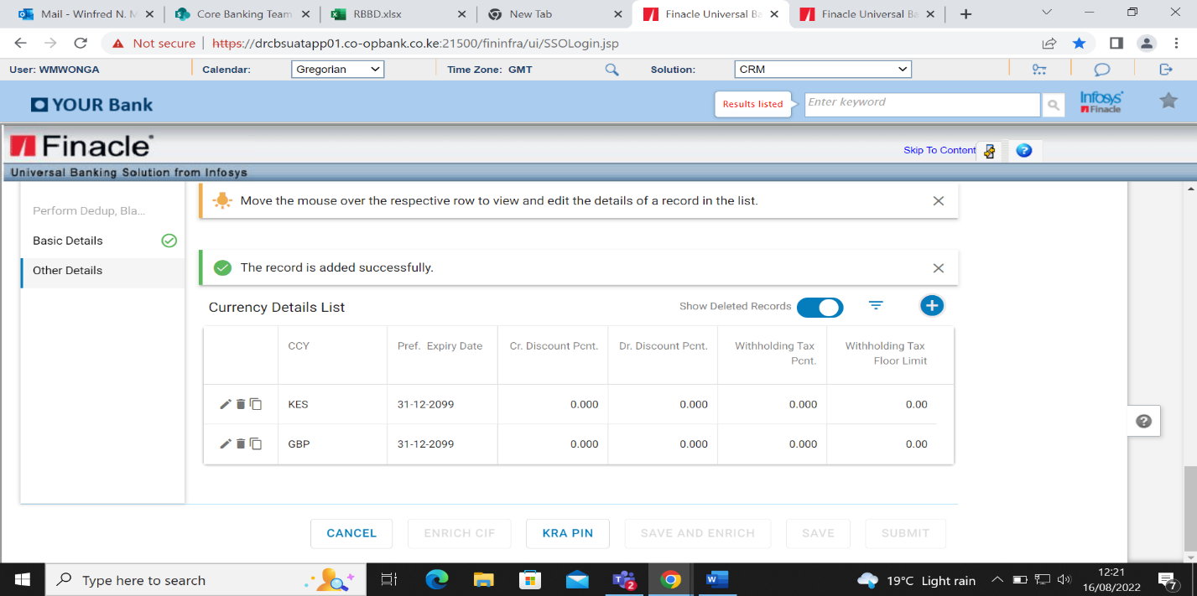

* Click KRA pin to auto populate the tax details as shown below.

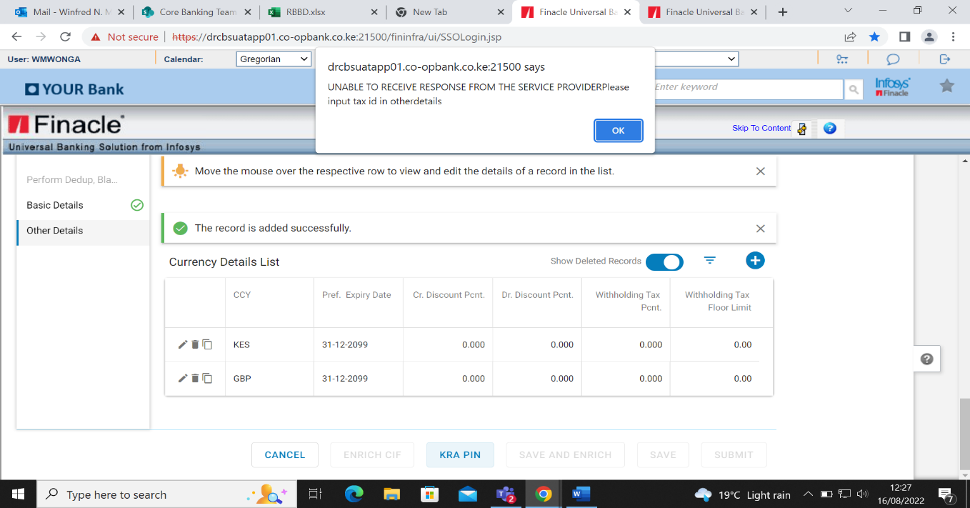

* Click OK.

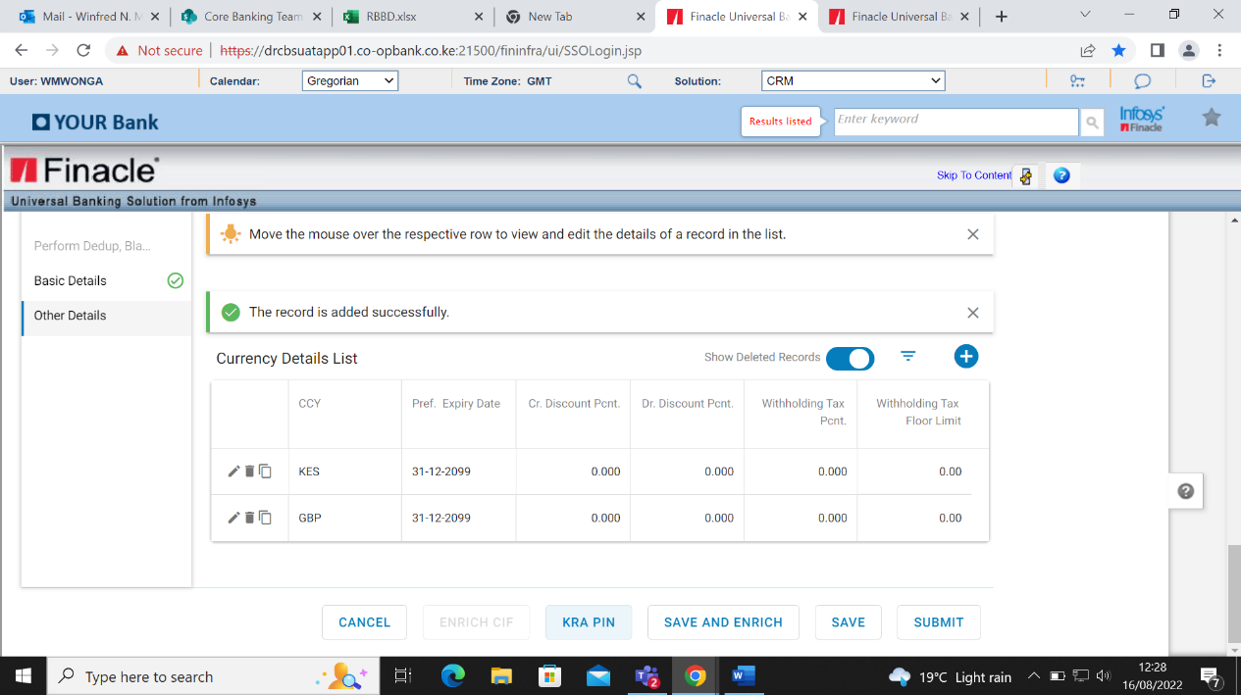

The following buttons will be activated.

* **Save and Enrich** – Use this option to save CIF as a draft while proceeding to specify remaining details in the CIF. After enriching the CIF, the customer can submit the CIF for approval.
* **Save**- Use this option to save CIF as a draft. The details are not updated to the database. Ince the CIF record is saved, it remains in the user’s self-tray. The CIF can be accessed only by the maker through the enrichment menu.
* **Submit**- Use this option to save CIF details into the database, the selected process is used for CIF approval and the status of the CIF is changed to ‘Under Verification’ status.
* **Cancel**- Deletes all the details.
* Click on the Save and Enrich. A CIF ID is generated

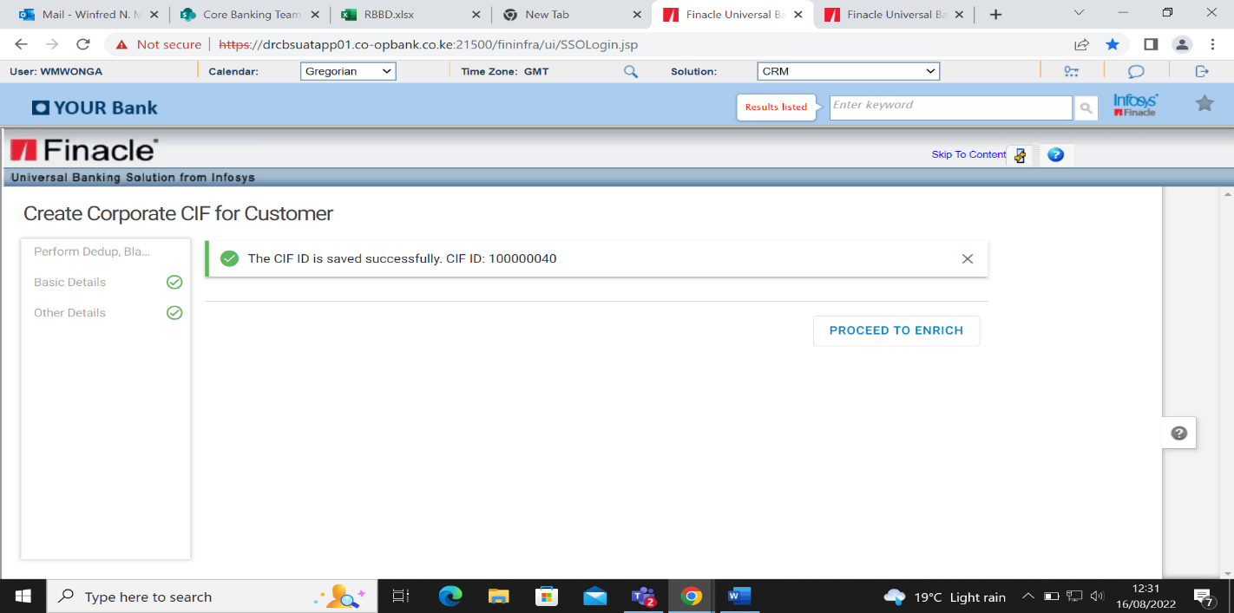

* Click on Proceed To Enrich>Additional Details

## Additional Details

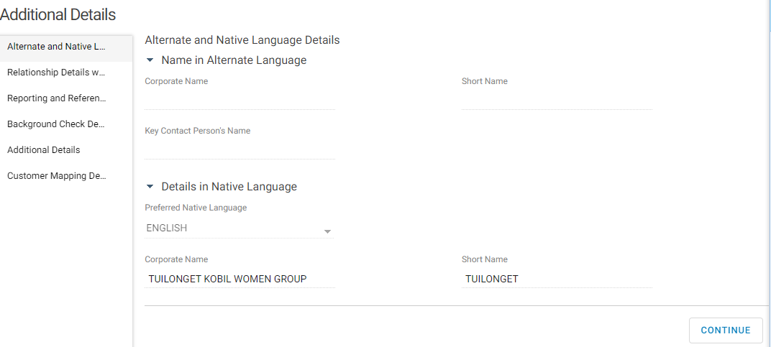

* Click continue>Relationship details with other banks

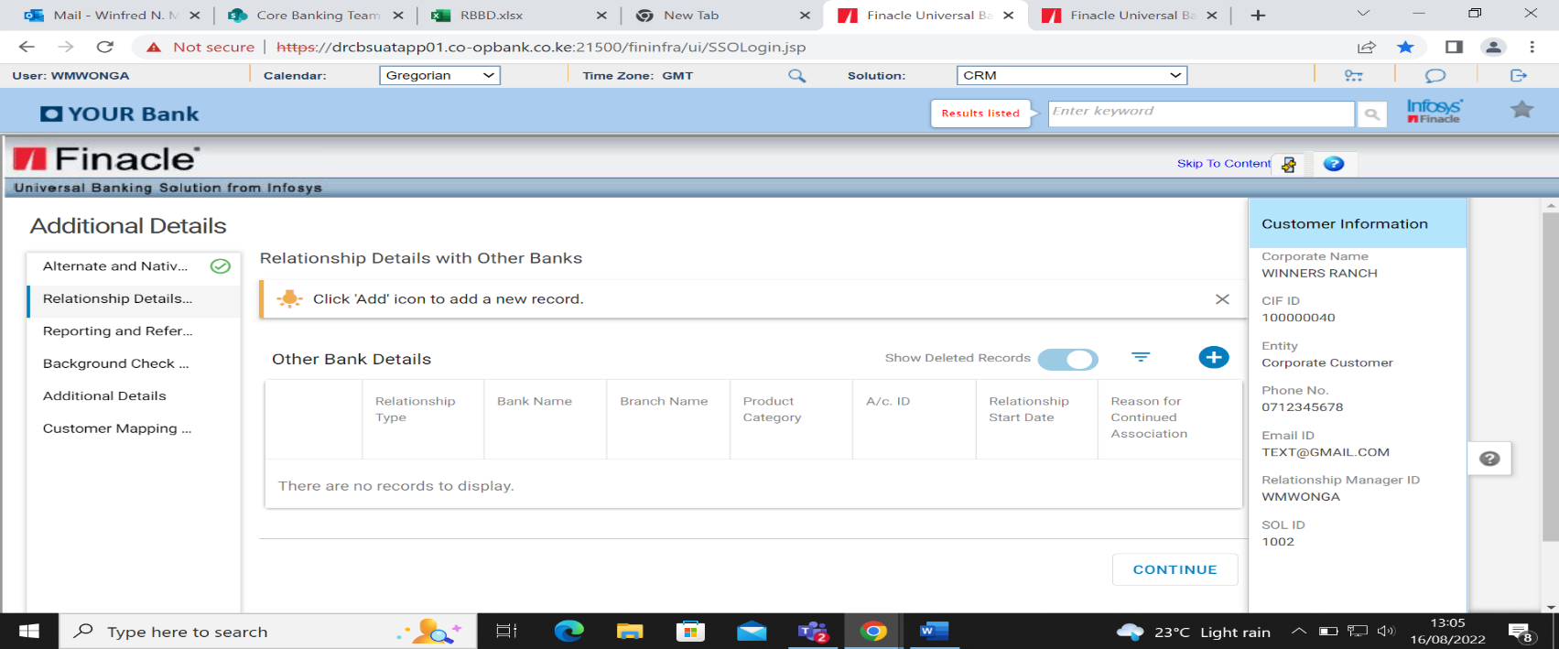

* Click on continue button >Reporting and reference details
* Select Sector and Subsector>CBK sector and subsector
* Select Region
* Select Affiliate to Bank.

Affiliated is the case of subsidiaries to the bank such as Kingdom Securities Ltd, Jamii Bora Bank etc.

* Select Insider to bank. Insider is in the case of Director, CEO, and Significant Shareholder.

If the customer is an insider, the insider role must be selected.

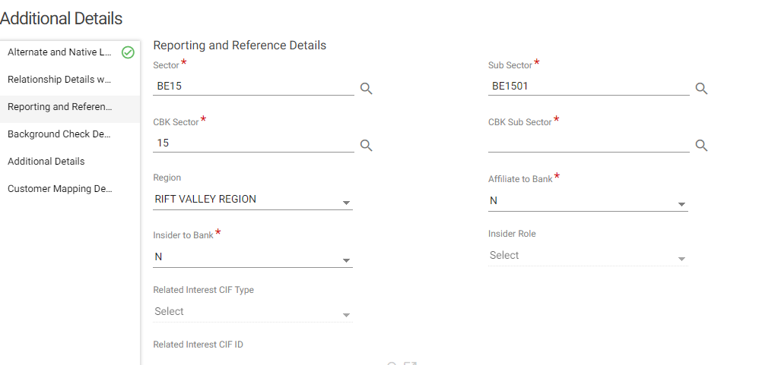

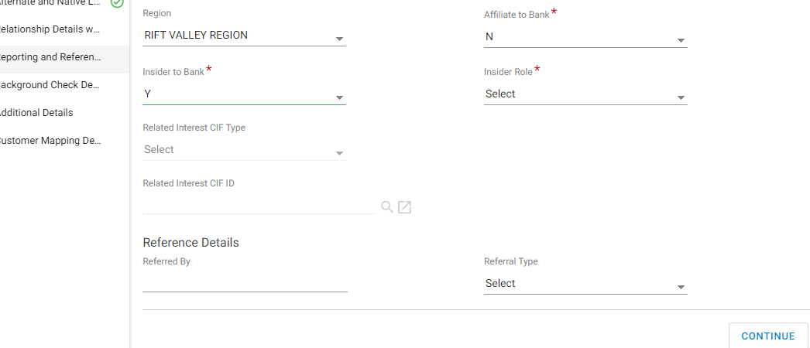

* Click on Continue> Background check details

## Background Check Details

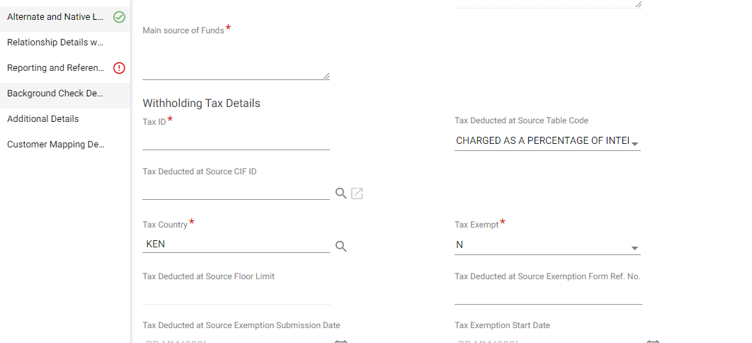

* Input main source of funds
* Input Tax Id (KRA pin)
* Select Tax Country
* Select whether the corporate is tax exempt Y or not N>Foreign Account Tax Details.

**Note1:** Where the corporate has registered a KRA pin, the system will auto populate the number on the Tax ID field, however, if the KRA PIN is not generated the user will have to enter manually.

**Note 2:** Where the corporate is tax exempt field is Y the following fields will be activated as mandatory.

* Tax deducted at source exemption form ref no.
* Tax deducted at source exemption submission date.
* Tax exemption start date.
* Tax exemption end date.



This section is used to record tax details for US locale only.

Fatca identification, requirement and process is covered in detail on APPENDIX VI – FATCA IDENTIFICATION REQUIREMENTS AND PROCESS

Foreign A/c Tax reporting required field will be applicable for US citizen, otherwise the default status will be N

For US citizen, Select Yes on the Foreign A/c Tax reporting required field this will activate the mandatory fields

* Click the + button to add a record
* Input foreign tax reporting country
* Enter tax reporting status
* Enter the foreign Tax Identification Number
* Select the last tax reporting review Date
* Select the next Foreign tax reporting review date.

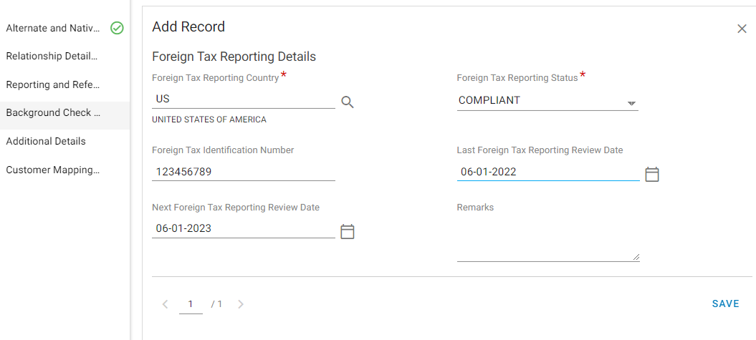

* Click on Save

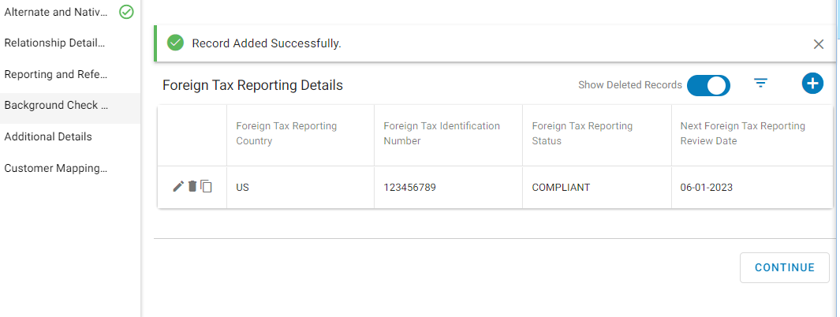

* Click on Continue > Additional Details
* Select Y/N on owned by foreigner
* Select Y/N for owned by women
* Select template type.
* For template type, select NGO for non-profit organization,
* Select Government for government institutions while the default for any other corporate.

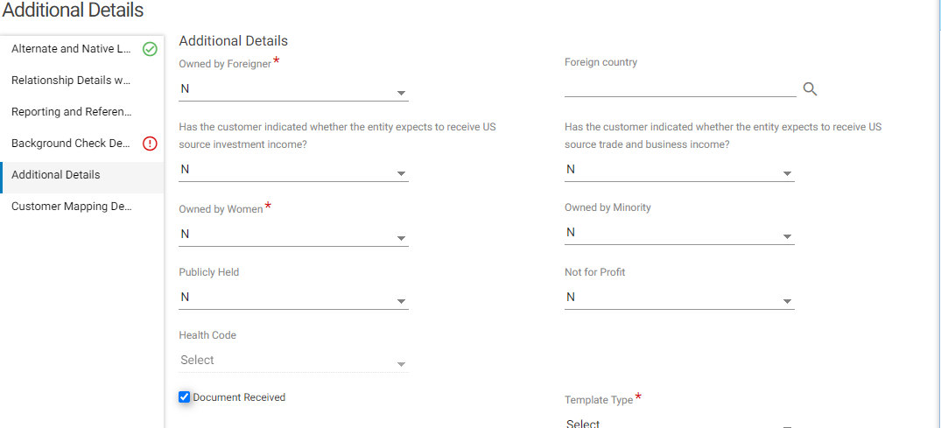

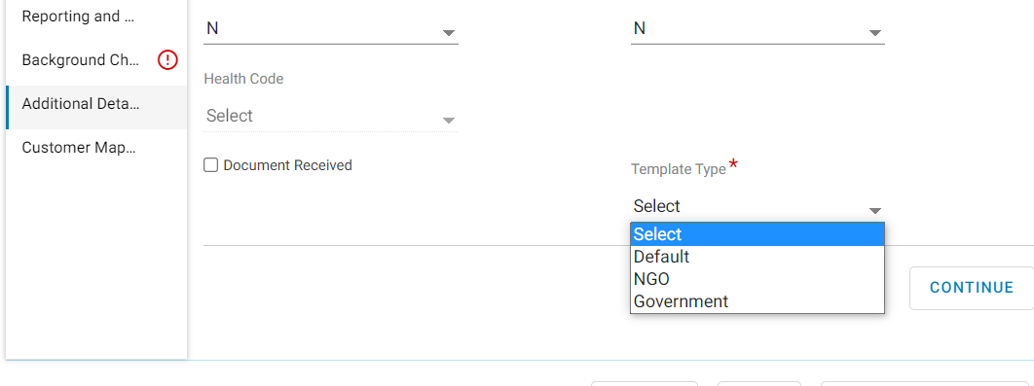

* Click continue button >Customer Mapping

## Customer Mapping

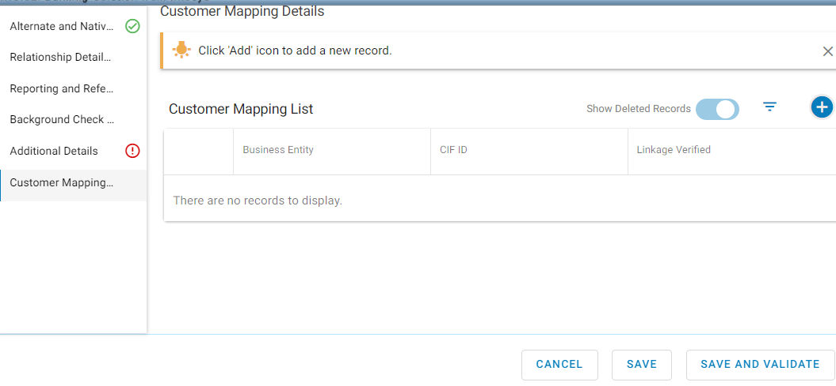

* Click on save and validate.

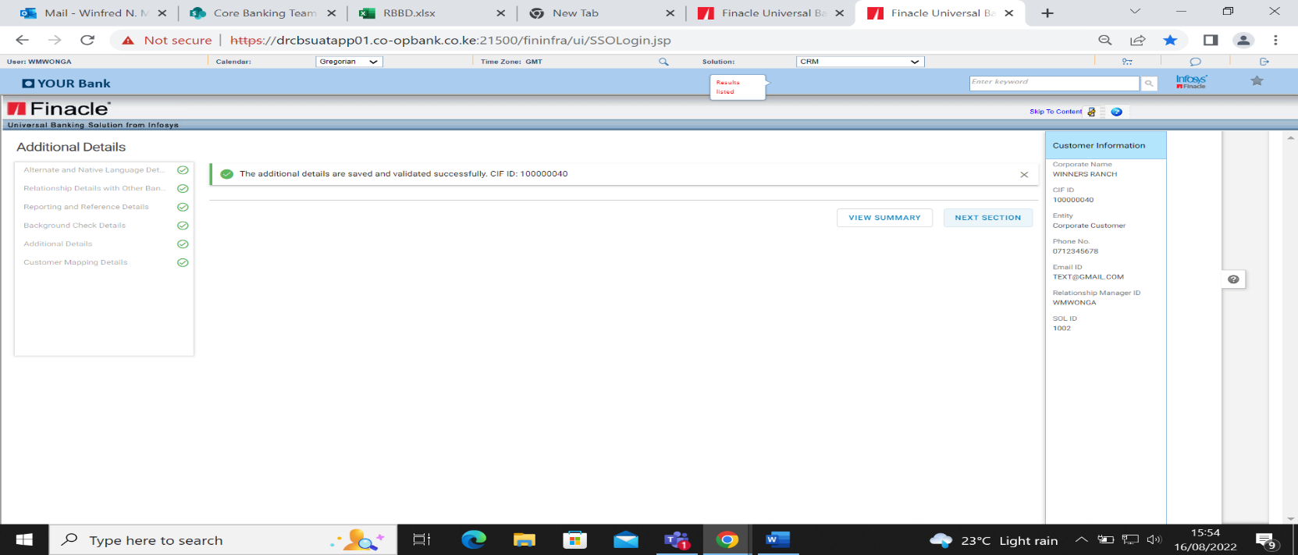

* Click next section>Bank Defined Details

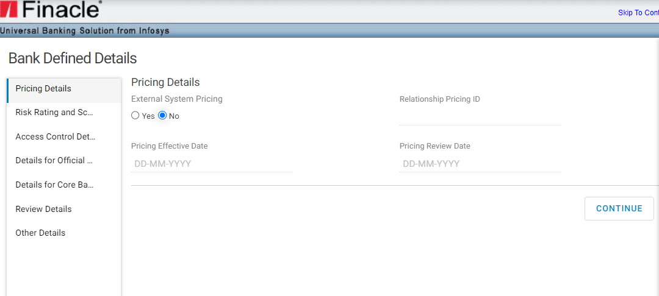

Pricing details are not edited.

* Click continue >Risk rating and Score Details.

## Risk rating and Score Details

* Select customer rating
* Select PEP/PEP Associate as either Y/N

Risk rating is system generated

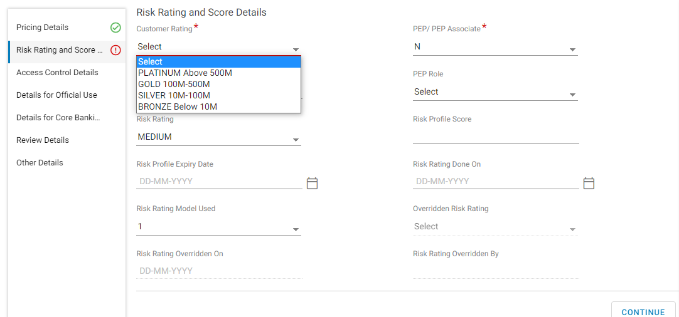

* When PEP/PEP Associate is selected as Y, PEP name and the PEP role details must be input.

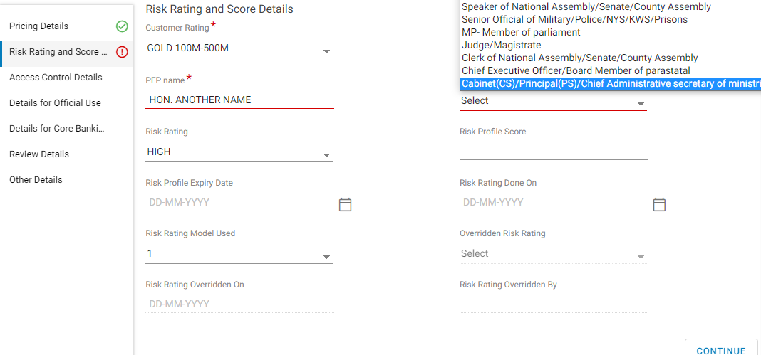

* Click Continue button > Access Control Details

## Access Control Details

This section is used to feed Finacle CRM on which users shall be able to access the entity’s CIF. Only the users in the access control can access the entity’s CIF. Access Control has the following attributes.

* Access owner Group-This is Business group. The system defaults to General Banking
* Access Owner Segment-This is the Access Owner and Access Segment, and it defaults to Preferential Banking.



* Click on Continue > Details for Official use.

## Details for Official Use

* Select status as Active>Select secondary segment.

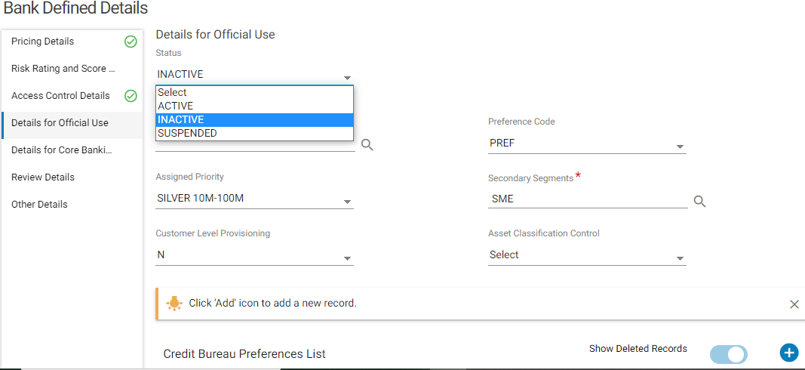

* Click the Continue button > Details for Core Banking

## Details for Core Banking

* Capture Bank SWIFT Code indicator as Y and the Customer SWIFT code if applicable

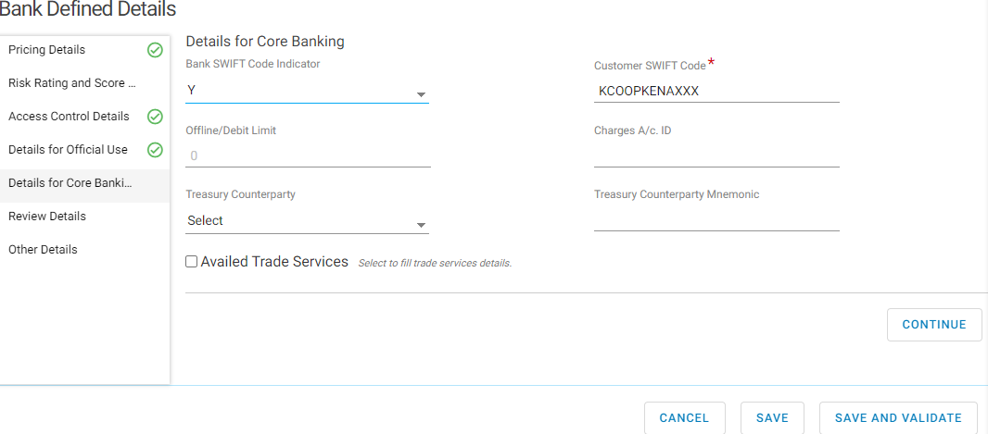

* Click Continue button > Review Details

## Review Details

Review details section is not editable.

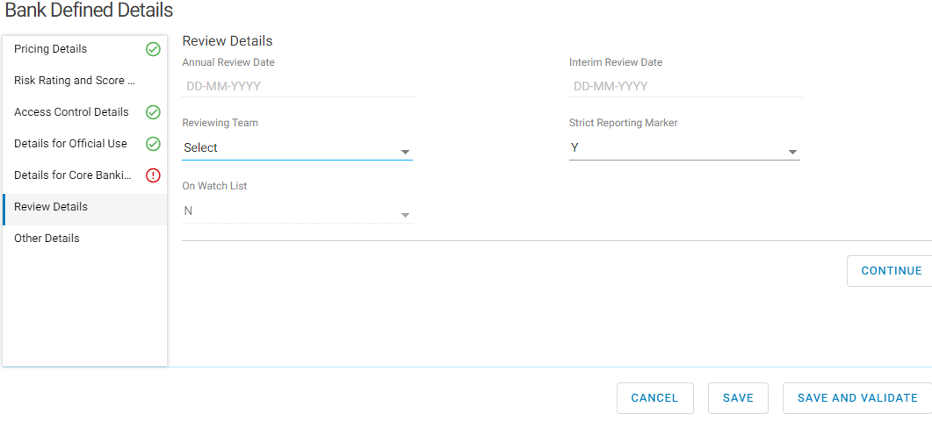

* Click Continue button >Other details

## Other Details

* Click on + button to add a record of the Business Name
* Click Save
* Click Save and validate to proceed to the next section.

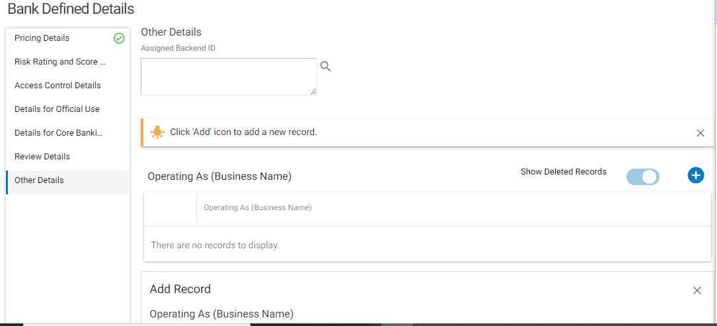

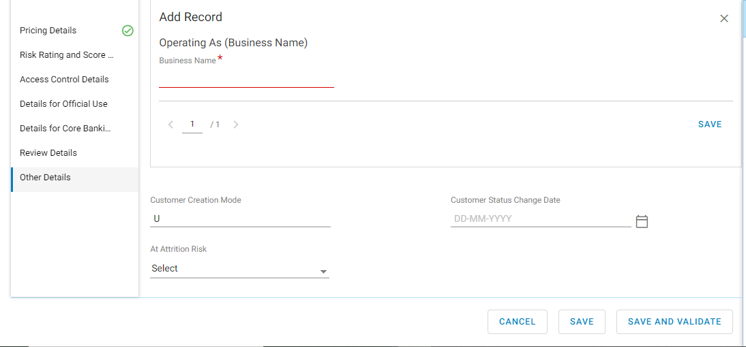

* Click on Save and Validate.

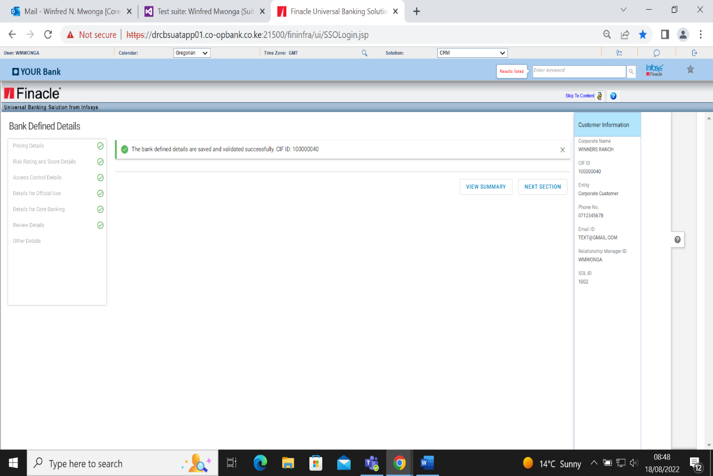

* Click on Next section> Preference Details

## Preference Details

* Select Enable E-banking as either Y/N
* Select Preferred Communication Channel

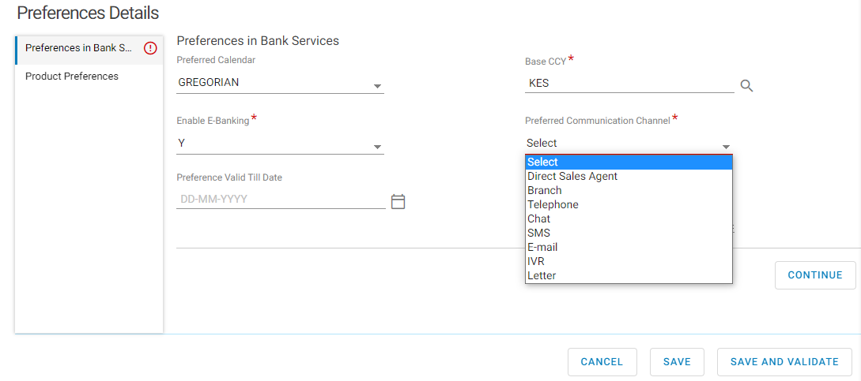

* Click on Continue> Product And Preferences

## Product and Preferences

* Click + button to add any records on product preferences list
* Select Product Category from the drop down
* Enter Product name
* Enter subscription Start and End date
* Enter any additional Remarks
* Click save to display the records> Click Save and validate> Click Next section.

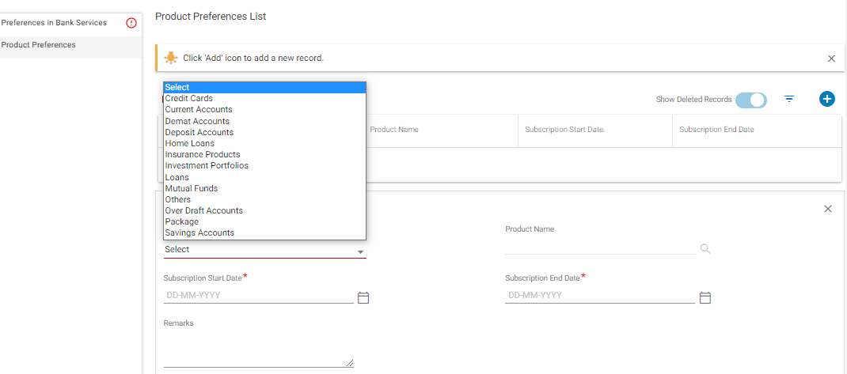

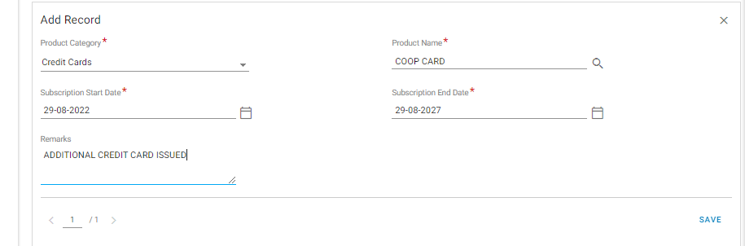

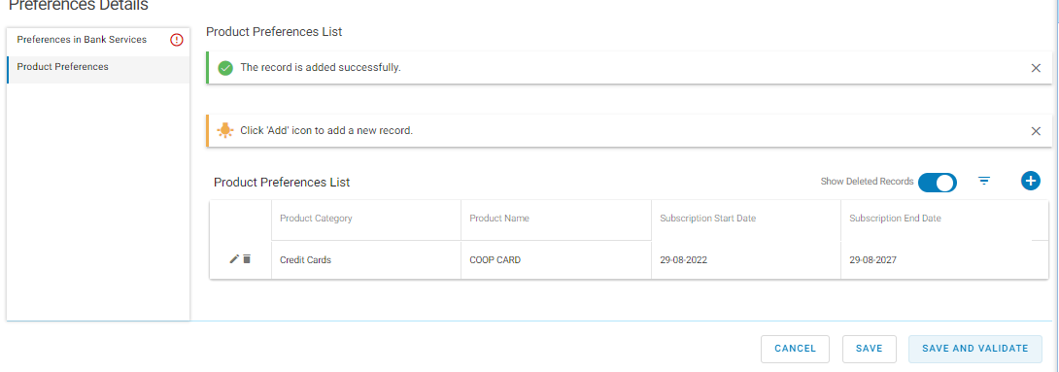

* Click on Save and Validate

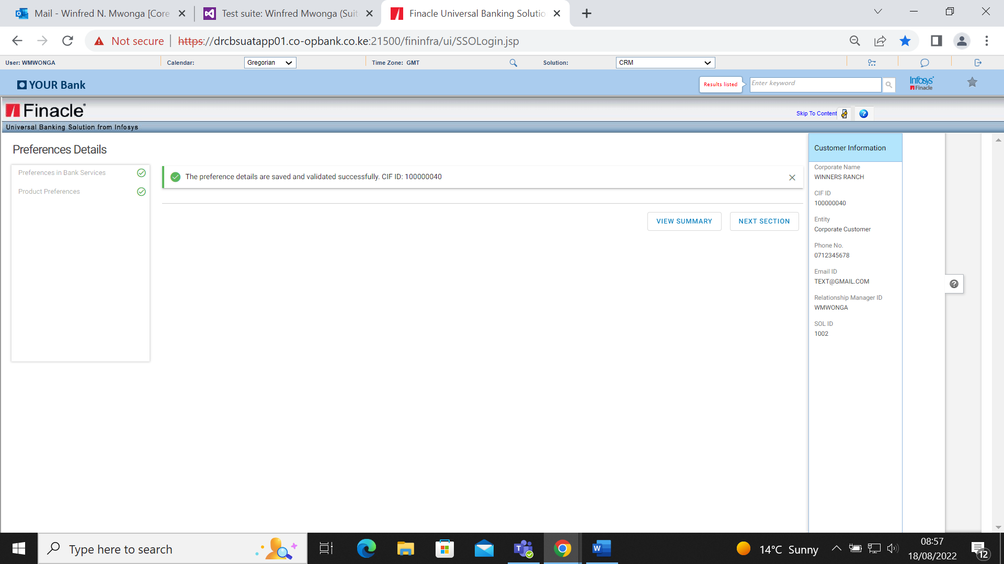

* Click Next Section> Financial Details

## Financial Details

This section entails capturing of Transaction Details, Corporate Financial Details and Other details. It is not a mandatory section.

### Transaction Details

* Click (+) Add button to capture all the transaction details
* Click save and preview to display the added records
* Click Continue

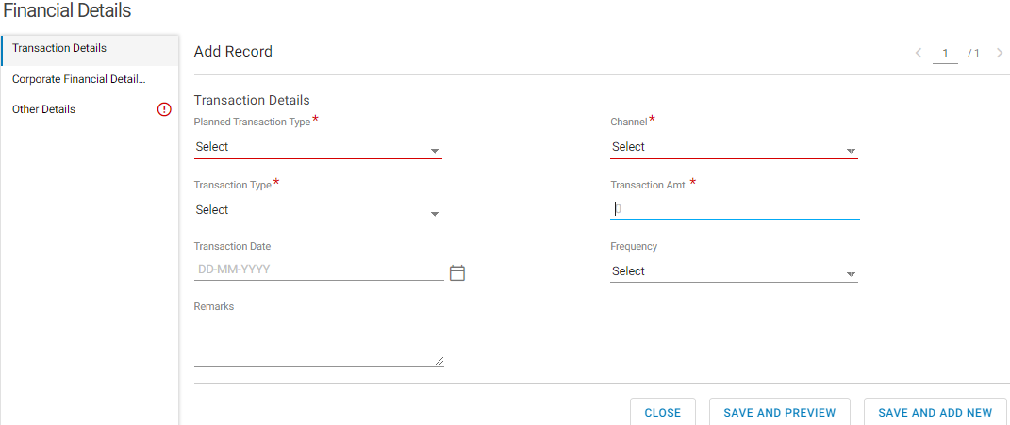

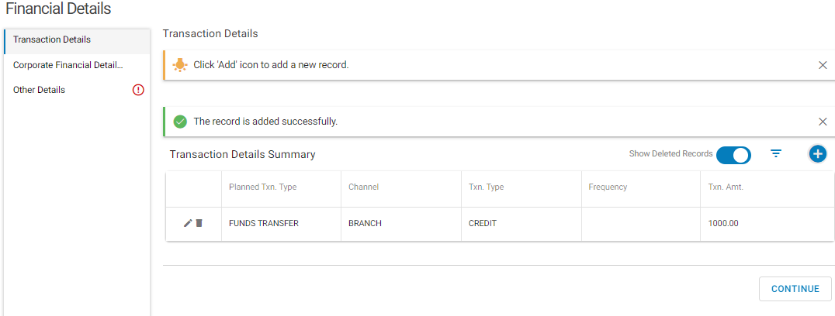

### Corporate Financial Details

* Enter the General Details. Year, Month, Audit Status and Frequency.

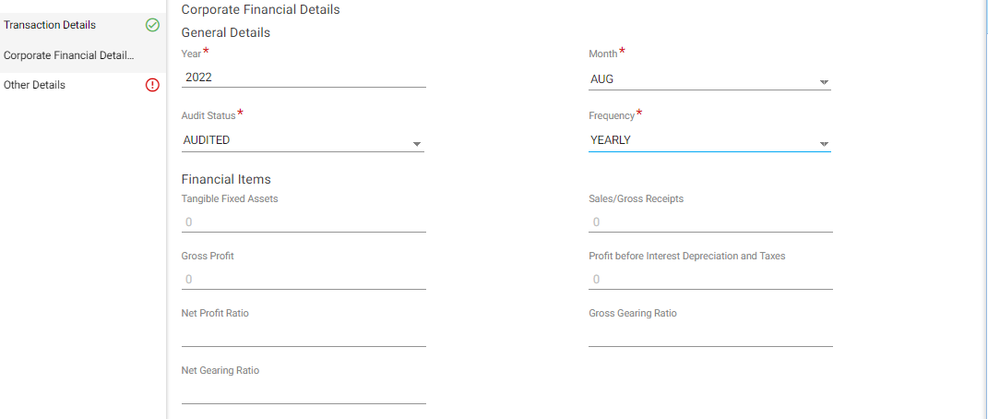

* Click Save and Preview to display the summary.

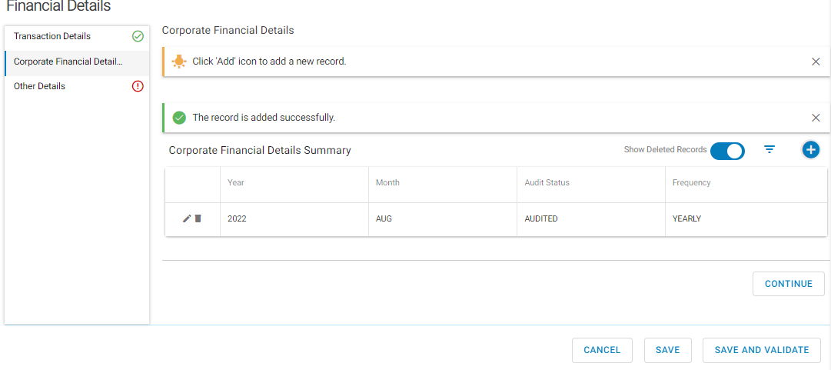

* Click Continue button > other details.

### Other Details

* Enter average annual income
* Select income range
* Select share holder indictor as Y or N

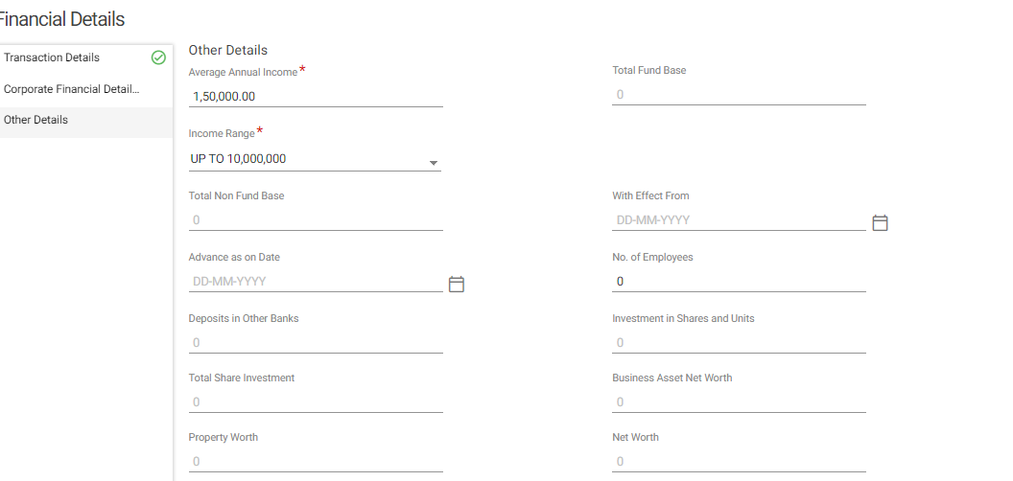

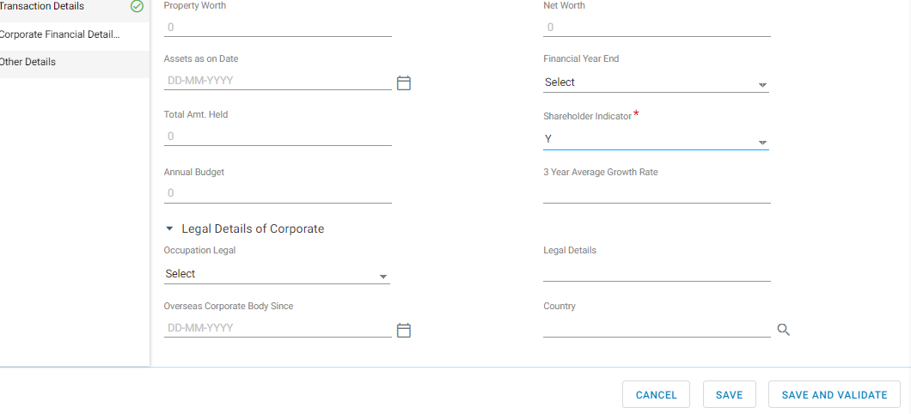

* Click on save and validate.

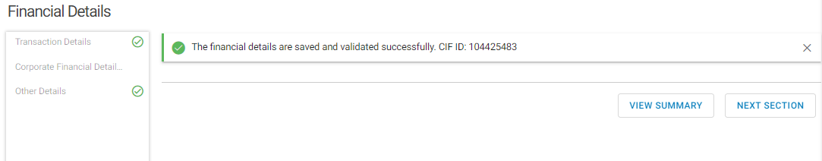

* Click next section>Relationship Details

### Relationship Details

This section captures details of other banking relationship, corporate branch relationship and Relationship details with other banks.

**Other Banking Relationship**

* Click on the add (+) button on the relationship list
* Select the Relationship type
* Select Existing CIF if N proceed to create new CIF if there is an existing CIF input the number
* Enter the Address category, Address type and Roles

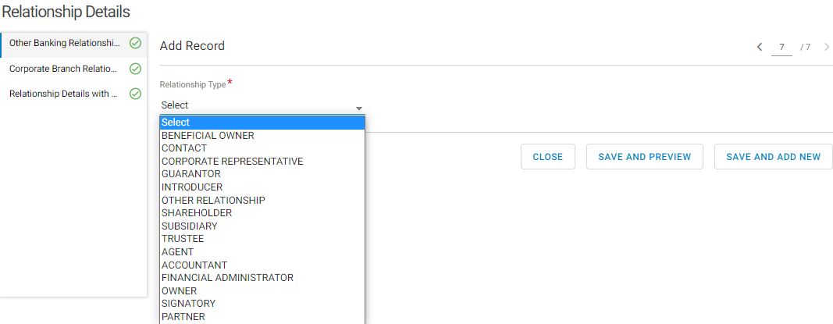

* Click Save and Preview >Click continue

The screen below will be displayed with all the banking relationship.

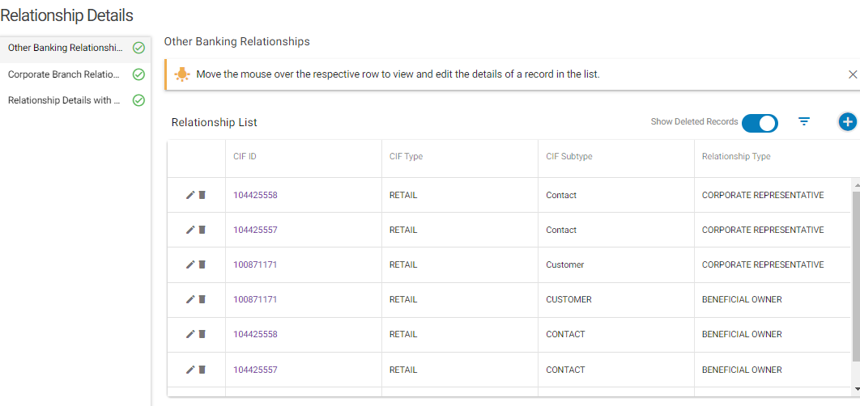

### Corporate Branch Relationship

This section captures details of any corporate relationships.

* Click the (+) Add button
* Select Corporate Branch type
* Input Corporate branch name
* Input details of Corporate branch address

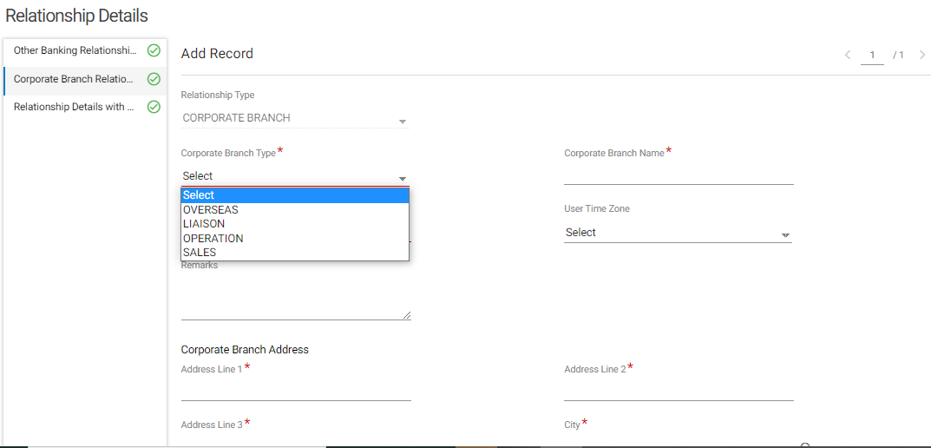

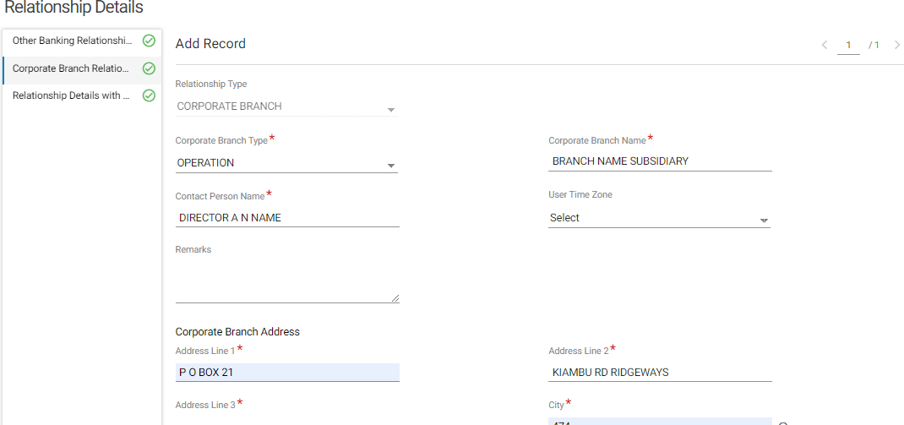

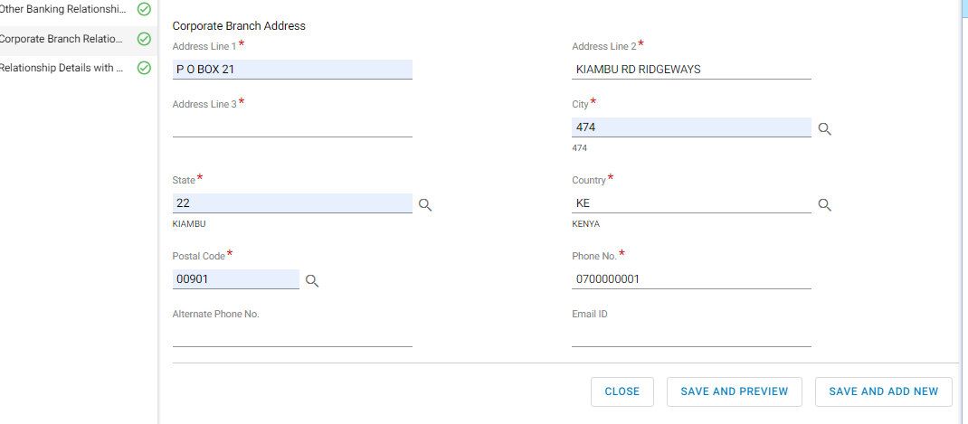

* Click Save and Preview> Click continue

The below shows a summary of the corporate branch relationship

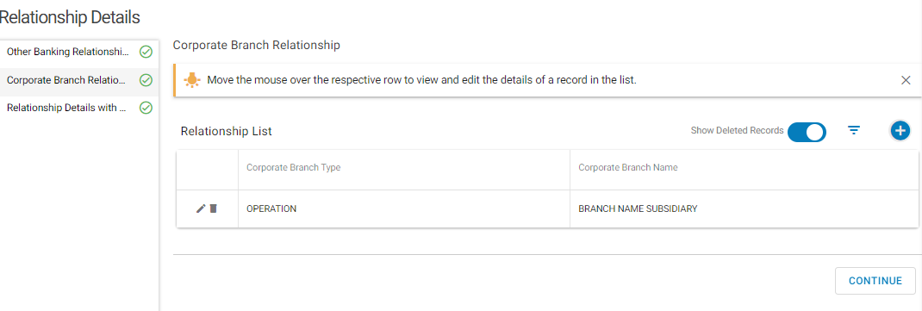

**Relationship with other banks**

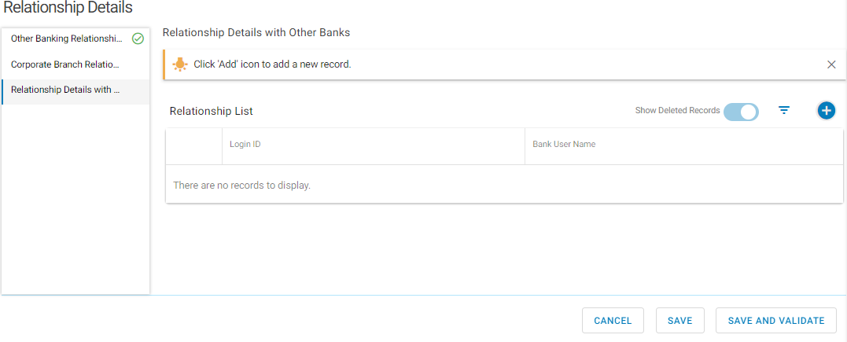

* Click on save and validate.

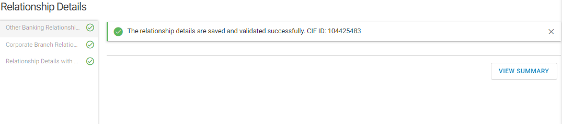

* Click view summary, the below screen is displayed.

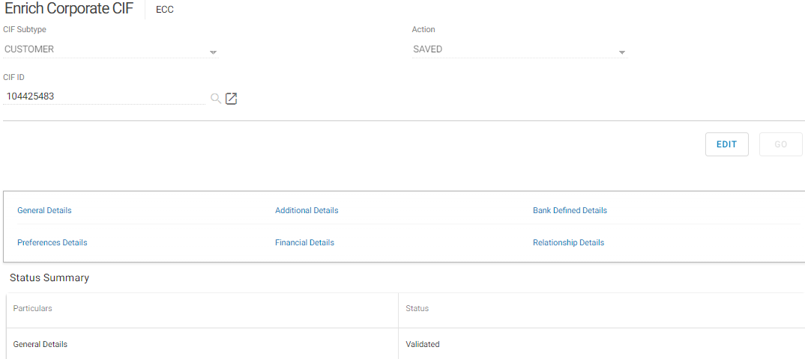

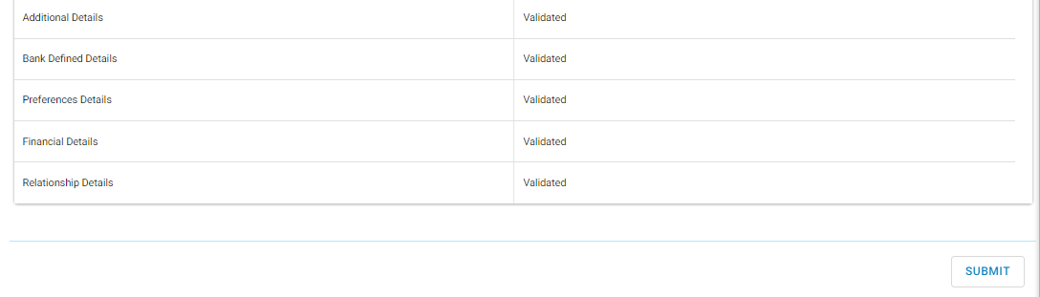

**Note:** All the six fields shall be in validated status before proceeding to submit for approval.

* Click on submit to forward the corporate CIF for approval.

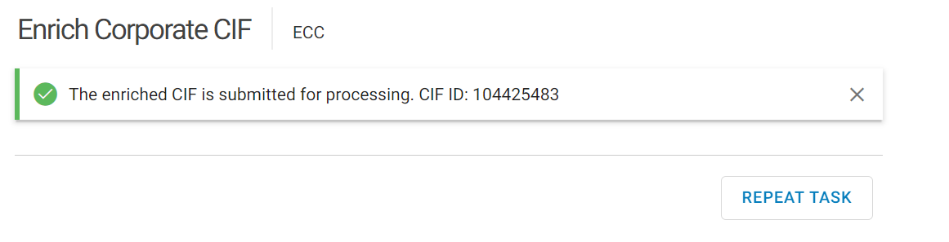

## Corporate CIF Verification

* Invoke menu RCCAT (Retail and Corporate CIF Approval Tray)
* Select Corporate on CIF type
* Select Approve on Action
* Select the Entity Type
* Click Search to view the pending work.

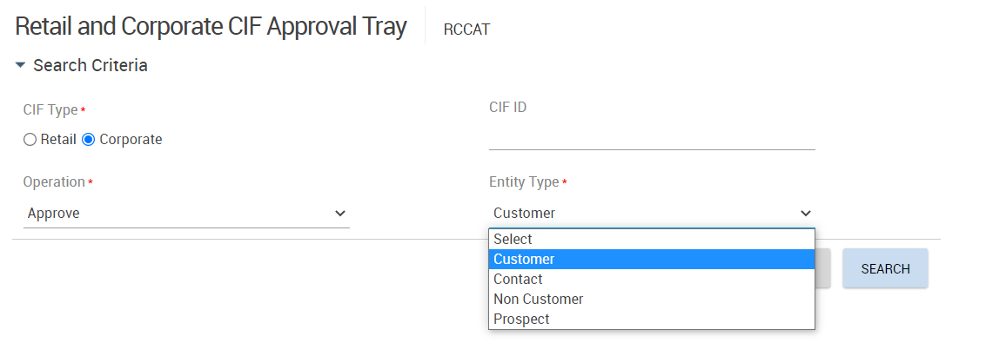

All the corporate CIFs for the SOL awaiting approval will be displayed.

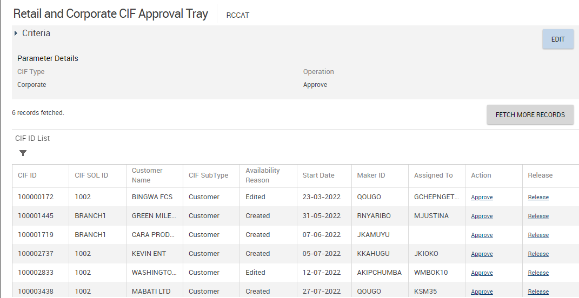

* Select Approve on the desired CIF under Action.

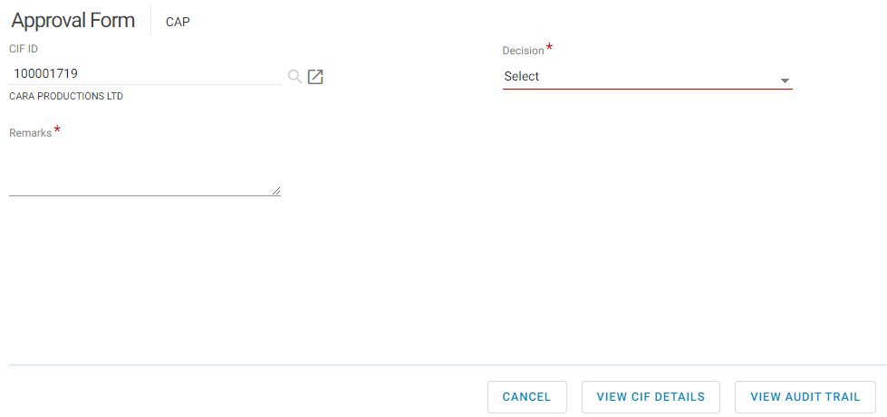

* Click the View Audit Trail button
* Click on + button to view all details.

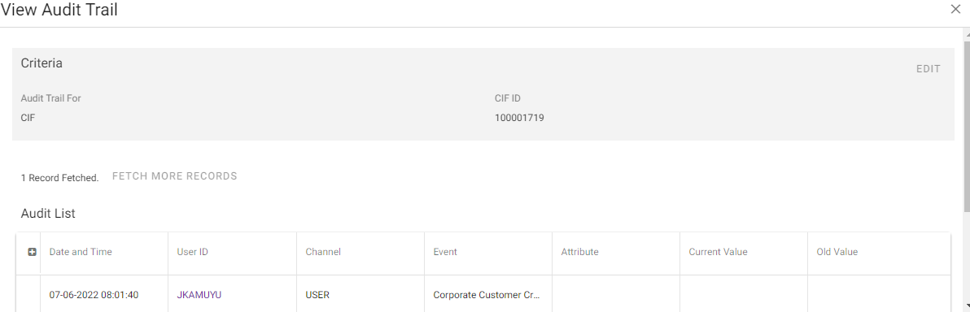

* Click on close

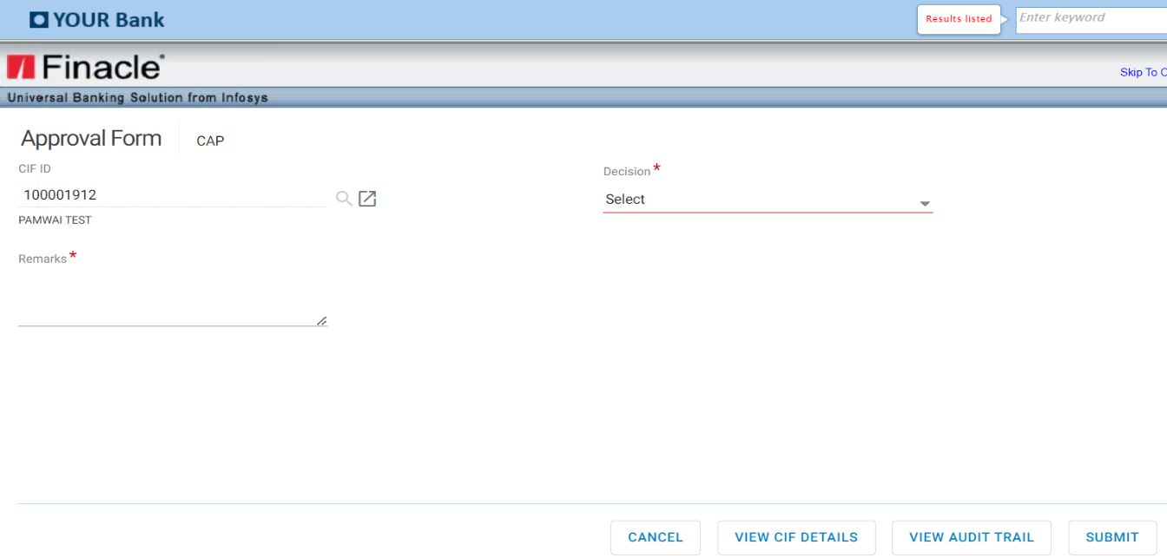

* Click on View CIF details >defaults to menu **IECC** Inquire on Corporate CIF
* Click on all the fields to view
* Click cancel to go back.

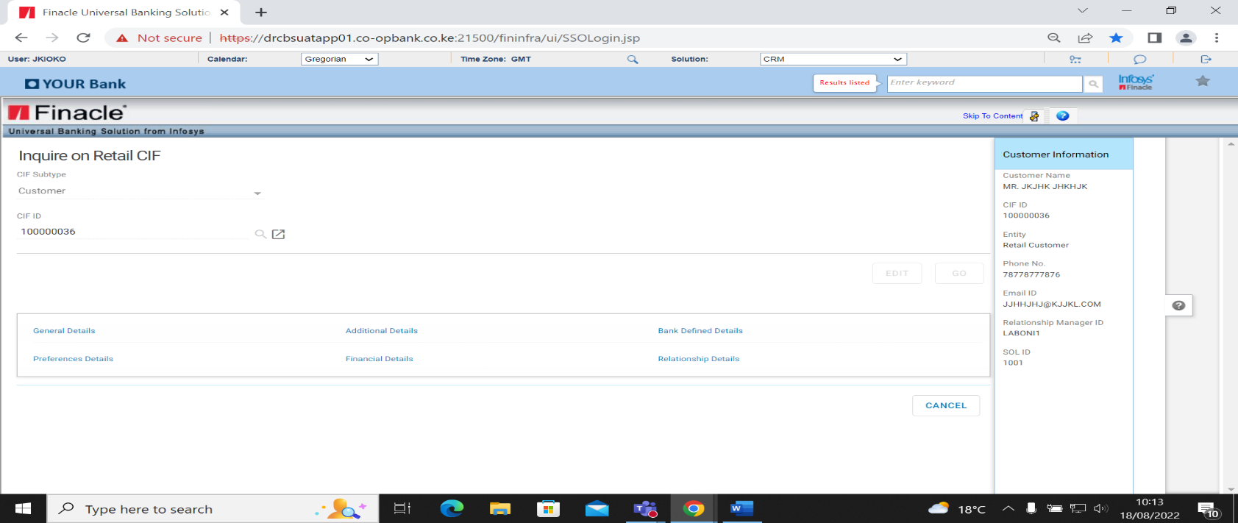

* Click on each tab to view the details entered
* Click Back to Summary

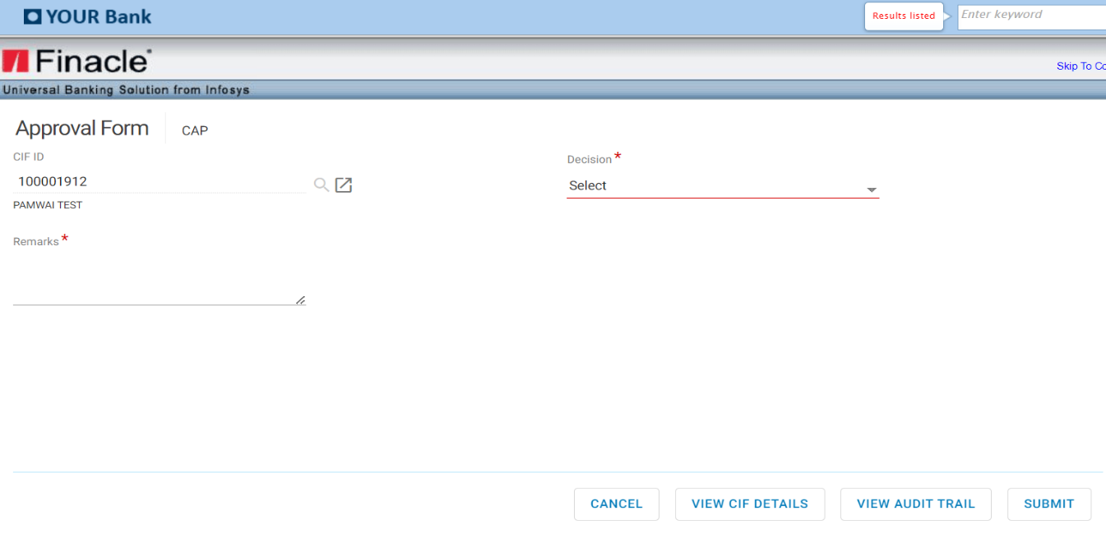

* After satisfactorily viewing and confirming all the details, the Checker can now select on Decision from the drop down (Approve, Close or Rework)

**Approve**

* Select Approve
* Input the Remarks

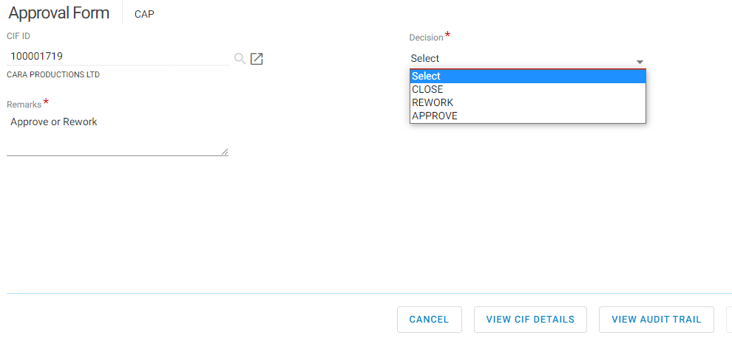

* Click on the submit button to complete the process.

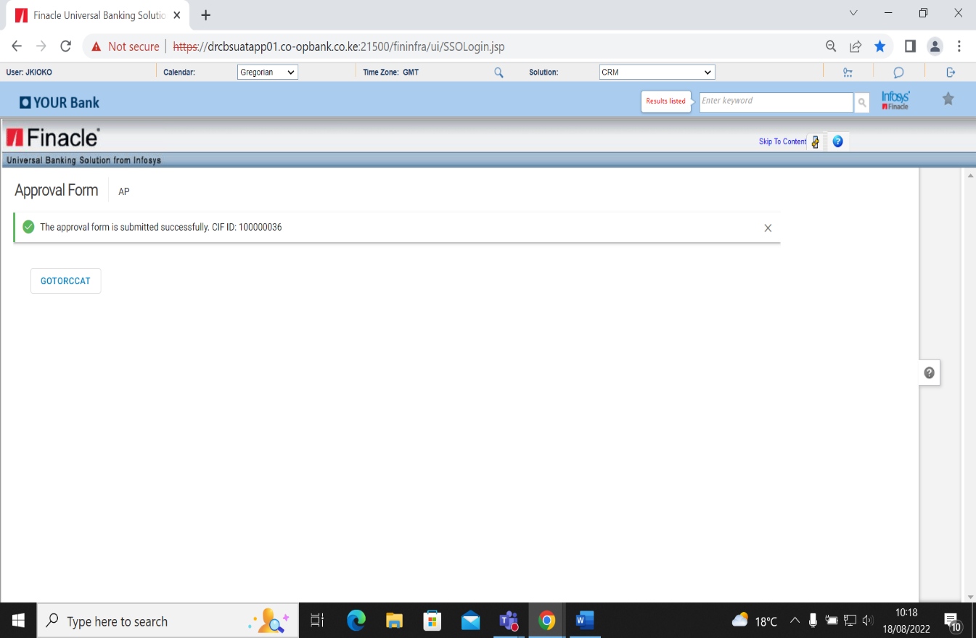

The corporate CIF has been verified successfully.

**Rework**

When the checker has viewed all the details and is not satisfied with the data captured, they shall select this option to return to the maker for amendment.

* Select Rework on Decision
* Input Remarks-Reason for return.

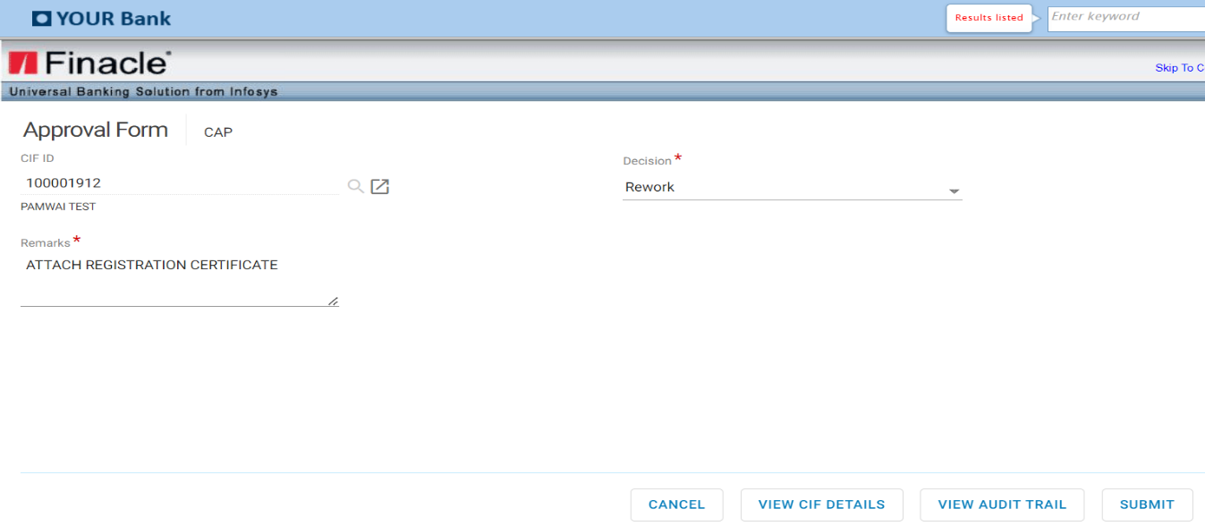

* Click on Submit

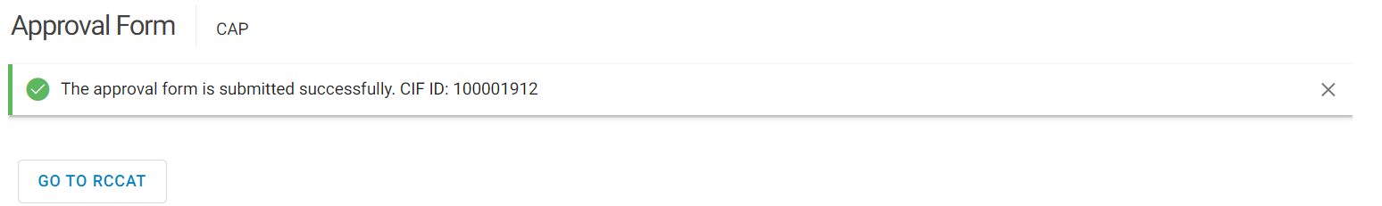

**Close**

This option is used to delete the CIF from existence.

* Select Close on Decision
* Input Remarks-Reason for deleting

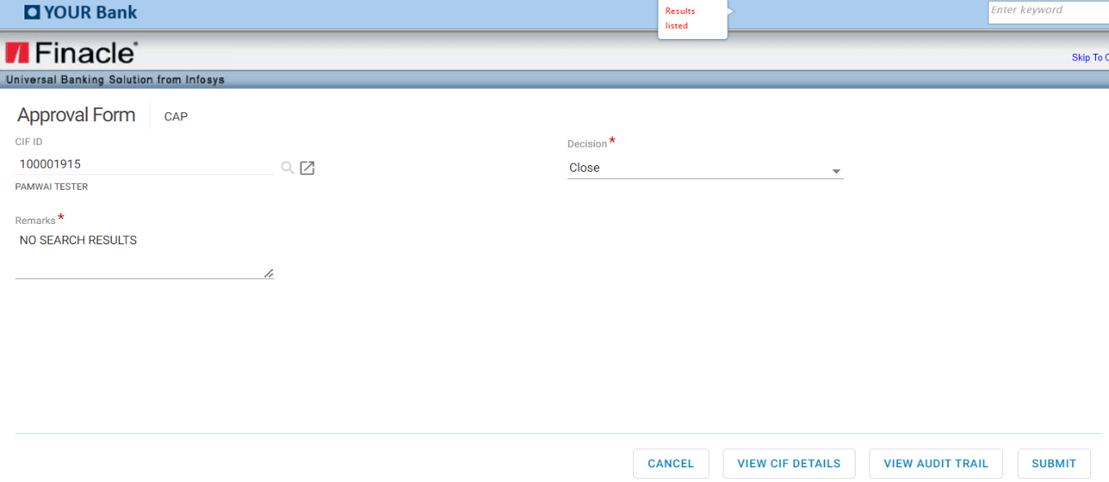

* Click on Submit

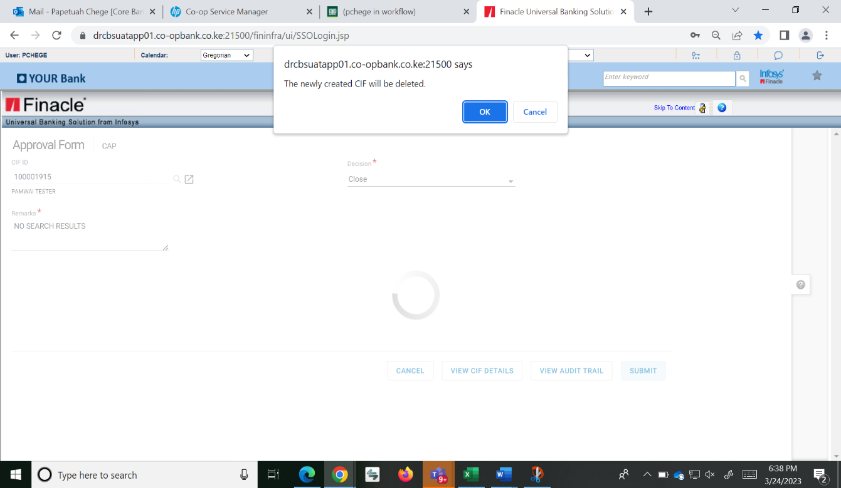

* Click on Ok.



## Corporate Account Opening Process

* Invoke menu OSA (Open Savings Account) to open savings account or menu OCA (Open Current Account) to open a current account**.**





* Input Corporate CIF ID
* Select scheme code
* Select Currency from CCY field
* Click Go Button

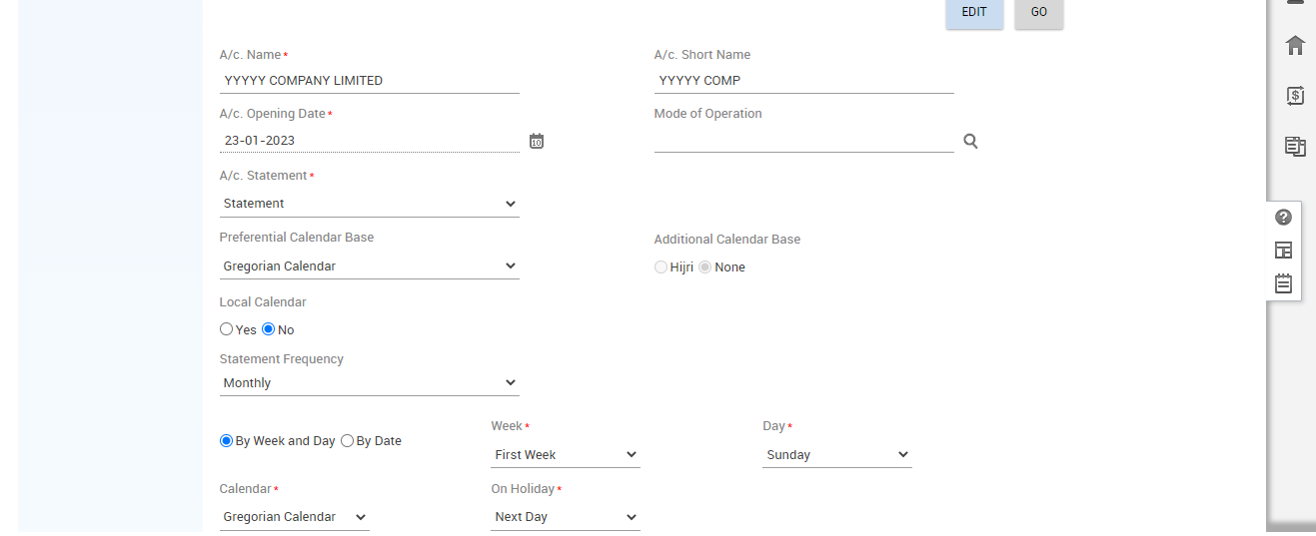

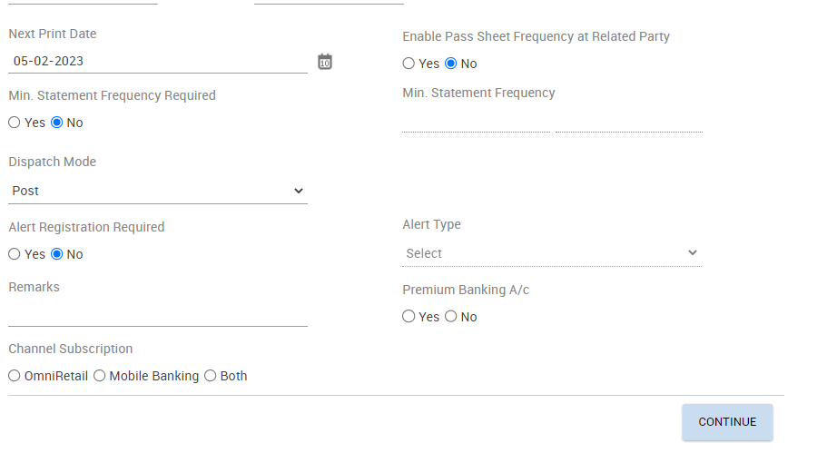

* Select Statement frequency, Dispatch Mode
* Select Yes on Enable Pass Sheet Frequency at Related Party
* Select Alert registration required. * if yes select alert type (Credit, Debit or Both)
* Select Premium Banking A/c for executive banking services
* Select Channel Registration (Omni Retail, Mobile Banking or Both)
* Click on Continue> Additional Details

### Additional Details

**Interest Details**







**Interest Details page (Not mandatory)**

This field is default, populated with the value specified at scheme level. Specifies information (all interest and tax related parameters information) in the Interest Details.

**Pay Interest** - This field indicates if interest must be paid to the account. The valid values are: Yes or No.

**Collect Interest** - This field indicates if interest must be collected from the account. The valid values are: Yes or No.

**Credit Interest % min. /max**. - This field indicates the minimum and maximum interest percent payable to the account.

**Allow Negative Credit Interest** field would determine whether negative interest will be applied for account or not. The default percolation would happen from scheme level. If Allow Negative Credit Interest is yes at the scheme level, then P&L Placeholder and Negative Payable Placeholder exist at the scheme level.

**If “Allow Negative Credit Interest” indicator is Yes** at scheme level and changed to No at A/c. level or vice versa, Default parameter overridden exception is shown to user.

**Debit Interest % min. / max**. - This field indicates the minimum and maximum interest percent to be collected from the account.

**Customer Preferential Interest (Cr)** - This field indicates the preferential interest (positive percent) set at the customer level which is applicable to the account. The value is defaulted from the value set at CIF level.

**Customer Preferential Interest (DR)** - This field indicates the preferential interest (negative percent) set at the customer level which is applicable to the account.

**A/c Preferential Interest (Cr) -** This field indicates the preferential interest (positive percent) set at the account level which is applicable to the account. This field will be hidden for the accounts opened under negotiated interest type of product.

**A/c Preferential Interest (Dr) -** This field indicates the preferential interest (negative percent) set at the account level which is applicable to the account. This field will be hidden for the accounts opened under negotiated interest type of product.

**Interest Credit A/c.** - This field indicates the account to which interest rate must be credited. The valid values are: Operative account, original account and Payment system.

**Interest Debit A/c.** - This field indicates the account to which interest rate must be debited. The valid values are: O - Operative account, S - Original account and T - Payment system.

**Interest Debit A/c ID -** This field indicates the ID of the account to which interest must be Debited. The system allows you to specify the Int. Dr. A/c ID whose currency is different from the account currency.

**Interest Credit A/c ID -** This field indicates the ID of the account to which interest must be credited. The system allows you to specify the Int Cr. A/c ID whose currency is different from the account currency.

**Interest Rate Code -** This field indicates the code of the interest rate table to be used for calculation of interest. This field is default populated with the value specified at scheme level. This can be modified. This field will be hidden for the accounts opened under negotiated interest type of product.

**Account Pegged –** This field indicates if the interest rate applicable to the account must be pegged to the account and be kept constant for a specific period. The valid values are: Yes and No. Any change in the interest rate is not applicable to those accounts for which the value of the field account pegged is set as Yes and for which a pegging frequency is specified. All such accounts must be reviewed on the review date else the interest calculation would not go through for these accounts. This field will be hidden for the accounts opened under negotiated interest type of product.

**Pegging Review Date -** This field indicates the date until which the account is pegged. Finacle automatically reviews the pegged interest rate for the account on this date. This field will be hidden for the accounts opened under negotiated interest type of product.

**Pegging Frequency –** This field indicates the frequency in months and days for pegging interest rate to the account. This field will be hidden for the accounts opened under negotiated interest type of product. This field will be hidden for the accounts opened under negotiated interest type of product.

**Interest Calculation Frequency Credit -** This field represents the frequency at which the interest must be calculated. The value in this field is default populated from the scheme level. This can be modified.

**Next interest calculation date (Cr)** - This field indicates the next interest calculation date.

**Interest Calculation Frequency (Dr) -** This represents the frequency at which the interest must be calculated. The value in this field is default populated from the scheme level. This can be modified.

**Next Interest Calculation Date (Dr) -** This field indicates the next interest calculation date.

**Interest Compounding Frequency (Dr) -** This indicates the frequency at which the debit interest must be compounded. For example, it could be ‘Daily’.

**Credit Compounding Rest Indicator -** This indicates the compounding rest used for compounding the interest.

**Apply Discounted Interest Rate (Dr) -** This field indicates whether discounted interest rate must be applied for calculating the interest. This field is applicable to loan accounts when the bank wishes to recover interest upfront during disbursement of the loan. The bank also pays interest on a deposit account at discounted rate of interest instead of the contracted rate if the interest is paid before the specified interest flow date. The bank applies a discounting factor to the original interest if the customer requests payment of interest before the normal interest payable date.

* Click on Continue>Tax Details

**Tax Details**

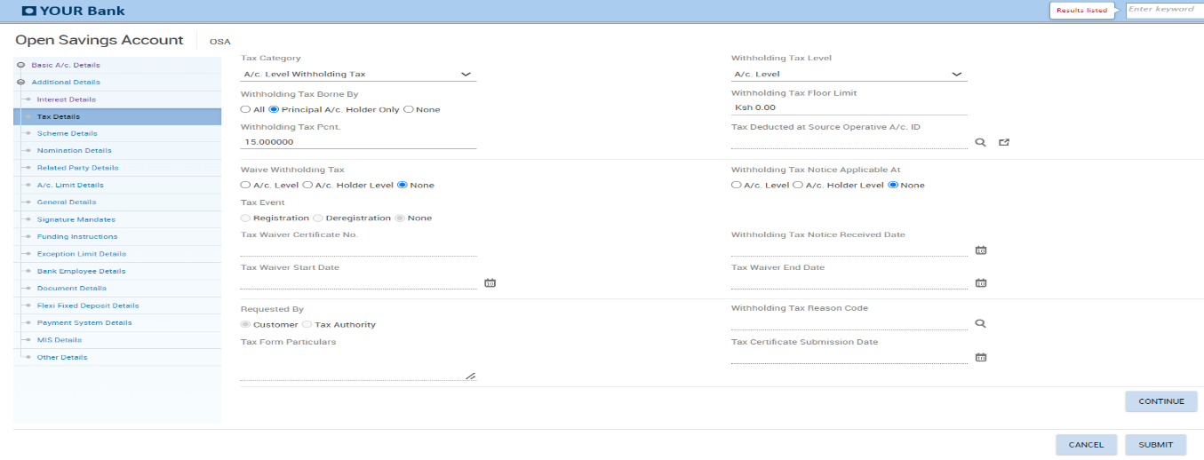

**Tax Details Fields**

**Tax Category -** This field indicates the category of the tax to be collected. The valid values are Account Level withholding Tax, Customer Tax Deducted at Source, Eligible for Tax Deduction at Source and No Tax.

**Withholding Tax Level -** This field indicates the level from which the tax parameters for tax calculation must be picked up. The valid values are Scheme level, Customer Level and Account level.

**Withholding tax floor Limit -** This field indicates the withholding tax floor limit applicable for tax calculation.

**Withholding Tax % -** This field indicates the percentage of the interest amount which is payable as withholding tax. It defaults to 15% for residents.

**Withholding tax borne by -** This field indicates the person who must bear the tax. The valid values are None, All and Principal A/c. holder only.

* For customers who are exempted from paying withholding tax such as SACCOs, this field shall be NONE

**Tax Deducted at Source Operative A/c. ID -** This field indicates the ID of the account from which the tax is to be recovered.

**Waive Withholding Tax -** This field indicates if withholding tax must be applied at the account level, account holder level or none. This filed is applicable if the **Tax Category** field is ‘A/c. Level Withholding tax’.

**Withholding Tax Notice Applicable At -** This filed indicates if the notice is applicable at the account level or account holder level.

**Withholding Tax Notice Received Date -** This date is used in calculating the withholding tax along with the Withholding Tax Notice Period field.

Tax certificate Number, Tax Waiver Start Date, Tax Waiver End date, Tax Certificate Submission Date and Tax Form Particulars – These fields are used to capture the tax details and are applicable where withholding tax is waived.

Click on Continue> Scheme details

**Scheme Details**

The following information is displayed in the Scheme Details tab which its set up is done at the product level





* Click on Continue>Nomination Details

**Nomination Details Field**

This is a non-mandatory screen which is only used if the nomination indicator is set as Yes in the scheme details. Nomination shall always be NO.



* Click on Continue button>Related Party Details

**Related Party Details**

Account signatories are added in this section.

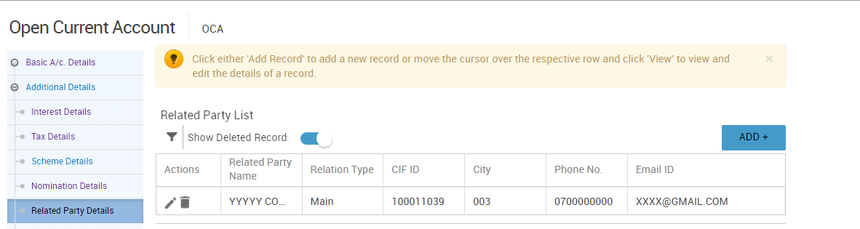

* Click Add Button
* Select the Relation type as Authorized Signatory



* Enter valid CIF for a signatory

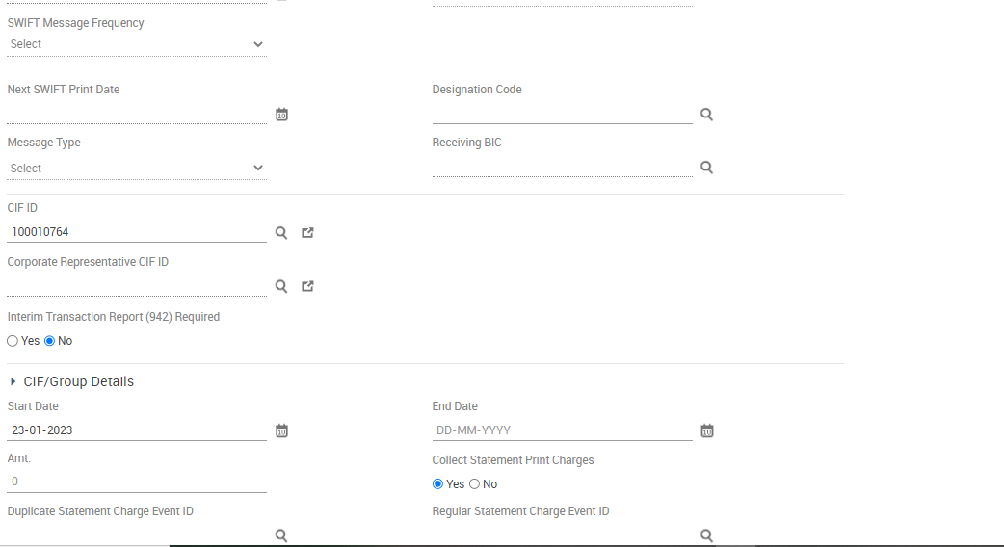

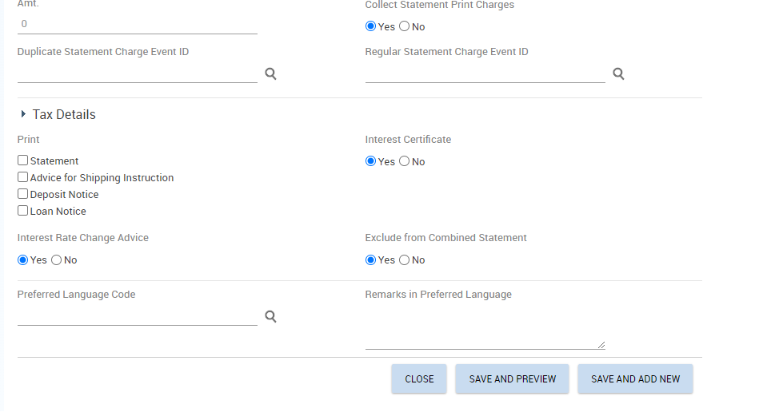

* Click on Save and Add New to add the other account signatories
* Click Save on Preview

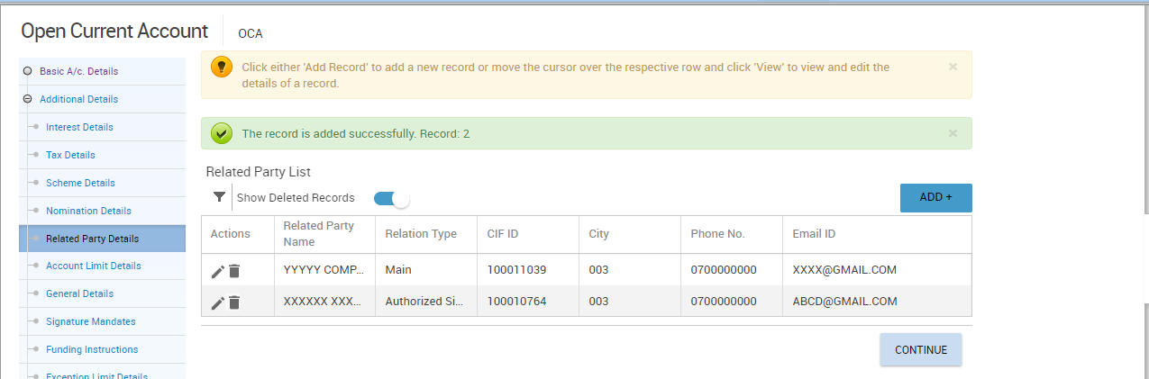

* Click on Continue>Account Limit Details

**Account Limit Details**

This section shall be used to set limit at account level



* Click on Continue>General Details

**General Details**

This section is used to set overdraft limits, language and cheque limit details, fetches details from scheme level.





* Click on Continue>Signature mandates

**Signature Mandates**



* Click continue button>Funding Instructions

**Funding Instructions**

Used when a customer wishes to fund account through transfer from an existing account.

* Select Transfer on Transaction Type
* Input currency of the funding account on CCY
* Input the amount to transfer on Transaction Amt
* Input funding account on Debit A/C ID.





* Click continue button>Exception Limit Details

**Exception Limit Details**

Used to capture Limits pertaining to cash, clearing and transfer the limits set during CGSP are defaulted here.



* Click continue button>Bank Employee Details

**Bank Employee Details**

The relationship manger details captured from the CIF level will be displayed on this page and its editable if the relationship manager at CIF level is different with account relationship manager for account.

If the account holder is a relative of an employee, then those details shall be captured on this page under related Bank Employee details.



* Click Continue button>Document details

**Documents details**

* You can upload various scanned documents collected for the account opening in this section.



* Click on the ADD button



* Select Document Code>Due Date: The date before which the document must be submitted to the bank>Received Date: The date on which the document is received by the bank > Expiry Date: The expiry date of the documents received by the bank
* Click on Upload document to attach the desired report.
* Click on Save
* Click on Save and Add new to attach another document
* Click on Save and Preview after uploading the desired documents
* Click on Continue>Flexi Fixed Deposit Details

**Flexi Fixed Deposit Details**

Finacle supports Flexi Fixed Deposit facility which customer has the option to choose for making deposits under specified scheme for specified period when the balance in the operative accounts exceeds specified threshold limit





* Click on Continue>Payment System Details

**Payment System Details**

Used to capture the payment system details if the Interest Credit indicator is set as payment system in the interest Details Screen

* Click Continue button>Base II Compliance Details

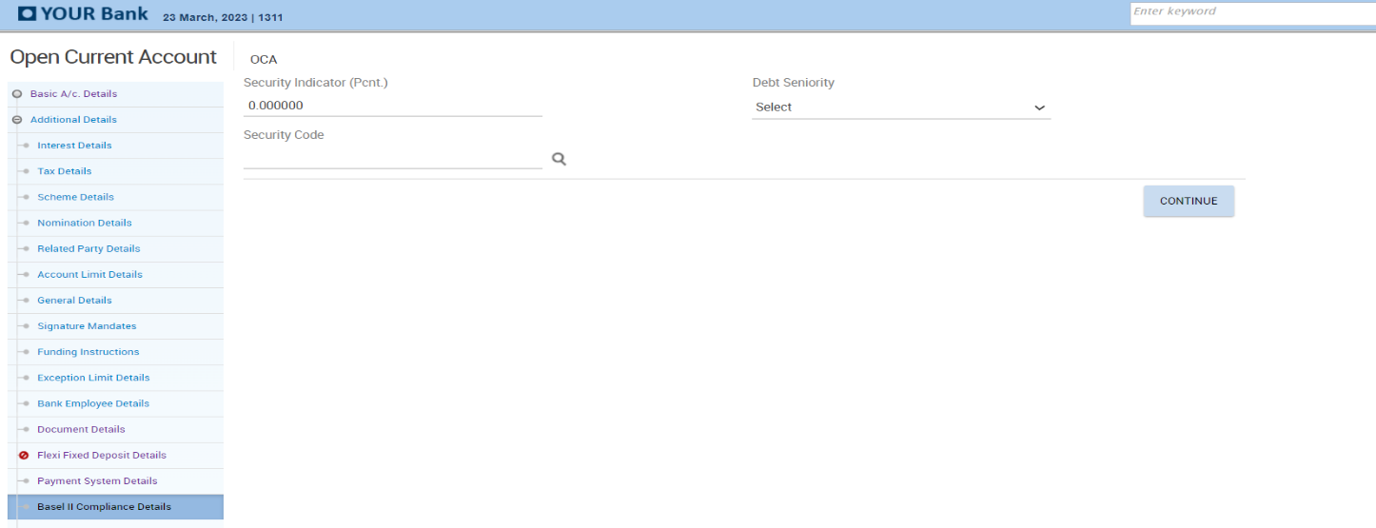

* Click Continue button>MIS Details

**MIS Details**

Mandatory field where MIS codes for the accounts opened will be captured. Entry of details is done through the codes. The entry of appropriate codes is useful for generating various MIS reports.

* Select Sector Code and Subsector Code.
* Click Free codes
* Select DSO Code
* Select Business Economic Activity Code
* Select Product Segment if applicable



* Click Free Text
* Input Purpose of Account
* Input Source of funds
* Select Bank Specific Sector Code
* Select Bank Specific Sub-Sector Code

Note that ARO code will be auto populated.





* Click Continue button>Other details

**Other Details**

This is a non- mandatory section used for capturing details pertaining to applicability of Payment system, DSA Details and Account label details.





* Click Submit button

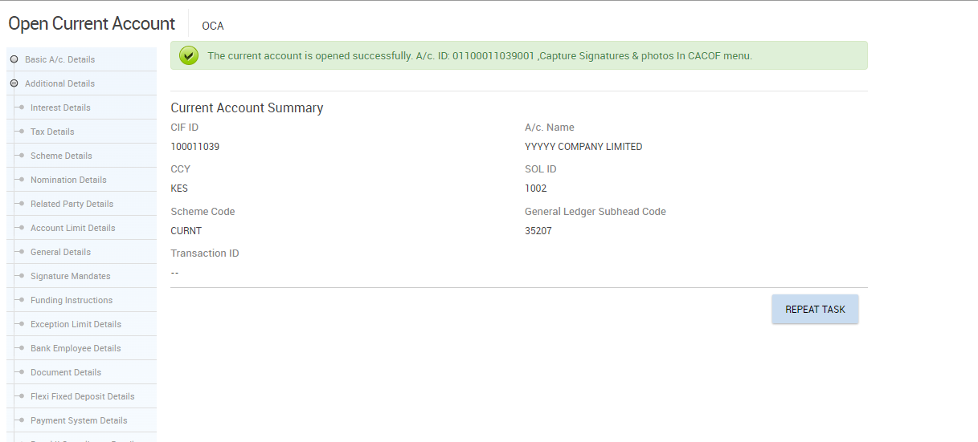

### Photo & Signature capture for Corporate Account Opened

The Account opening officer shall capture photos & signatures for all account holders.

* Invoke menu CACOF (Account Opening Form)
* Select Generate Form from Function
* Input account number or select it from the searcher
* Select a CIF for one of the account holders

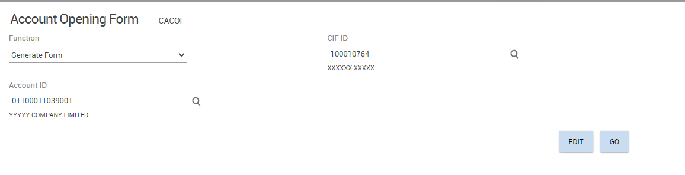

* Click Go Button

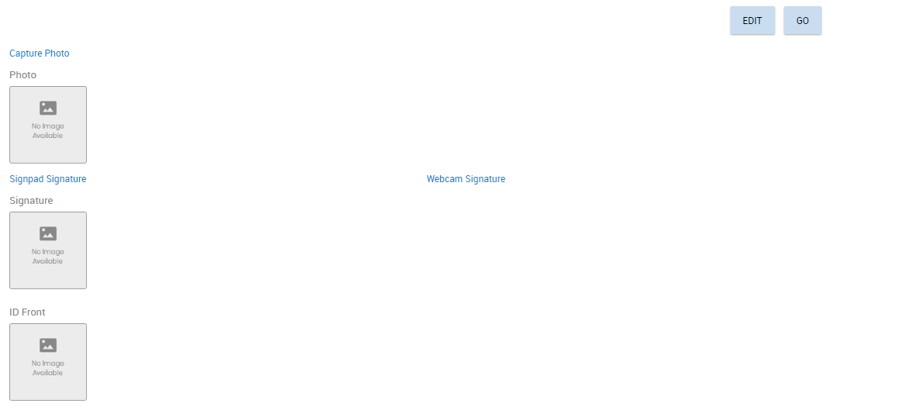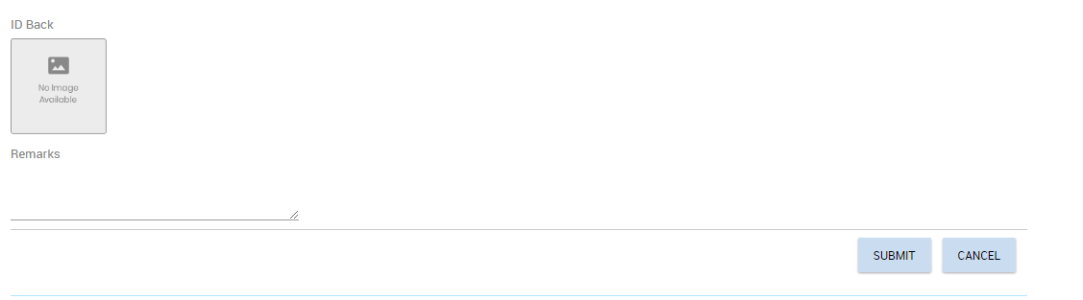

* Capture photo and signature of the account holder
* Input Customer Name, Identification document No and designation such as Treasurer where applicable on **Remarks** field
* Click Submit button

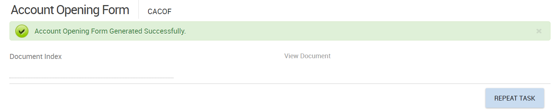

* Click on Repeat Task to capture signature, photo, and remarks for all account signatories.
* After capturing signatures and photographs of all signatories, capture account name as remarks for the main CIF on CACOF and click on SUBMIT

### CACOF Verification for Corporate Account Opening

* Checker shall invoke menu CACOF
* Select Generate Form on Function
* Input Account Id or select from the searcher

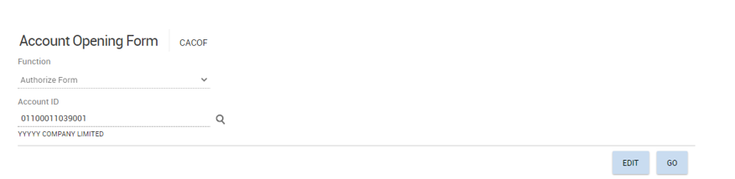

* Click on Go

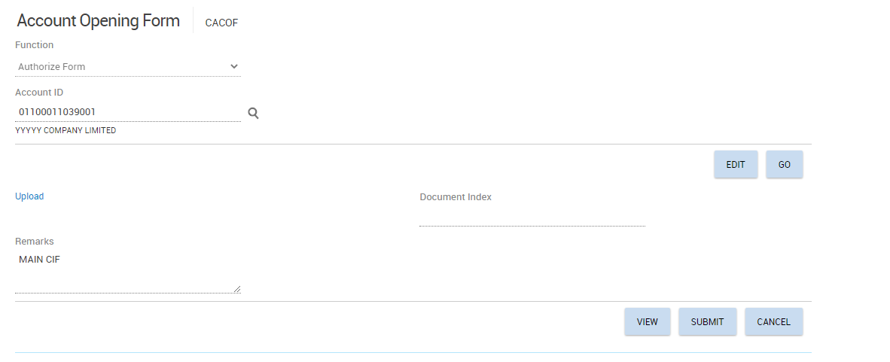

* Click View Button To generate mandate
* Click Upload button and attach the mandate generated>Click Submit button

### Corporate Account Opening Verification

Referto “Account Opening Verification” process

## Corporate Account /Joint accounts Rules (Maintaining and mapping of the rules)

### Add a Rule

The user shall:

* Invoke menu SVS (Signature Verification System)
* Click on Maintain rules
* Select Add on the function dropdown
* Under Rule Name Input a unique rule Name such as account number then alpha at the end to differentiate various rules for the same account, e.g., if account **0110000033001** has three rules, then rule names shall be as follows.
* 0110000033001A
* 0110000033001B
* 0110000033001C

**NB:** The rule name should not contain any spaces or special characters.

* Click on **Go** button

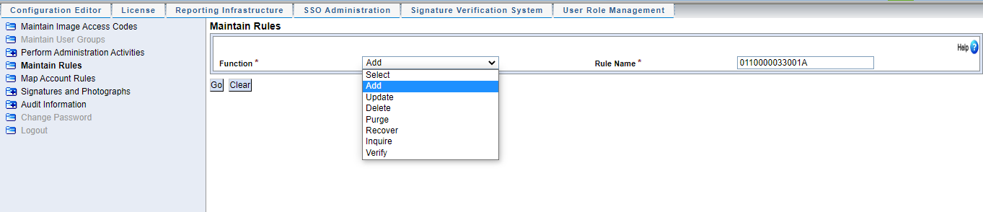

* Select an item from Entity Name drop down list, the list includes.
* Account Id
* Customer Id
* Employee Id
* Sol Id
* Image Access Code
* Sign Power No
* Keyword
* Credit/debit
* Transaction Amount
* Transaction Type
* Transaction Subtype
* Signature Group.

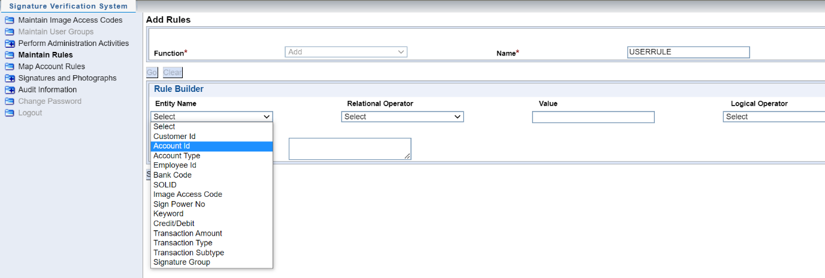

* On the Rule builder indicate correct values as indicated on the entity name table below. Entity name shall correspond to the correct values as indicated below.

|  |  |
| --- | --- |
| **ENTITY NAME** | **VALUE** |
| ACCOUNT ID | VALID ACCOUNT NUMBER |
| CUSTOMER ID | CIF NUMBER |
| ACCOUNT TYPE | SCHEME CODE |
| EMPLOYEE ID | PF NUMBER |
| BANK CODE | 01 |
| SOL ID | BRANCH CODE EG. 1002, COOP HOUSE |
| IMAGE ACCESS CODE | ALL,DORM,VIP, VVIP |
| CREDIT/DEBIT | C OR D |
| TRANSACTION AMOUNT | Numerical Value |
| TRANSACTION TYPE | CASH-C , CLEARING-L, TRANSFER-T |
| TRANSACTION SUB TYPE-NORMAL PAYMENT | * NORMAL PAYMENT –NP * NORMAL RECEIPT-NR * CASH TRANSFER-CT, * ECS OUTWARD TRANSACTION-EO, * ECS INWARD TRANSACTION-EI, * INWARD CLEARING-I, * OUTWARD CLEARING-O, * CUSTOMER INDUCED-CI, * BANK INDUCED-BI |

Select an operation from Relational operator. Example of available values are

= : means Equal to.

!= : means not equal to.

>= : means greater or equal to.

<= : means less or equal to.

< : means less than.

> : means greater than.

Max : means maximum.

Min : means minimum.

Like : means comparison.

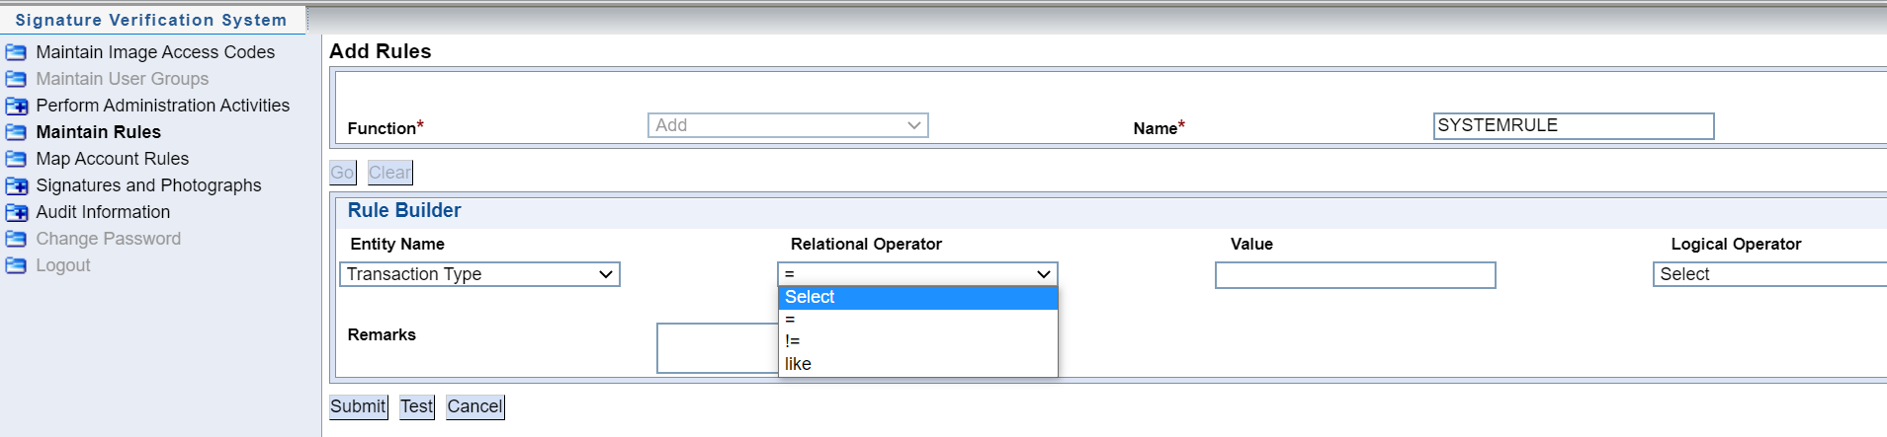

* Input valid value (e.g. if the entity name is account id, input a valid account number).

**Examples of Rules:**

1. Account Type = 0110000033001 and Transaction Amount<=10000, then under remarks we indicate ‘Either to Sign’

This means that for account number 011000033001 when transacting amounts below or equivalent to ten thousand either of mandated signatories will sign for this particular transaction. The system will display this rule when transacting amounts up to 10,000.

1. Transaction amount >10,000 and transaction amount <=500,000, then under remarks field indicate ‘Any Three to sign’

This means that for the transaction above 10,000 and below or equal to 500,000, any three of mandated signatories will sign. Rule will apply to amounts above.

1. Transaction amount > 0 or transaction amount !=0, then indicate in the remarks that ‘All To Sign’

This rule means that if transaction amount is not equal to zero (it can be positive or negative transaction as long as it is not a Zero) or transaction is greater than Zero then all to Sign for non-zero transactions.

1. Account like *0110000033001 and Transaction Type =L then on the remarks field indicate ‘Secretary and Treasurer to sign’*

This rule means that if the account matches above account and transaction type is clearing (refer to entity name table above) then Secretary and Treasurer are to sign.

**Note:**

* + This value can be a number or String depending on the item chosen in Entity Name. (Refer to the entity name table above) for the values to be entered when a specific entity name is chosen
  + When you specify these three values, a condition is defined

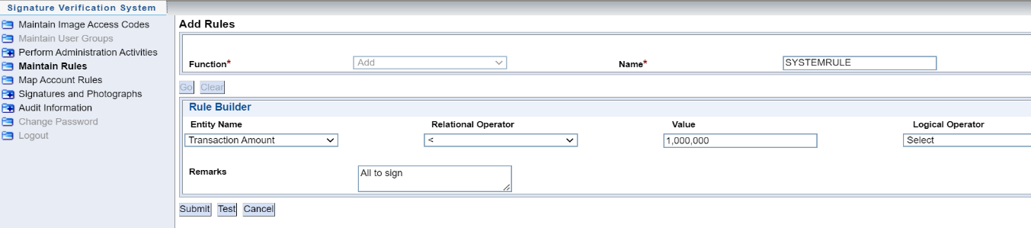

Example above shows how to build a rule based on transaction amount

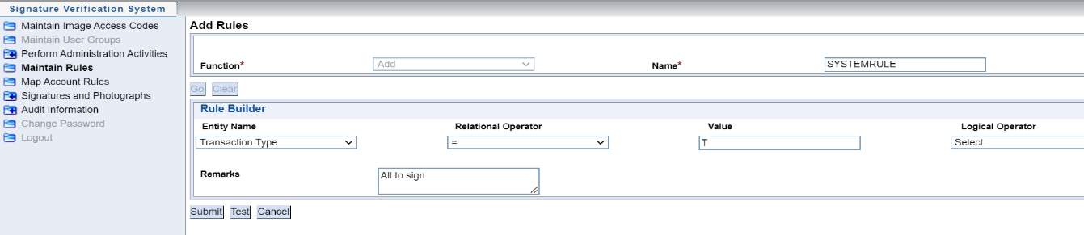

Example above shows how to build a rule based on transaction Type-Transfer

* Use the Logical operator option to define complex conditions as illustrated below.

**Note:**

The Logical Operator drop-down list has two options ‘AND’ and ‘OR’.

* **AND-** Is a logical operator to create additional criteria while building a rule, it means that when all the conditions of the rule are met while transacting, then the rule will display.
* **OR-** Is a logical operator for creating additional criteria while adding a rule and it means that if either of the conditions in the rule is met when transacting then the rule will display.

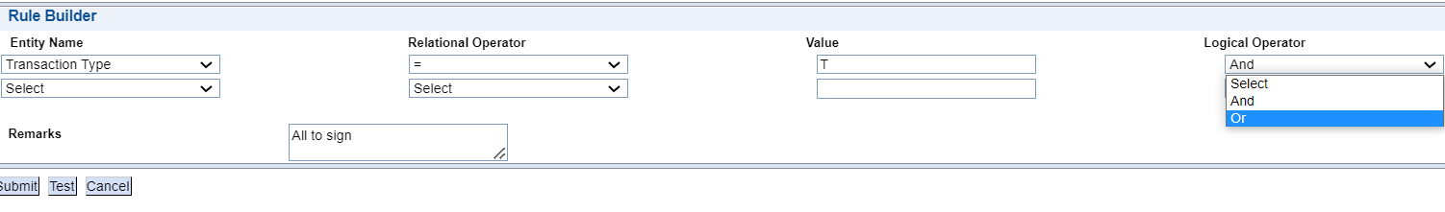

* Define remarks or comments associated with the rule.(e.g. signing mandate, special account operating instructions)

**Note:** The size of remarks field can take up to 650 characters. Remarks field is used to note few important points about a rule.

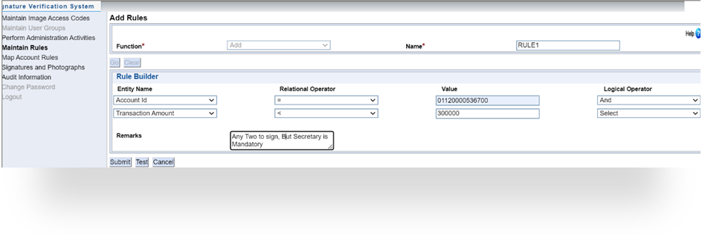

* Click TEST button to test the syntax of the defined rule i.e. whether the rule is defined properly
* Click SUBMIT button. On submission the record is sent for approval
* Click CANCEL to clear the rule.

### Verify Rule

The checker shall follow the below procedure to verify a rule.

* Invoke menu SVS (Signature Verification System)
* Click on Maintain Rules
* select Verify from the Function dropdown

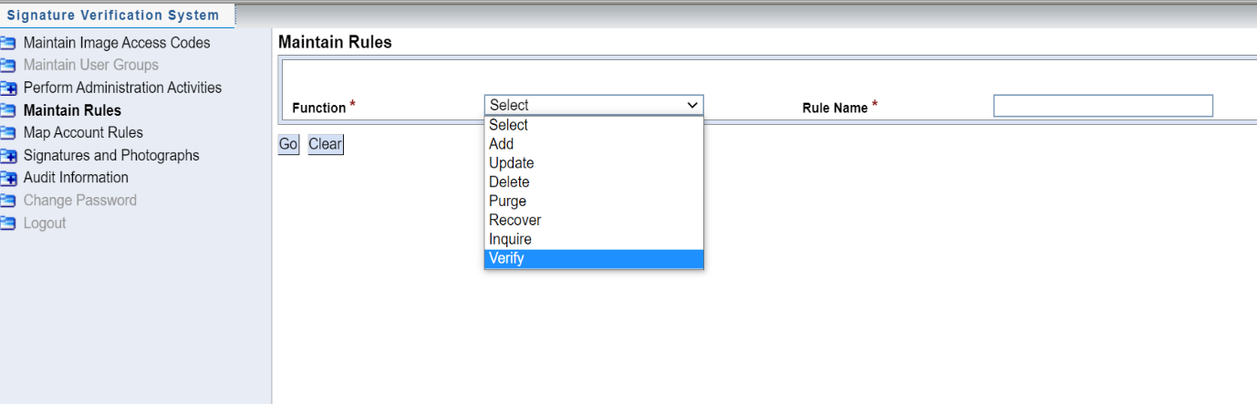

* Click on Go

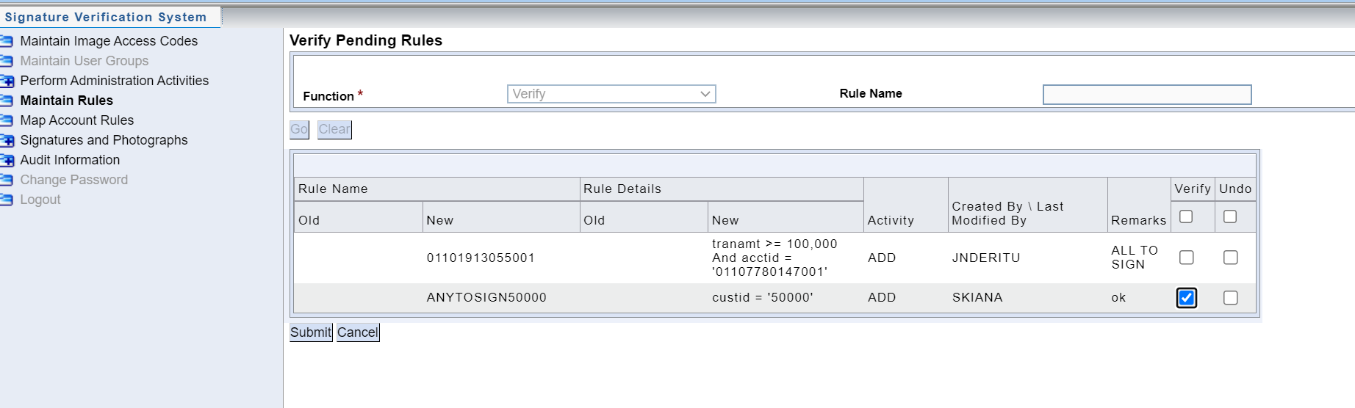

* Select the rule to verify by checking on Verify check box.
* Click Submit to verify and Undo to reject a record.

**Note:** When the rule is rejected, the maker must initiate creation of a new rule

### Inquire Rule

The user shall follow the steps below to inquire on a rule

* Invoke menu SVS (Signature Verification System)
* Click Maintain Rules
* Select Inquire under Function dropdown

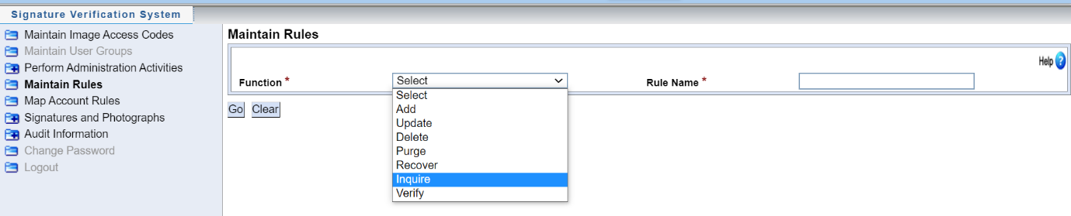

* Click Go button
* Type valid values in the Rule Name or search using search button 

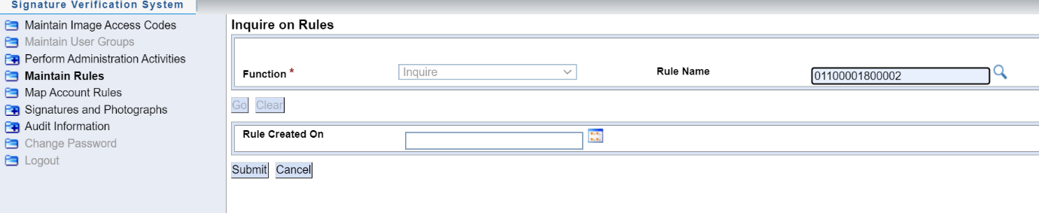

* A rule can be searched alternatively using the date it was created, Type the Date the rule was created on or search the date using searcher  on Rule Created on Option.

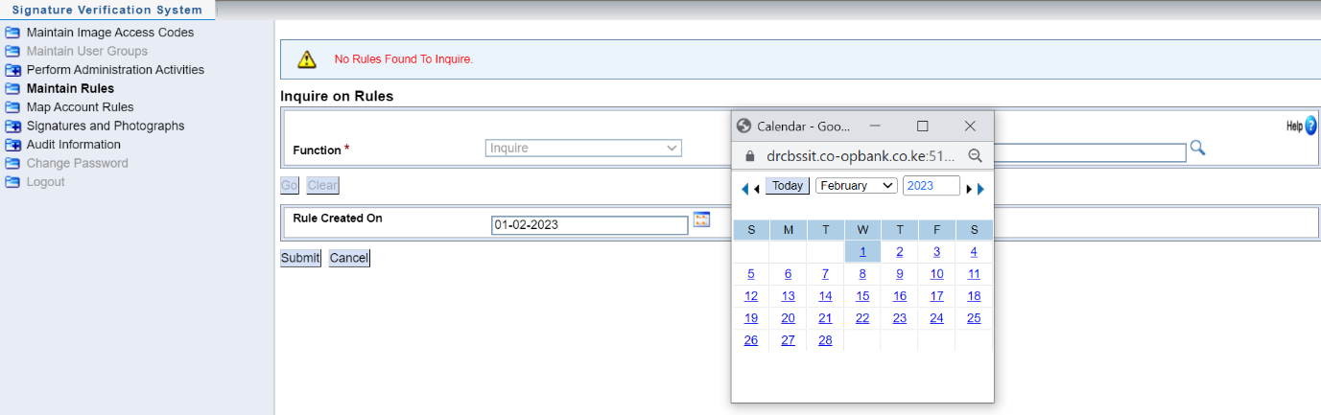

* Click Submit to view details of the defined rule.

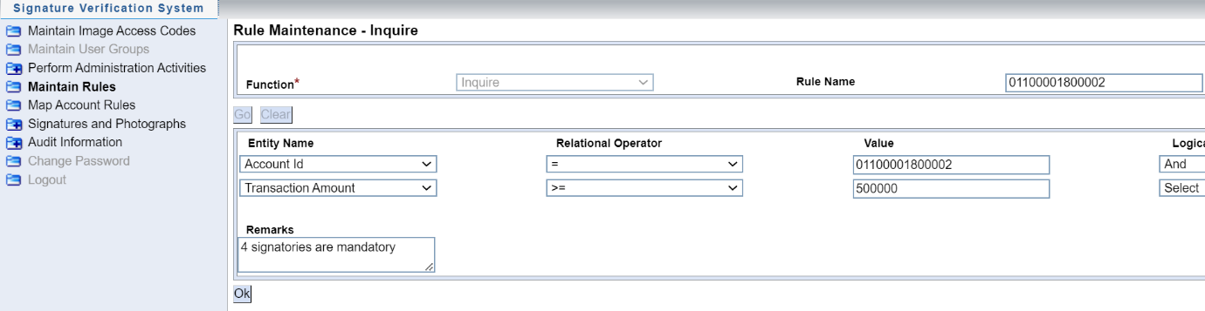

* Click Ok to exit the menu

### Common Rules

Common rules are the signing instructions that apply to majority of accounts across the bank network. BOS will create such rules in the system and the user will map the right common rule to account depending on the customer request, these rules are as follows.

***Rule Name Rule Description***

Sole : Sole signatory

Anyonetosign :   Any one to sign

Eithertosign :   Either to sign

Bothtosign :     Both to sign

Anytwo : Any two to sign

Anythree :         Any three to sign

Anyfour :          Any four to sign

Alltosign :         All to sign

Anythreebutsec : Any three but secretary is mandatory

During account opening the user shall capture signatures in CACOF menu then proceed to Map the common rule to account if the customer indicated any signing instructions as listed above. If the customer has a more specific rule which does not conform to rules above, then proceed to create a rule then map to the account.

### Mapping Account Rules

Rules defined shall be mapped to account signatures using **Map Account Rules** option. An account may be associated with more than one rule, and each rule may be mapped to different sets of signatures.

The number of signatures and the actual mapped signatures may vary from rule to rule. Similarly, signatures can also be mapped to rules associated with customers or employees.

If mandatory conditions set in the customized rule map screen, then during verification process these conditions along with remarks will be displayed to the user.

User shall verify signatures based on conditions and the result will be sent back to CORE.

Incase multiple rule matching, any one of condition for the matched rule (that is logical OR condition of all matched rules) will be considered.

The following procedure shall be followed to map a rule to an account:

* Invoke menu SVS (Signature Verification System)
* Click on Map Account Rules
* Select ADD on Function drop down. This function is to associate Rules to signatures, photos, and account

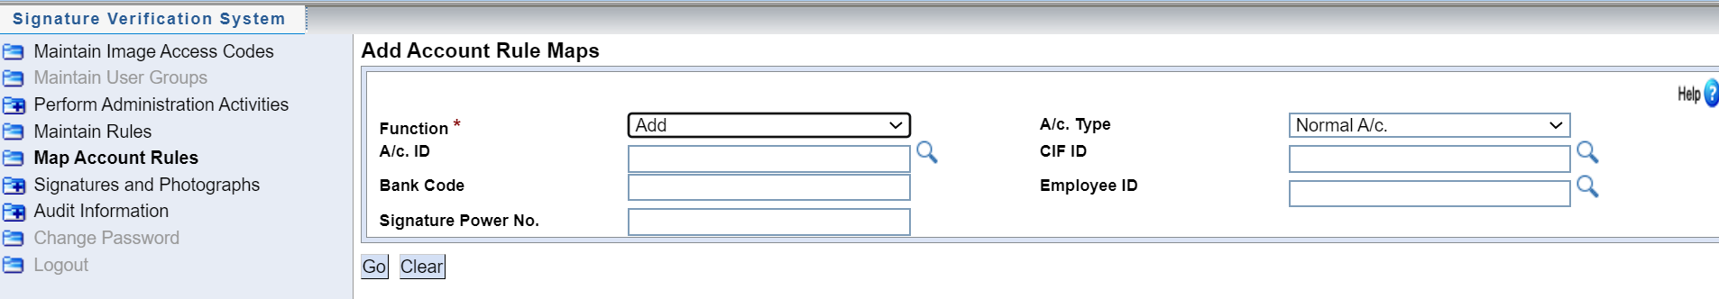

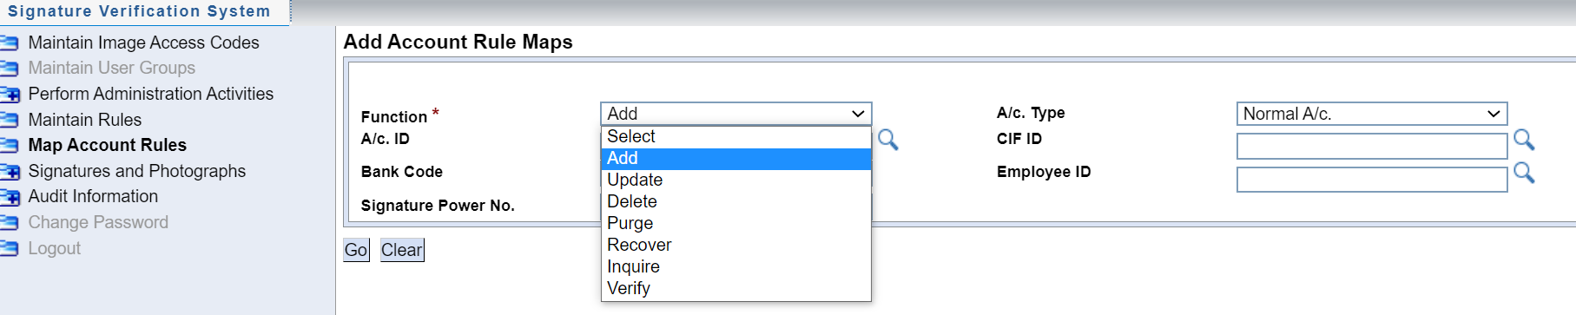

**Note:** An account can have multiple number of rules linked

* Input valid Account IDs Or search for from the search button

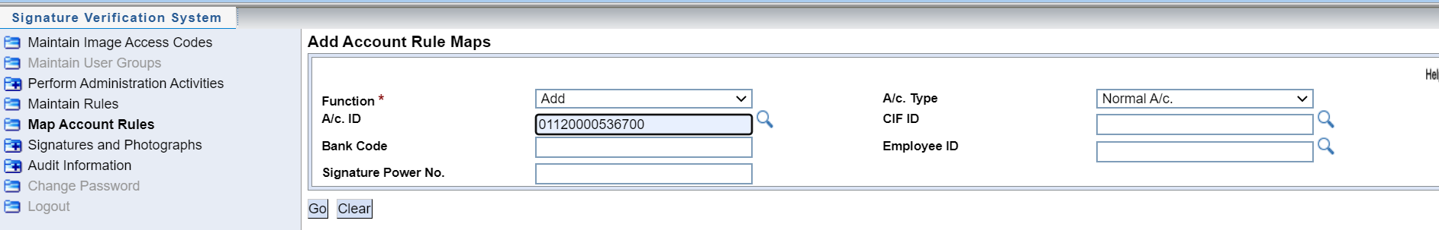

* Click Go to proceed

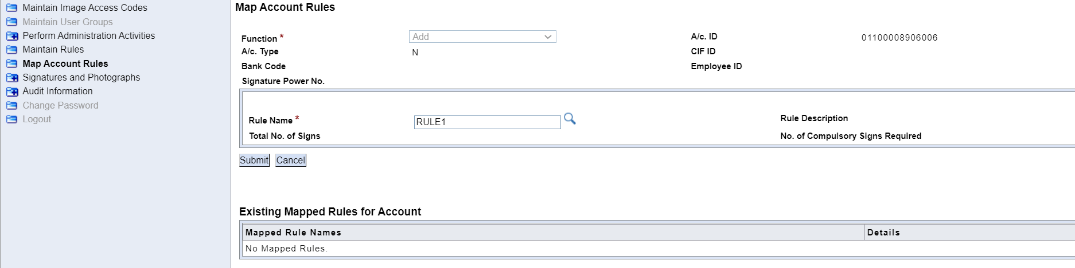

* On the Rule Name, Type the rule to be linked to the account selected or search for the rule using search button.
* Click on SUBMIT to proceed to the next window for map Rule

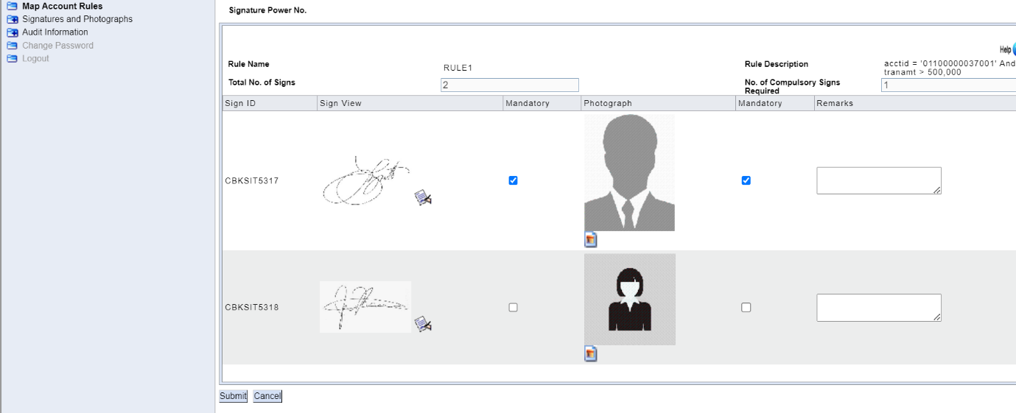

* View the signature by clicking on view icon 
* View photographs by clicking on the view icon 
* Specify the number of compulsory signatures.

If a signatory is compulsory select the Mandatory box for both the Signature and Photograph e.g. If the signing mandate is ALL TO SIGN, check all the signatories’ photos and signature boxes. If there are no mandatory signatories do not check the boxes.

* Click submit button. On submission the record is sent for verification.
* Click Cancel to delete rule mapping performed

**Note:**

* Checking the Compulsory box implies that if you create transaction that satisfies this rule, you must verify this signature by selecting the Verify check box that appears when you verify the signature.
* If you fail to click on the verify check box, of the signatures marked as mandatory then a report is generated in the core Banking Solution. This report has the status of all signatures for which signature verification is mandatory and transaction status is marked as failed for the signatures that were not verified.

### Verify Account Signature Map

To verify signature Map, the following process shall be followed:

* Invoke menu SVS (Signature Verification System)
* Click on Map Account Rules
* Select Verify on Function drop down

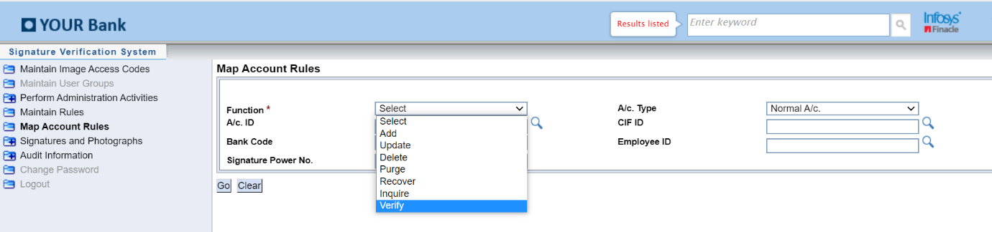

* Click Go button

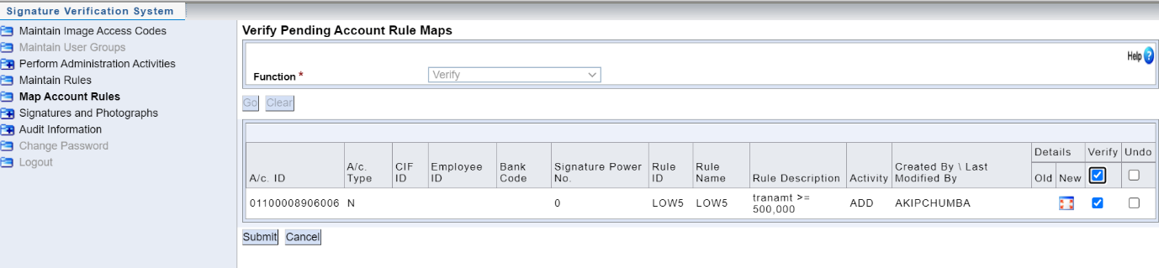

* Click on details for a particular account

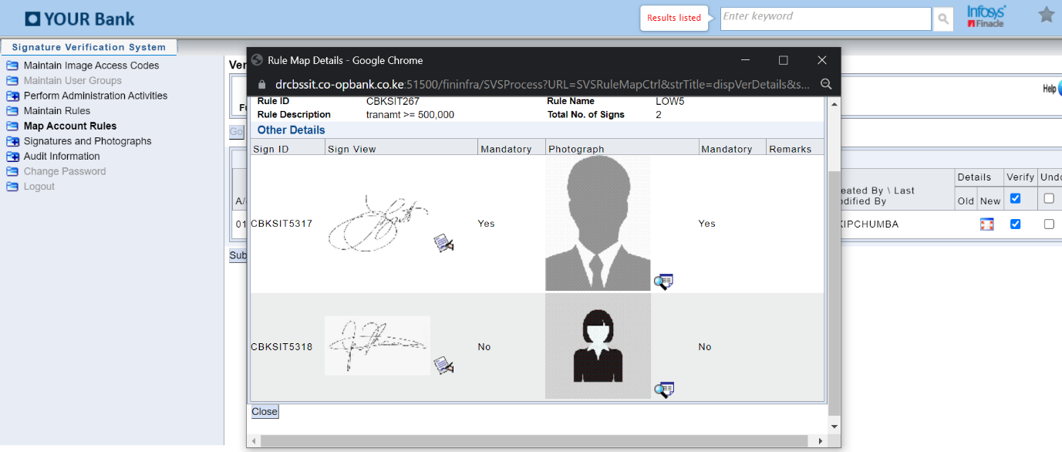

* Verify the record by selecting Verify checkbox or Reject by selecting Undo check-box

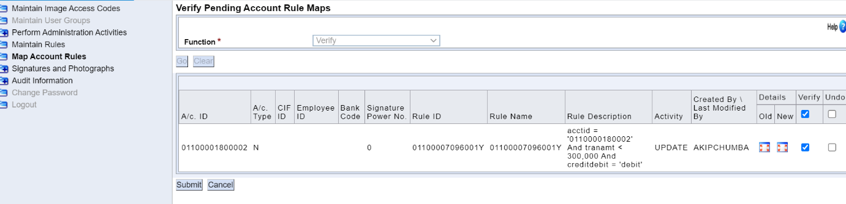

* Click SUBMIT button to complete verification of Transaction

# MINOR ACCOUNT OPENING

## Introduction

Minor accounts are grouped into two categories:

1. Accounts for Minors under 18 years.

Opened with Birth Certificate or Birth Notification as Identification document

1. Accounts for the Unborn.

Opened by an expectant mother with her personal Identification Document.

## Minor CIF Creation

The procedure below shall be followed to create a minor CIF.

* Invoke menu CERC (Create Retail CIF)

The CIF creation screen is displayed as shown below.

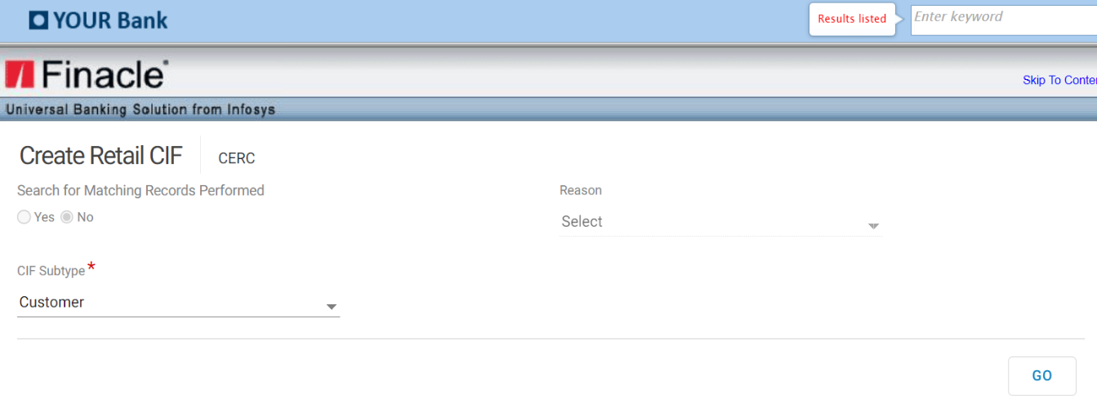

* Select the CIF subtype as “Customer”
* Click on GO button, below screen is displayed.

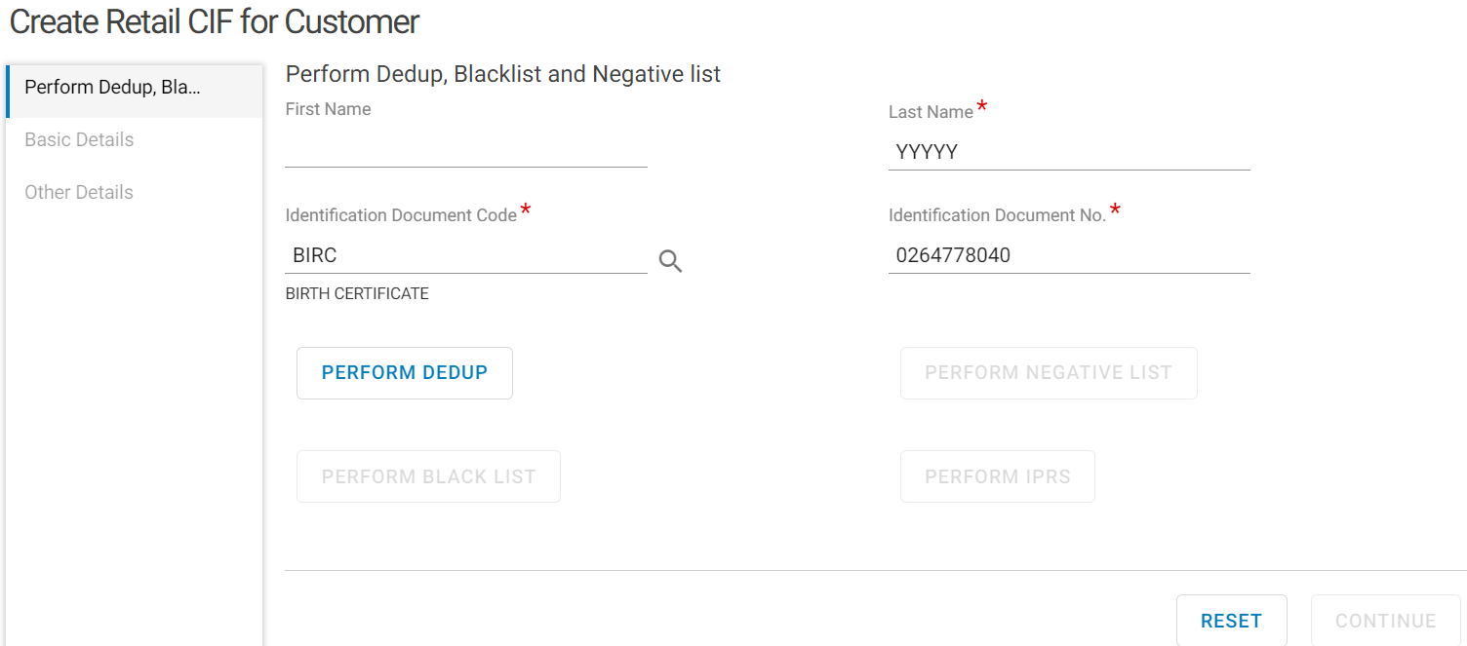

* Enter the minor Last name which is mandatory
* Select the Identification Document Code from the searcher as BIRC for birth certificate or BRN for birth notification.
* Enter the Identification Document Number in the Identification Document No. Field.
* Click on PERFORM DEDUP
* Click on PERFORM NEGATIVE LIST
* Click on PERFORM BLACKLIST
* Click on PERFORM IPRS
* Click Continue to proceed to Basic Details

## Capturing Basic Details.

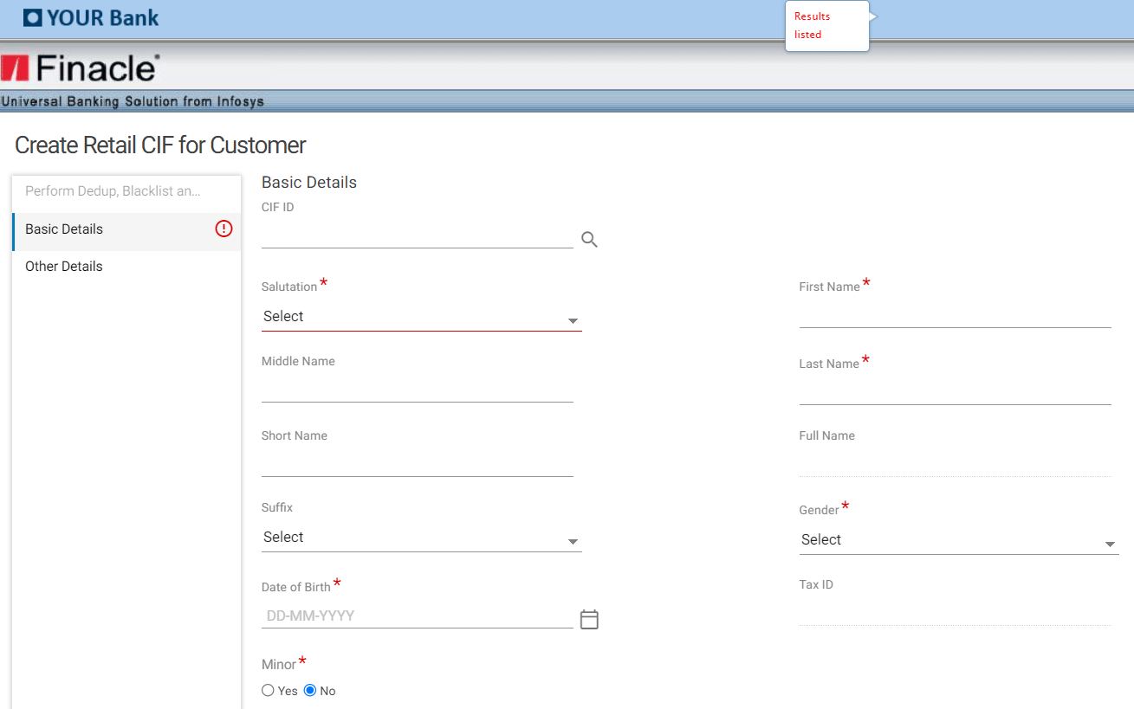

* Input Salutation> First Name>Middle Name>Last Name>Gender>Date of Birth>Select YES on Minor
* Enter CIF ID for the parent or guardian
* Select the guardian type on Guardian (Mother, Father, Guardian)

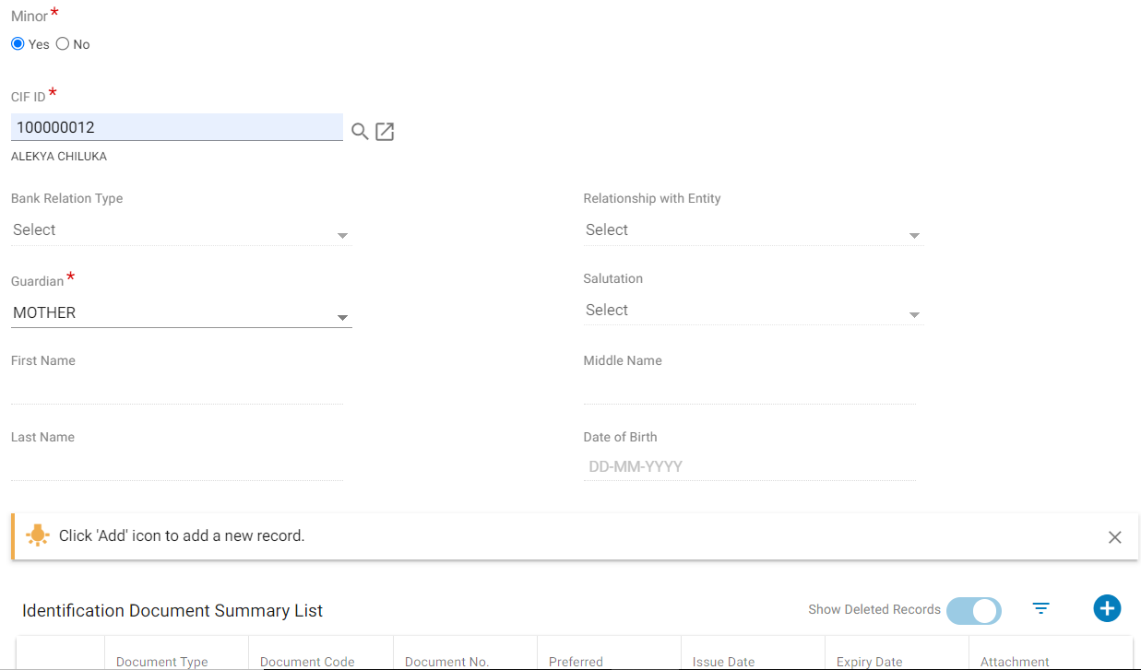

* Click on ADD (+)
* Select **IDENTIFICATION PROOF FOR RETAIL(IDPRF)** on Document Type
* Select Document Code as Birth Certificate or Birth Notification
* Input Birth Certificate or Birth Notification number on Document number
* Select Preferred as Y
* Input Issue Date

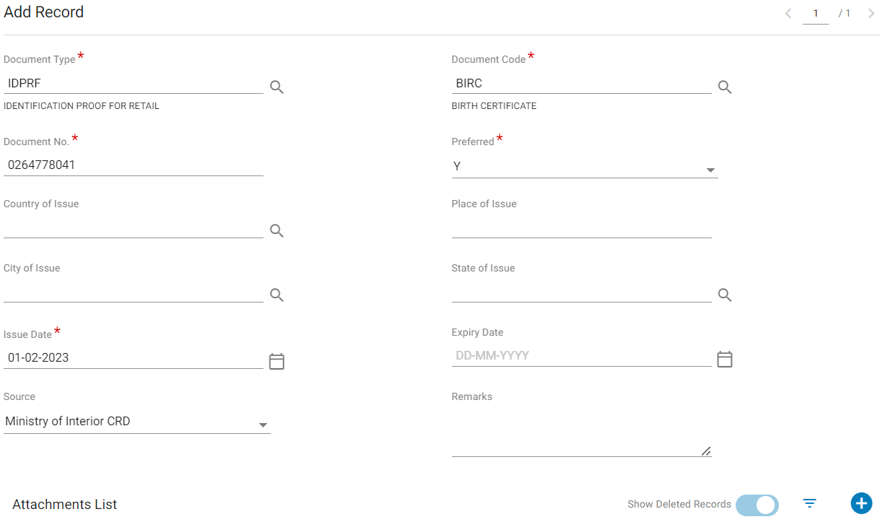

* Click on ADD (+) on Attachments List
* Select the Appropriate Mode to Add the Record:
* Link- If the guardian has an existing CIF id with the same document used as the identification document. (Refer to ‘Capturing Identification Document for a retail CIF’
* Capture – when the SDO wishes to take a photo of the identification document using a webcam. Refer to Capturing Identification Document for a Retail CIF’
* Add –To choose an already scanned and saved document on the computer in PDF or JPEG format.
* Click on Upload
* Click on Save.

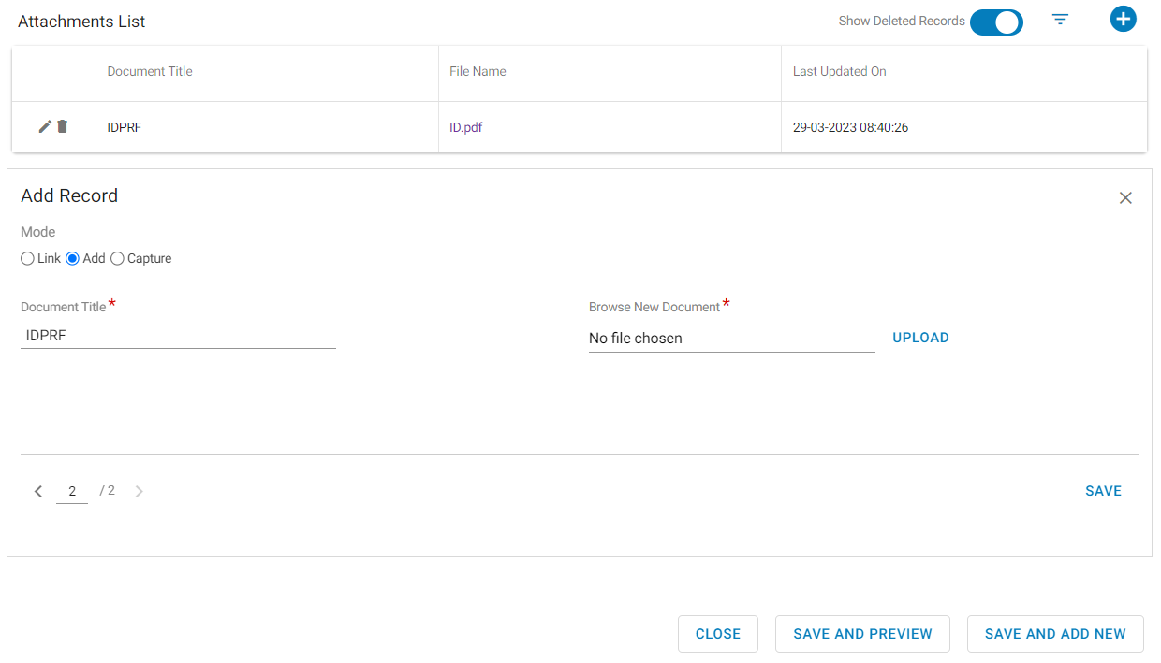

* Click on Save and Preview

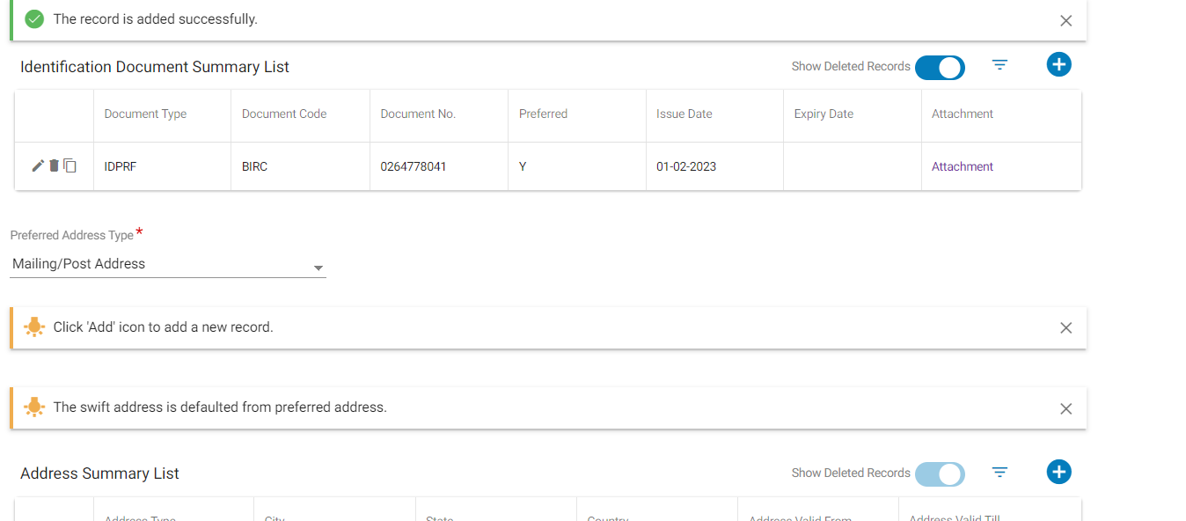

## Adding Customer Address

Refer to the section on ‘Adding Customer Address’ above.

## Capturing Contact Details.

Refer to section on ‘Capturing Contact Details’ above.

## Capturing Other Details.

Capturing Residential Details, Miscellaneous Details and Currency Details

Refer to section on ‘Capturing Other Details’ above

* Click on KRA to Generate KRA details then click on Save and Enrich

Proceed to Enrich the CIF details on the displayed sections.

## Additional Details.

To Enrich the MINOR CIF Additional Details, follow the same process used to Enrich a Retail CIF.

Refer to the section on ‘Additional Details’ above

## Bank Defined Details.

Same process used above for a Retail CIF enrichment of Bank Defined Details is followed

## Preferences Details.

Minor CIF Preferences Details process is like that followed during Retail CIF Enrichment Above.

Refer to the section on ‘Preferences Details’ above.

## Financial Details.

Same process as Retail CIF Financial Details Enrichment done above.

## Relationship Details.

Follow the Process used to Enrich a Retail CIF Relationship Details done above

* Click on the View Summary Button to confirm that all the sections are Saved and Validated.
* Click on the Submit button to send the CIF for approval.

## Verification of Retail CIF

Using the menu RCCAT (Retail and Corporate CIF Approval Tray)

Refer to the section on ‘Approval of a Retail CIF’

## Minor Account Opening

Minor accounts shall be opened under Savings account with scheme code MINOR using OSA (Open Savings Account)

### Basic Account Details

* Enter a valid enriched and verified Minor CIF on CIF ID field
* Select Scheme Code as Minor
* Click Go Button, the CIF details will be auto populated and displayed as shown below.

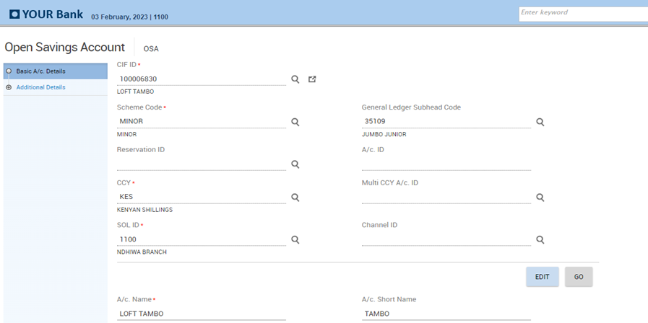

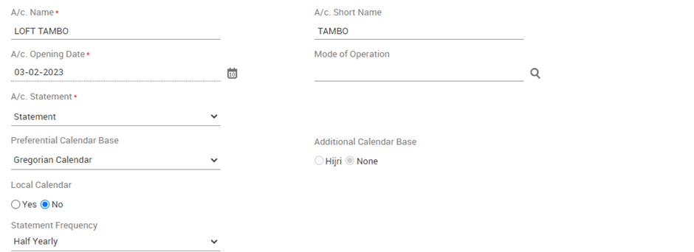

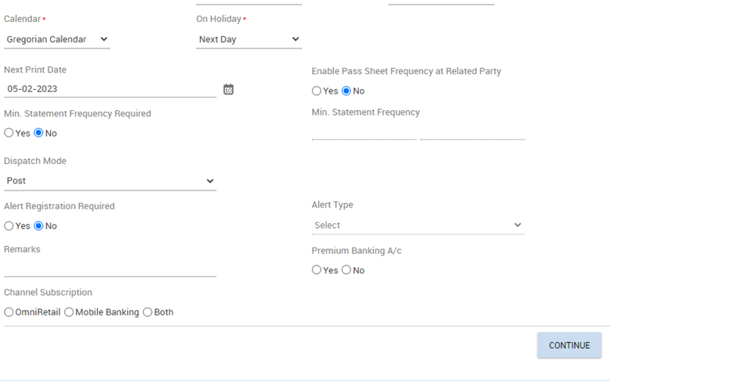

* Click CONTINUE to proceed to Additional Details.

### Capture Additional Details

On the **Related Party Details**, SDO shall under additional details page:

* Click ADD button to add Guardian’s Record or Records where account has more than One Signatories.

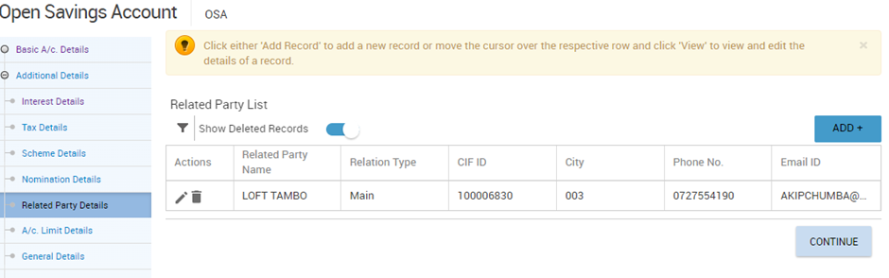

The main CIF /Minor CIF details are available on the Related Party List.

* Click on ADD (+) button to add the Guardian (s).
* Capture the Relation Type as Authorized Signatory and the appropriate Relation Code.
* Scroll down to Capture the Guardian CIF Id on the CIF ID field

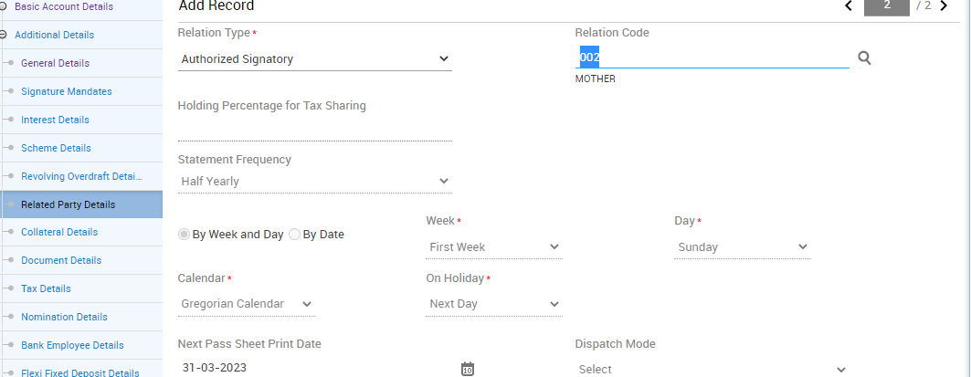

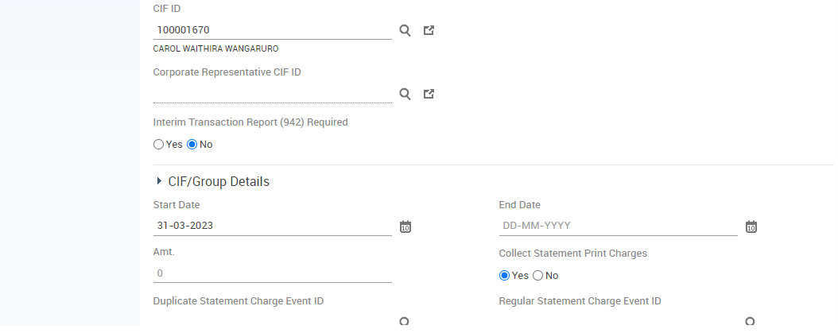

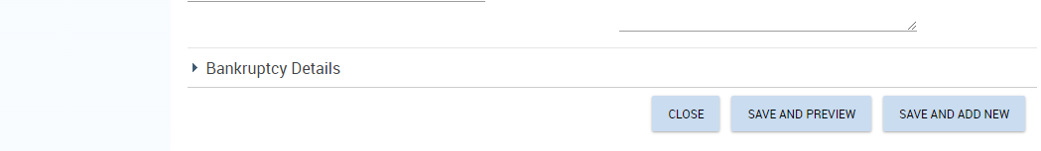

* Click on SAVE AND ADD NEW to add second signatory or SAVE AND PREVIEW to view a summary of the Related Party List.

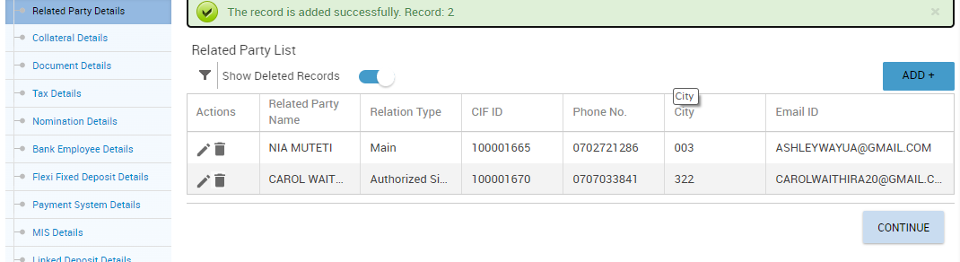

* Proceed to Document Details Section and Capture the Relevant KYC Documents presented by the Guardian (s)

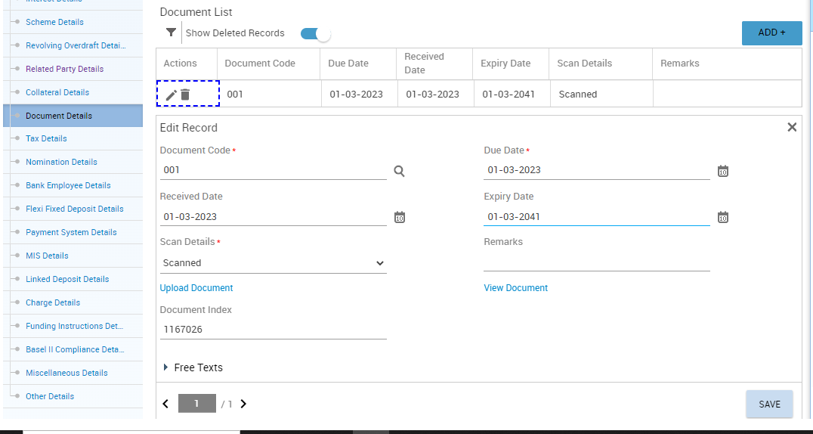

* Click on the SAVE button to save the Record and proceed to add any other document Presented.
* Click on SAVE AND PREVIEW to view a summary of the Documents.
* Click on MIS details section and capture all the mandatory fields.

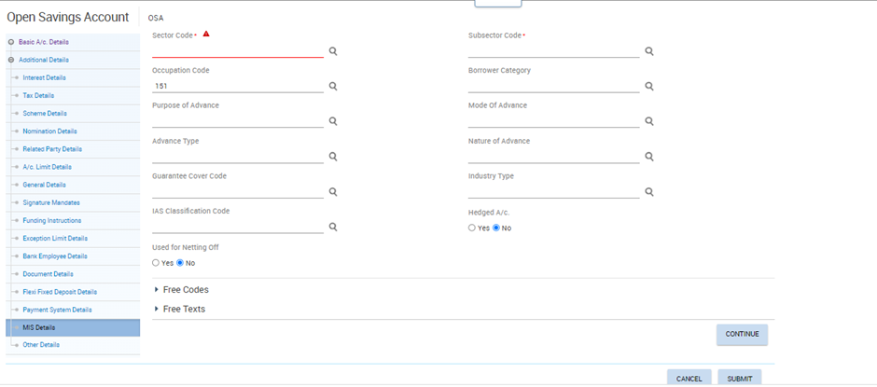

* Click Submit and Proceed to Capture Photos & Signatures for the guardian(s)

## Photo & Signature Capture for Minor Account

SDO shall:

* Invoke CACOF menu to capture photo & signatures using Webcam and Signature pad available.

Remarks shall include Guardian Details which include Name, ID no, Designation & Signing Instructions.

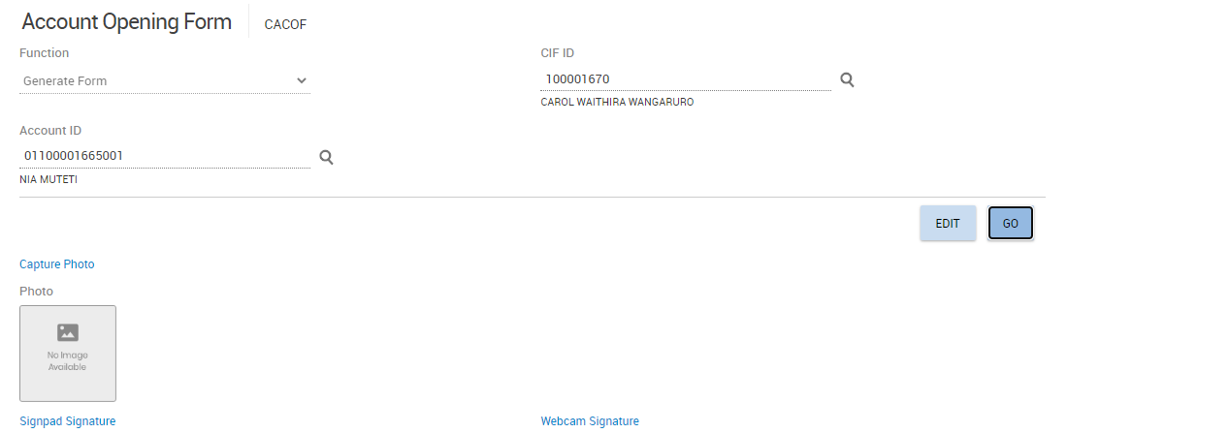

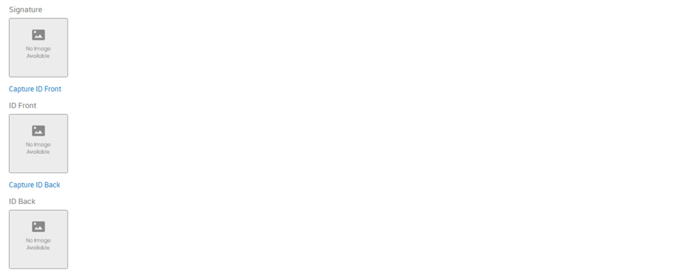

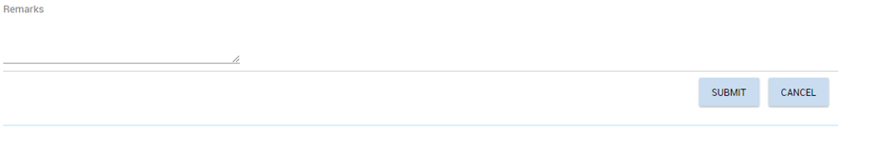

* **SUBMIT** for Verification.

## CACOF Verification for Minor Account

CACOF verification for minor account shall follow the same process as of Individual Retail Account.

Follow steps **Ref 17.2** CACOF verification for Retail Individual Account

## Minor Account Opening Verification

Jumbo Junior account shall be verified using VSAO/VCAO menu. Follow step **15 Account Opening Verification**

## Unborn CIF Creation

Opened by an expectant mother with her personal Identification Document.

The procedure below shall be followed to create a CIF ID for an Unborn Child.

* **Invoke** menu CERC (Create Retail CIF)

The **CIF** creation screen is displayed as shown below

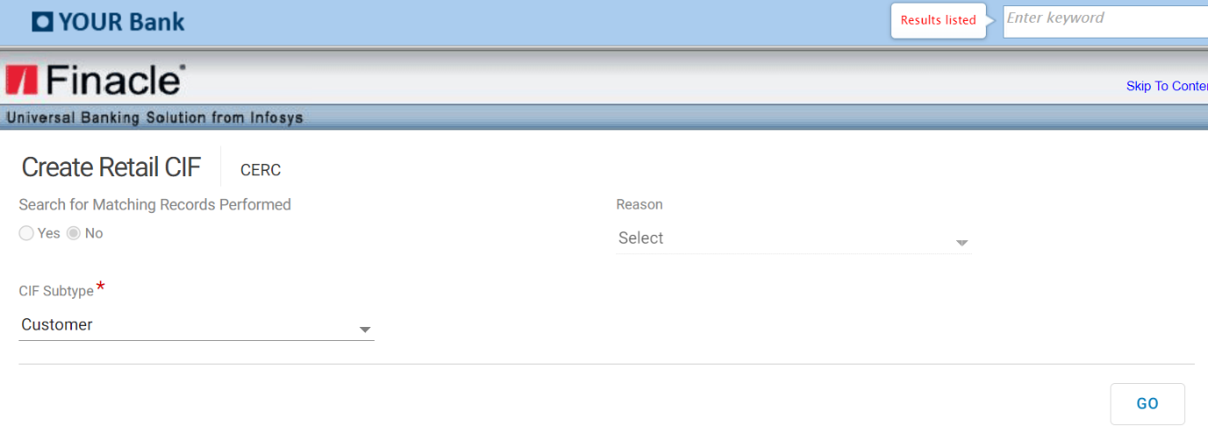

* Select the CIF subtype as “Customer”
* Click on GO button, below screen is displayed.

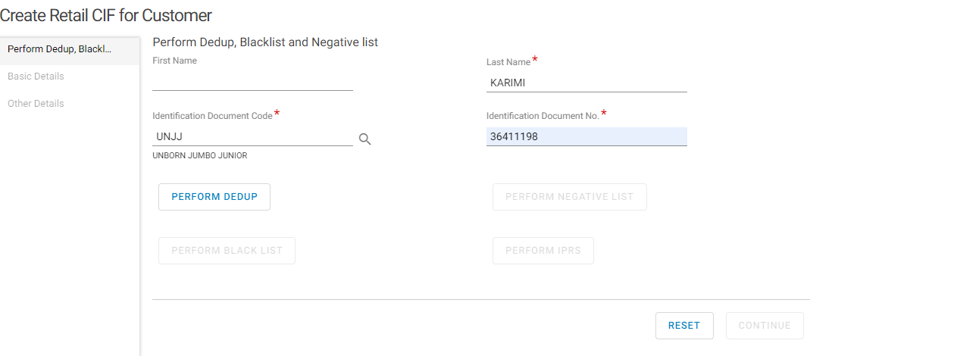

* Enter the minor Last name which is mandatory
* Select the Identification Document Code from the searcher as UNJJ for Unborn Jumbo Junior.
* Enter the Identification Document Number Presented by the Guardian i.e., Passport, National ID etc., in the Identification Document No. Field.
* Click on PERFORM DEDUP
* Click on PERFORM NEGATIVE LIST
* Click on PERFORM BLACKLIST
* Click on PERFORM IPRS
* Click Continue to proceed to Basic Details

## Basic Details Page



* Input Salutation, First Name, Middle Name, Last Name and Gender Details for the Guardian.
* Capture Date of Birth as BOD
* Select YES on Minor option field.
* Enter CIF ID for the parent or guardian
* Select the guardian type on Guardian (Mother, Father, Guardian)



* Click on ADD (+)
* Select **IDENTIFICATION PROOF FOR RETAIL(IDPRF)** on Document Type
* Select Document Code as UNJJ for unborn Jumbo junior
* Enter the guardian Identification Document Number on Document No. Field in the following format:

Identification document number plus a running sequence e.g. 1234567801 where 12345678 is the id document no. and 01 being the running sequence for the very first unborn CIF ID created for the customer.

* Select Preferred as Y
* Input Issue Date as BOD (current date).
* Expiry Date input 15 months after BOD(current date)

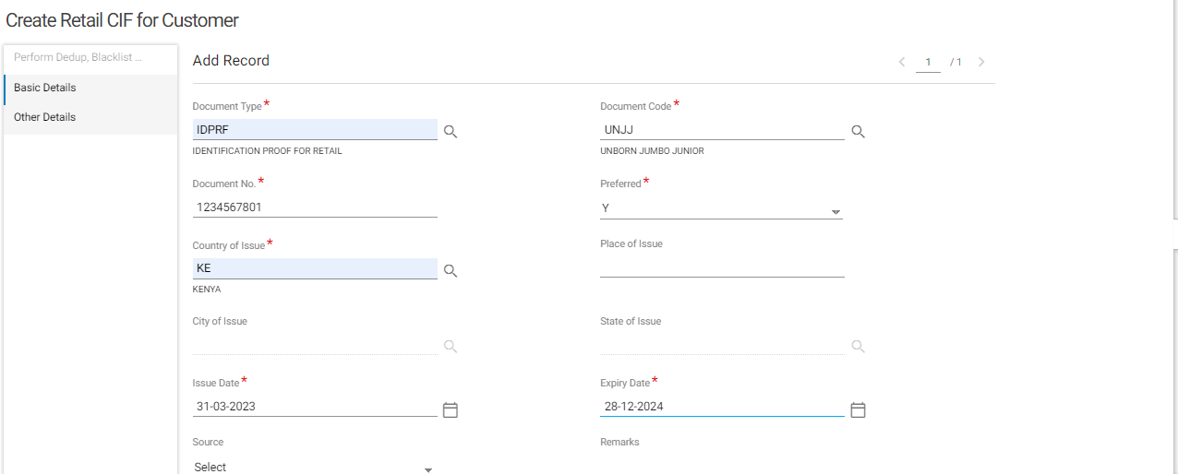

* Click on ADD (+) on Attachments List
* Select the Appropriate Mode to Add the Record:
  + Link- If the guardian has an existing CIF id with the same document used as the identification document. Refer to section on Capturing Identification Document for a retail CIF.
  + Capture – when the SDO wishes to take a photo of the identification document using a webcam. Refer to section on Capturing Identification document for a retail CIF
  + Add –To choose an already scanned and saved document on the computer in PDF or JPEG format.
* Click on Upload
* Click on Save.



* Click on Save and Preview

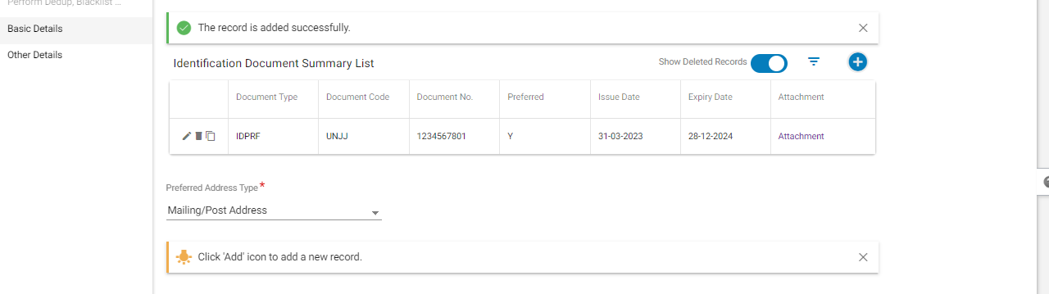

## Adding Customer Address Summary

Follow the process used to add customer Address summary for a retail CIF documented above.

## Capturing Contact Details

Follow the process used to Capture Contact Details for a retail CIF documented above.

## Capturing Other Details

Follow Documented Process for a Retail CIF to Capture Other Details.

* Capturing Residential Details
* Capturing Miscellaneous Details
* Capturing Currency Details
* Click on KRA to Generate KRA details then click on Save and Enrich
* Proceed to Enrich the CIF details on all the following sections.
  + Additional Details-REF 10
  + Bank Defined Details- REF 11
  + Preferential Details- REF12
  + Financial Details-REF13
  + Relationship Details-REF 14

## Unborn Child Account Opening

The process remains the same as illustrated in MINOR ACCOUNT OPENING.

# Marketed Account

For marketed accounts, the same Process for Retail and Corporate CIF creation and Savings and current account opening processes shall be followed.

The difference is that the SDO shall:

* Capture the customers **Photo, ID front** and **ID back and Signature** using a Webcam.
* Capture very clear images to avoid RTS.
* Attach the mandate filled by the customer shall be attached on Document details during account opening on menu OSA (Open Savings Account) or menu OCA (Open Current Account).



# ModifyING Account Before Verification

Opening a current/Savings account involves capturing various details. These details, if required, can be modified only by the maker before the verification of the account opening process. This activity allows you to modify account details before the account is verified.

Details that can be amended before Verification for both Savings and Current Accounts Include the following:

**Basic Account Details Page:**

* A/c Name
* A/c statement details
* Alerts Registration Details
* Premium Banking Details
* Channel Subscription

**Additional Details:**

* Tax Details
* Related party Details
* Funding Instructions
* Bank Employee
* Document Details
* MIS details

For Savings account, Maker shall invoke menu MOSAV

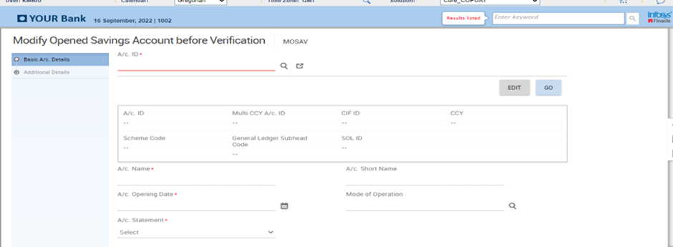

For Current account MOCAV Menu shall be used

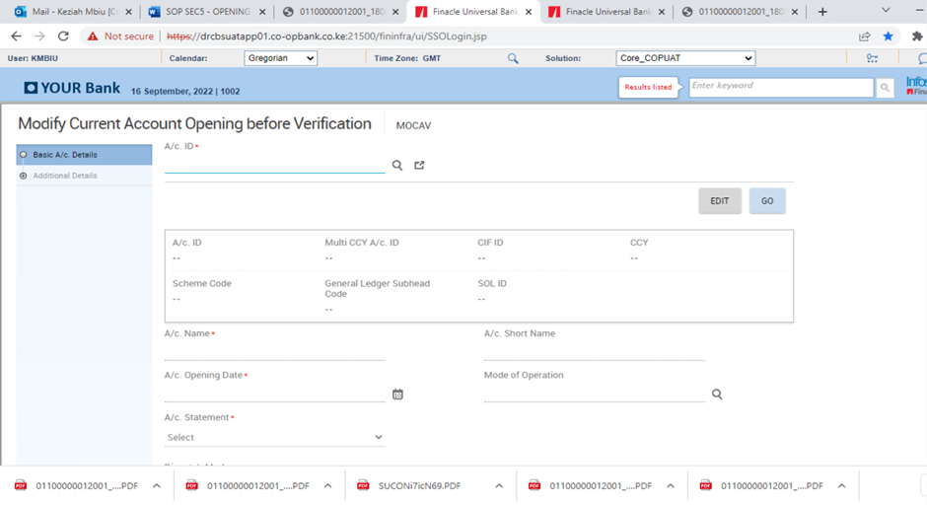

* Select the account form the searcher

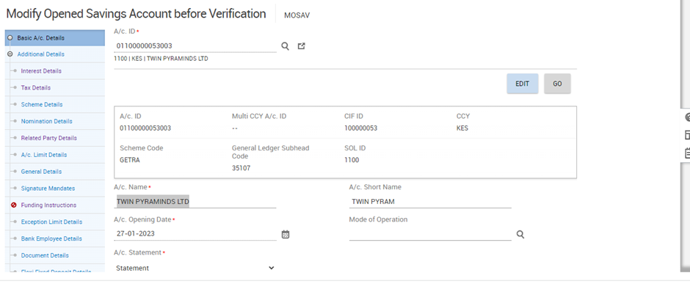

* Amend the required record and submit account for verification using VSAO/ VCAO menu

# CancelING Savings/Current Account Opening Before Verification

* Invoke:
  + - Menu CSAO (Cancel Savings Account Opening) Menu for Savings Account
    - Menu CCAO (Cancel Current Account Opening) menu for Current Account
* Key in account ID or select the account from the searcher

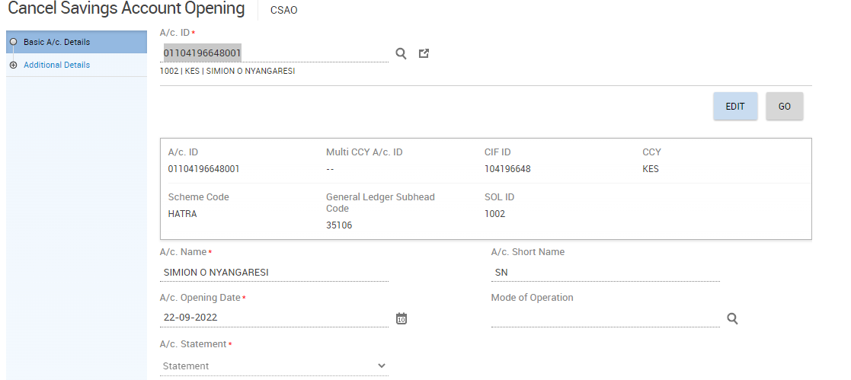

* Click Go button to view the accounts details

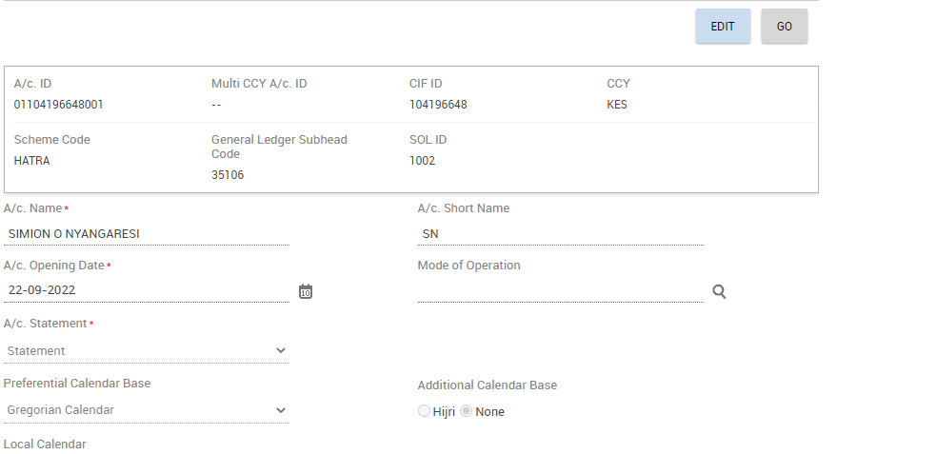

* Click Continue button to proceed to account additional details

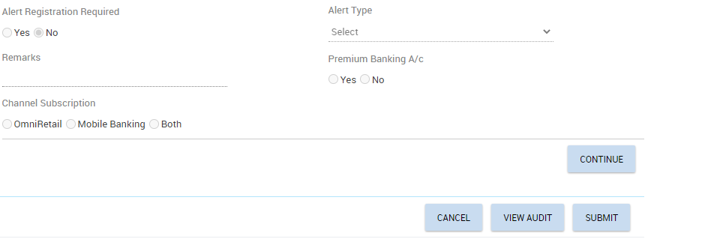

* View all the pages under additional details

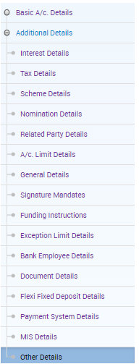

Visit all the details pages

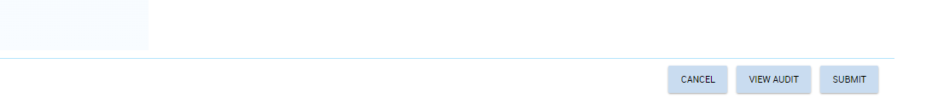

* Click Submit Button to complete cancellation

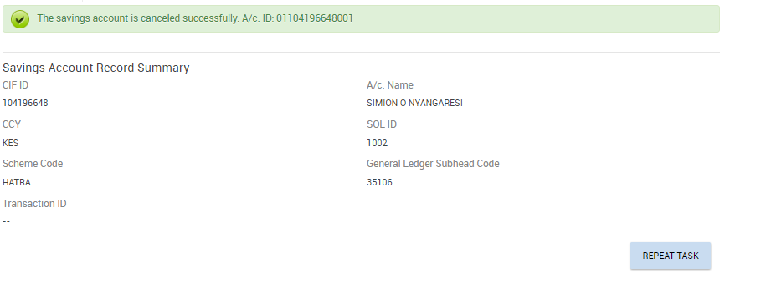

# Transfer of account between schemes

The below procedure shall be followed to transfer an account from one scheme code to another.

* Invoke menu TASS (Transfer Accounts between Schemes)
* Input the account number to be transferred

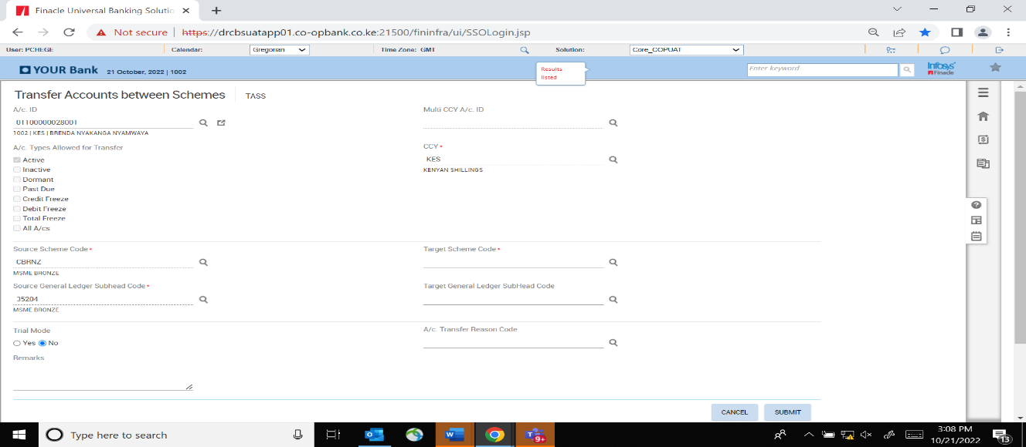

**Note**:

That the source scheme code will default from the account number.

* The process shall be carried out as follows:
  + Select target scheme code i.e., the new scheme code for the account and input Remarks which shall be the reason for account scheme transfer.

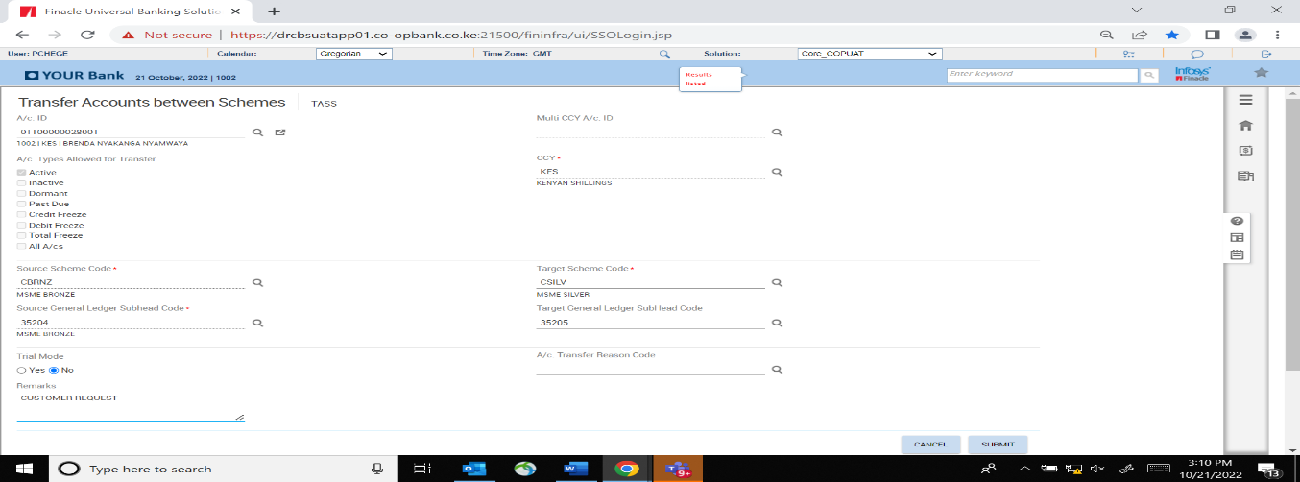

* + Click on submit button

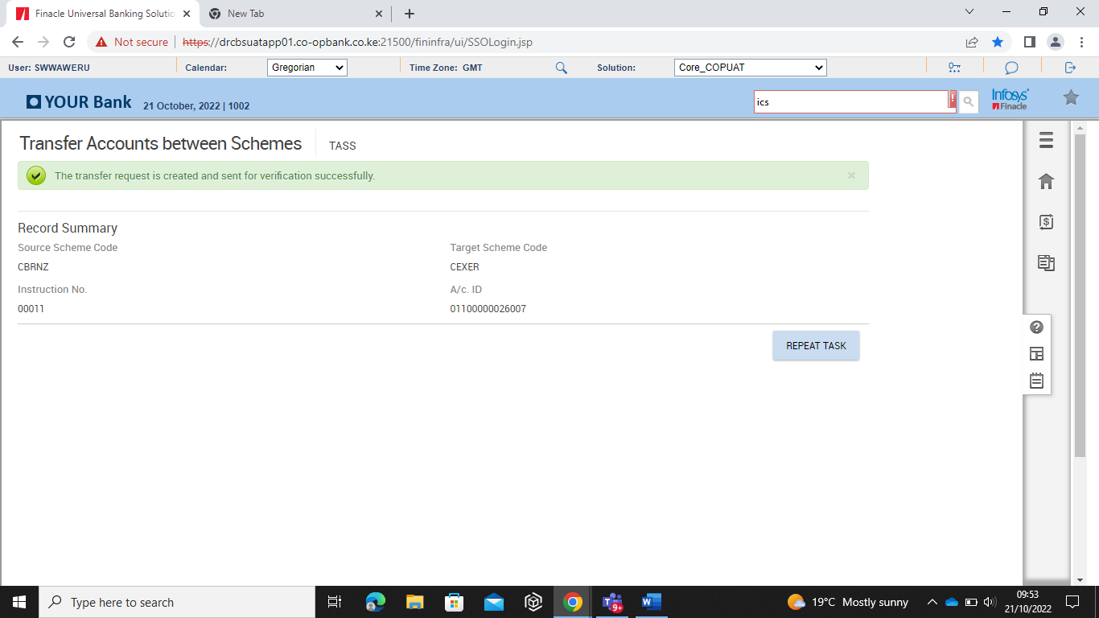

* + On submission an Instruction Number is generated and the record is sent for verification

## Cancelling of account transfer between schemes

This function is performed to undo transfer action before verification is done. The following procedure shall be followed to cancel transfer of account between schemes.

* Invoke menu CATSS (Cancel Accounts Transfer between Schemes)
* Input instruction number or select it from the searcher then click Go button.

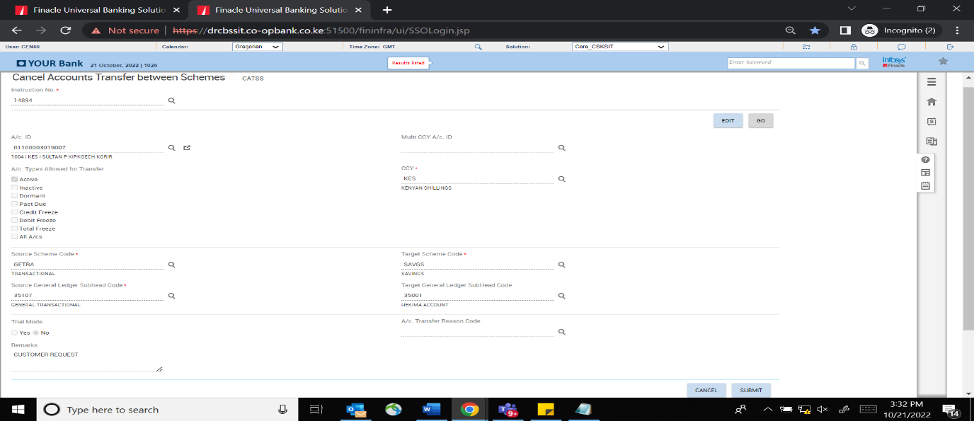

* Click on the submit button to cancel the transfer.
* On submission, the screen below shall be displayed once transfer of account from one scheme to another is successful.

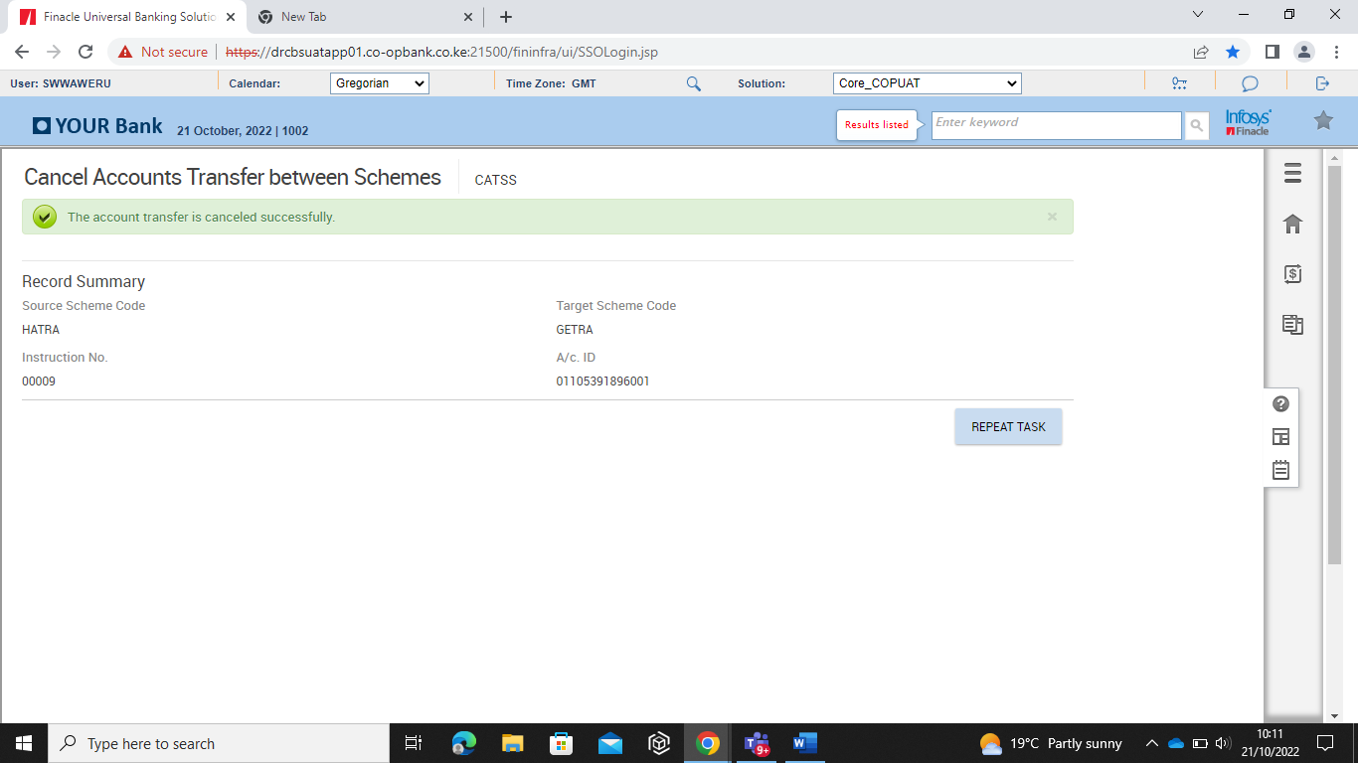

## Verification of transfer of accounts between schemes

The following procedure shall be followed to verify transfer of accounts between schemes.

* Invoke menu VATRS-Verify Transfer between Schemes
* Input instruction number or select it from the searcher then click GO button

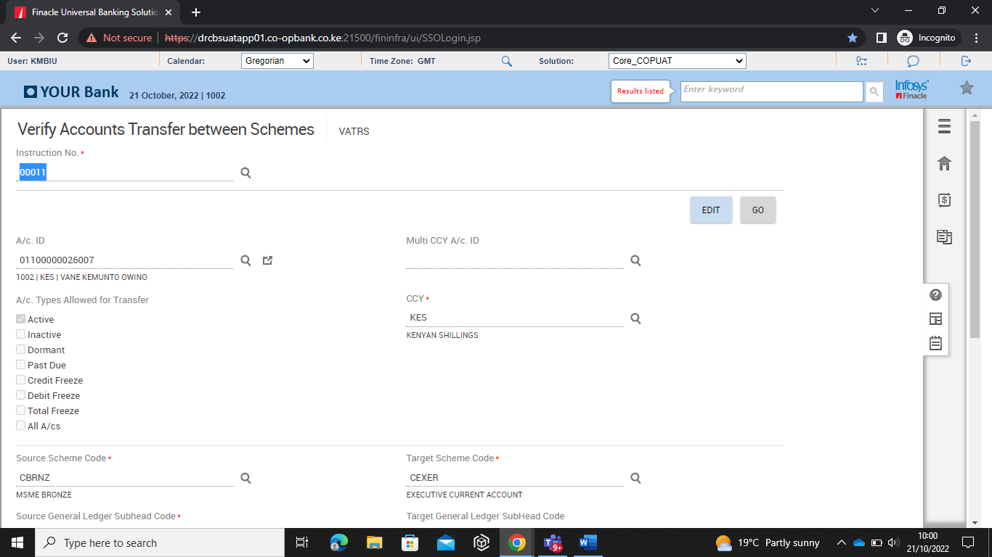

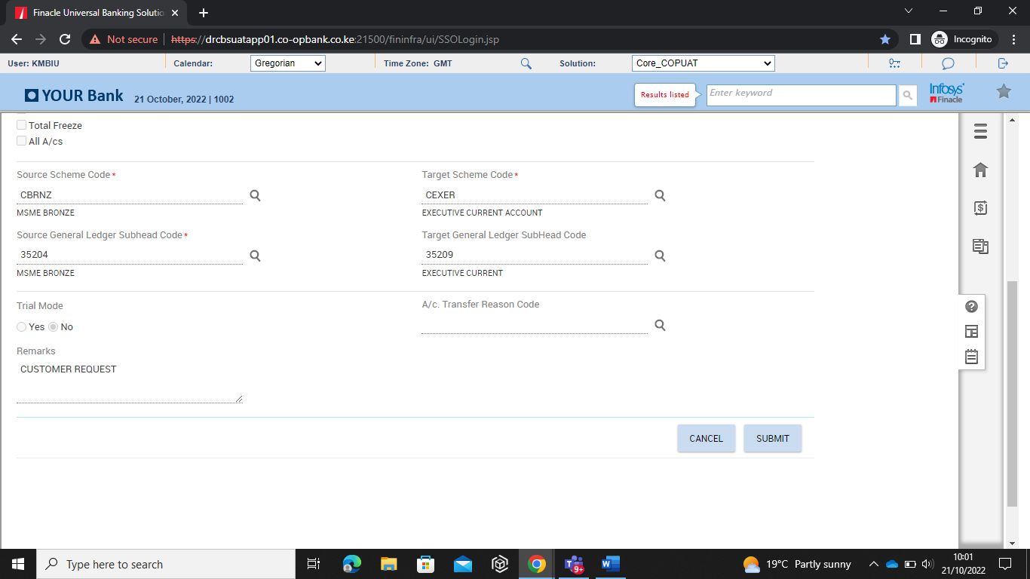

* Click submit button to approve the transfer

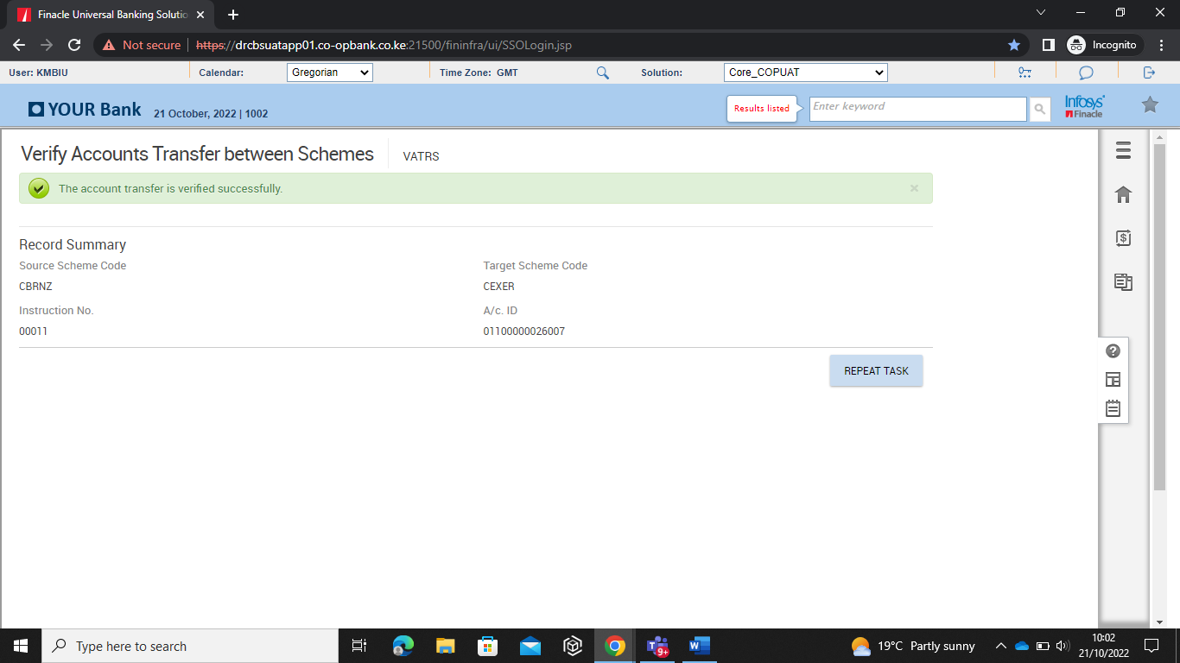

* On verification the account will be successfully transferred from one scheme code to another.
* Confirm the account has been transferred by using menu IEA (Inquire on Account)
* Invoke menu IEA (Inquire on Account)
* Input the account number and click on Go as shown below.

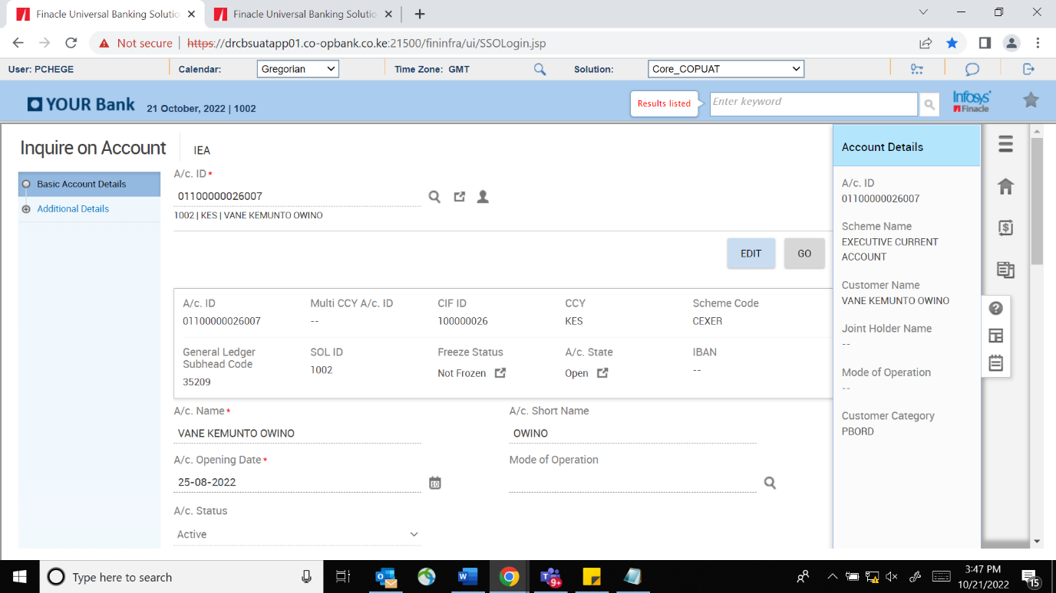

* View the scheme code field to confirm the new account scheme code.